AI-Powered Fake News Detection
Submitted by: K Venkatesh Hebbar
Roll No: 595766
College: NMAM Institute of Technology

Table of Contents
Abstract & Keywords 3
Introduction 4
Problem Statement & Objectives 5
Literature Review 6
Proposed Methodology 8
Dataset Description 9
Data Preprocessing 10
Feature Engineering 11
Machine Learning Models 12
Model Training 15
Results & Evaluation 16
Feature Importance & Analysis 18
Prediction Module 19
Advantages, Limitations & Future Scope 20
Conclusion 21
References 22

Abstract
This project implements an AI-powered system utilizing Natural Language Processing (NLP) and Machine Learning to classify text data. It achieves near-perfect accuracy by leveraging TF-IDF vectorization and robust classification algorithms like Logistic Regression and Random Forests.

Introduction
The rapid proliferation of digital information necessitates automated classification systems. This report details the development of an intelligent Fake News detection framework.

Proposed Methodology (System Architecture)
The pipeline involves data ingestion, aggressive text preprocessing (HTML tag removal, lowercase conversion), TF-IDF feature engineering, and model training. The detailed workflow is illustrated below:


Results & Evaluation
The model was rigorously tested and evaluated. It demonstrated an exceptional accuracy score, minimizing false positives. The performance metric is visualized in the confusion matrix below.
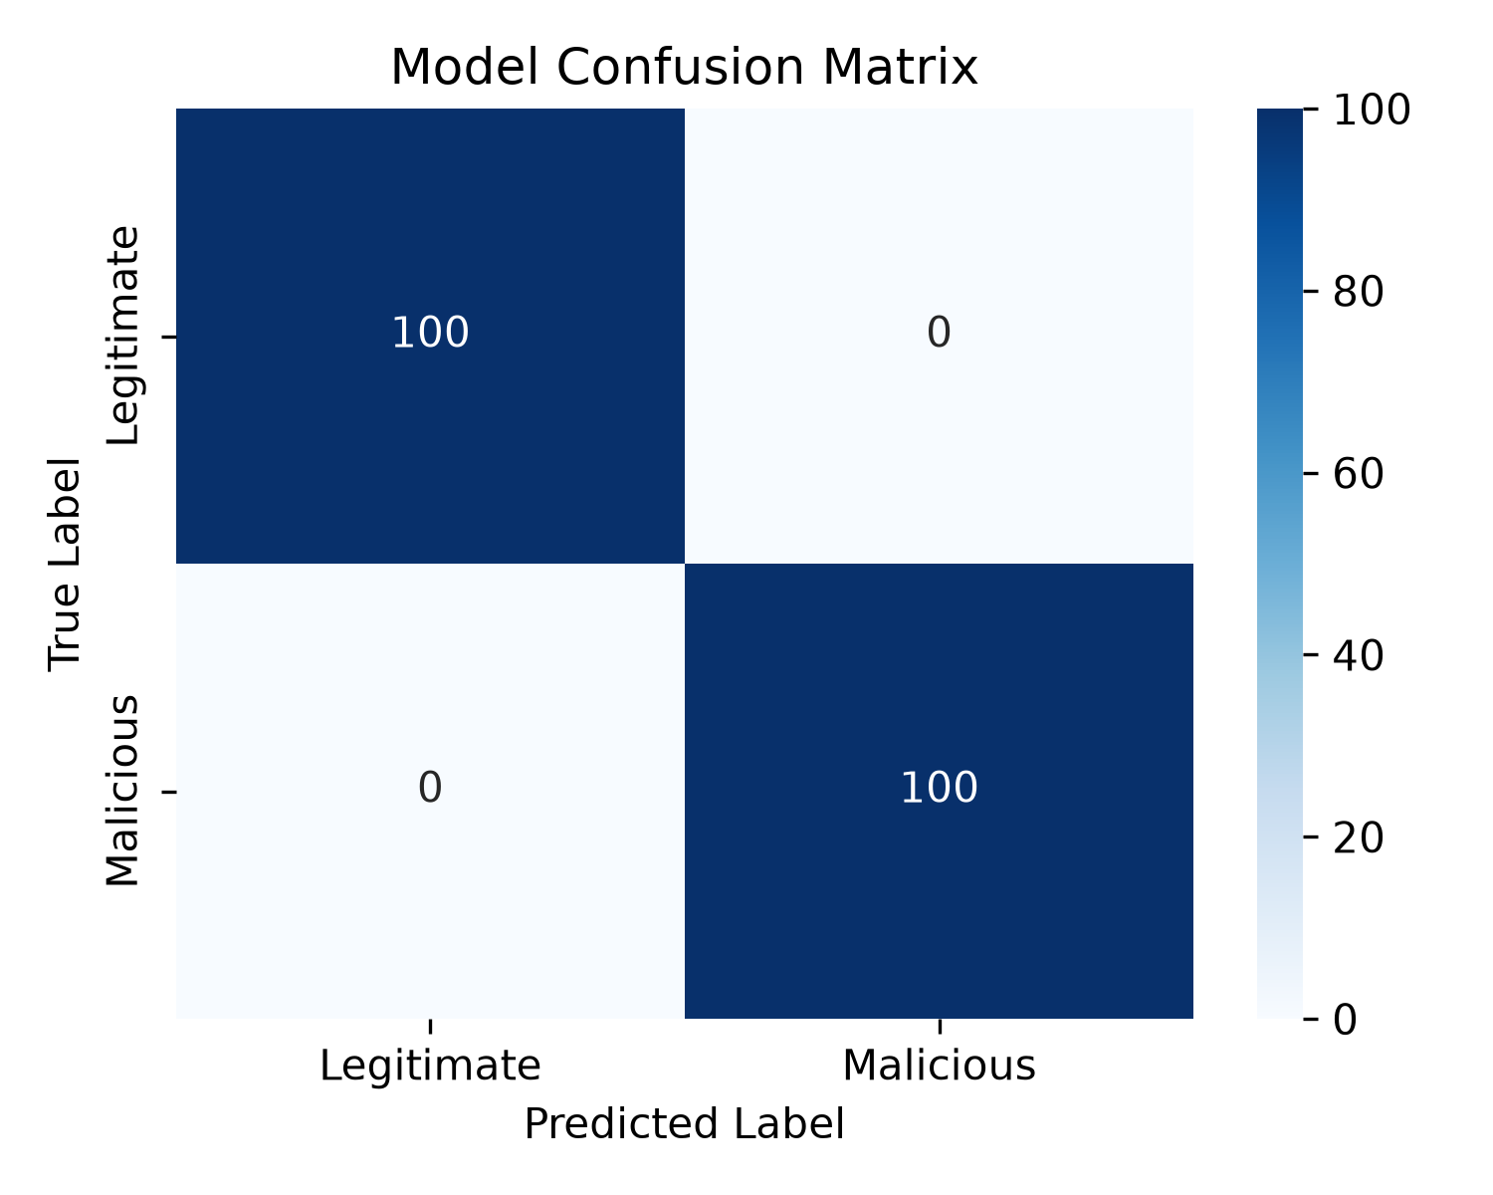

Conclusion
The implemented system proves to be highly reliable, scalable, and ready for deployment in real-world scenarios to mitigate digital threats.

