SwordNex Billing
User Guide for Business Owners

How to use the app, the industries available, and the features built for each industry.
Grocery • Pharmacy • Mobile Shop • Clothing • Pet Shop • Academy • Software Development
Version 1.0 — September 2026
Screenshots show sample data from demo businesses.

Contents
1. Welcome to SwordNex Billing 3
1.1 What you can do 3
1.2 What you need 3
2. Getting Started 4
2.1 Create your account 4
2.2 Sign in 4
2.3 Choose your industry (one-time setup) 5
3. A Quick Tour of the Screen 7
3.1 The Dashboard 8
4. Industries Available 9
4.1 Menu (modules) by industry 9
4.2 Features by industry 10
4.3 Words the app uses for your industry 10
5. Everyday Features 11
5.1 Inventory — your products and stock 11
5.2 POS Billing — making a sale 12
5.3 Barcodes 13
5.4 GST Bill — A4 tax invoices 13
5.5 Record — all your data in one place 14
5.6 Credit — customer dues and online payment links 15
5.7 Cash Book — income and expenses 16
5.8 Reports 17
5.9 Staff logins (Sub-users) and Subuser Records 17
6. Industry-Specific Guides 20
6.1 Grocery Store 20
6.2 Pharmacy 20
6.3 Mobile Shop 22
6.4 Clothing 25
6.5 Pet Shop 26
6.6 Academy 27
6.7 Software Development 31
7. Settings 34
7.1 Profile, tax and printer 35
7.2 Changing your industry 36
7.3 Getting support 37
8. Plans and Subscription 38
9. Frequently Asked Questions 39
10. Getting Help 40

1. Welcome to SwordNex Billing
SwordNex Billing is an online billing, point-of-sale and stock management system built for small and growing businesses in India. You can make bills in seconds, print GST invoices, track stock and expiry dates, follow up on customer dues, record expenses and see how your business is doing — from any computer with a web browser.
What makes SwordNex Billing different is that it adapts to your type of business. When you tell the app your industry, the menu, the screens and even the words used (Customer, Student or Client; Product, Course or Service) change to match the way you work.

1.1 What you can do
Feature | What it means for you
Fast POS billing | Tap or scan products, collect payment by Cash, UPI, Card or Wallet, and print a receipt.
GST invoices | Create professional A4 GST invoices with CGST/SGST/IGST worked out automatically.
Stock management | See quantity, value and low-stock warnings for every item. Stock reduces automatically as you sell.
Barcodes | Every product gets a barcode you can print and stick on shelves or packets.
Customer dues (credit) | Record sales on credit, collect part payments, and send customers an online payment link.
Cash Book | Record rent, salaries, electricity and other income/expenses to see your real profit.
Records & Reports | Search every bill, invoice, customer and supplier; export to Excel; see revenue and GST collected.
Staff logins | Give your staff their own login. You see everything they do; they only see their own work.
Industry modules | Extra screens for your trade — Expiry Alerts, Repair Tickets, IMEI Lookup, Students, Trainers, Clients, Milestones, Pet profiles.

1.2 What you need
- A computer, laptop or tablet with a modern browser (Google Chrome or Microsoft Edge recommended) and an internet connection.
- An email address you can open (a verification code is sent there when you sign up).
- Optional: a USB barcode scanner, and a receipt or A4 printer.
- A Windows desktop version of the app is also available on request.

2. Getting Started

2.1 Create your account
Open the SwordNex Billing website and click Register on the sign-in page. Sign-up has three short steps:
- Business Information — your business name, business type (Sole Proprietorship, Partnership, Private Limited, etc.) and number of employees.
- Personal Information — your name, mobile number, email and password. A 6-digit code is sent to your email; type it in and click Verify & Continue. The code is valid for 5 minutes; use Resend code if it does not arrive (check your spam folder).
- Address & Tax Details — your address, and GSTIN / PAN if you have them. Click finish to create your account.
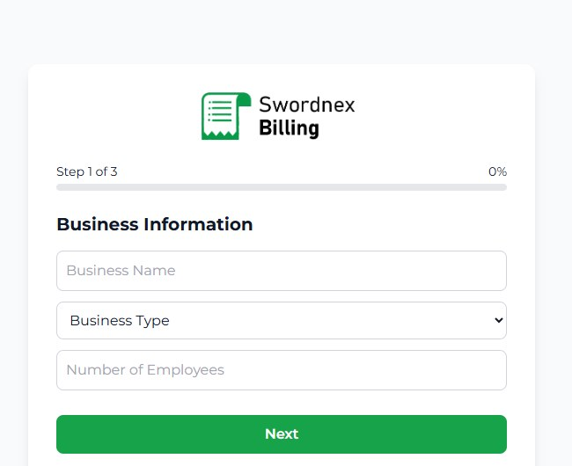
Figure 1: Step 1 of sign-up — Business Information
Free trial: Your 14-day free trial starts automatically the moment you sign up — no payment details needed. You get full access to every feature during the trial.

2.2 Sign in
Go to the sign-in page, enter your email and password and click Sign In.
- Use the Admin tab if you are the business owner.
- Staff members use the Team tab with the email and password the owner created for them.
- Forgot your password? Click Forgot?, enter your email, and follow the reset link we email you (valid for 30 minutes).
- For security, you are signed out when you close the browser tab, and after 24 hours.
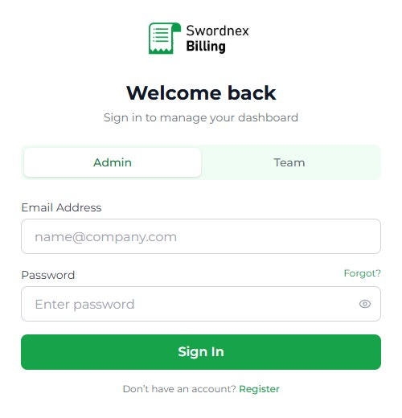
Figure 2: Sign-in page — Admin (owner) and Team (staff) tabs

2.3 Choose your industry (one-time setup)
When you first sign in, the app shows a general menu that works for any shop. A green banner at the top of the Dashboard asks you to complete your Company Profile and pick your industry. Do this first — it unlocks the screens built for your trade.
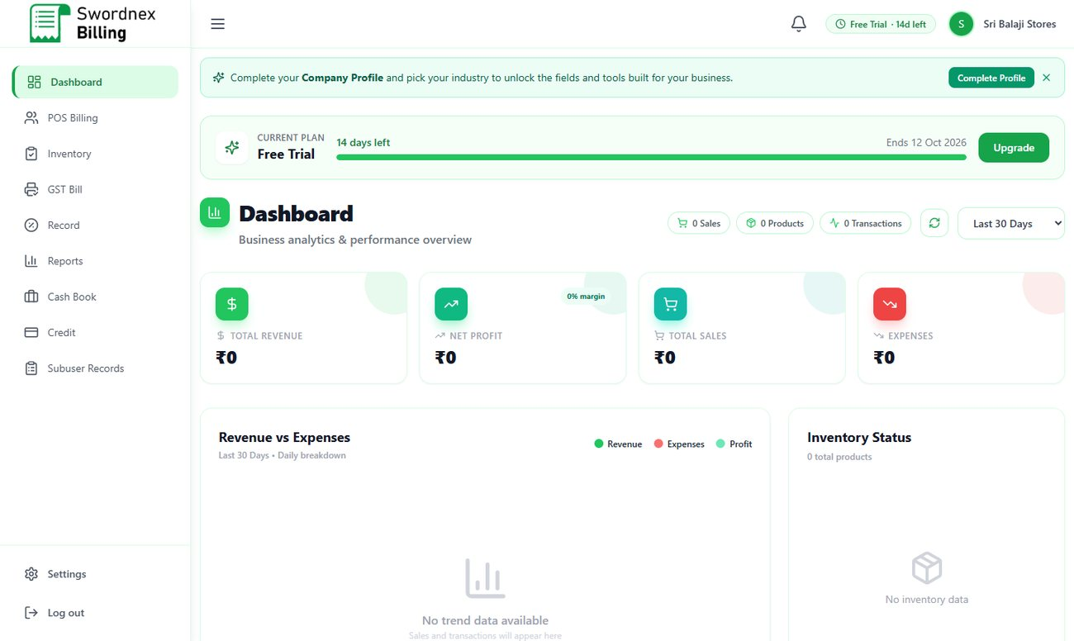
Figure 3: First sign-in: the banner asks you to choose your industry
- Click Complete Profile on the banner (or go to Settings → Profile).
- In the Industry field choose your business type and click Save Industry.
- Your menu changes immediately to the modules for that industry.
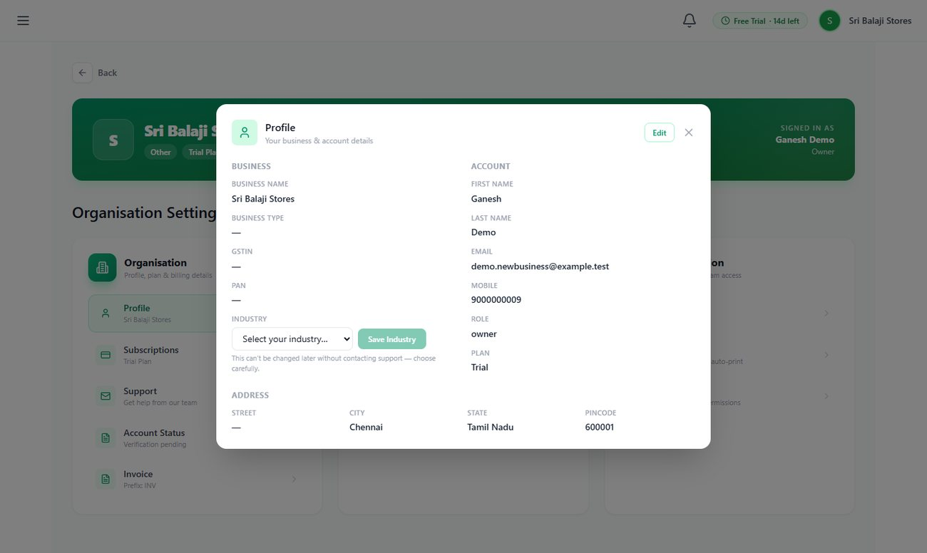
Figure 4: Settings → Profile: pick your industry and click Save Industry
Choose carefully: The industry is locked once saved, because your stock, bills and screens are organised around it. If you ever need to change it, use Contact support in Settings → Profile (see section 7.2) and our team will switch it for you.

3. A Quick Tour of the Screen
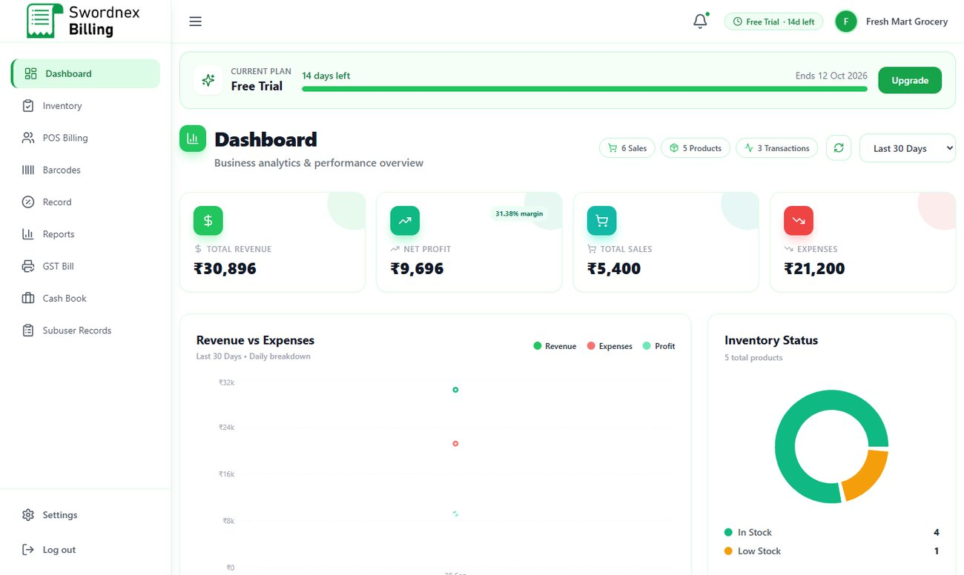
Figure 5: The main screen: menu on the left, header on top, Dashboard in the middle
Area | What you find there
Left menu (sidebar) | All the modules available for your industry. The highlighted item is the page you are on. Settings and Log out are at the bottom. Click the ☰ icon to collapse the menu.
Bell icon | Notifications — for example, products that are running low on stock, with a Reorder Now shortcut.
Plan badge | Shows your current plan and how many days are left (e.g. "Free Trial · 14d left").
Business name | Your business name and logo initial.
Current plan bar | On the Dashboard: days left in your plan and an Upgrade button.

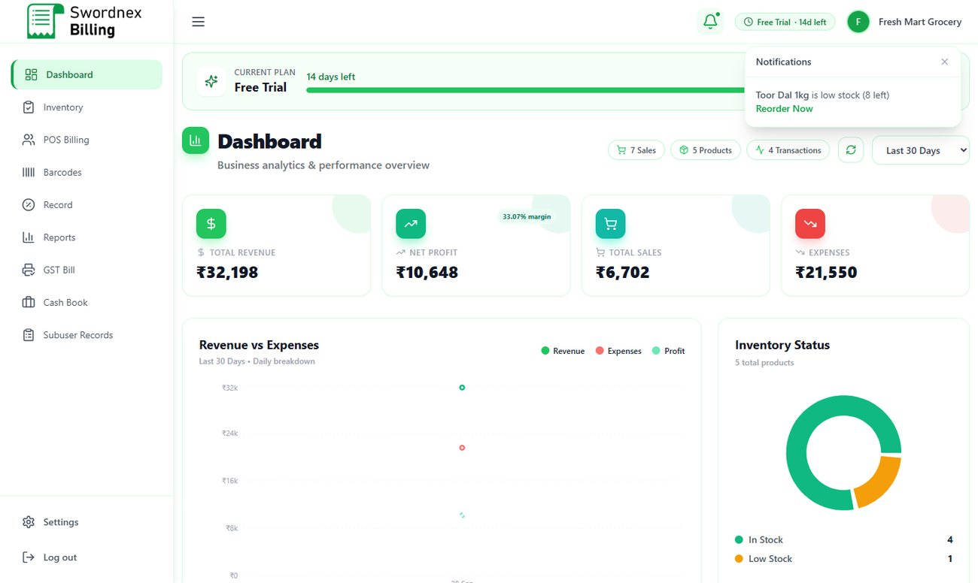
Figure 6: Low-stock notification from the bell icon

3.1 The Dashboard
The Dashboard is your daily snapshot. Use the drop-down at the top right to change the period (for example, Last 30 Days) and the refresh button to reload figures.
- Total Revenue, Net Profit (with margin %), Total Sales and Expenses cards.
- Revenue vs Expenses chart, day by day.
- Inventory Status — how many items are in stock or low on stock.
- Academy dashboards show Fees Collected and Total Students instead of product figures.

4. Industries Available
SwordNex Billing currently supports seven industries. If your business does not fit any of them, you can keep using the general setup ("Other"), which includes all the standard retail features.
Industry | Best for | Billing style | Special modules
Grocery Store | Supermarkets, kirana and general stores | Retail POS | Barcodes, Reports
Pharmacy | Medical shops and chemists | Retail POS | Batch & expiry tracking, Expiry Alerts, Credit
Mobile Shop | Mobile phone and accessory stores | Retail POS | IMEI tracking, Repairs & Warranty, IMEI Lookup, Credit
Clothing | Garment and fashion stores | Retail POS | Sizes, Barcodes
Pet Shop | Pet food, accessories and grooming | Retail POS | Batch & expiry, Pets (pet profiles)
Academy | Coaching centres, institutes, training academies | Course fees & instalments | Courses, Students, Trainers, Fee Dues
Software Development | IT services, agencies, freelancers | Project / milestone billing | Services, Clients, Milestones

4.1 Menu (modules) by industry
Module | Grocery | Pharmacy | Mobile | Clothing | Pet Shop | Academy | Software
Dashboard | ✓ | ✓ | ✓ | ✓ | ✓ | ✓ | ✓
Inventory | ✓ | ✓ | ✓ | ✓ | ✓ | Courses | Service
POS Billing | ✓ | ✓ | ✓ | ✓ | ✓ | ✓ | ✓
Barcodes | ✓ | — | ✓ | ✓ | ✓ | — | —
Record | ✓ | ✓ | ✓ | ✓ | ✓ | ✓ | ✓
Reports | ✓ | — | ✓ | — | ✓ | — | —
GST Bill | ✓ | ✓ | ✓ | ✓ | ✓ | ✓ | ✓
Cash Book | ✓ | ✓ | ✓ | ✓ | ✓ | ✓ | ✓
Credit / Fee Dues | — | ✓ | ✓ | — | — | Fee Dues | —
Expiry Alerts | — | ✓ | — | — | — | — | —
Repairs | — | — | ✓ | — | — | — | —
IMEI Lookup | — | — | ✓ | — | — | — | —
Pets | — | — | — | — | ✓ | — | —
Students | — | — | — | — | — | ✓ | —
Trainers | — | — | — | — | — | ✓ | —
Clients | — | — | — | — | — | — | ✓
Milestones | — | — | — | — | — | — | ✓
Subuser Records | ✓ | ✓ | ✓ | ✓ | ✓ | ✓ | ✓

4.2 Features by industry
Feature | Grocery | Pharmacy | Mobile | Clothing | Pet Shop | Academy | Software
Barcode scanning at billing | ✓ | ✓ | ✓ | ✓ | ✓ | — | —
Loyalty points | ✓ | ✓ | ✓ | ✓ | ✓ | — | —
Customer wallet | ✓ | ✓ | ✓ | ✓ | ✓ | — | —
Stock quantity tracking | ✓ | ✓ | ✓ | ✓ | ✓ | Seats | —
Batch & expiry dates | — | ✓ | — | — | ✓ | — | —
IMEI / serial numbers | — | — | ✓ | — | — | — | —
Sizes (variants) | — | — | — | ✓ | — | — | —
Sale on credit (dues) | — | ✓ | ✓ | — | — | ✓ | —
Instalment (term) payments | — | — | — | — | — | ✓ | —
GST invoices | ✓ | ✓ | ✓ | ✓ | ✓ | ✓ | ✓

4.3 Words the app uses for your industry
Industry | Your buyers are called | What you sell is called | Stock screen is called
Retail industries | Customers | Products | Inventory
Academy | Students | Courses | Courses
Software Development | Clients | Services | Service

5. Everyday Features
This chapter explains the screens every business uses. The pictures show a grocery store; other industries look the same unless noted in chapter 6.

5.1 Inventory — your products and stock
Inventory lists everything you sell with its SKU, category, value, GST, quantity and status (In Stock, Low Stock, Out of Stock). The cards at the top show total items, total quantity, inventory value and how many items are low or out of stock.
- Search by name, SKU, category or batch, and filter by category or status.
- Use the icons on each row to view, edit or add stock.
- Add Supplier saves your supplier contacts.
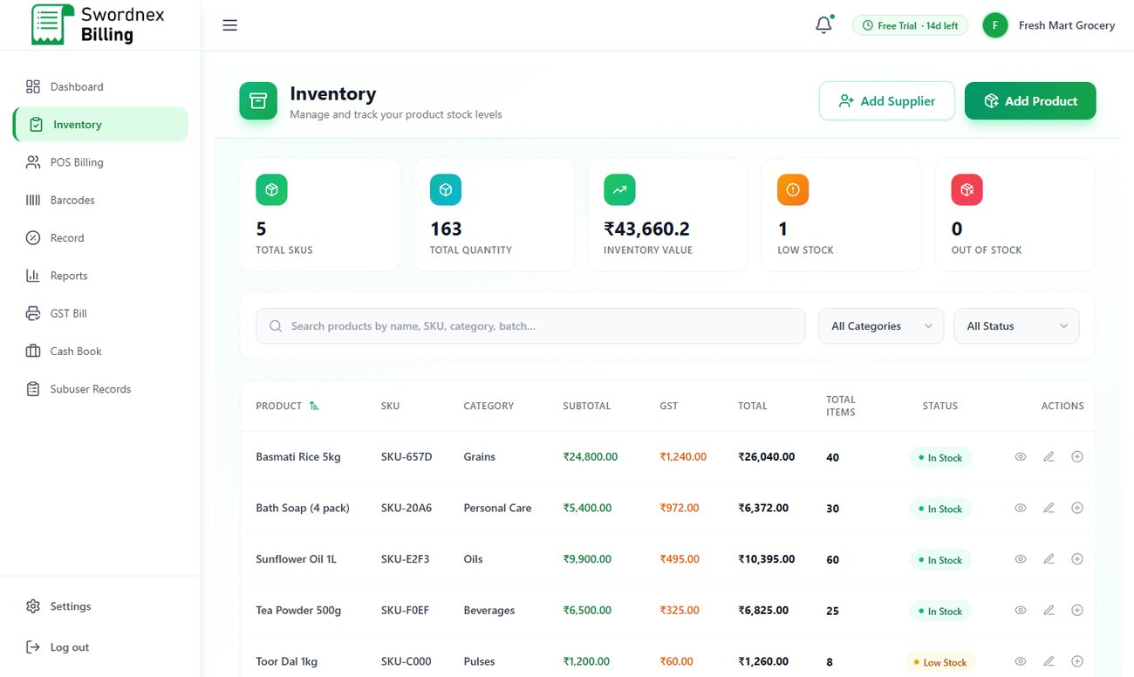
Figure 7: Inventory with stock status and value

Adding a product
- Click Add Product. A barcode number is created for you automatically (you can type your own).
- Purchase Details tab: category, product name, brand, SKU, supplier, purchase price, purchase GST %, quantity, purchase date, unit and reorder level (the quantity at which you want a low-stock warning).
- Sales Details tab: selling price and sales GST %. The GST amount and total are calculated for you.
- Click Save. The product appears in Inventory, POS Billing and Barcodes.
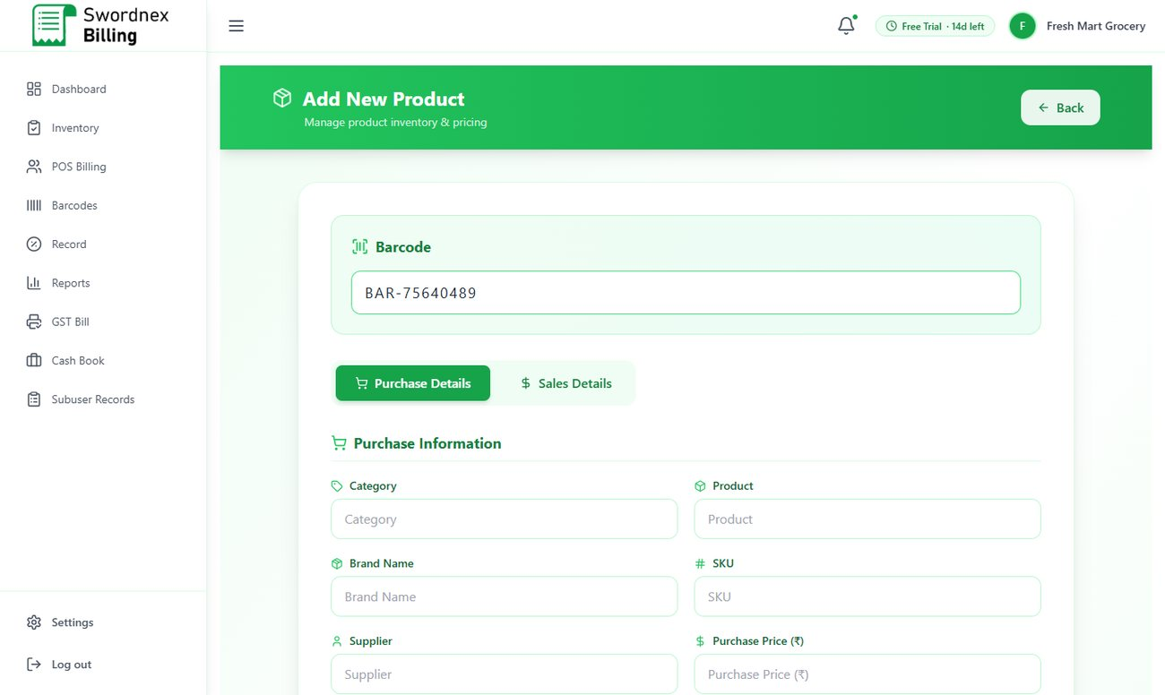
Figure 8: Add New Product — Purchase and Sales details
Tip: Set a sensible reorder level for fast-moving items. When stock falls to that level, the item shows as Low Stock and appears under the bell icon.

5.2 POS Billing — making a sale
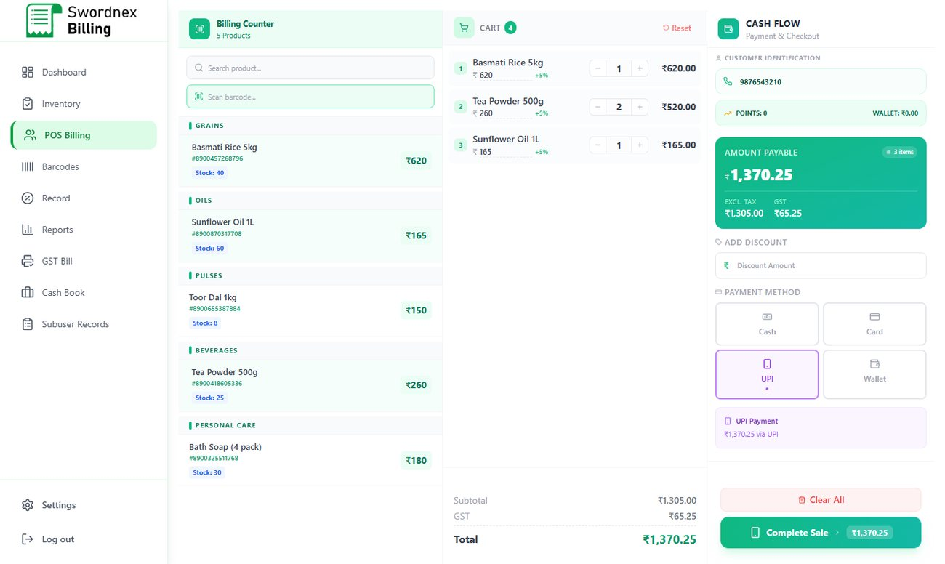
Figure 9: POS Billing: products on the left, cart in the middle, payment on the right
- Open POS Billing. Tap a product in the list, or scan its barcode into the Scan barcode box. You can also search by name.
- Adjust quantities with + / − in the cart. The subtotal, GST and total update instantly.
- Enter the customer's phone number. Returning customers are found automatically, with their loyalty points and wallet balance.
- Add a discount if needed.
- Choose the payment method: Cash, Card, UPI or Wallet. For cash, enter the amount received to see the change to return.
- Click Complete Sale. Print the receipt or save it as PDF.

Loyalty points and wallet
- Customers earn 1 loyalty point for every ₹100 spent. When they have 100 points or more, you can redeem them for a discount (₹10 per 100 points) at billing.
- The Wallet lets customers keep a prepaid balance with you. Top up a customer's wallet from Record → Customers, and choose Wallet as the payment method at billing.

Selling on credit
In industries with Credit (Pharmacy, Mobile Shop, Academy), if the customer pays less than the total, the balance is automatically added to Credit as a due, so nothing is forgotten.

5.3 Barcodes
Barcodes shows a printable barcode label for every product. Click the printer icon on a card to print one label, or Print All to print labels for everything. Use the search box to find a product quickly.
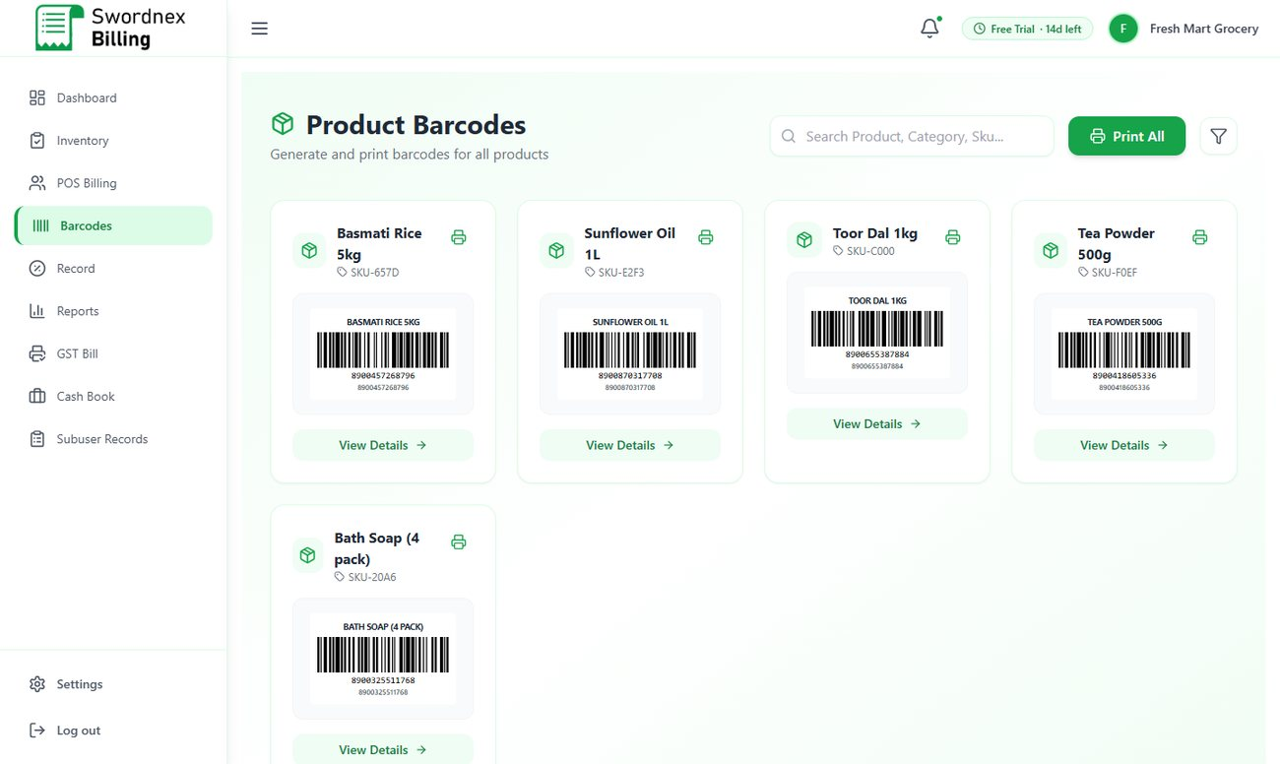
Figure 10: Barcodes ready to print

5.4 GST Bill — A4 tax invoices
Use GST Bill when a customer needs a formal tax invoice (for example, a business buyer who claims input GST).
- Check the invoice number and dates (filled in for you).
- Seller details come from your company profile. Enter the buyer's name, address, GSTIN, state, phone and email.
- Add items: select products, quantities and prices. CGST + SGST (same state) or IGST (other state) are calculated automatically.
- Use Preview, Download (PDF) or Print, and Save Invoice to keep it in your records.
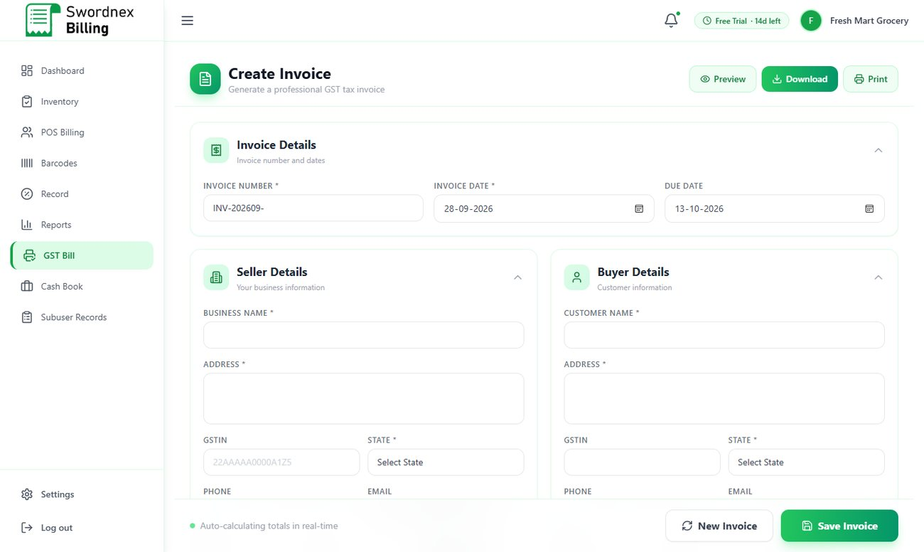
Figure 11: Create Invoice screen for GST bills

5.5 Record — all your data in one place
Record gathers everything in tabs: Inventory, Buy Details, Billing, Credit, Cashbook, GST Invoice, Customers and Suppliers (Academy shows Billing, Fee Dues, Cashbook, GST Invoice, Students and Trainers). Each tab shows totals at the top, a search box and filters.
- Click Export Excel to download the current tab as an Excel file for your accountant.
- In the Customers tab you can view, edit or delete customers and top up wallet balances.
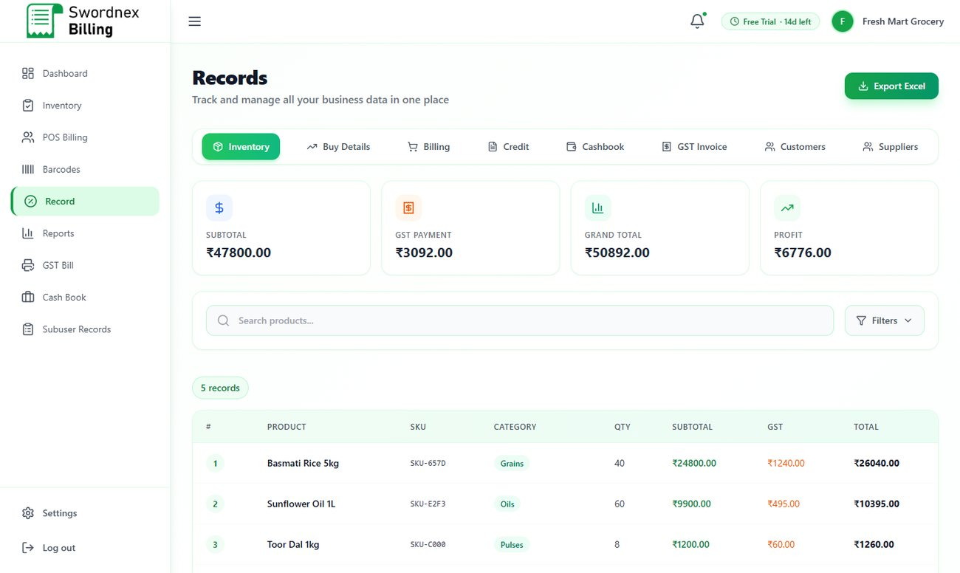
Figure 12: Record — tabs for every kind of data, with Excel export

5.6 Credit — customer dues and online payment links
Credit lists customers who owe you money: bill total, amount paid, due amount and status (Pending / Cleared).
- Record a payment when the customer pays at the counter; the balance updates automatically.
- Copy pay link (link icon) — copies a secure online payment link you can send by WhatsApp or SMS.
- Email pay link (mail icon) — emails the link to the customer.
- The customer opens the link and pays by UPI, card or net banking (powered by Razorpay). The due is marked paid automatically and an email receipt is sent.
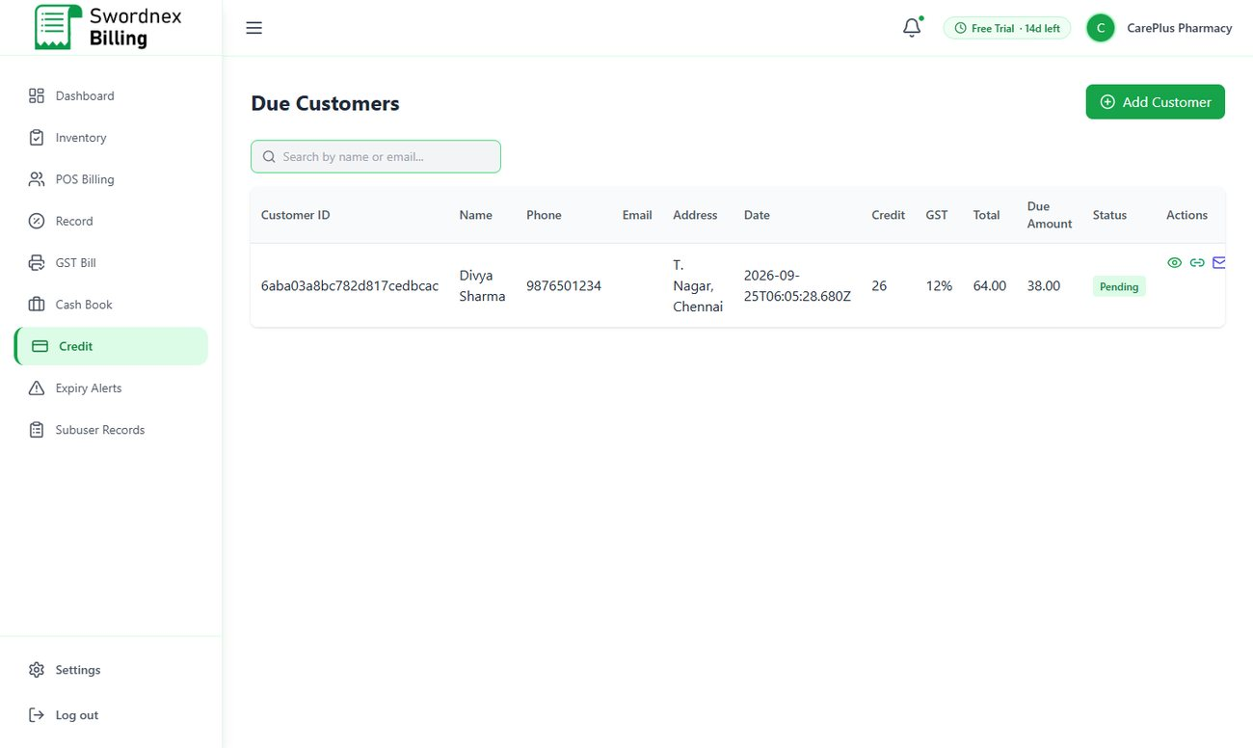
Figure 13: Credit (Due Customers) with pay-link actions

5.7 Cash Book — income and expenses
Record money that comes in or goes out outside of billing — rent, salaries, electricity, transport, owner's cash deposits and so on. Click Add New, choose Income or Expense, a category, amount and date.
- The cards show Total Income, Total Expenses, Net Balance and Savings Rate.
- Switch to Analytics for charts, and use Filters to see a period or category.
- Expenses recorded here are included in the Dashboard's profit figure.
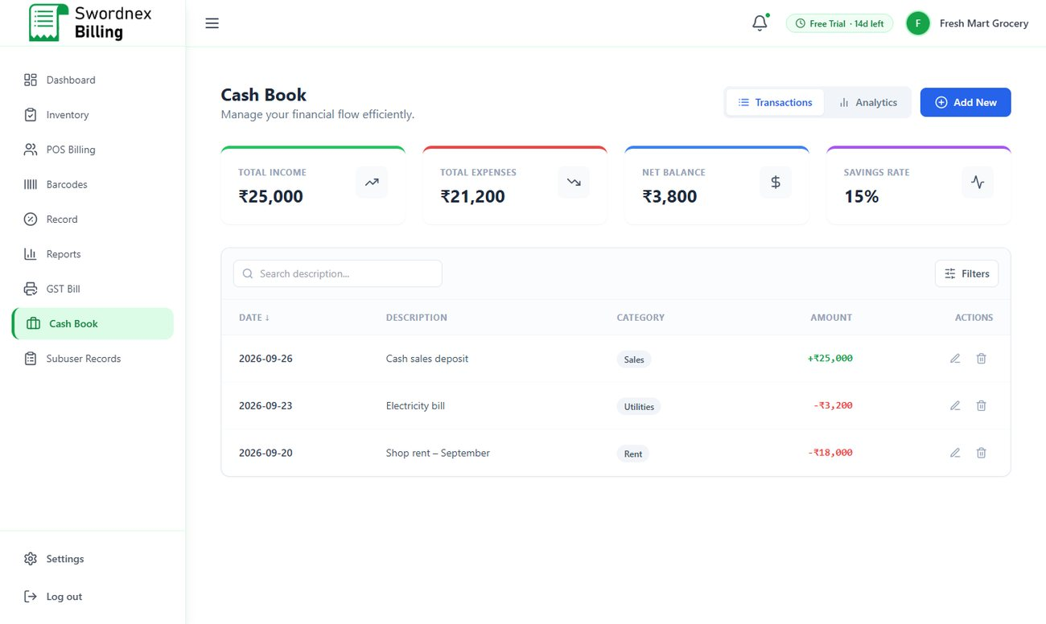
Figure 14: Cash Book with income and expenses

5.8 Reports
Reports & Analytics shows total revenue, number of invoices, GST collected and average order value for the month, plus a list of recent invoices and customers.
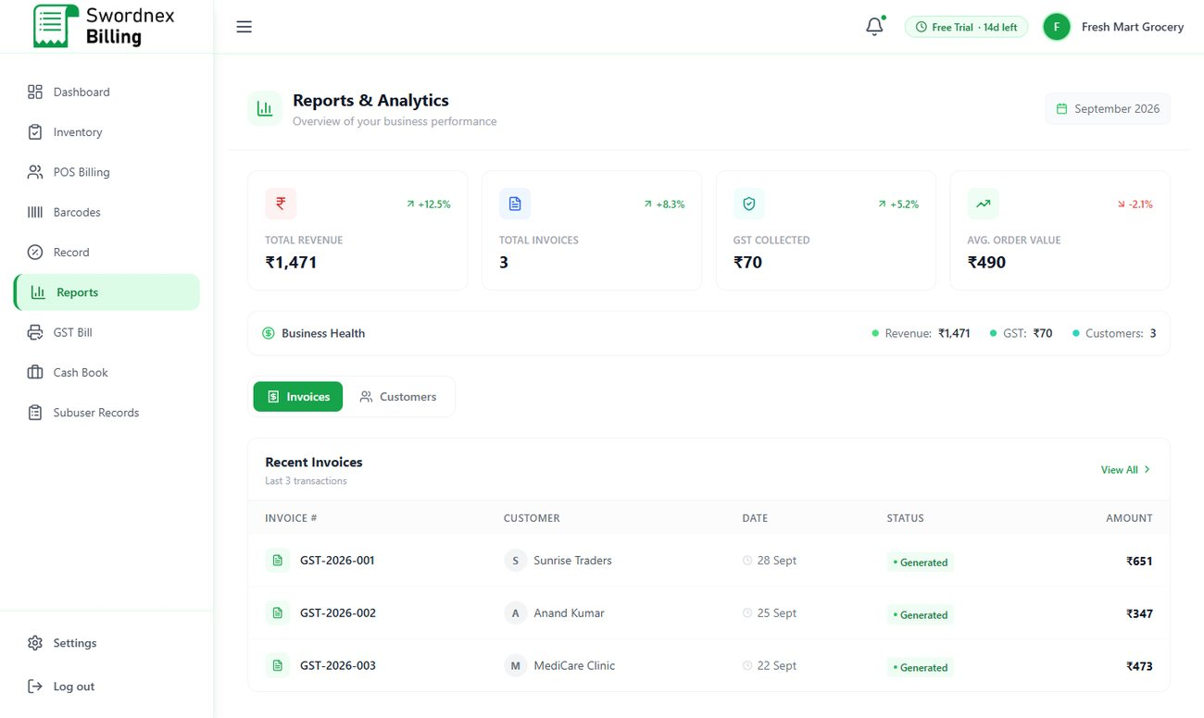
Figure 15: Reports & Analytics

5.9 Staff logins (Sub-users) and Subuser Records
Give each staff member their own login so you know who billed what.
- Go to Settings → Sub-Users.
- Enter the staff member's name, email, password, branch/location and employee ID, and save.
- The staff member signs in using the Team tab on the sign-in page.
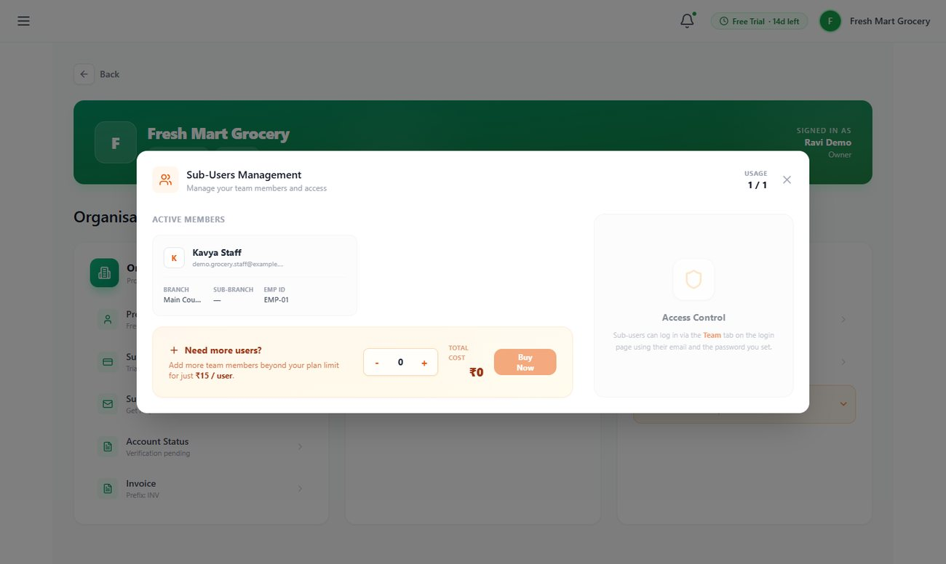
Figure 16: Sub-Users Management — active members and usage
- Staff see and create only their own bills and records. You (the owner) see everything, including all staff activity.
- The number of staff logins depends on your plan (see chapter 8). Need more? Use Need more users? → Buy Now in the same window.
- Subuser Records in the menu shows every action by your staff — bills, inventory changes, credit and cash book entries — with staff name, time and amount. Filter by staff or type and Export Data to Excel.
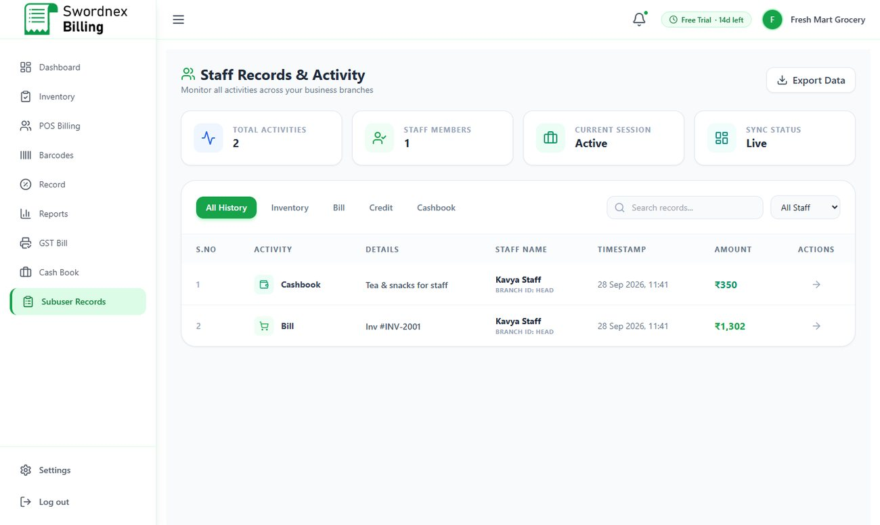
Figure 17: Subuser Records — staff activity log

6. Industry-Specific Guides
This chapter covers what is special about each industry. Everything in chapter 5 applies to all industries unless stated otherwise.

6.1 Grocery Store
Grocery uses the standard retail setup: fast barcode billing, loyalty points and wallet, barcodes, inventory with low-stock alerts, GST bills, reports and cash book. Tip: use units for items sold in packs (for example, a carton of 12) so stock is counted correctly.
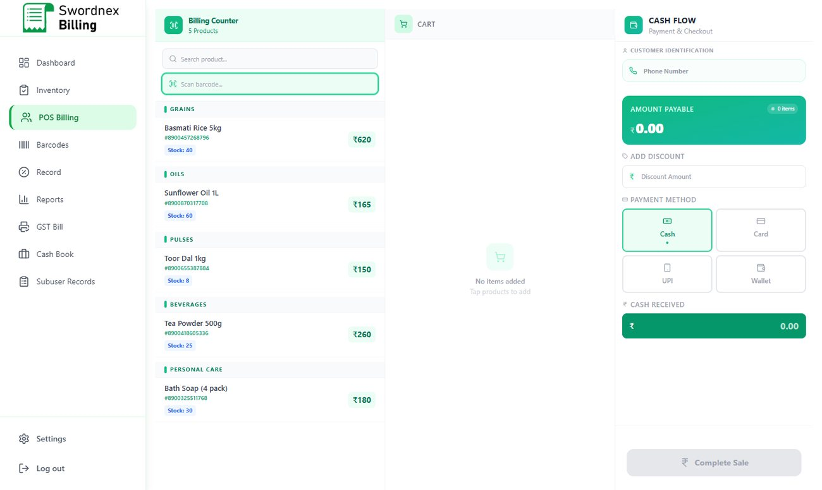
Figure 18: Grocery POS Billing grouped by category

6.2 Pharmacy

Batch and expiry details on every medicine
When adding a product in Pharmacy, the form has extra fields: Manufacturer / Brand, Supplier Licence / Reg. No., HSN Code, Batch Number, Manufacturing Date and Expiry Date. Enter them for each batch you buy.
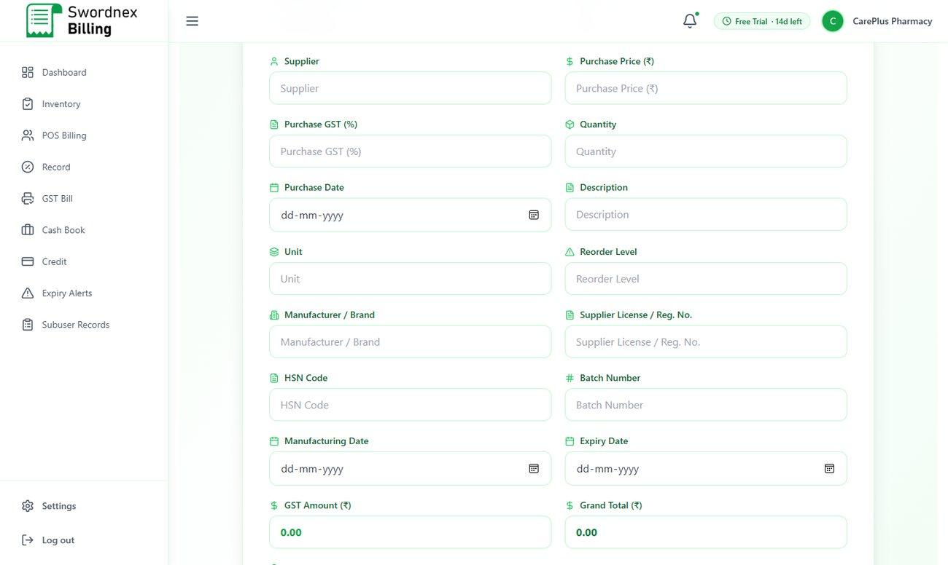
Figure 19: Pharmacy product form with batch and expiry fields
Inventory then shows the batch number and expiry date for each item, with expired dates highlighted in red.
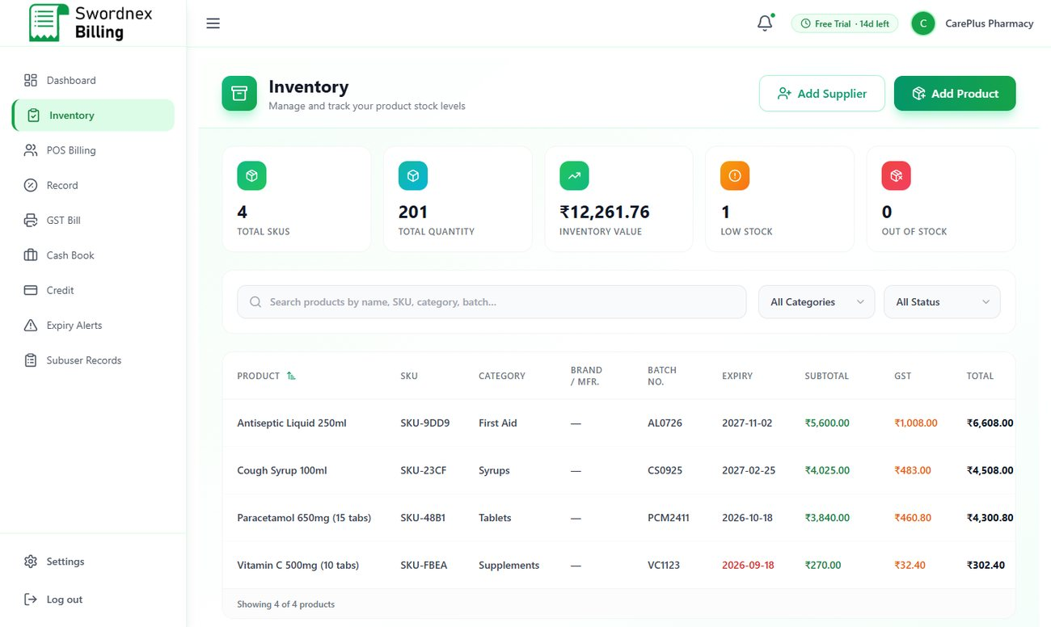
Figure 20: Pharmacy inventory with batch and expiry columns

Expiry Alerts
Expiry Alerts lists every batch sorted by the nearest expiry date, with the days left and a status: Expired, Expiring Soon (within 30 days) or OK. The cards at the top count expired items and items expiring within 30 days. Check this screen weekly to return or clear stock before it expires.
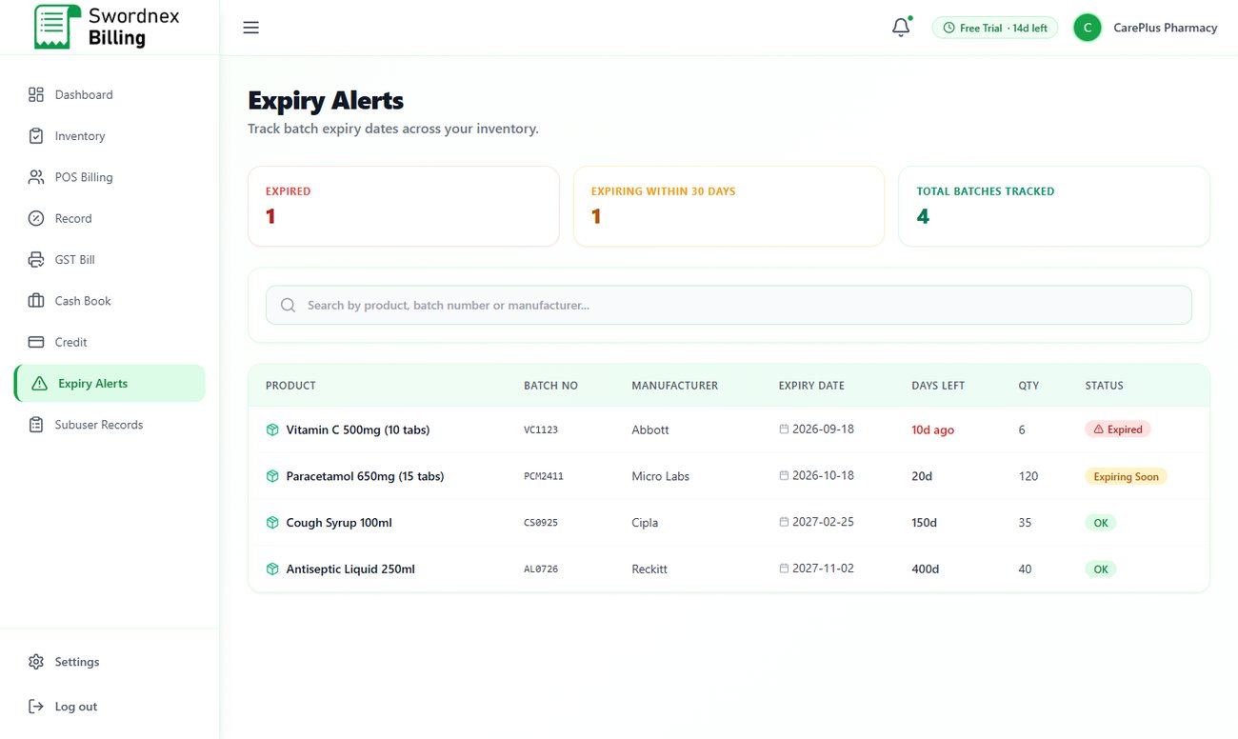
Figure 21: Expiry Alerts

Credit
Pharmacy includes the Credit module for regular customers who pay monthly, with online pay links (section 5.6).

6.3 Mobile Shop

Adding phones with IMEI numbers
The Mobile Shop product form is designed for handsets. For category Mobile, enter IMEI 1, IMEI 2 (optional) and colour for each device — use Add New Device to add several handsets of the same model in one go, or Scan Barcode to read the IMEI from the box. Each handset is stored as its own item so you always know exactly which unit was sold. Accessories (chargers, earbuds, covers) are added with a simple stock quantity.
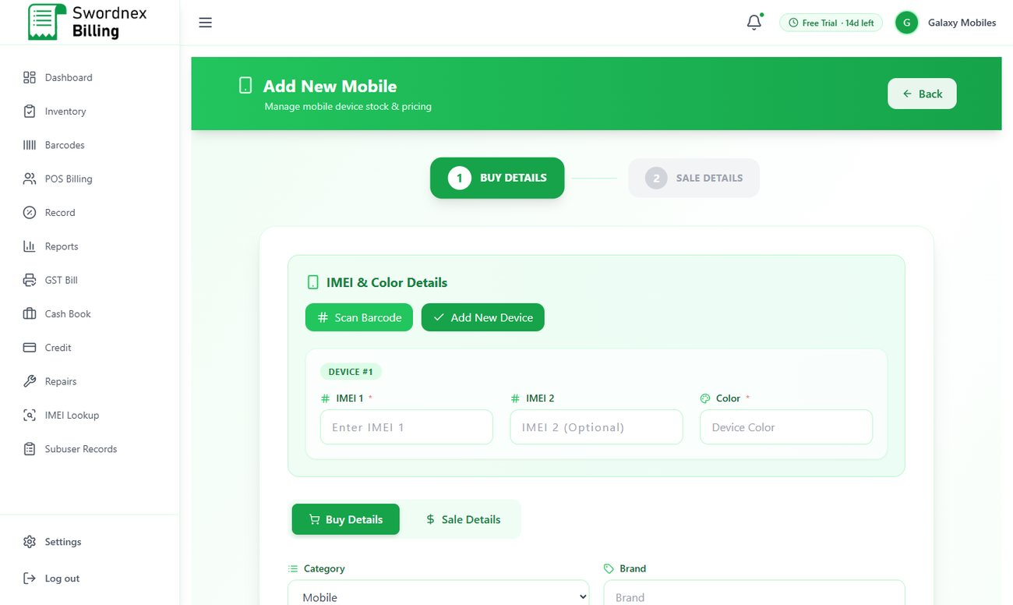
Figure 22: Add New Mobile — IMEI and colour for each device
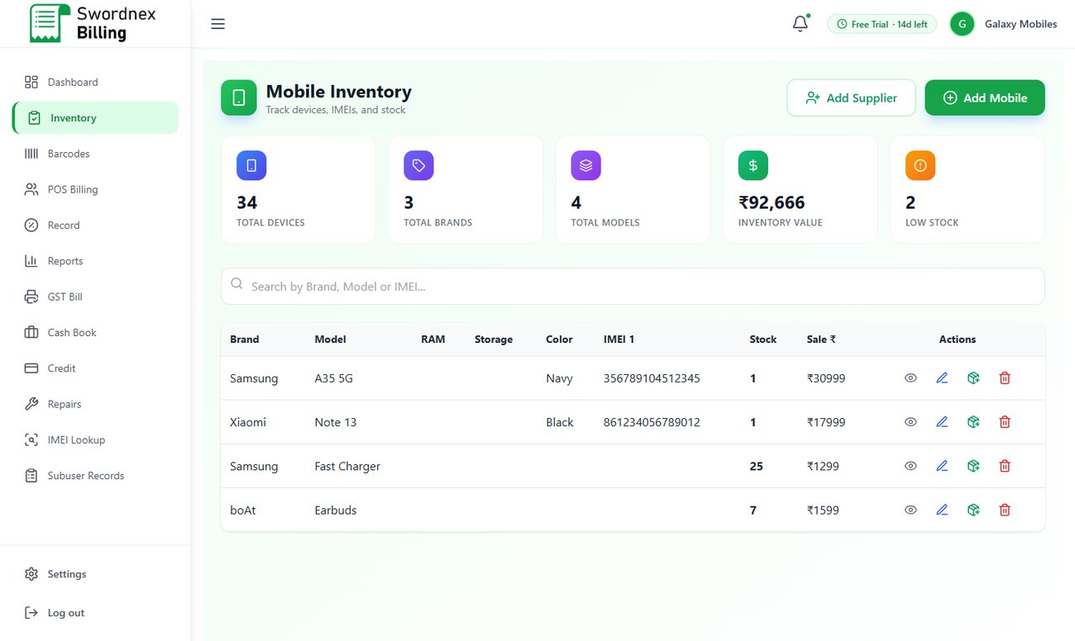
Figure 23: Mobile Inventory with brand, model, IMEI and stock

Repairs and warranty claims
Repairs tracks phones customers leave with you for repair or warranty service.
- Click New Ticket and choose Repair or Warranty Claim.
- Enter the customer name and phone, device brand and model, IMEI, and describe the issue.
- Set the status (Received, In Progress, etc.), estimated cost, received date, promised date and technician.
- Update the status and final cost as the job progresses. Use the tabs to switch between Repairs and Warranty Claims, and search by customer, phone, device or IMEI.
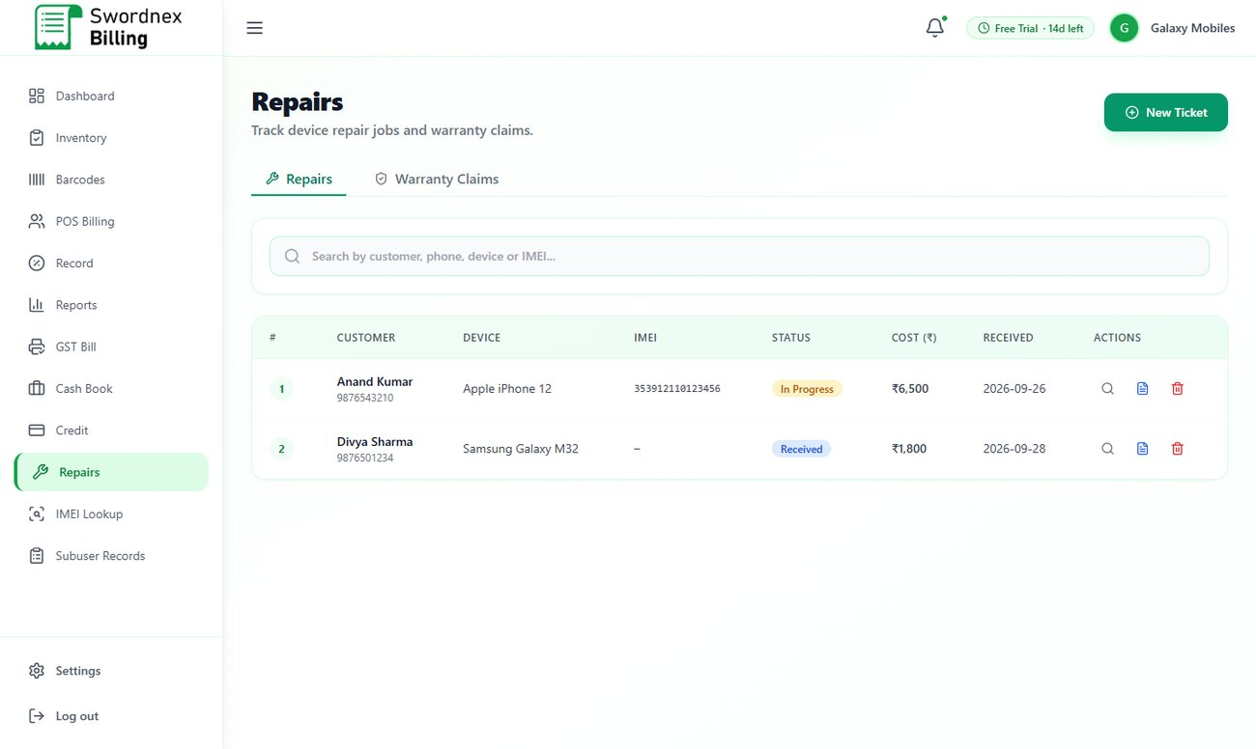
Figure 24: Repairs list with status badges
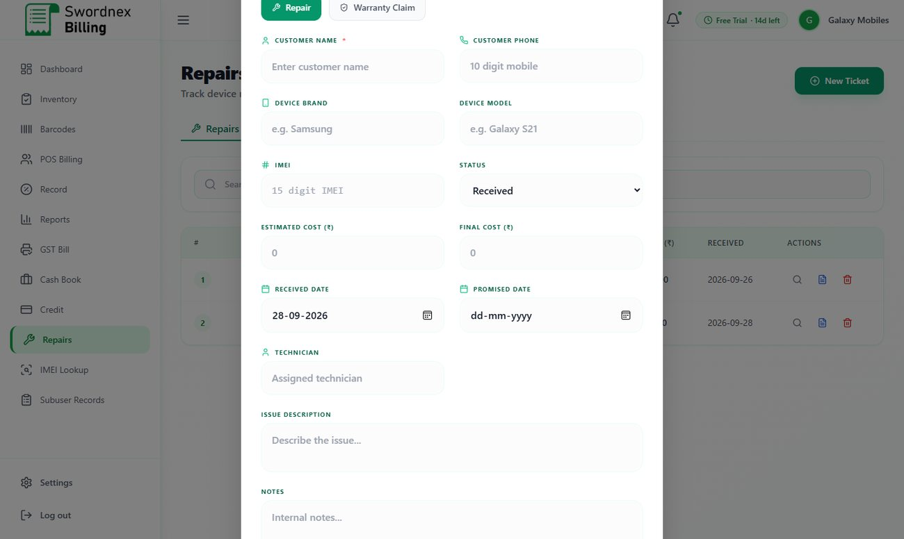
Figure 25: New repair / warranty ticket form

IMEI Lookup
Type any part of an IMEI, brand or model into IMEI Lookup to instantly find a handset in your stock — useful for warranty checks and customer queries.
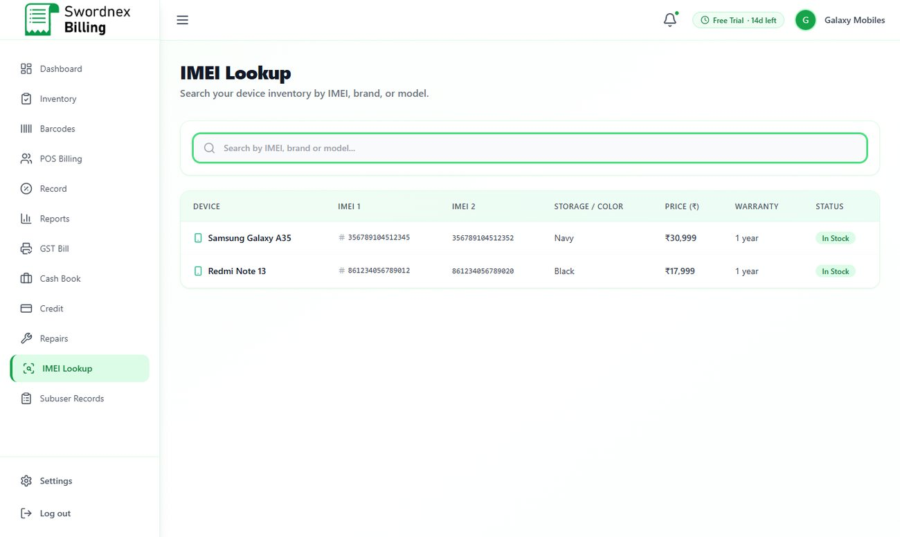
Figure 26: IMEI Lookup

6.4 Clothing
Clothing uses the retail setup with a Size field on each product (for example S, M, L, XL or waist size 32), barcodes for tags, and fast POS billing with loyalty points and wallet.
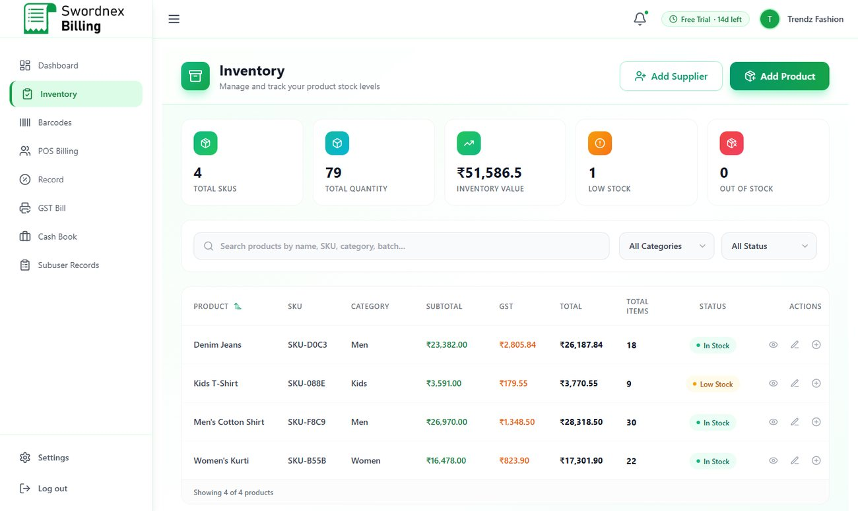
Figure 27: Clothing inventory

6.5 Pet Shop
Pet Shop includes batch and expiry tracking for pet food and medicines, barcodes and reports, plus a Pets module.

Pets — pet profiles
- Open Pets and click Add Pet.
- Search and select the pet owner from your customers (their phone number fills in automatically).
- Enter the pet's name, species, breed, date of birth, last vaccination date and any medical notes (allergies, conditions).
Use the search box to find a pet by name, species, breed or owner — handy for reminding owners about vaccinations.
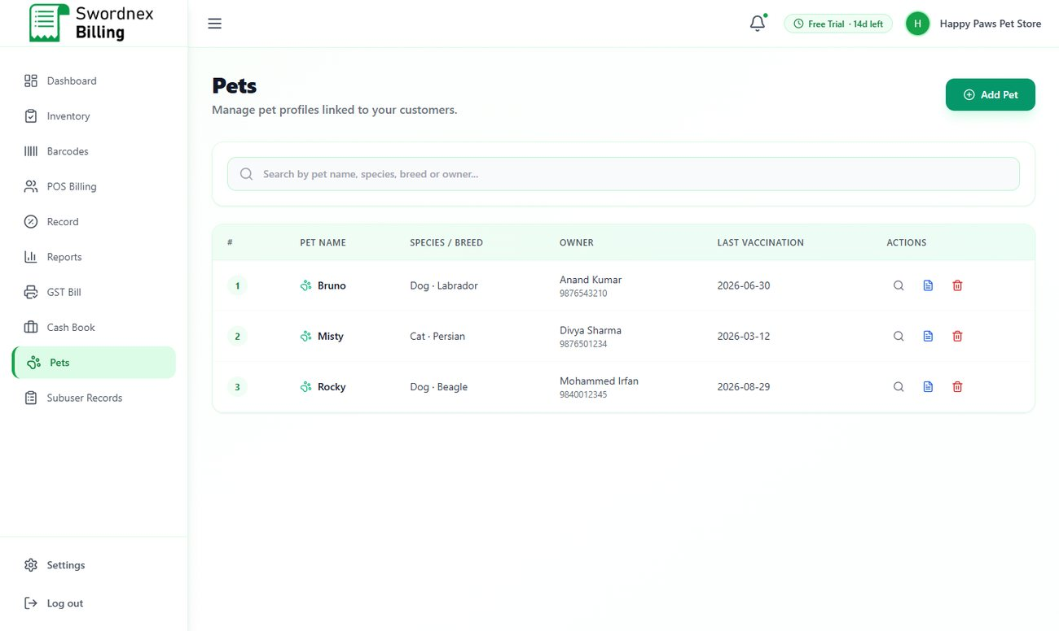
Figure 28: Pets list linked to owners
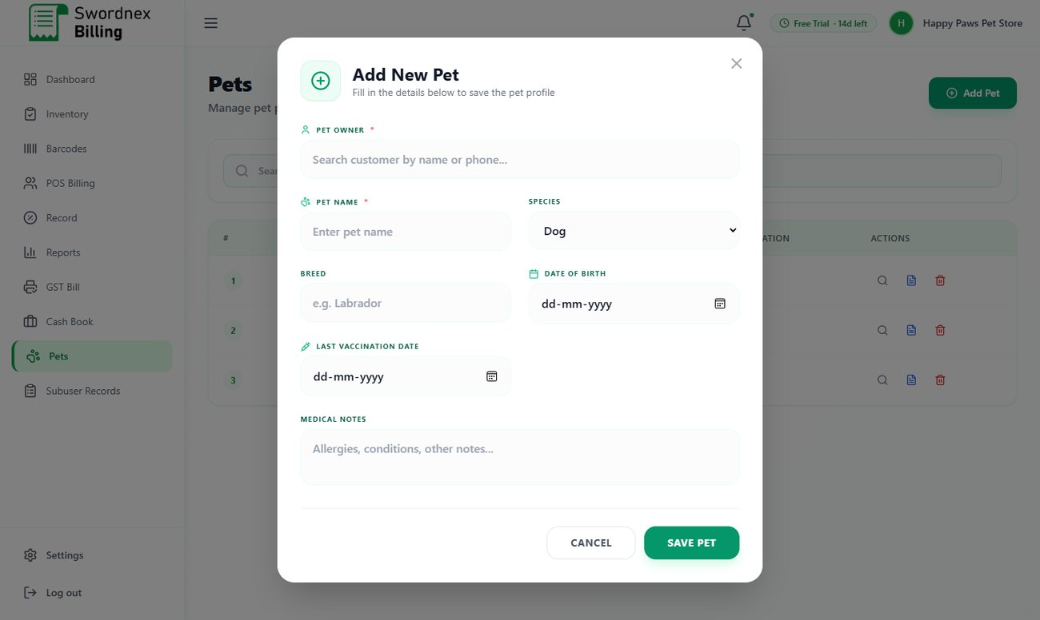
Figure 29: Add New Pet form

6.6 Academy
The Academy setup is built for coaching centres and institutes: you sell courses to students, often in instalments.

Courses
The Courses screen (Inventory for other industries) lists your courses with code, category, duration, trainer, mode (online/offline), batch size and fee. Click Add Course and enter the course name, code, trainer, duration, category, level, mode, batch size, course fee, GST % and whether a certificate is provided.
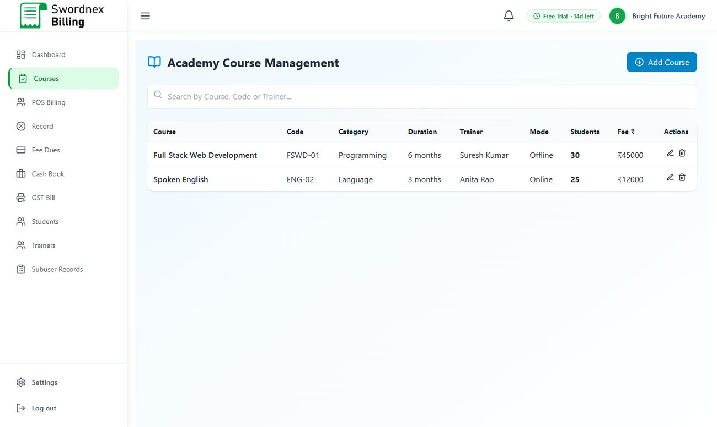
Figure 30: Academy Course Management
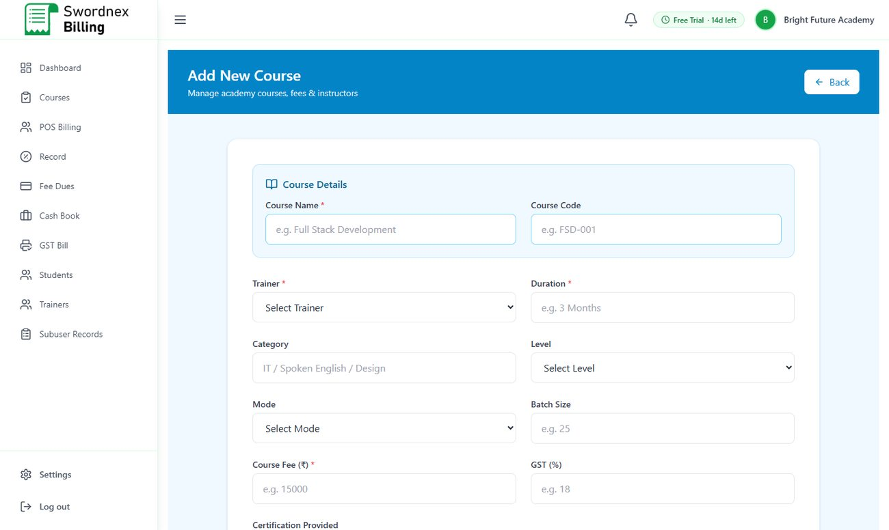
Figure 31: Add New Course

Students and Trainers
- Students — list, search, add, edit and remove students (name, phone, location, GSTIN).
- Trainers — keep your trainers' details: specialisation, code, mobile, email and salary.
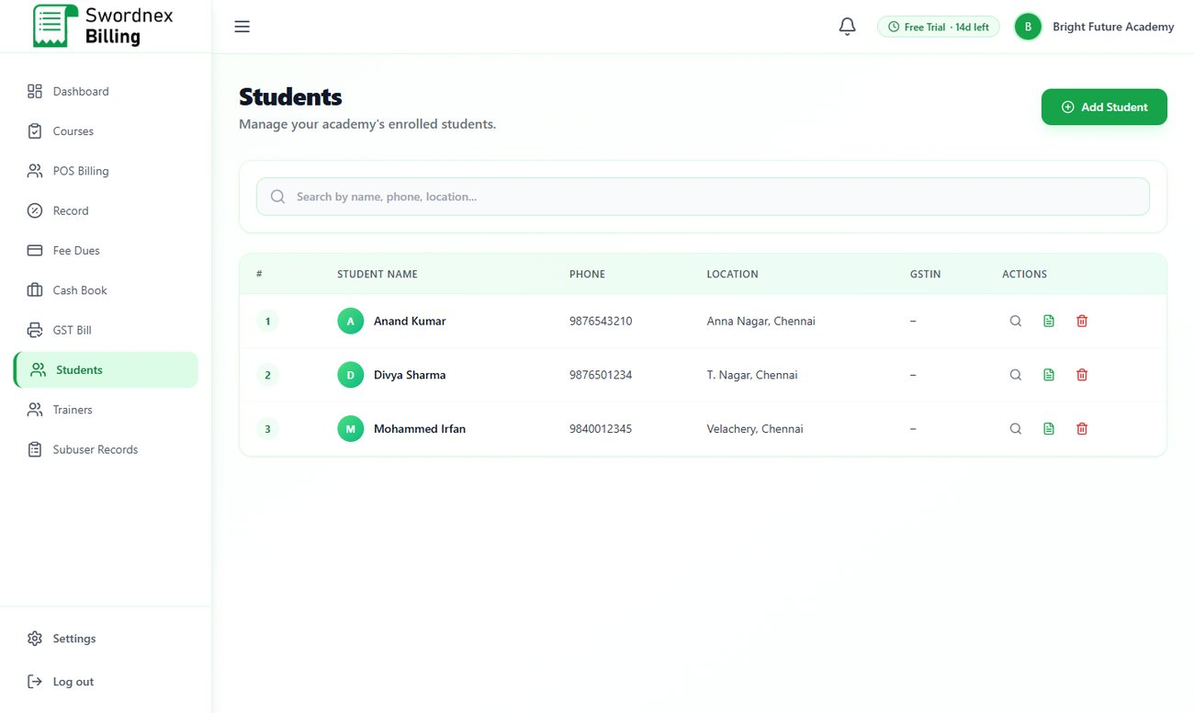
Figure 32: Students
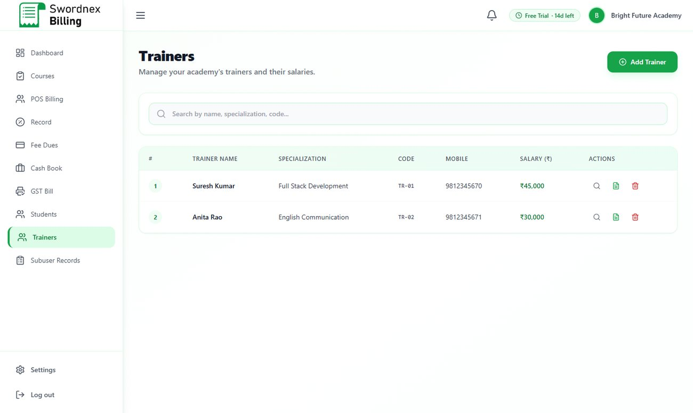
Figure 33: Trainers

Billing course fees and instalments
In POS Billing, select the course(s), enter the student's phone number and choose the payment method. Choose Term to collect the fee in instalments: record the amount paid now, and the balance is tracked automatically as a due.
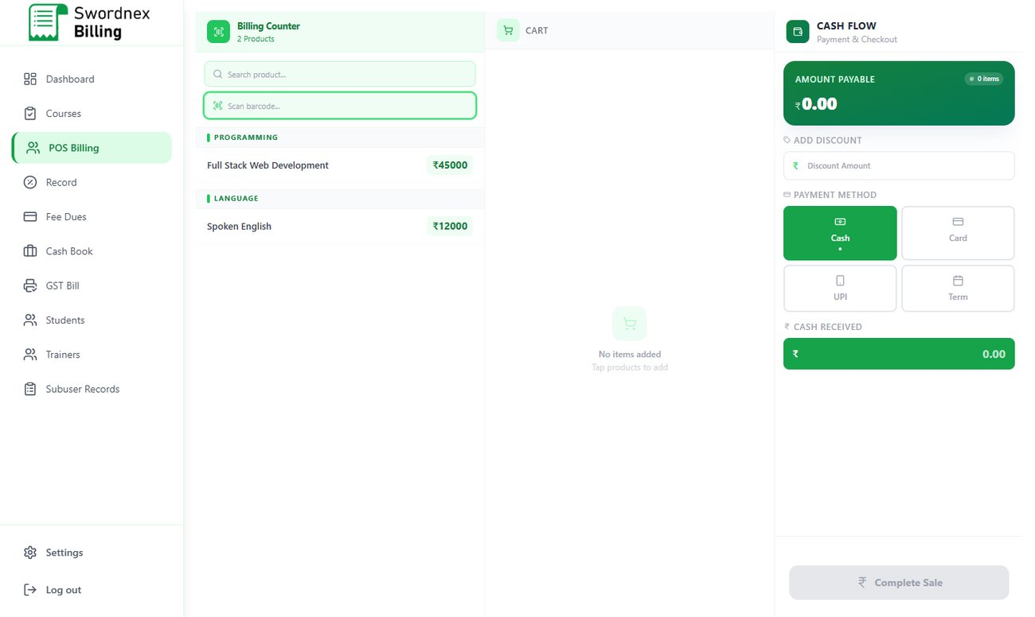
Figure 34: Academy billing with the Term (instalment) option

Fee Dues
Fee Dues in the menu opens the Record screen on the Fee Dues tab. It shows each student's course, total fee, amount paid, balance and status, with total pending dues at the top. Collect the next instalment from here when the student pays.
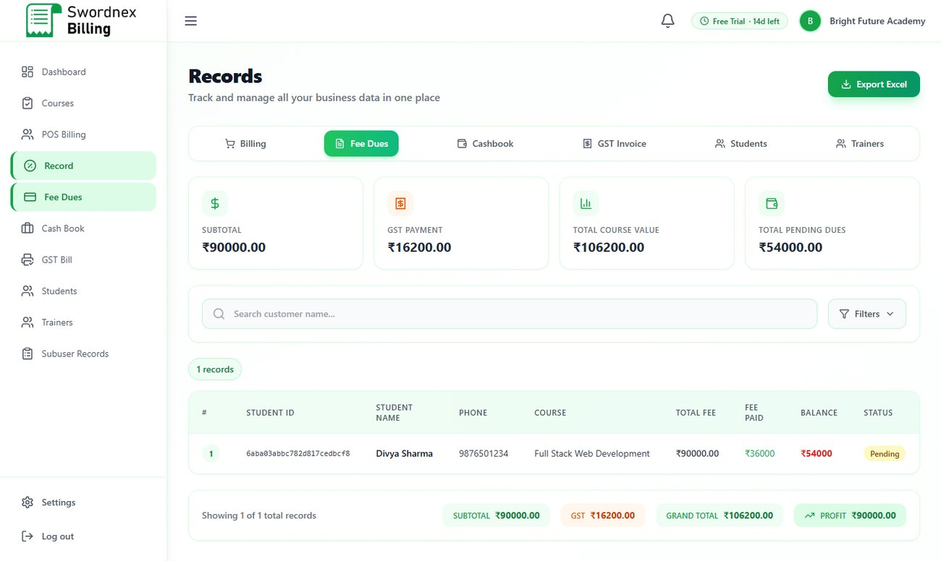
Figure 35: Fee Dues — pending instalments

6.7 Software Development
The Software Development setup is for agencies and IT service providers who bill clients for services and project milestones.

Services
The Service screen lists the services you offer with category, platform / tech stack, lead or team, and your rates (hourly, daily and annual maintenance). Click Add Service to create one.
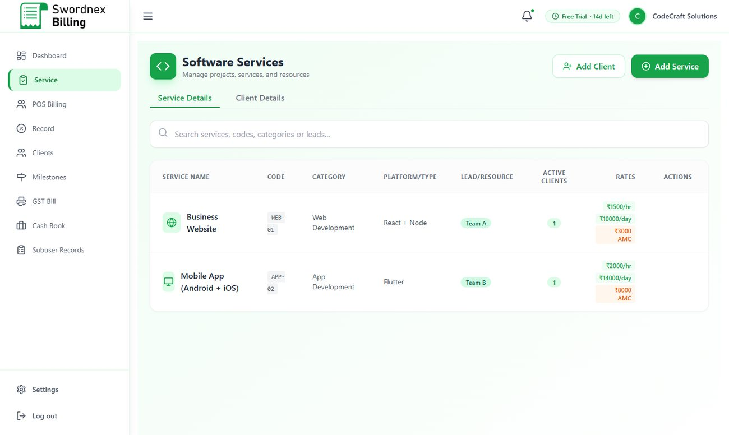
Figure 36: Software Services
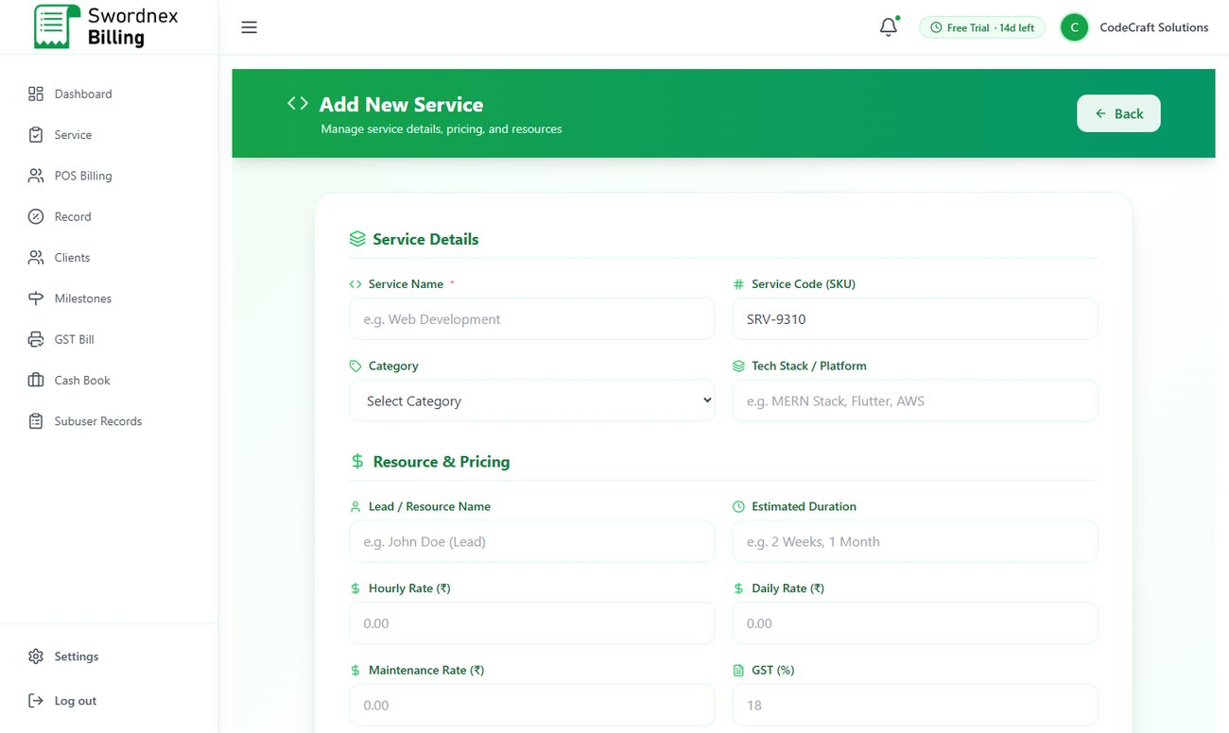
Figure 37: Add New Service — details, resources and rates

Clients
Clients stores each client's company, contact person, email, phone, industry, project name and type, deadline and budget, plus requirements and notes. Click Add Client to add one; use the row icons to view or edit.
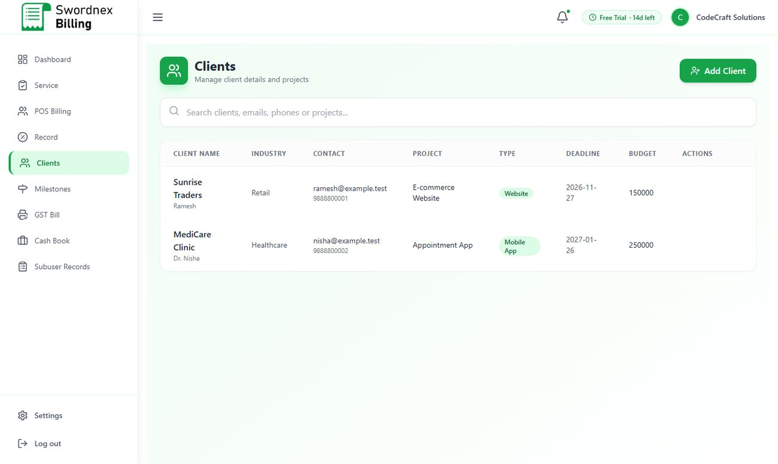
Figure 38: Clients

Milestones
Break each project into milestones with a title, description, due date, amount and status (Pending, In Progress, Completed). Click New Milestone, pick the client from the list, and fill in the details. The list shows every milestone across all clients so you can see what to bill next.
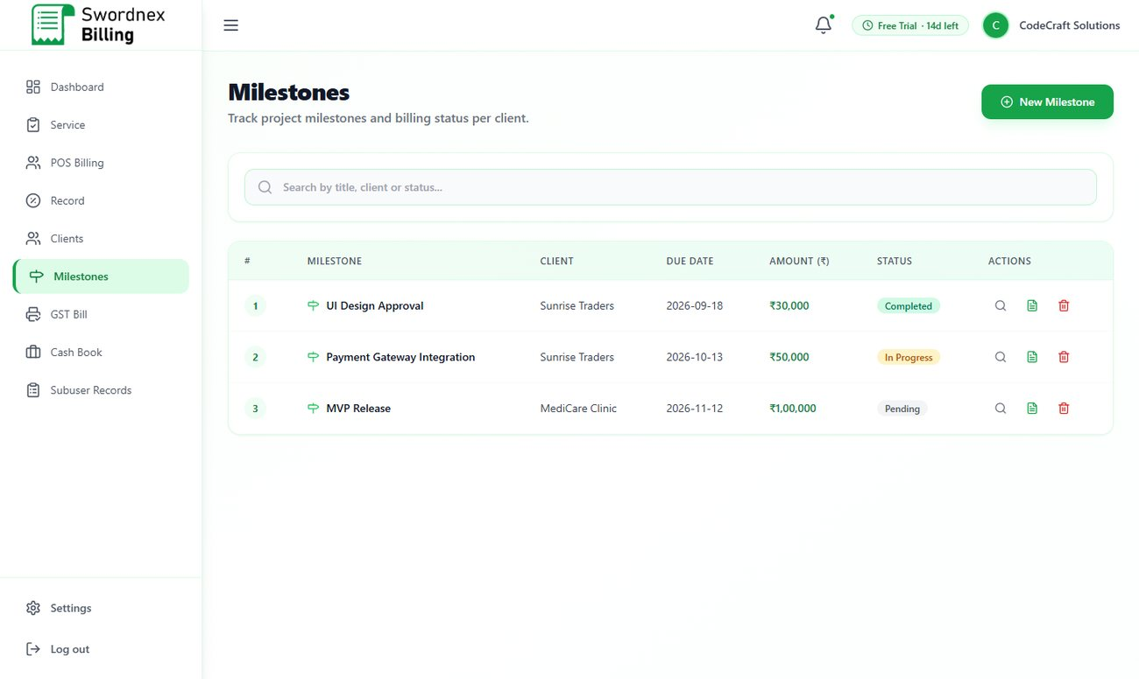
Figure 39: Milestones by client with status

Billing a client
In POS Billing your clients are listed on the left. Select the client, add the amount for the milestone or service, choose Cash, Card, UPI or Term, and complete the bill. Use GST Bill when the client needs a formal tax invoice.
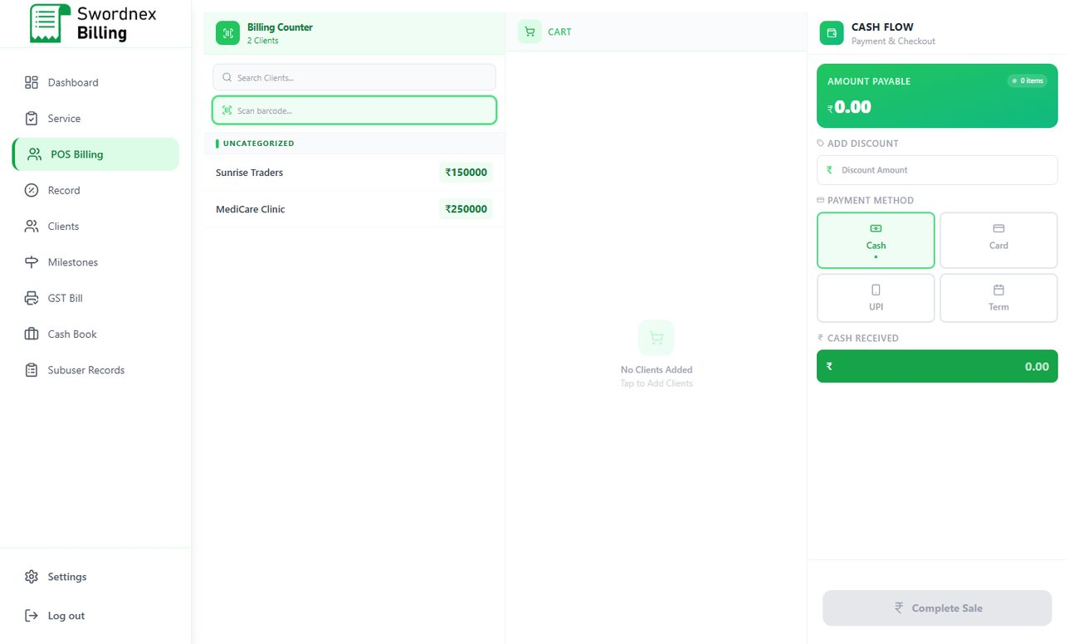
Figure 40: Software Development billing

7. Settings
Open Settings at the bottom of the menu. Settings are grouped into three panels: Organisation, Security and Configuration.
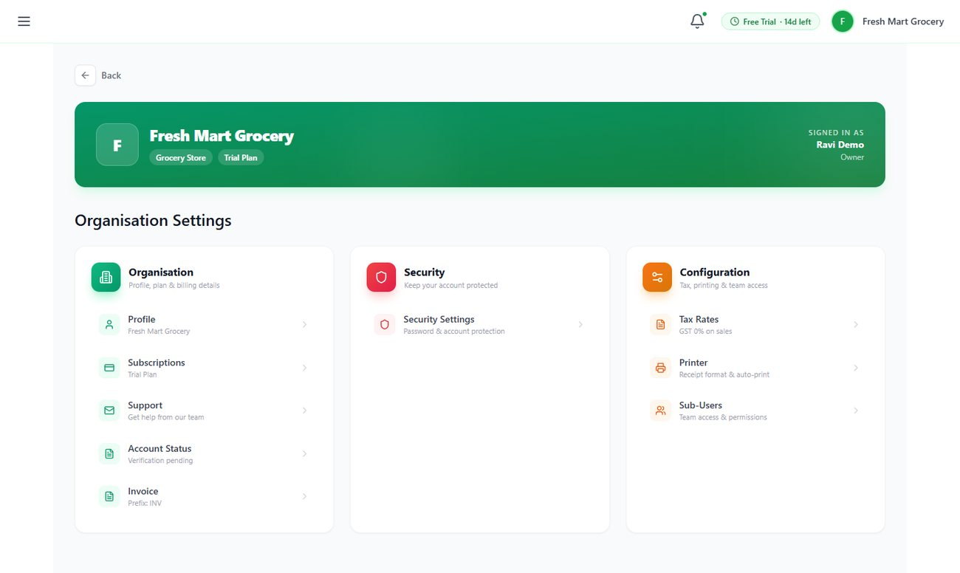
Figure 41: Settings home
Setting | What you can do
Profile | Business name and type, GSTIN, PAN, industry, your name, mobile and address. Click Edit to change details. These appear on your bills and invoices.
Subscriptions | See your current plan and days left; upgrade or renew.
Support | Send a question to the SwordNex team.
Account Status | Your account verification status.
Invoice | Invoice number prefix (e.g. INV) and the next invoice number.
Security Settings | Change your password — click Password and we email you a secure reset link.
Tax Rates | Default purchase GST % and sales GST %, and whether prices are tax-inclusive. New products use these defaults.
Printer | Receipt format and Auto-Print on Sale (opens the print dialog automatically after every sale).
Sub-Users | Create and manage staff logins (section 5.9).

7.1 Profile, tax and printer
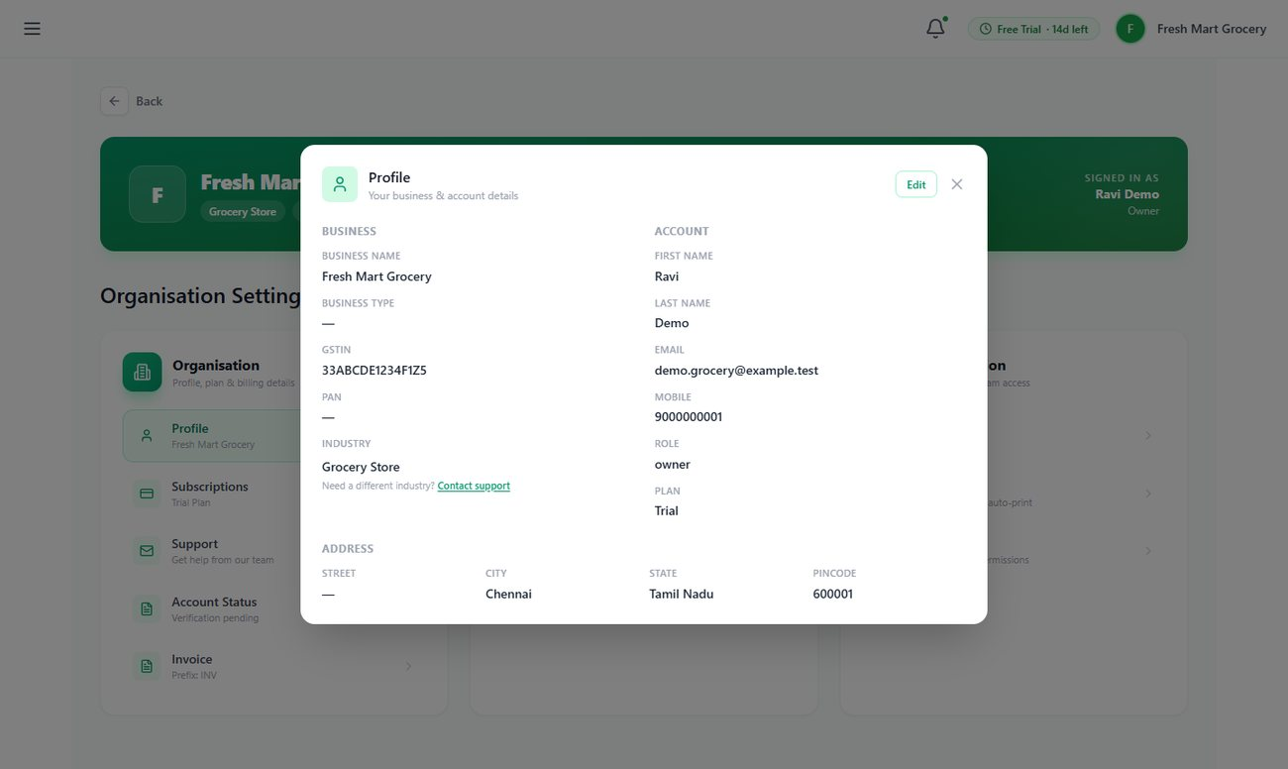
Figure 42: Profile details
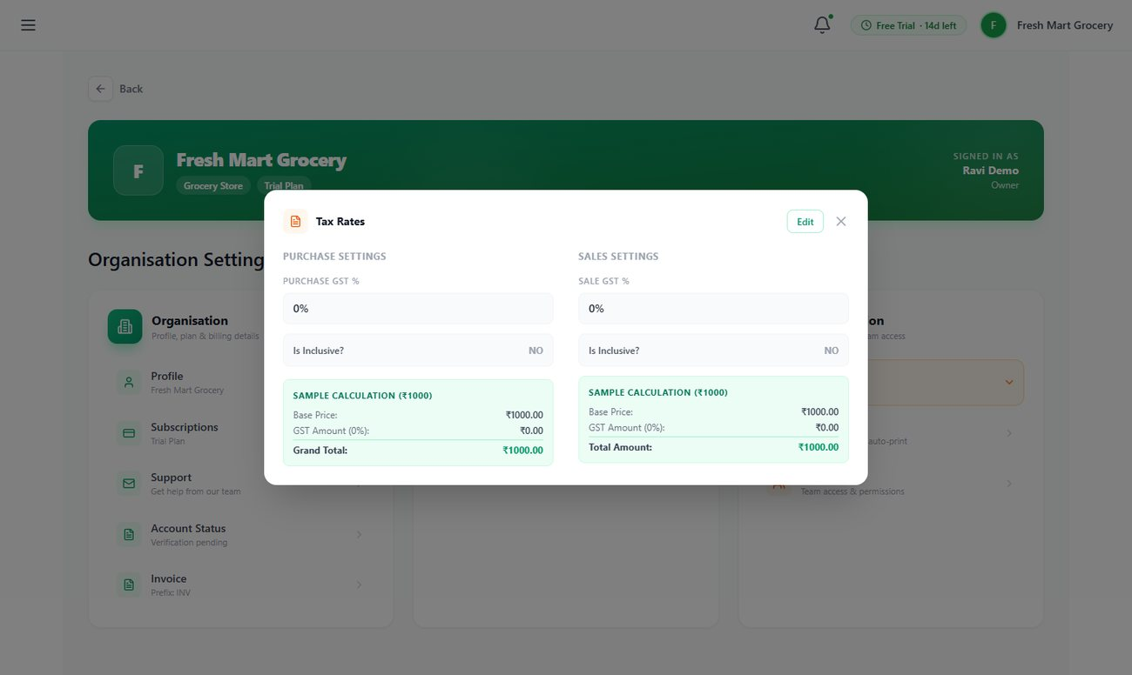
Figure 43: Tax Rates with a sample calculation
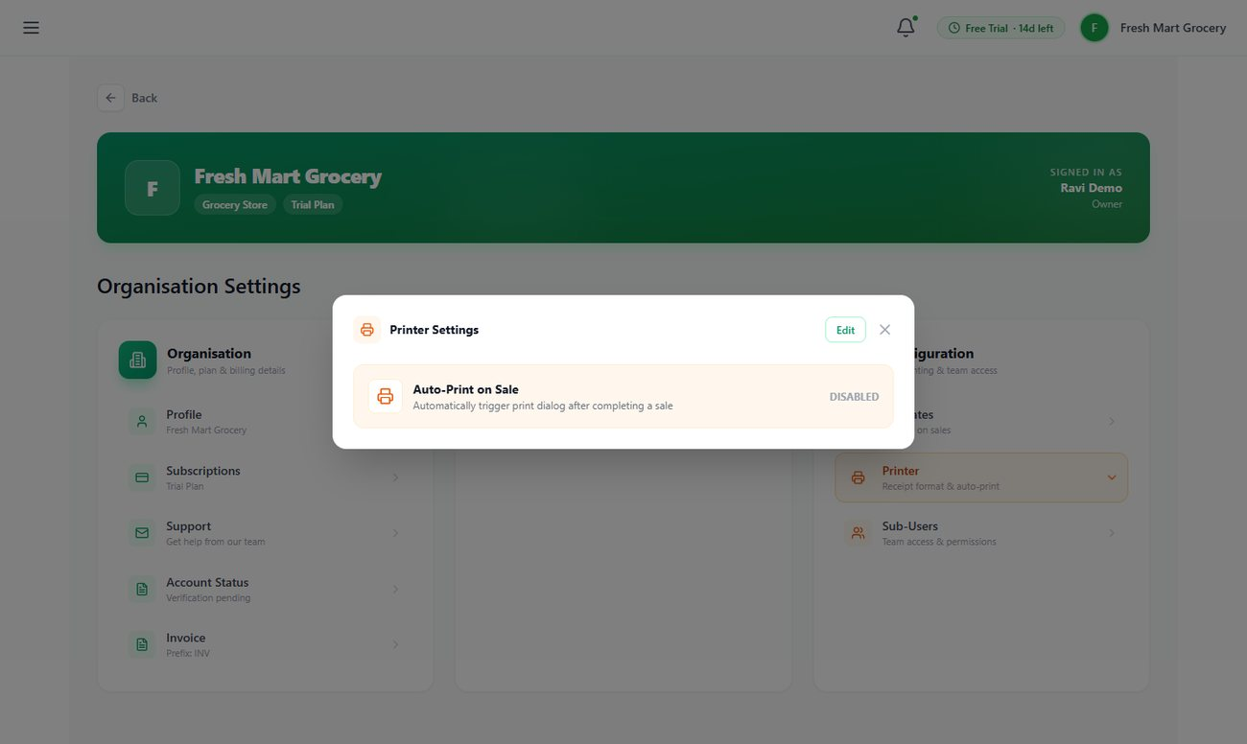
Figure 44: Printer settings — Auto-Print on Sale

7.2 Changing your industry
Because your industry is locked after you choose it, changes are made by the SwordNex team:
- Go to Settings → Profile and click Contact support under Industry.
- Choose the industry you want to switch to and write a short message explaining why.
- Click Send Request. The profile shows "Change requested · Pending" until our team approves it.
- Once approved, sign in again to see the new menu. Your existing data stays in your account.
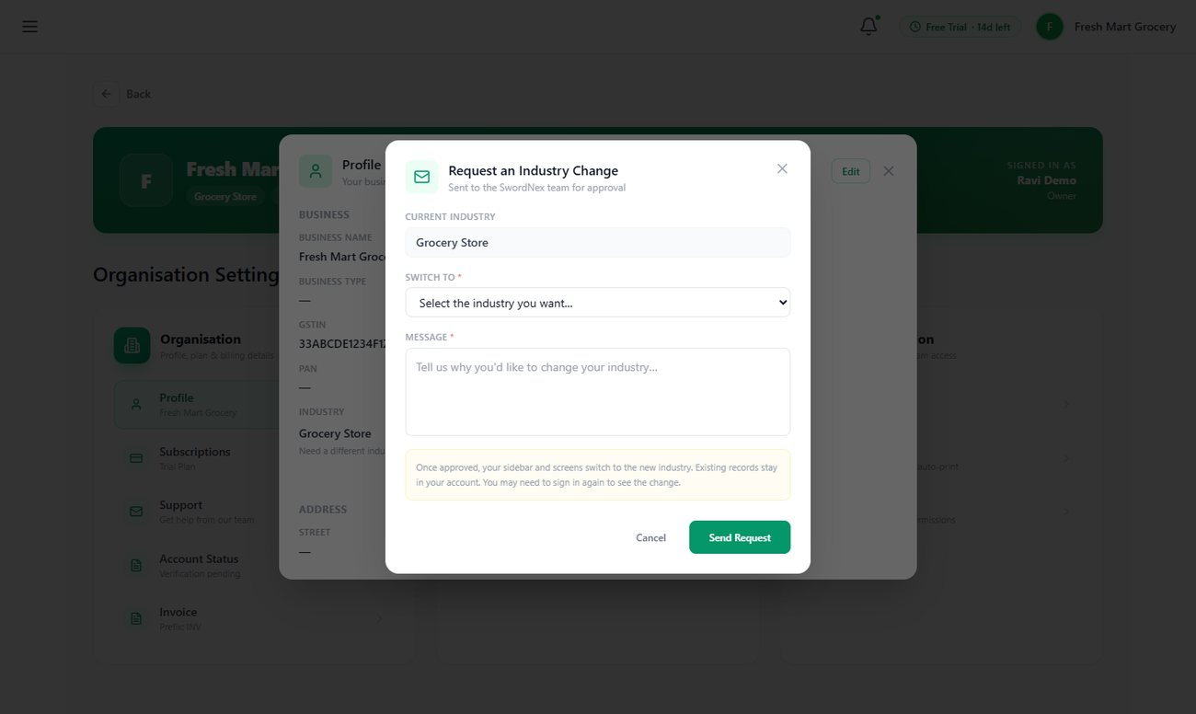
Figure 45: Request an Industry Change
Note: Only the business owner can request an industry change. Staff members will see a message asking them to contact the owner.

7.3 Getting support
Use Settings → Support to send us a question. Your name, business and email are filled in; just type your query and click Submit Query. Our team will reply by email.
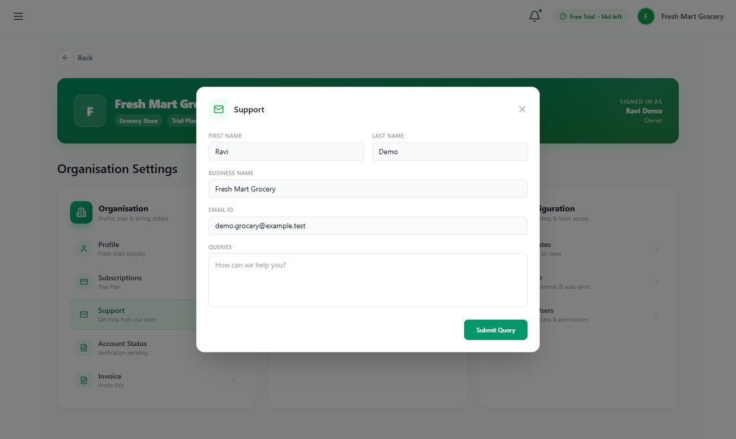
Figure 46: Support form

8. Plans and Subscription
Every new account starts with a 14-day Free Trial that includes all Premium features. Before it ends, choose a paid plan from Settings → Subscriptions or the Upgrade button on the Dashboard. Plans can be paid monthly, yearly or for 3 years, securely online through Razorpay (UPI, cards, net banking). For current prices, please contact the SwordNex team or see the Plans page in the app.
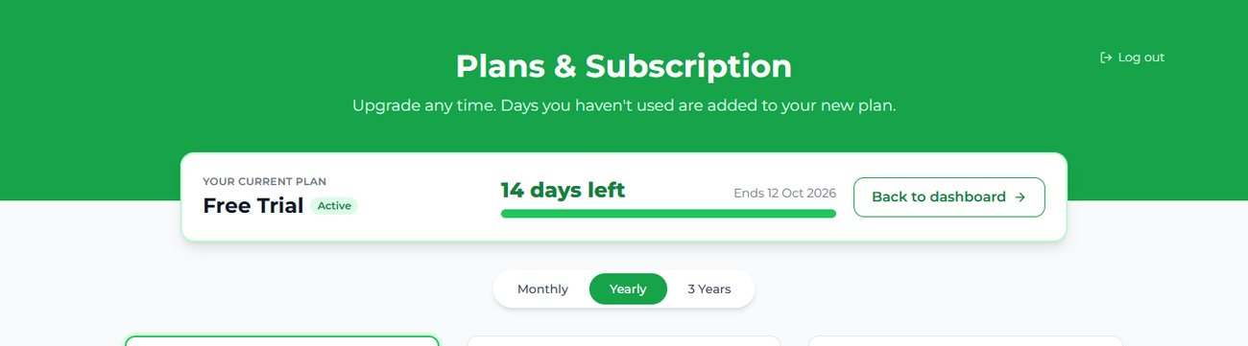
Figure 47: Plans & Subscription — your current plan and days left
 | Free Trial | Standard | Premium
Duration / billing | 14 days, starts at sign-up | Monthly, yearly or 3 years | Monthly, yearly or 3 years
Bills, invoices & GST bills | Up to 300 | Unlimited | Unlimited
Products | Up to 500 | Up to 2,000 | Unlimited
Inventory, Records & Cash Book | ✓ | ✓ | ✓
Industry-specific modules | ✓ | ✓ | ✓
Credit / customer dues | ✓ | Manual payments | ✓
Online payment links + email receipts | ✓ | — | ✓
Reports & analytics | Full | Basic dashboard | Full
Barcode generation | ✓ | — | ✓
Data export (Excel / PDF) | ✓ | Limited | ✓
Staff logins included | 1 | 3 (+ add-on) | 6 (+ add-on)
Support | Email | Email | Priority

- Renew or upgrade any time — unused days on your current plan are added on top of the new plan, so you never lose days you have paid for.
- Extra staff logins can be bought individually from Settings → Sub-Users.
- When a plan expires, you are taken to the Plans page when you sign in. Your data is kept safe; renew to continue using the app.
- A payment invoice is emailed to you after every successful payment.

9. Frequently Asked Questions
Question | Answer
I did not receive the sign-up code. | Check your spam/junk folder, wait 30 seconds and click Resend code. Make sure the email address is typed correctly (use Change email to fix it). Codes expire after 5 minutes.
I forgot my password. | Click Forgot? on the sign-in page, enter your email, and open the reset link we send (valid for 30 minutes). Staff can ask the business owner, who can set a new password for them in Settings → Sub-Users.
A module I need is not in my menu. | Menus depend on your industry (see section 4.1). If you have not chosen an industry yet, do so in Settings → Profile. If you chose the wrong industry, request a change (section 7.2).
The app sends me to the Plans page. | Your trial or plan has ended. Choose a plan to continue — your data is safe.
I was signed out. | For your security, sessions end when the browser tab is closed and after 24 hours. Just sign in again.
Can my staff see my profit and reports? | Staff see only their own bills and records. Owners see everything, including all staff activity in Subuser Records.
Stock is not reducing when I sell. | Stock reduces for products sold through POS Billing. Check the product's unit (pack size) in Inventory, and that the sale was completed.
How do customers pay their dues online? | Open Credit, use the link or mail icon on the customer's row, and send them the link. They pay by UPI/card and the due is updated automatically.
Can I use a barcode scanner? | Yes. Any USB barcode scanner that types like a keyboard works. Click the Scan barcode box in POS Billing and scan.
Is my data safe? | Your data is stored securely in the cloud and is visible only to your business and your staff. Passwords are encrypted, and online payments are processed by Razorpay; we never see your customers' card details.

10. Getting Help
If you need help, we are happy to assist:
- In the app: Settings → Support. Your message goes directly to our support team.
- Industry changes: Settings → Profile → Contact support.
- Email: support@swordnex.com (replace with your support address)
- Phone / WhatsApp: +91 XXXXX XXXXX (replace with your support number)
Quick start checklist: 1) Sign up and verify your email 2) Choose your industry in Settings → Profile 3) Set tax rates and invoice prefix 4) Add your products 5) Add staff logins 6) Make your first sale in POS Billing.

