**Visualise a**

**Relational**

**Database**



**Venkataratnam**

**Vasabathula**

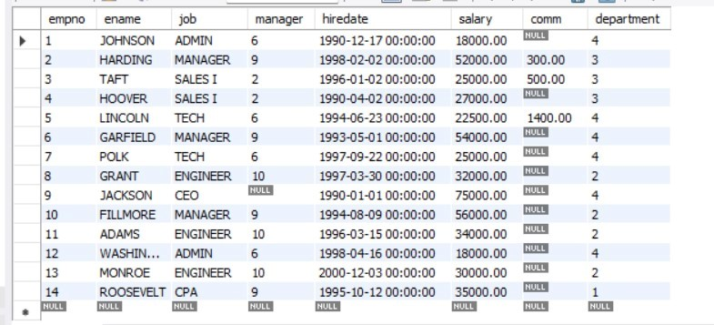

**Introducing Today's Project!**

**What is Amazon RDS?**

Amazon Relational Database Service (Amazon RDS) is a managed cloud database service provided by Amazon Web Services (AWS). It simplifies the process of setting up, operating, and scaling relational databases.

**How I used Amazon RDS in this project**

Today I used RDS to create a relational database that I populated using MySQL workbench I then visualize my data using quicksight.

**One thing I didn't expect in this project was...**

How much Security Group action there was! They matter a lot!

**This project took me...**

It took me 3 hours of time to complete this project.

**In the first part of my project...**

**Creating a Relational Database**

I created my relational database by RDS serviice in AWS.

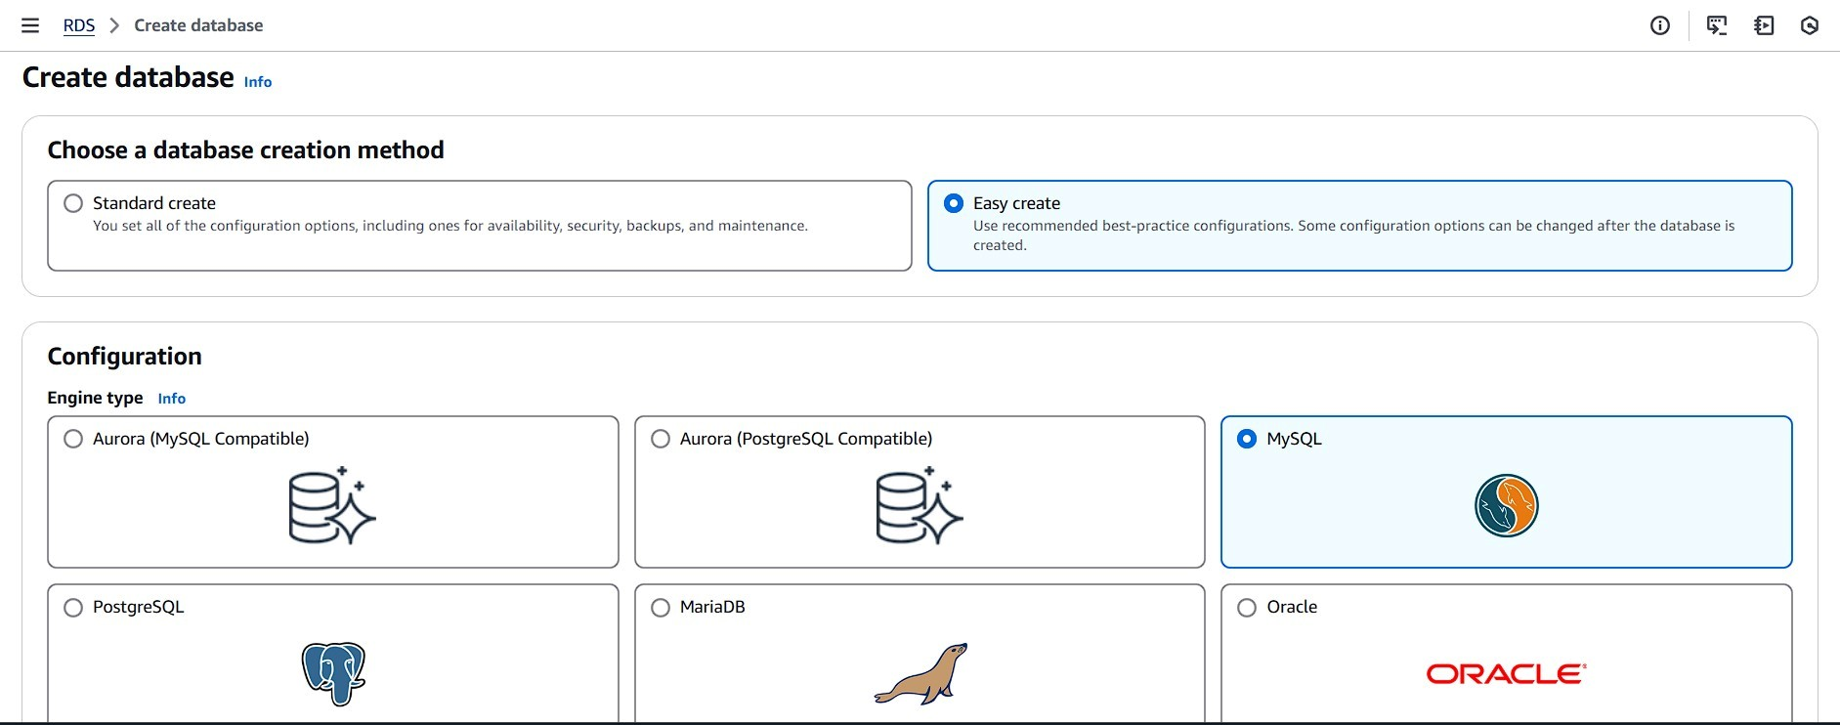

# Understanding Relational Databases

A relational database is a type of database that organizes data into tables, which are collections of rows and columns. Kind of like a spreadsheet! We call it "relational" because the rows relate to the columns and vice-versa.

**MySQL vs SQL**

-> MySQL is software used to create, manage, and interact with relational databases but is only one of many options for using SQL to manage relational data. -> SQL is a programming language manage & manipulate relational databases.

# Populating my RDS instance

The first thing I did was make my RDS instance public because to allow connections from outside the AWS network (ie. from our local machine using MySQL Workbench)

I had to update the default security group for my RDS schema beacause We need MySQL Workbench to access our database, so we need to change the inbound traffic rules in the security group.

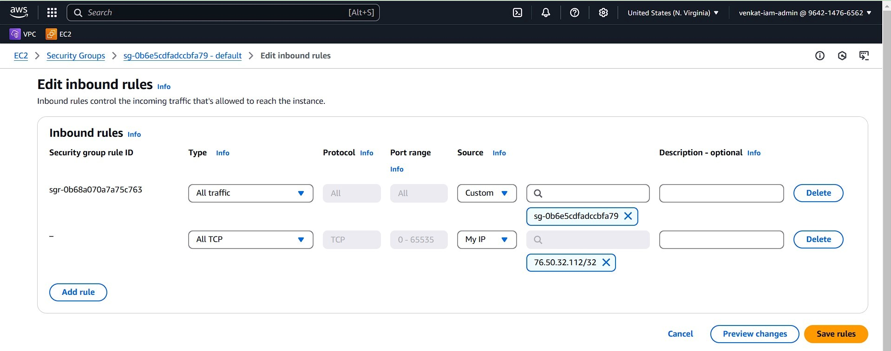

# Using MySQL Workbench



To populate my database I Used SQL in MySQL workbench app to create and populate my database tables. First I had to connect my RDS instance to MySQL using the Endpoint, Port, Username and Password.

# Connecting QuickSight and RDS

To connect my RDS instance to QuickSight I made my security group around my RDS instance allow traffic from any IP address so that QuickSight connect easily.

This solution is risky because anyone can access our RDS instance not only QuickSight

**A better strategy**

First, I made a new security group so that my QuickSight will be secure

Next, I connected my new security group to QuickSight by creating a connection to QuickSight and my VPC and then my security group had to update my IAM

# Now to secure my RDS instance

To make my RDS instance secure I made it not publicly accessible and then created a new security group for my RDS instance.

I made sure that my RDS instance could be accessed from QuickSight by creating the correct inbound rules that allowed querying of my RDS instance from my QuickSight security group.

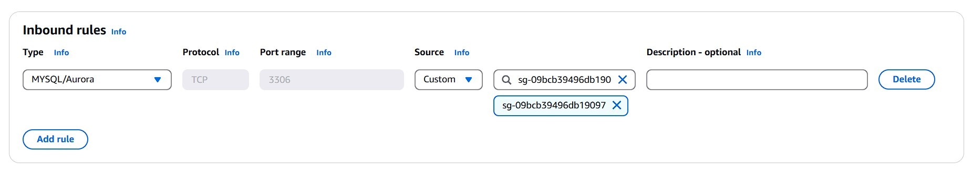

# Adding RDS as a data source for QuickSight

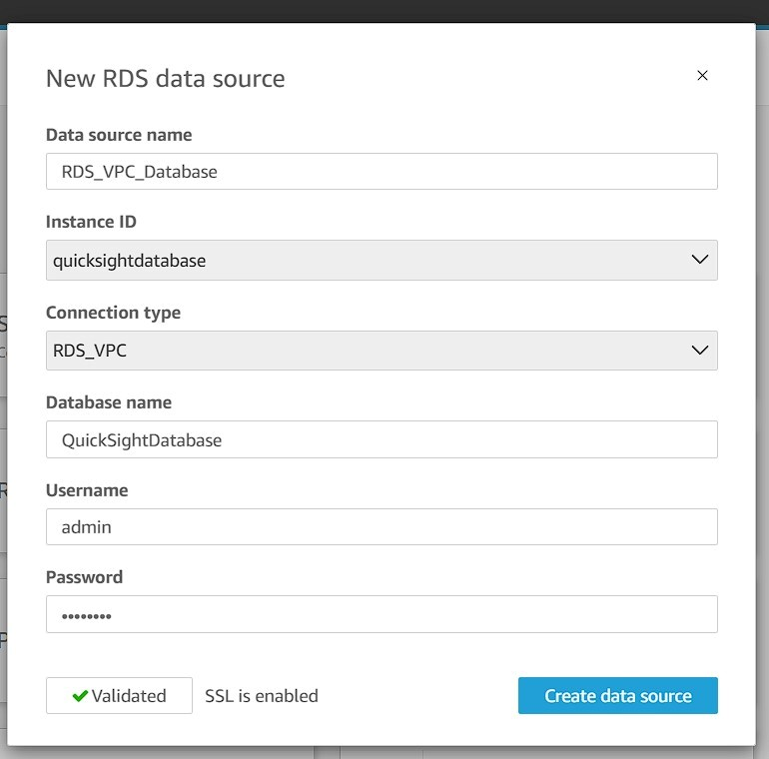

This data source is different from my initial data source because it is secure! We are using security groups to access our data in a much more secure way rather than the defaults or things just being public.

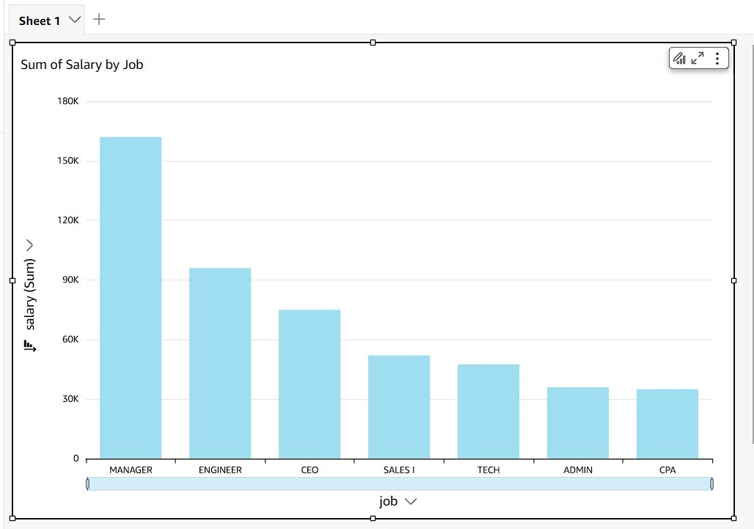

**DASH BOARD IN QUICK SIGHT**

