Experiment No: 3 Date:14/05/2025

Roll No:AM.EN.U4ELC22007

Name: Venkata Durga

**Autoencoder**

# Objectives

To use Convolutional Denoising Autoencoder on MNIST for noise removal and reconstruction.

* Compare Mean square error (MSE), PSNR (Peak Signal to Noise), SSIM (Structural Similarity Index Measure).

**Main**

**Code**

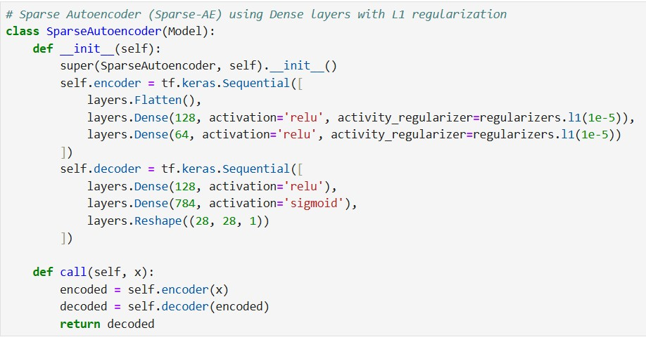

* To study the Autoencoder variants and its effect on image reconstruction.

# Group Question 1

1. **Compares a CNN-based Autoencoder with a Sparse Autoencoder.**
2. **Vary the L1 regularisation and compare the MSE, SSIM and PSNR**

**Program**

# Code for modifying the main code as per our question

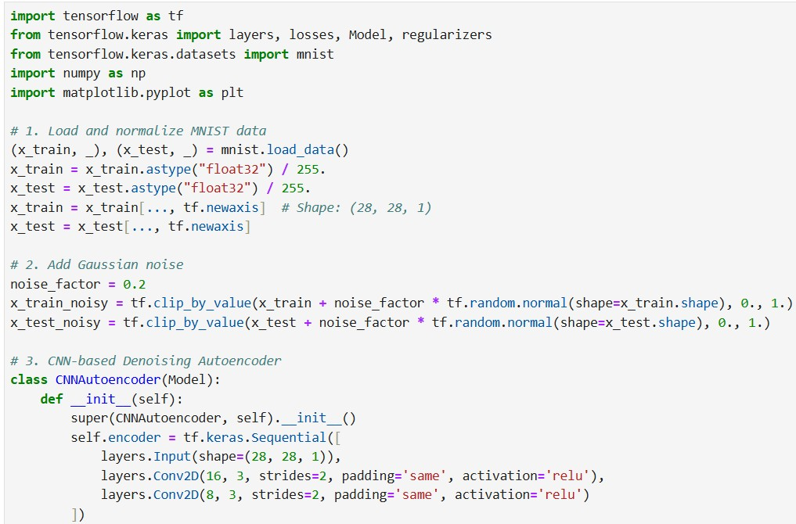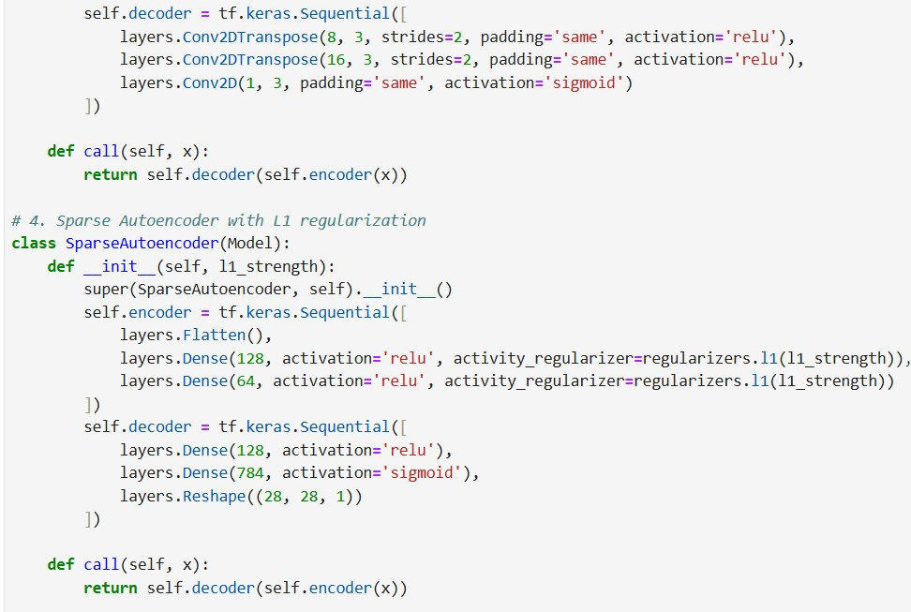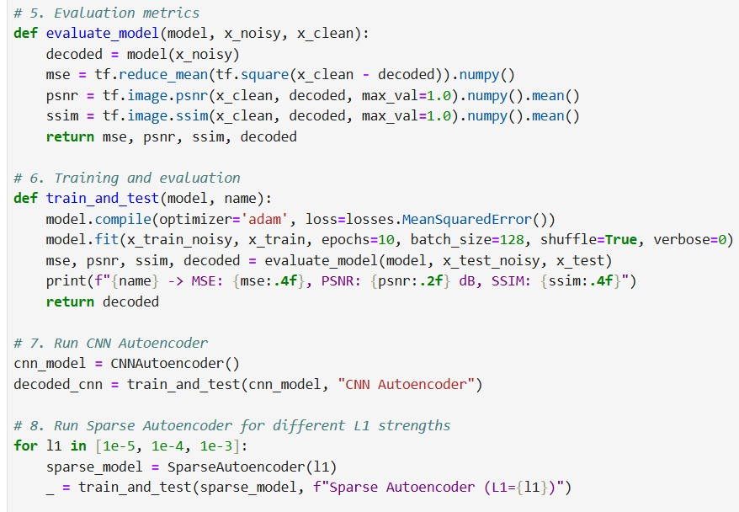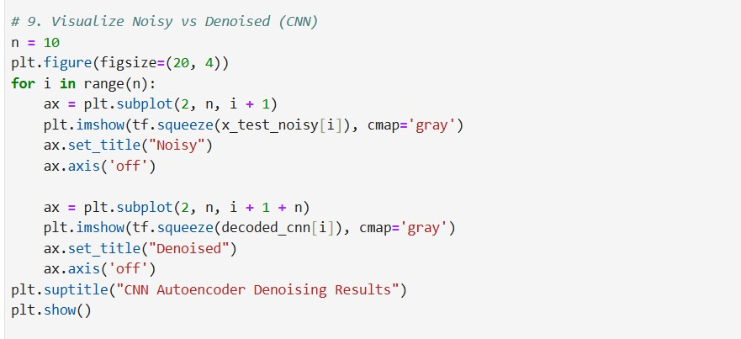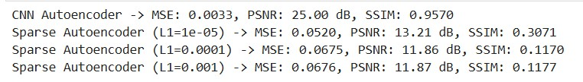

# Plots

**Results**

**and Inferences**

