**Front End Web Development**

Aim:

To create and design a website containing contenting 3 webpages for online shopping model using HTML 5, CSS 3.0, PHP

First Webpage:

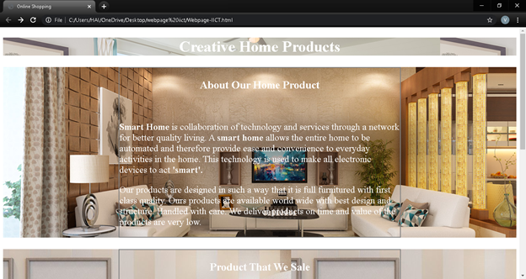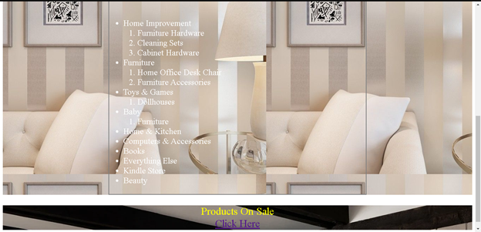

First webpage HTML code:

<!DOCTYPE html>

<html>

<head>

<title>Online Shopping</title>

<style type="text/css">

. A {

border: 2px solid grey;

margin-left: 300px;

margin-right: 300px;

margin-top: 30px;

background-color: transparent;

color: white;

font-size: 24px;

}

</style>

</head>

<body>

<h1 style="text-align: center;color: white;background-image: url(https://www.drhorton.com/-/media/DRHorton/Teasers/fpo-why-carousel-dsktp/brand-carousel-EXP.ashx?h=488&w=1135&la=en&hash=DB133F5BEECD85326A0A920219075A0AE8F39C41);">Creative Home Products</h1>

<section style="background-image: url(https://www.kataak.co.in/webroot/mobile/images/main_banner.jpg);">

<div class="A"><h3 style="text-align: center">About Our Home Product</h3><br>

<p><strong>Smart Home </strong> is collaboration of technology and services through a network for better quality living. A <strong>smart home </strong> allows the entire home to be automated and therefore provide ease and convenience to everyday activities in the home. This technology is used to make all electronic devices to act <strong>'smart'.</strong></p>

<p>Our products are designed in such a way that it is full furnitured with first class quality. Ours products are available world wide with best design and structure. Handled with care. We deliver products on time and value of the products are very low. </p>

</div>

<p>

</p>

</section>

<section style="background-image: url(https://i.pinimg.com/originals/58/f7/da/58f7da7f88ba7aa81ec949574b7e0971.jpg);">

<div class="A"><h3 style="text-align: center;color: white">Product That We Sale</h3><br>

<ul style="color: 30px solid white">

<li>Home Improvement</li>

<ol>

<li>Furniture Hardware</li>

<li>Cleaning Sets</li>

<li>Cabinet Hardware</li>

</ol>

<li>Furniture</li>

<ol>

<li>Home Office Desk Chair</li>

<li>Furniture Accessories</li>

</ol>

<li>Toys & Games</li>

<ol>

<li>Dollhouses</li>

</ol>

<li>Baby</li>

<ol>

<li>Furniture</li>

</ol>

<li>Home & Kitchen</li>

<li>Computers & Accessories</li>

<li>Books</li>

<li>Everything Else</li>

<li>Kindle Store</li>

<li>Beauty</li>

</ul>

</div>

</section>

<section style="background-image: url(https://media.architecturaldigest.com/photos/5e39c63fe71de50008ce2f78/master/w_1600%2Cc_limit/HEM_NACKA_1609_2048x2048.jpg);">

<p style="text-align: center;font-size: 30px;color: yellow">Products On Sale<br>

<a href="C:\Users\HAI\OneDrive\Desktop\webpage iict\products.html">Click Here</a>

</p>

</section>

</body>

</html>

Link:

The word at last “Click Here” on clicking that it will redirect to 2nd webpage , to see the products that are for sales.

Second webpage:

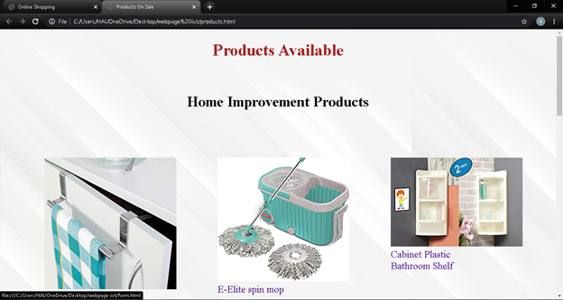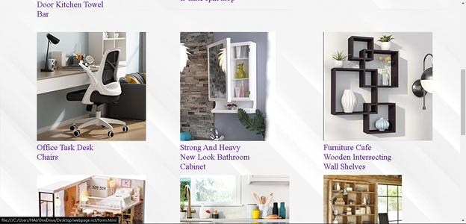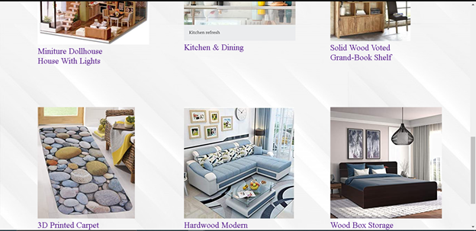

Second webpage HTML code:

<!DOCTYPE html>

<html>

<head>

<title>Products On Sale</title>

<style type="text/css">

.pic{

height: 300px;

width: 300px;

float: left;

padding: 60px;

}

.socialmedia{

border: 1px solid grey;

margin-left: 300px;

margin-right: 300px;

margin-top: 1800px;

background-color: lightyellow;

}

#media{

top: 10px;

max-height: 50px;

width: 600px;

}

</style>

</head>

<body style="background-image: url(https://img.freepik.com/free-vector/elegant-white-background-with-shiny-lines_1017-17580.jpg?size=1000&ext=jpg);">

<div>

<h1 style="text-align: center; color: brown">Products Available<br><br></h1>

<h3 style="text-align: center; font-size: 35px">Home Improvement Products</h3>

<section>

<a href="C:\Users\HAI\OneDrive\Desktop\webpage iict\form.html" target="_blank"><div class="pic"><figure><img src="https://m.media-amazon.com/images/I/71vrtRq45kL._AC_UL320_.jpg"><figcaption style="font-size: 24px">Door Kitchen Towel Bar</figcaption></figure></div>

</a>

<a href="C:\Users\HAI\OneDrive\Desktop\webpage iict\form.html" target="_blank"><div class="pic"><figure><img src="https://m.media-amazon.com/images/I/716OnT32WgL._AC_UL320_.jpg"><figcaption style="font-size: 24px">E-Elite spin mop</figcaption></figure></div>

</a>

<a href="C:\Users\HAI\OneDrive\Desktop\webpage iict\form.html" target="_blank"><div class="pic"><figure><img src="https://m.media-amazon.com/images/I/81C6FTSMnuL._AC_UL320_.jpg"><figcaption style="font-size: 24px">Cabinet Plastic Bathroom Shelf</figcaption></figure></div>

</a>

<a href="C:\Users\HAI\OneDrive\Desktop\webpage iict\form.html" target="_blank"><div class="pic"><figure><img src="https://images-na.ssl-images-amazon.com/images/I/61HbU5HsmWL._AC_UL320_.jpg"><figcaption style="font-size: 24px">Office Task Desk Chairs</figcaption></figure></div>

</a>

<a href="C:\Users\HAI\OneDrive\Desktop\webpage iict\form.html" target="_blank"><div class="pic"><figure><img src="https://m.media-amazon.com/images/I/81BQvRGnYZL._AC_UL320_.jpg"><figcaption style="font-size: 24px">Strong And Heavy New Look Bathroom Cabinet</figcaption></figure></div>

</a>

<a href="C:\Users\HAI\OneDrive\Desktop\webpage iict\form.html" target="_blank"><div class="pic"><figure><img src="https://m.media-amazon.com/images/I/61gysM95GxL._AC_UL320_.jpg"><figcaption style="font-size: 24px">Furniture Cafe Wooden Intersecting Wall Shelves</figcaption></figure></div>

</a>

<a href="C:\Users\HAI\OneDrive\Desktop\webpage iict\form.html" target="_blank"><div class="pic"><figure><img src="https://m.media-amazon.com/images/I/71L0eCa2s7L._AC_UL320_.jpg"><figcaption style="font-size: 24px">Miniture Dollhouse House With Lights</figcaption></figure></div>

</a>

<a href="C:\Users\HAI\OneDrive\Desktop\webpage iict\form.html" target="_blank"><div class="pic"><figure><img src="https://images-na.ssl-images-amazon.com/images/G/01/img18/home/Harmony/storefront/2020/Q1/Spring_Storefront_KitchenDin_KitchenRef_2_column_desktop_._UL320_.jpg"><figcaption style="font-size: 24px">Kitchen & Dining</figcaption></figure></div>

</a>

<a href="C:\Users\HAI\OneDrive\Desktop\webpage iict\form.html" target="_blank"><div class="pic"><figure><img src="https://encrypted-tbn0.gstatic.com/images?q=tbn%3AANd9GcSpgIOX9M1BWxbXOe2ePFigRrywVrSvbl2JIFlwvCAzC8eZOZQTivQpjq5CPR8&usqp=CAc"><figcaption style="font-size: 24px">Solid Wood Voted Grand-Book Shelf</figcaption></figure></div>

</a>

<a href="C:\Users\HAI\OneDrive\Desktop\webpage iict\form.html" target="_blank"><div class="pic"><figure><img src="https://m.media-amazon.com/images/I/81KL-5uBZdL._AC_UL320_.jpg"><figcaption style="font-size: 24px">3D Printed Carpet Rug</figcaption></figure></div>

</a>

<a href="C:\Users\HAI\OneDrive\Desktop\webpage iict\form.html" target="_blank"><div class="pic"><figure><img src="https://m.media-amazon.com/images/I/51qWv4KPdbL._AC_UL320_.jpg"><figcaption style="font-size: 24px">Hardwood Modern Fabric L Shape Sofa</figcaption></figure></div>

</a>

<a href="C:\Users\HAI\OneDrive\Desktop\webpage iict\form.html" target="_blank"><div class="pic"><figure><img src="https://m.media-amazon.com/images/I/71mZawr34KL._AC_UL320_.jpg"><figcaption style="font-size: 24px">Wood Box Storage With King Size Bed In Denver Oak</figcaption></figure></div>

</a>

</section>

</div>

<section>

<div>

<div class="socialmedia"><h3 style="color: red;text-align: center;">For Further Information Contact Us On</h3>

<figure ><img src="https://upload.wikimedia.org/wikipedia/commons/thumb/e/e7/Instagram_logo_2016.svg/1200px-Instagram_logo_2016.svg.png" height="50px" width="50px" style="float: left;padding-left: 55px;padding-right: 20px"></figure>

<figure ><img src="https://images.idgesg.net/images/article/2018/05/gmail_logo-100758589-large.jpg" height="50px" width="50px" style="float: left;padding-left: 55px;padding-right: 20px"></figure>

<figure ><img src="https://imageog.flaticon.com/icons/png/512/124/124010.png?size=1200x630f&pad=10,10,10,10&ext=png&bg=FFFFFFFF" height="50px" width="50px" style="float: left;padding-left: 55px;padding-right: 20px"></figure>

<figure ><img src="https://cdn2.iconfinder.com/data/icons/social-media-square-set/960/Twitter_Sq-512.png" height="50px" width="50px" style="float: left;padding-left: 55px;padding-right: 20px"></figure>

<figure ><img src="https://cdn0.iconfinder.com/data/icons/social-flat-rounded-rects/512/telegram-512.png" height="50px" width="50px" style="float: left;padding-left: 55px;padding-right: 20px"></figure>

</div>

</div>

</section>

</body>

</html>

Link:

The images present in the webpage are hyperlinks on clicking a specific image it will redirect to fill the form where the contents are processed by using PHP code for back end server.

Form page:

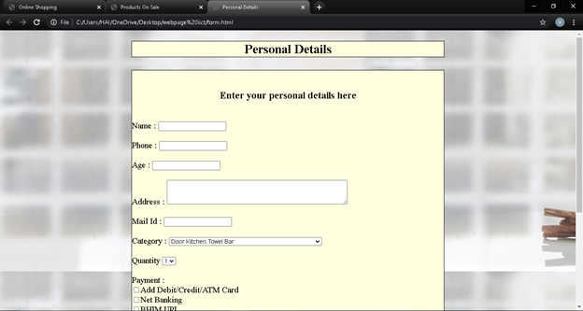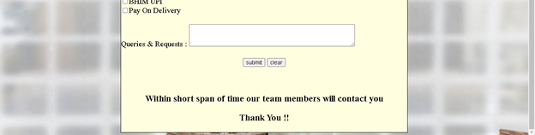

Form HTML code:

<!DOCTYPE html>

<html>

<head>

<title>Personal Details</title>

<style type="text/css">

.A{

border: 1px solid black;

margin-top: 30px;

margin-left: 300px;

margin-right: 300px;

background-color: lightyellow;

}

</style>

</head>

<body style="background-image: url(https://img.freepik.com/free-photo/stack-clean-towels-white-table-background-copy-space_44344-1207.jpg?size=850&ext=jpg);">

<h2 style="background-color: lightyellow;text-align: center;margin-right: 300px;margin-left: 300px;border: 1px solid black">Personal Details</h2>

<div class="A">

<form method="POST" action="form.php">

<br>

<h3 style="text-align: center;">Enter your personal details here</h3><br>

<label for="Name">Name : </label>

<input type="text" name="Name"><br><br>

<label for="Phone">Phone : </label>

<input type="text" name="Phone"><br><br>

<label for="Age">Age : </label>

<input type="text" name="Age"><br><br>

<label for="Address">Address : </label>

<textarea name="Address" rows="3" cols="50"></textarea><br><br>

<label for="Mail">Mail Id : </label>

<input type="Mail" name="Mail"><br><br>

<label for="Category">Category : </label>

<select name="Category">

<option value="Home Improvement">Door Kitchen Towel Bar</option>

<option value="Home Improvement">E-Elite Spin Mop</option>

<option value="Home Improvement">Cabinet Plastic Bathroom Shelf</option>

<option value="Furniture">office Task Desk Chairs</option>

<option value="Furniture">Strong And Heavy New Look Bathroom Cabinet</option>

<option value="Furniture">Furniture Cafe Wooden Intersecting Wall Shelves</option>

<option value="Dollhouse">Miniture Dollhouse House With lights</option>

<option value="Home & Kitchen">kitchen & Dining</option>

<option value="Home & Kitchen">3D Printed Carpet Rug</option>

<option value="Books">Solid Wood Voted Grand-Book Shelf</option>

<option value="Hall">Hardwood Modern Fabric L Shape Sofa</option>

<option value="Room">Wood Box Storage With king Size Bed In Denver Oak</option>

</select><br><br>

<label for="Quantity">Quantity</label>

<select name="count">

<option value="count">1</option>

<option value="count">2</option>

<option value="count">3</option>

<option value="count">4</option>

<option value="count">5</option>

</select><br><br>

<label for="Payment">Payment : </label><br>

<input type="checkbox" name="Payment">Add Debit/Credit/ATM Card<br>

<input type="checkbox" name="Payment">Net Banking<br>

<input type="checkbox" name="Payment">BHIM UPI<br>

<input type="checkbox" name="Payment">Pay On Delivery<br><br>

<label for="q&r">Queries & Requests : </label>

<textarea name="q&r" rows="3" cols="50"></textarea><br><br>

<center>

<input type="submit" name="submit" value="submit" >

<input type="button" name="clear" value="clear">

</center>

<br><br>

<h3 style="text-align: center;">Within short span of time our team members will contact you</h3>

<h3 style="text-align: center;">Thank You !!</h3>

</form>

</div>

</body>

</html>

PHP Code:

The php code gets the user information and sends the copy of invoice to the customer and dealer who can further contact each other for further developing the business.

<?PHP

$Name = $_POST["Name"];

$Phone = $_POST["Phone"];

$Age = $_POST["Age"];

$Address = $_POST["Address"];

$Mail = $_POST["Mail"];

$Cat = $_POST["Category"];

$Quantity = $_POST["Quantity"];

$Payment = $_POST["Payment"];

$q&r = $_POST["q&r"];

$information = array($Name,$Phone,$Age,$Address,$Mail,$Cat,$Quantity, $Payment,$q&r);

$to = "[venkatanand2002@gmail.com](mailto:venkatanand2002@gmail.com)";

$subject : "Customer Information";

$v = mail($to,$subject,$information,$Mail);

if($v == true)

{

echo "Please check your email for further information";

}

else{

echo "There is fault in sending the mail. Please try again later.";

}

?>

Bibliography:

* [www.w3schools.com](http://www.w3schools.com)
* www.geeksforgeeks.com