***LEARNER’S ACADEMY – CLASS REPORT PORTAL***

This document contains the following

* Project and developer details
* Sprint planning and tasks completion
* Algorithms and Flowchart of the application
* Core concepts used in the project
* Links to the GitHub repository
* Demonstration of product capabilities, appearance, and user interactions
* Unique Selling Points of the application
* Conclusion

***Project and Developer details:***

**Project objective:**

As a Full Stack Developer, complete the features of the application by planning the development in terms of sprints and then push the source code to the GitHub repository. As this is a prototyped application, the user interaction will be via a command line.

**You must use the following:**

* Eclipse/IntelliJ: An IDE to code for the application
* Java: A programming language to develop the prototype
* Git: To connect and push files from the local system to GitHub
* GitHub: To store the application code and track its versions
* Scrum: An efficient agile framework to deliver the product incrementally
* Search and Sort techniques: Data structures used for the project
* Specification document: Any open-source document or Google Docs

**The following requirements should be met:**

* The source code should be pushed to your GitHub repository. You need to document the steps and write the algorithms in them.
* The submission of your GitHub repository link is mandatory. In order to track your task, you need to share the link to the repository. You can add a section to your document.
* Document the step-by-step process starting from sprint planning to the product release.
* Application should not close, exit, or throw an exception if the user specifies an invalid input.
* You need to submit the final specification document which includes:
  + Project and developer details
  + Sprints planned and the tasks achieved in them
  + Algorithms and flowcharts of the application
  + Core concepts used in the project
  + Links to the GitHub repository to verify the project completion
  + Your conclusion on enhancing the application and defining the USPs (Unique Selling Points)

**Developer Details:**

Venkadathasan D

[venkadathasan001@gmail.com](mailto:venkadathasan001@gmail.com)

*Sprint planning and Task completion:*

This project is intended to be delivered in three sprints.

Sprint 1: Analysed the application’s features and prepared a flow chart and Git Repository.

Sprint 2: Wrote different sub-methods required for the application's main method followedb by the welcome screen and menu. Resolved exceptions and errors.

Sprint 3: Tested the application numerous times to ensure a high-end quality product andpushedit to GitHub. Prepared this document highlighting the application’s capabilities, appeaseappearance, and user interactions.

*Flowchart of the application:*

Flowchart:

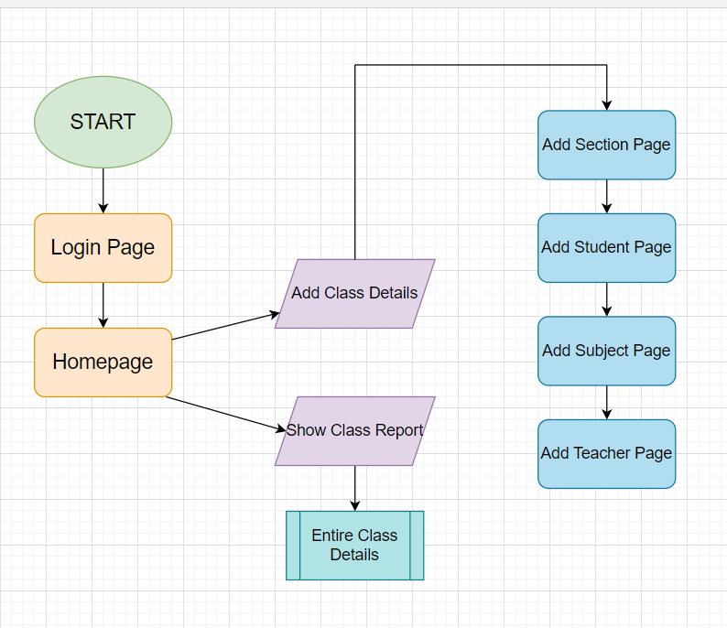

*Core concepts used in the project:*

* Servlet.
* Hibernate.

*Links to the GitHub repository:*

<https://github.com/Priya-2705/LockedMe.com.git>