MULTIPLICATION

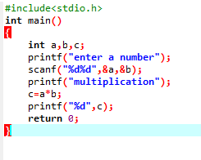

OUTPUT

