CareerSphere AI: An Explainable, Skill-Aware Campus Placement Platform with Opportunity Math, Skill Roadmaps and a Grounded AI Copilot
A Report submitted in partial fulfillment of the requirements for the Degree of
Bachelor of Technology
in
COMPUTER SCIENCE AND ENGINEERING
by
V. Venkata Rupin | (2311CS010689)
E. Manideep Reddy | (2311CS010182)
J. Pruthvi Sai | (2311CS010264)
S. Jaffer Ali | (2311CS010639)
Under the guidance of
[Guide name]
[Designation], Department of CSE

Department of Computer Science and Engineering
School of Engineering
MALLA REDDY UNIVERSITY
Maisammaguda, Dulapally, Hyderabad, Telangana 500100
2026

CareerSphere AI: An Explainable, Skill-Aware Campus Placement Platform with Opportunity Math, Skill Roadmaps and a Grounded AI Copilot
A Major Report submitted in partial fulfillment of the requirements for the Degree of
Bachelor of Technology
in
COMPUTER SCIENCE AND ENGINEERING
by
V. Venkata Rupin | (2311CS010689)
E. Manideep Reddy | (2311CS010182)
J. Pruthvi Sai | (2311CS010264)
S. Jaffer Ali | (2311CS010639)
Under the guidance of
[Guide name]
[Designation], Department of CSE

Department of Computer Science and Engineering
School of Engineering
MALLA REDDY UNIVERSITY
Maisammaguda, Dulapally, Hyderabad, Telangana 500100
2026


Department of Computer Science and Engineering
CERTIFICATE
This is to certify that the project report entitled “CAREERSPHERE AI: AN EXPLAINABLE, SKILL-AWARE CAMPUS PLACEMENT PLATFORM WITH OPPORTUNITY MATH, SKILL ROADMAPS AND A GROUNDED AI COPILOT” submitted by V. Venkata Rupin (2311CS010689), E. Manideep Reddy (2311CS010182), J. Pruthvi Sai (2311CS010264) and S. Jaffer Ali (2311CS010639) towards the partial fulfillment for the award of Bachelor’s Degree in Computer Science and Engineering, Malla Reddy University, Hyderabad, is a record of bonafide work done by them. The results embodied in the work are not submitted to any other University or Institute for award of any degree or diploma.

INTERNAL GUIDE DEAN-CSE
Guide name Dr. A.V.L.N. Sujith
Designation, CSE

External Examiner

Department of Computer Science and Engineering
DECLARATION
We hereby declare that the project report entitled “CAREERSPHERE AI: AN EXPLAINABLE, SKILL-AWARE CAMPUS PLACEMENT PLATFORM WITH OPPORTUNITY MATH, SKILL ROADMAPS AND A GROUNDED AI COPILOT” has been carried out by us and this work has been submitted to the Department of Computer Science and Engineering, Malla Reddy University, Hyderabad in partial fulfillment of the requirements for the award of degree of Bachelor of Technology. We further declare that this project work has not been submitted in full or part for the award of any other degree in any other educational institutions. All data used in this report is fictional demo data created for the project.

Place: Hyderabad
Date: DD-MM-2026

V. Venkata Rupin 2311CS010689
E. Manideep Reddy 2311CS010182
J. Pruthvi Sai 2311CS010264
S. Jaffer Ali 2311CS010639
ACKNOWLEDGEMENT
We extend our sincere gratitude to all those who have contributed to the successful completion of this project report. Firstly, we would like to express our heartfelt thanks to Mr. Chamakura Malla Reddy, Chairman, and Dr V. S. K. Reddy, Vice-Chancellor, for their visionary leadership and unwavering commitment to academic excellence.
We would also like to express our deepest appreciation to our project guide, Guide name, Designation, Department of Computer Science and Engineering, whose invaluable guidance, insightful feedback and constant support have been instrumental throughout the course of this project.
We sincerely thank Dr. A.V.L.N. Sujith, Dean, CSE, School of Engineering, for his encouragement and support throughout our academic journey, and the Training and Placement Cell of the university for explaining how campus placement works in practice, including the placement portal that shaped the placement profile in this project.
We are deeply indebted to all of them for their support, encouragement and guidance, without which this project would not have been possible.

V. Venkata Rupin 2311CS010689
E. Manideep Reddy 2311CS010182
J. Pruthvi Sai 2311CS010264
S. Jaffer Ali 2311CS010639
ABSTRACT
Campus placement portals record profiles, applications and results, but rarely tell anyone what to do next: which skill a student should learn, which students a recruiter should look at, or which training the placement cell should run. This project designs, implements and evaluates CareerSphere AI, a placement platform for students, recruiters and the placement cell built on one transparent, level-aware match rule: the weighted share of a job’s required skills a student has, where must-have skills count twice as much as nice-to-have ones and a skill below the level asked earns half credit, with a 70% “within reach” threshold and the recruiter’s CGPA cutoff. Skill levels can be verified by server-graded assessments or by certificates checked by the placement cell.
Four decision tools are built on the rule. Opportunity Math ranks each learning step by how many open jobs it would bring within reach. A Skill Roadmap searches every bundle of up to three steps exactly and marks steps that only pay off together. Hidden Talent shows recruiters consented students who fit a job but have not applied. A Workshop Planner chooses k workshops for the batch by exact bit-mask search, because the objective is not submodular and greedy selection can fail. A Copilot (Google Gemini with eight read-only tools) and an evidence-checked résumé skill finder are grounded in the same data and work without an AI key. The system uses Spring Boot, React and MySQL, runs from Terminal, Xcode, VS Code and Android Studio and online with Docker, and has 39 unit tests and 17 API tests.
On a fictional batch of 35 students and 12 jobs, Opportunity Math brings 1.43 jobs per student within reach against 1.03 for the most-demanded missing skill; the Skill Roadmap raises this to 2.89 with two steps and 4.71 with three, helping all 7 students for whom no single skill helps; Hidden Talent surfaces 10 fitting non-applicants; and three exactly planned workshops give all 35 students a job within reach where greedy selection reaches 32, in 6.5 ms.
Keywords: campus placement, skill-gap analysis, explainable recommendation, combinatorial optimisation, large language models, Spring Boot, React.
TABLE OF CONTENTS
ABSTRACT VI
LIST OF FIGURES IX
LIST OF TABLES XI
ABBREVIATIONS AND NOTATIONS XII
CHAPTER 1 INTRODUCTION 1
1.1 Project Overview 1
1.2 Problem Statement 1
1.3 Scope and Research Questions 2
1.4 Feasibility Analysis 2
CHAPTER 2 LITERATURE SURVEY 4
2.1 Foundations of Matching, Explanation and Coverage 4
2.2 Related Work and Existing Systems 4
2.3 Research Gap and Rationale for the Proposed System 5
CHAPTER 3 PROJECT OBJECTIVES AND REQUIREMENTS 6
3.1 Project Objectives 6
3.2 Limitations and Scope Boundaries 6
3.3 Functional and Non-Functional Requirements 7
3.4 Hardware and Software Requirements 7
CHAPTER 4 DESIGN AND METHODOLOGY 9
4.1 Proposed System Framework 9
4.2 System Architecture 9
4.3 Functional Module Description 10
4.4 Methods and Mathematical Formulation 11
4.5 Database Design 14
4.6 API Design 15
4.7 Data Flow Diagrams (Levels 0, 1 and 2) 16
4.8 UML Design Models 17
CHAPTER 5 TESTING 26
5.1 Need for Testing and Verification Strategy 26
5.2 Unit Testing of the Rules 26
5.3 Integration and API Testing 27
5.4 User Interface Testing and Validation 27
CHAPTER 6 CODE AND IMPLEMENTATION 29
6.1 Technology Stack and Project Structure 29
6.2 Core Source Code 31
6.3 System Execution Logs and Output Verification 33
6.4 Screens of the Application 33
6.5 Running on Different Platforms 44
CHAPTER 7 RESULTS AND DISCUSSION 45
7.1 Experimental Results 45
7.2 Discussion and Evaluation of the Research Questions 49
7.3 Comparison with Existing Approaches 49
CHAPTER 8 CONCLUSION AND FUTURE SCOPE 51
8.1 Conclusions and Research Contributions 51
8.2 Future Scope 51
REFERENCES 52
APPENDIX SETUP COMMANDS, DEMO SCRIPT AND API LIST 54
LIST OF FIGURES
Fig 4.1 Framework of CareerSphere AI from inputs through the match rule to decisions and evaluation 9
Fig 4.2 Layered architecture of CareerSphere AI 10
Fig 4.3 Entity–relationship diagram (rotated to fit the page) 15
Fig 4.4 Data flow diagrams at Level 0 (context), Level 1 (processes) and Level 2 (matching and planning) 17
Fig 4.5 Use case diagram of CareerSphere AI 18
Fig 4.6 Class diagram of the principal entities and services 19
Fig 4.7 Sequence diagram of login and an authenticated request 20
Fig 4.8 Sequence diagram of applying to a job 21
Fig 4.9 Sequence diagram of the Copilot with function calling 21
Fig 4.10 Sequence diagram of the evidence-checked résumé skill finder 22
Fig 4.11 Sequence diagram of building a Skill Roadmap 22
Fig 4.12 Activity diagram of the student placement flow 23
Fig 4.13 Deployment diagram of the local and online environments 24
Fig 4.14 Flow of the exact Workshop Planner 25
Fig 6.1 Mind map of the project: features, algorithms and technologies 30
Fig 6.2 Login page with demo accounts for the three roles 34
Fig 6.3 Career Map: each open job placed by match score; skill levers on the right 34
Fig 6.4 Career Map with the Copilot panel open 35
Fig 6.5 Opportunity Math: the skills that bring the most jobs within reach 35
Fig 6.6 Skill Roadmap: best one-, two- and three-step plans 36
Fig 6.7 Job listings with explained match scores 36
Fig 6.8 Job detail: why this score, and the job’s requirements 37
Fig 6.9 Placement profile of a new student: guided steps and résumé score 37
Fig 6.10 Placement profile of a student who has completed most steps 38
Fig 6.11 Skill assessments: verified and unverified skills 38
Fig 6.12 A timed assessment in progress 39
Fig 6.13 Assessment result: fewer than 4 correct verifies nothing; retake after 24 hours 39
Fig 6.14 Certifications: a verified certificate and how verification works 40
Fig 6.15 Readiness leaderboard 40
Fig 6.16 Recruiter: posting a job with skill levels and must-have or nice-to-have flags 41
Fig 6.17 Recruiter: applicants ranked by match, with verified skills 41
Fig 6.18 Recruiter: Hidden Talent for a job, with invitations 42
Fig 6.19 Placement cell: analytics and the curriculum–market skill gap 42
Fig 6.20 Placement cell: Workshop Planner for three workshops 43
Fig 6.21 Placement cell: certificates waiting for verification 43
Fig 6.22 The same app on a phone: Career Map and the slide-in menu 44
Fig 7.1 Mean new jobs within reach per student for each way of choosing what to learn 46
Fig 7.2 Outcome of each planning method for k = 1 to 4 workshops; dotted line: today. (a) Reach goal; (b) Matches goal 47
Fig 7.3 Exact Workshop Planner runtime against the number of workshops (logarithmic scale) 48
Fig 7.4 Hidden Talent per job: consented students who have not applied, within reach or one step away 48
LIST OF TABLES
Table 1 Typical placement portal compared with CareerSphere AI 5
Table 2 Functional requirements by role 7
Table 3 Hardware and software configuration 8
Table 4 Modules of the system 11
Table 5 Résumé score rules 13
Table 6 Main REST endpoints 16
Table 7 Unit tests 26
Table 8 End-to-end API test cases 27
Table 9 Technology stack 29
Table 10 Recommended next skill, 35 students 45
Table 11 Skill Roadmap, 35 students 45
Table 12 Workshop plans: students reached / matches (Reach goal) 46
Table 13 Planner runtime, median of 9 calls 47
Table 14 Comparison of existing approaches with CareerSphere AI 49
Table 15 Demo accounts 54
Table 16 All REST endpoints 55
ABBREVIATIONS AND NOTATIONS
Abbreviation / Symbol | Meaning
API | Application Programming Interface
BCrypt | Blowfish-based adaptive password hashing function
CGPA | Cumulative Grade Point Average
CSS | Cascading Style Sheets
DFD | Data Flow Diagram
DTO | Data Transfer Object
ER | Entity–Relationship
F1 | Harmonic mean of precision and recall
H2 | In-memory Java SQL database used for tests
HTTPS | Hypertext Transfer Protocol Secure
JPA | Jakarta Persistence API
JSON | JavaScript Object Notation
JWT | JSON Web Token
LLM | Large Language Model
REST | Representational State Transfer
SPA | Single-Page Application
SQL | Structured Query Language
UI | User Interface
UML | Unified Modeling Language
UUID | Universally Unique Identifier
ℓ_{s}(x) | Level of student s in skill x (0 none, 1 Beginner, 2 Intermediate, 3 Advanced)
m_{j}(x), w_{j}(x) | Minimum level and weight (2 must-have, 1 nice-to-have) of skill x in job j
κ | Credit of one skill: 1, ½ or 0
k | Number of workshops in a plan

CHAPTER - 1
INTRODUCTION

1.1 Project Overview
Campus placement is the main route from an engineering college to a first job in India. Within a few months each year a training and placement cell invites companies, students apply to openings, recruiters shortlist and interview, and offers are made. The process is high in volume and short in time: a mid-sized department may have several hundred final-year students and dozens of openings, each asking for its own mix of technical skills, a minimum CGPA and sometimes a particular branch.
Most colleges run this process on a placement portal, a website where students keep a profile and résumé, companies post drives and the placement cell tracks applications. These portals are good at recording what happened and weak at telling anybody what to do next. A student can see that a job asks for Java, Spring Boot and Git, but not whether learning Spring Boot or Docker would open more doors across all current openings. A recruiter sees a list of applicants, but not the students who would fit well and simply did not apply. A placement cell can see that many students lack a skill, but not which three workshops would help the most students reach at least one job.
This project, CareerSphere AI, is a campus placement platform for students, recruiters and the placement cell built around one transparent rule: how much of a job’s required skill set a student has, with must-have skills counting twice as much as nice-to-have ones and a skill below the level asked earning half credit. Because the rule is simple and exact, it can be evaluated thousands of times a second to answer “what if” questions for every user, and every answer can be explained line by line. On top of the rule the system offers Opportunity Math (the best next skill), a Skill Roadmap (the best two- and three-step learning plans), Hidden Talent (fitting students who did not apply), an exact Workshop Planner for the batch, verified skill levels, and an AI Copilot that is grounded in the same data.

1.2 Problem Statement
Existing placement systems either show a score and a list of missing skills, or predict whether a student will be placed. Neither tells a student which action to take, and neither helps the placement cell plan training for the whole batch. Advice that looks at one skill at a time can also be wrong in a way that matters, because skills pay off in combination: a student who has only Git gains nothing from learning Java alone or Spring Boot alone for a job that needs all three, but gains the job by learning both.
A second problem is trust. Skill claims on most portals are self-reported, and AI features, where they exist, can produce statements that nobody can check. A placement decision should not depend on a statement that cannot be verified.
The problem addressed in this project is therefore to design and build a placement platform that (i) scores every student against every open job with a transparent, level-aware rule; (ii) turns that score into concrete, explainable decisions for students, recruiters and the placement cell, treating skill combinations exactly; and (iii) uses large language models only where their output can be grounded in the same data.

1.3 Scope and Research Questions
The investigation is organised around four research questions that decide what is measured and how the results are read.
- RQ1 – Next skill. How many more open jobs does the action chosen by Opportunity Math bring within reach of a student, compared with recommending the missing skill that most jobs ask for?
- RQ2 – Multi-step plans. How much does an exact search over plans of two and three learning steps add to the best single step, and how often do those plans depend on skills that only pay off together?
- RQ3 – Batch planning. Does exact search over workshop combinations reach more students than greedy, one-at-a-time selection and simple demand-based rankings, and is it fast enough to use interactively?
- RQ4 – Recruiter reach. How many consented students fit a job, or are one step away from it, without having applied?
The system covers the core placement cycle inside one college: profiles, résumés, skills and levels, jobs, applications, shortlisting and offers, plus the guidance and planning features. All numbers in this report come from a fictional demo batch shipped with the system (35 students, 2 companies, 12 jobs, 22 skills), so they show how the methods behave rather than their effect on real placements.

1.4 Feasibility Analysis
Before development, the project was assessed from four viewpoints.
- Technical feasibility. Every component uses mature, free and widely taught technology: Java 17 with Spring Boot, React and MySQL. The exact searches are small (about 1,000 learning plans per student and 1,540 workshop plans for k = 3) and run in milliseconds on a laptop.
- Operational feasibility. The workflow follows the steps students and placement officers already know from the university placement portal (résumé, consent, assessment, video), and every screen explains its numbers in plain language. Demo accounts and seeded data let a new user explore all three roles at once.
- Economic feasibility. The software stack has no licence cost. Development and demonstration run on a student laptop; online hosting on a platform such as Railway costs a few dollars a month, and the system can equally run on a college server with Docker.
- AI feasibility. The AI features use the free tier of the Google Gemini API and fall back to rule-based answers when no key is set, so the system never depends on an external service to work.

CHAPTER - 2
LITERATURE SURVEY

2.1 Foundations of Matching, Explanation and Coverage
Job recommendation and person–job fit. De Ruijt and Bhulai [1] review a decade of job recommender systems and group methods into content-based, collaborative, hybrid and knowledge-based approaches. They note that job recommendation differs from product recommendation: it is reciprocal (both the candidate and the employer must agree), temporal (openings close), and has received limited attention to fairness. Zhu et al. [2] learn joint neural representations of résumés and job postings to predict person–job fit. Such models can be accurate when large labelled histories exist, but a college placement cell rarely has that data, and a learned score offers little explanation of why a particular student fits a particular job.
Explainable recommendation. Zhang and Chen [4] distinguish post-hoc explanations, generated after a black-box model makes a prediction, from models that are interpretable by construction. CareerSphere is of the second kind: every score is computed from the listed skills and levels, so the explanation (matched skills, missing skills, level gaps, CGPA rule) is the computation itself.
Coverage and submodularity. Choosing k items to cover as many users as possible is a maximum coverage problem. For monotone submodular objectives, where adding an item helps less the more items have already been chosen, the greedy algorithm achieves a 1 − 1/e (about 63%) approximation [5], which is the best possible in polynomial time unless P = NP [6]; Krause and Golovin [7] survey the area. Workshop and learning-plan selection in this project has a threshold (a job is within reach at 70% of its skills), which creates complementarities between skills and breaks submodularity, so the greedy guarantee does not apply.

2.2 Related Work and Existing Systems
Placement prediction. Alfana et al. [3] build probability models from cognitive and academic features to predict campus placement. Prediction is useful for planning, but it describes a situation rather than changing it: a 40% chance of placement does not say which skill to learn.
Tool use and grounding in language models. Toolformer [8] and ReAct [9] show that language models can decide when to call external tools and use the results in their answers; commercial APIs expose the same pattern as function calling [16]. Ji et al. [10] survey hallucination, where a model states things not supported by its input, and Gao et al. [11] show that even strong models often fail to support their statements with correct citations.
Fairness in algorithmic hiring. Raghavan et al. [12] examine the claims of vendors of algorithmic pre-employment assessments and the practical limits of removing bias. CareerSphere uses no demographic attributes; its inputs are skills, levels and the recruiter’s published CGPA cutoff, and every score can be audited by hand.
University placement portals. Portals such as the one used at our university offer student profiles, résumé upload, placement consent, skill assessments, certificate upload with verification, an introduction video, drive listings and a résumé score. CareerSphere includes these features and adds the decision-support layer (Table 1).
Table 1: Typical placement portal compared with CareerSphere AI
Feature | Typical portal | CareerSphere AI
Profile, résumé, consent, video | Yes | Yes, as guided steps
Skill assessment | Often | Yes, server-graded; sets a verified level
Certificate verification | Often | Yes, by the placement cell
Match score for a job | Rarely, or opaque | Explained line by line, level-aware
Best next skill across all jobs | No | Opportunity Math
Best two- and three-step learning plan | No | Skill Roadmap (exact search)
Recruiter sees fitting non-applicants | No | Hidden Talent with invitations
Workshop planning for the batch | No | Exact Workshop Planner
AI assistant | Rarely | Copilot grounded in 8 read-only tools
AI résumé reading | Rarely | Evidence-checked skill finder

2.3 Research Gap and Rationale for the Proposed System
The literature offers accurate but opaque fit models, outcome predictors, and general results on coverage and on tool-using language models. What is missing for a college is a system that connects a transparent score to decisions at three levels (student, recruiter, placement cell), recognises that skills pay off in combination and searches those combinations exactly, and uses language models only where their output can be checked. CareerSphere is designed to fill this gap. Its new elements are Opportunity Math, the Skill Roadmap with synergy detection, Hidden Talent, the exact Workshop Planner, verified skill levels, and grounded AI.

CHAPTER - 3
PROJECT OBJECTIVES AND REQUIREMENTS

3.1 Project Objectives
The engineering and research goals of the project are the following.
- Core platform. Build a working web platform for three roles (student, recruiter, placement cell) with secure login, profiles, résumé upload, job posting, applications and status tracking.
- Explainable match rule. Define a level-aware match score with must-have and nice-to-have skills, and a clear “within reach” rule that includes the recruiter’s CGPA cutoff.
- Student guidance. Provide Opportunity Math, a what-if Career Map, and a Skill Roadmap that finds the best two- and three-step plans exactly.
- Recruiter tools. Rank applicants with explanations and verified skills, and show Hidden Talent: consented students who fit but have not applied.
- Placement-cell tools. Provide batch analytics, certificate verification, a readiness leaderboard and an exact Workshop Planner.
- Verified levels. Verify skill levels through server-graded assessments and placement-cell-checked certificates.
- Grounded AI. Add a Copilot and a résumé skill finder that use only the student’s real data and keep working without an AI key.
- Evaluation. Test the system with automated unit and API tests, and evaluate the methods on a realistic demo batch against simple baselines.
- Portability. Make the project run from Terminal with one command, from Xcode, VS Code and Android Studio, and online with Docker.

3.2 Limitations and Scope Boundaries
To keep the work focused, the following limits were set.
- Fictional data. All results use a demo batch; no real student records are used, in line with the AI provider’s free-tier terms.
- Fixed weights. The weights (2 and 1), the half credit and the 70% threshold are design choices, not learned from data.
- Learning model. A workshop is assumed to teach its skill to every invitee, and effort in the roadmap is counted in levels, not hours.
- Out of scope. Interview scheduling with calendars, offer letters and communication with companies outside the platform.

3.3 Functional and Non-Functional Requirements
Table 2: Functional requirements by role
ID | Role | Requirement
FR-1 | All | Register (student or recruiter), log in and log out; admin accounts cannot be self-registered
FR-2 | Student | Maintain a profile: branch, CGPA, marks, links, headline, skills with levels
FR-3 | Student | Upload a résumé (PDF, DOC, DOCX up to 5 MB); have skills suggested from it with evidence
FR-4 | Student | Give or withdraw placement consent; record or upload a one-minute introduction video
FR-5 | Student | Take a timed skill assessment; upload certificates for verification
FR-6 | Student | See every open job with its match score and explanation; apply once per job
FR-7 | Student | See the Career Map, Opportunity Math, what-if results and the Skill Roadmap
FR-8 | Student | Track application status; see recruiter invitations and the readiness leaderboard
FR-9 | Student | Ask the Copilot questions about jobs, skills and applications
FR-10 | Recruiter | Post, edit, close and delete jobs with skill levels and must-have or nice-to-have flags
FR-11 | Recruiter | See applicants ranked by match with verified skills, certificates, résumé and video; update status
FR-12 | Recruiter | See Hidden Talent for a job and invite students to apply
FR-13 | Admin | See placement analytics, the skill demand–supply gap and the batch leaderboard
FR-14 | Admin | Verify or reject certificates with a note; plan k workshops and see whom to invite

The non-functional requirements are: security (BCrypt password hashes, stateless JWT login, every API restricted to one role on the server, ownership checks, uploads checked by size and file signature); privacy (recruiters see a student only after placement consent; the leaderboard shows other students by first name and initial; the AI key stays on the server); performance (every page answers in well under a second on the demo data); explainability (every number has a sentence saying how it was computed); reliability (the system works fully without an AI key; duplicate applications and invitations are prevented by database constraints); and portability (responsive layout down to phone width; browser, Mac, iPhone and Android).

3.4 Hardware and Software Requirements
The development and test environment is listed in Table 3.
Table 3: Hardware and software configuration
Component | Minimum | Used in development
Processor | Dual-core, 2 GHz | Apple M-series / Intel Core i5
Memory | 4 GB RAM | 8 GB RAM or more
Disk | 2 GB free | 5 GB free
Operating system | macOS, Windows or Linux | macOS 14 or later
Java | JDK 17 | OpenJDK 17 (Homebrew)
Node.js | Node 18 | Node 20 LTS
Database | MySQL 8 | MySQL 8.4 (Homebrew)
Build tools | Maven 3.9, npm | Maven (Homebrew), npm
Editors | Any | VS Code, Xcode 15+, Android Studio
Browser | Chrome, Safari, Edge, Firefox | Chrome, Safari
AI (optional) | Gemini API key | Gemini free tier, demo data only

CHAPTER - 4
DESIGN AND METHODOLOGY

4.1 Proposed System Framework
The framework separates the inputs, the single match rule, and the decisions built on it (Fig 4.1). Profiles, skill levels, résumés, certificates and jobs enter the system; assessments and certificate reviews turn self-reported levels into verified ones; the match rule scores every student against every open job; and four groups of decisions are computed from those scores for students, recruiters, the placement cell and the AI assistant. Because all decisions use the same rule, a student, a recruiter and the placement cell always see consistent numbers, and the whole pipeline can be evaluated against simple baselines on the same data.
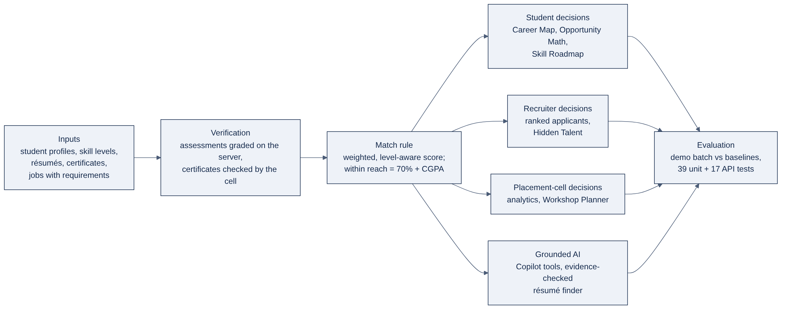
Fig 4.1: Framework of CareerSphere AI from inputs through the match rule to decisions and evaluation

4.2 System Architecture
CareerSphere follows a three-tier client–server architecture (Fig 4.2). The client is a single-page React application, used directly in a browser or wrapped by the Mac, iPhone and Android apps. The server is a Spring Boot application that exposes a REST API under /api. Every request passes through Spring Security, which validates the JSON Web Token and the user’s role before a controller is reached. Controllers call services, which hold the business rules, and services read and write MySQL through Spring Data JPA repositories. Uploaded files are stored on disk under random names.
Two layers deserve special mention. The rule engine (MatchService, RoadmapService, TalentService and WorkshopService) computes every score and plan from the same rule. The AI layer never writes data on its own: the Copilot reads data only through tools that call the same services, and the résumé skill finder only proposes skills that the student must confirm. The Gemini API key is held by the server and never sent to the browser.
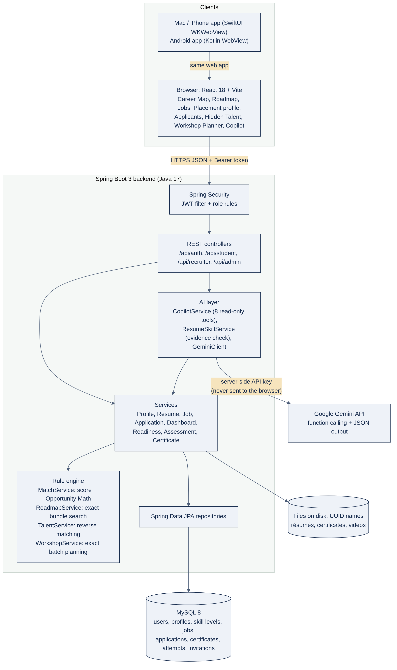
Fig 4.2: Layered architecture of CareerSphere AI

4.3 Functional Module Description
The code is divided into the loosely coupled modules listed in Table 4. Each module has its own endpoints, services and pages, and all modules share the match rule.
Table 4: Modules of the system
Module | Responsibilities | Main classes and pages
Authentication | Register, log in, JWT issue and check, role rules | AuthService, JwtService, SecurityConfig; Login
Student profile | Profile, skills and levels, résumé, consent, video, résumé score | StudentProfileService, ResumeService, ReadinessService; PlacementProfile
Skill verification | Timed assessments, certificate upload and review | AssessmentService, QuestionBank, CertificateService; Assessments, Certifications
Jobs and applications | Post jobs with levels, apply, track status, rank applicants | JobService, ApplicationService; StudentJobs, JobForm, Applicants
Guidance | Match score, Career Map, Opportunity Math, what-if, Skill Roadmap, next best action | MatchService, DashboardService, RoadmapService; CareerMap, Opportunities, Roadmap
Hidden Talent | Consented non-applicants who fit; invitations | TalentService, Invitation; Applicants page
Placement cell | Analytics, workshop planning, certificate review, leaderboard | WorkshopService, AdminController; AdminDashboard, WorkshopPlanner
AI | Copilot with tools; résumé skill finder | CopilotService, CopilotTools, ResumeSkillService, GeminiClient

4.4 Methods and Mathematical Formulation
All methods use integer arithmetic so that the planner, the roadmap and the explanation shown to the user never disagree by rounding.
(a) Explainable match score. Let a student s have level ℓ_{s}(x) ∈ {0, 1, 2, 3} for each skill x (0 means not known; 1 to 3 are Beginner, Intermediate and Advanced) and CGPA g_{s}. Let an open job j require the skill set R_{j}, with a minimum level m_{j}(x) for each skill, a weight w_{j}(x) = 2 for a must-have and 1 for a nice-to-have skill, and an optional CGPA cutoff c_{j}. The credit for one skill and the score are
κ(ℓ, m) = 1 if ℓ ≥ m; ½ if 0 < ℓ < m; 0 if ℓ = 0 (4.1)
score(s, j) = round( 100 · Σ_{x} w_{j}(x) · κ(ℓ_{s}(x), m_{j}(x)) / Σ_{x} w_{j}(x) ) (4.2)
with both sums over the required skills x ∈ R_{j}. In code the sums are kept in half units, and the percentage is computed as (200 · half + total) div (2 · total), which rounds halves up without floating point. When every skill is a must-have at Beginner level, (4.2) reduces to the plain share of required skills. Example: a job needs Java at Intermediate (must-have), Spring Boot (must-have) and Git (nice-to-have); a student has Java at Beginner, Spring Boot and Git. Credit in half units is 2 + 4 + 2 = 8 of 10, so the score is 80%, and the explanation names Java as a level gap.
(b) Within reach. A job is within reach when
reach(s, j) = [ score(s, j) ≥ 70 ] ∧ [ g_{s} ≥ c_{j} ] (4.3)
With default jobs the threshold admits 3 of 4 and 4 of 5 required skills but not 2 of 3 (67%). The CGPA rule is reported separately and never changes the score.
(c) Opportunity Math. An action is learning a skill x to a level t, or raising a known skill to a level t that some open job asks for. With L_{s} the student’s levels and reach(L, j) equal to (4.3) evaluated with levels L, the gain of an action is
gain_{s}(x, t) = | { j : ¬reach(L_{s}, j) ∧ reach(L_{s} ⊕ (x, t), j) } | (4.4)
Actions are ranked by gain, ties broken by the number of open jobs requiring the skill. The what-if simulator applies the same rule to any set of actions; on the Career Map each job is drawn at distance 100 − score from the student, so the 70% ring separates jobs within reach from the rest.
(d) Skill Roadmap. Because skills pay off together, the roadmap searches exactly over bundles B of 1, 2 and 3 actions, at most one per skill, and for each size keeps the bundle with the most jobs within reach and then the least effort
effort(B) = Σ_{(x, t) ∈ B} ( t − ℓ_{s}(x) ) (4.5)
A bundle is shown only if it beats every smaller one, and it is marked works together when its gain exceeds the sum of the single gains (4.4) of its steps. For every nearby job the roadmap also finds the cheapest subset of that job’s own gaps that brings it within reach, or names the CGPA cutoff when no skill can help (Algorithm 1). With about 30 candidate actions a student needs roughly 10³ bundle checks.
Algorithm 1: Skill Roadmap for one student
1: input: levels L, CGPA g, open jobs J
2: A ← every (skill, target level) some job asks for above L
3: for k ← 1 to 3 do
4: best ← bundle of k actions, one per skill, with most jobs within reach, then least effort
5: if reach(best) > reach of every smaller bundle shown then
6: order steps by immediate effect; mark works together if gain > sum of single gains
7: for each job j not within reach do
8: if g < cutoff(j) then report the CGPA blocker
9: else cheapest subset of j’s gaps that brings j within reach
10: return bundles, paths to the closest jobs, number of bundles checked

(e) Hidden Talent. For a recruiter’s job the rule is run from the job’s side over every student who gave placement consent and has not applied to that job. Students for whom the job is within reach are listed, and so are students for whom one action from (c) would bring it within reach, with that action named. The recruiter can send an invitation; a unique (job, student) constraint prevents repeats.
(f) Workshop Planner. Let S be the students, J the open jobs and C the candidate skills. A plan is a set T ⊆ C of k workshops; a workshop raises every attendee to at least Intermediate. With n_{s}(T) the number of jobs within reach of s after the plan, the objectives are
f_{reach}(T) = | { s : n_{s}(T) > 0 } |, f_{match}(T) = Σ_{s} n_{s}(T) (4.6)
The goal Reach every student maximises (f_{reach}, f_{match}) in that order and Most matches overall maximises (f_{match}, f_{reach}). The objective is not submodular: for one student with {Git} and one job requiring {Java, Spring Boot, Git}, f({Java}) = f({Spring Boot}) = 0 while f({Java, Spring Boot}) = 1, so greedy selection can miss the best plan and the 1 − 1/e guarantee [5] does not hold. The planner therefore enumerates all C(|C|, k) subsets with bit masks (one per level and weight class), so each test of (4.3) costs a few OR, AND and population-count operations; it falls back to greedy and says so if C(|C|, k) · |S| · |J| would exceed 3 × 10⁸. Each student is invited only to the smallest subset of the plan that gives them the same result.
(g) Résumé score, readiness and assessments. The résumé score out of 100 is computed from ten fixed rules (Table 5). Readiness points for the leaderboard add 15 per verified skill, 10 per verified certificate and 5 per job within reach. An assessment draws 8 questions (4 basic, 4 advanced) for one of 15 skills from a bank of 120, shuffles the options, stores their order on the server and never sends the answers; 8 correct verify Advanced, 6–7 Intermediate, 4–5 Beginner, and below 4 a retake waits 24 hours.
Table 5: Résumé score rules
Rule | Points | Maximum
Résumé uploaded | 15 | 15
About you: 150+ characters (5 points for 50+) | 10 | 10
Skills listed, up to 5 | 4 each | 20
Skills at Intermediate or above, up to 5 | 2 each | 10
Skills verified by assessment or certificate, up to 3 | 5 each | 15
Verified certificates, up to 2 | 5 each | 10
GitHub link / LinkedIn link | 5 / 5 | 10
Introduction video | 5 | 5
CGPA, 10th and 12th marks filled in | 5 | 5
Total |  | 100

(h) Grounded AI. The Copilot uses Gemini function calling [16] with eight read-only tools (snapshot, matches, opportunities, simulation, job explanation, application status, and two action proposals). The server runs each tool for the student identified by the token, proposed actions run only when the student clicks them, and every answer lists the data it used. The résumé skill finder extracts text with PDFBox or Apache POI and keeps a Gemini suggestion only if its quoted evidence line occurs in the résumé and the skill is in the catalogue; without a key, word-boundary patterns are used (JavaScript is not Java; “react quickly” is not React).

4.5 Database Design
Fig 4.3 shows the entity–relationship diagram. The users table holds every account with a role. Students and recruiters each have a one-to-one profile. Skills are a shared catalogue. A student’s skills are stored with a level and, separately, the verified level. A job’s skills are stored with a minimum level and a must-have or nice-to-have flag. Applications and invitations each link one job and one student, with a unique constraint on the pair. Certificates and assessment attempts belong to a student and a skill. Hibernate creates the 16 tables from the entity classes.
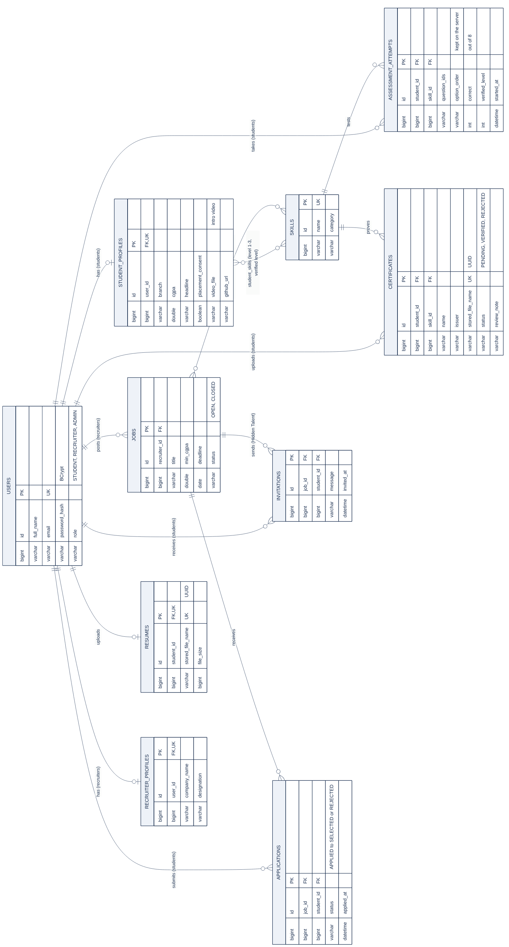
Fig 4.3: Entity–relationship diagram (rotated to fit the page)

4.6 API Design
The REST API is grouped by role. All endpoints except register, login, health and the skill catalogue need a valid token, and each prefix is open to one role only. Errors return a status code with a plain-language message and, for forms, a message per field. Table 6 lists the main endpoints; the Appendix lists all of them.
Table 6: Main REST endpoints
Method and path | Role | Purpose
POST /api/auth/register, /login | Public | Create an account; log in and receive a token
GET /api/student/dashboard | Student | Career Map data, top matches, next best action
GET /api/student/opportunities | Student | Opportunity Math ranking
GET /api/student/what-if?skills= | Student | Re-score all jobs with extra skills or levels
GET /api/student/roadmap | Student | Best 1-, 2-, 3-step bundles and paths to jobs
POST /api/student/applications | Student | Apply to a job
POST /api/student/assessments/start | Student | Start a timed assessment
POST /api/student/copilot | Student | Ask the Copilot
POST /api/recruiter/jobs | Recruiter | Post a job with skill levels
GET /api/recruiter/jobs/{id}/applicants | Recruiter | Ranked, explained applicants
GET /api/recruiter/jobs/{id}/talent | Recruiter | Hidden Talent for a job
POST /api/recruiter/jobs/{id}/invite/{sid} | Recruiter | Invite a student to apply
GET /api/admin/workshops?rounds=&goal= | Admin | Workshop plan
PATCH /api/admin/certificates/{id} | Admin | Verify or reject a certificate

4.7 Data Flow Diagrams (Levels 0, 1 and 2)
The movement of data is modelled at three levels of detail in Fig 4.4.
- Level 0 (context). CareerSphere is a single process exchanging data with three external entities: students send profiles, résumés, answers and applications and receive scores, plans and the roadmap; recruiters send jobs, status updates and invitations and receive ranked applicants and hidden talent; the placement cell sends reviews and workshop requests and receives analytics and plans.
- Level 1 (main processes). P1 authentication, P2 profile and verification, P3 matching and planning, P4 jobs and applications, and P5 the Copilot and résumé finder, with two data stores: D1 the MySQL database and D2 the uploads folder.
- Level 2 (P3 matching and planning). P3 is expanded into loading levels and jobs, scoring every job in half units, generating learning actions, searching bundles of one to three actions, and returning the best bundle of each size with paths and CGPA blockers.
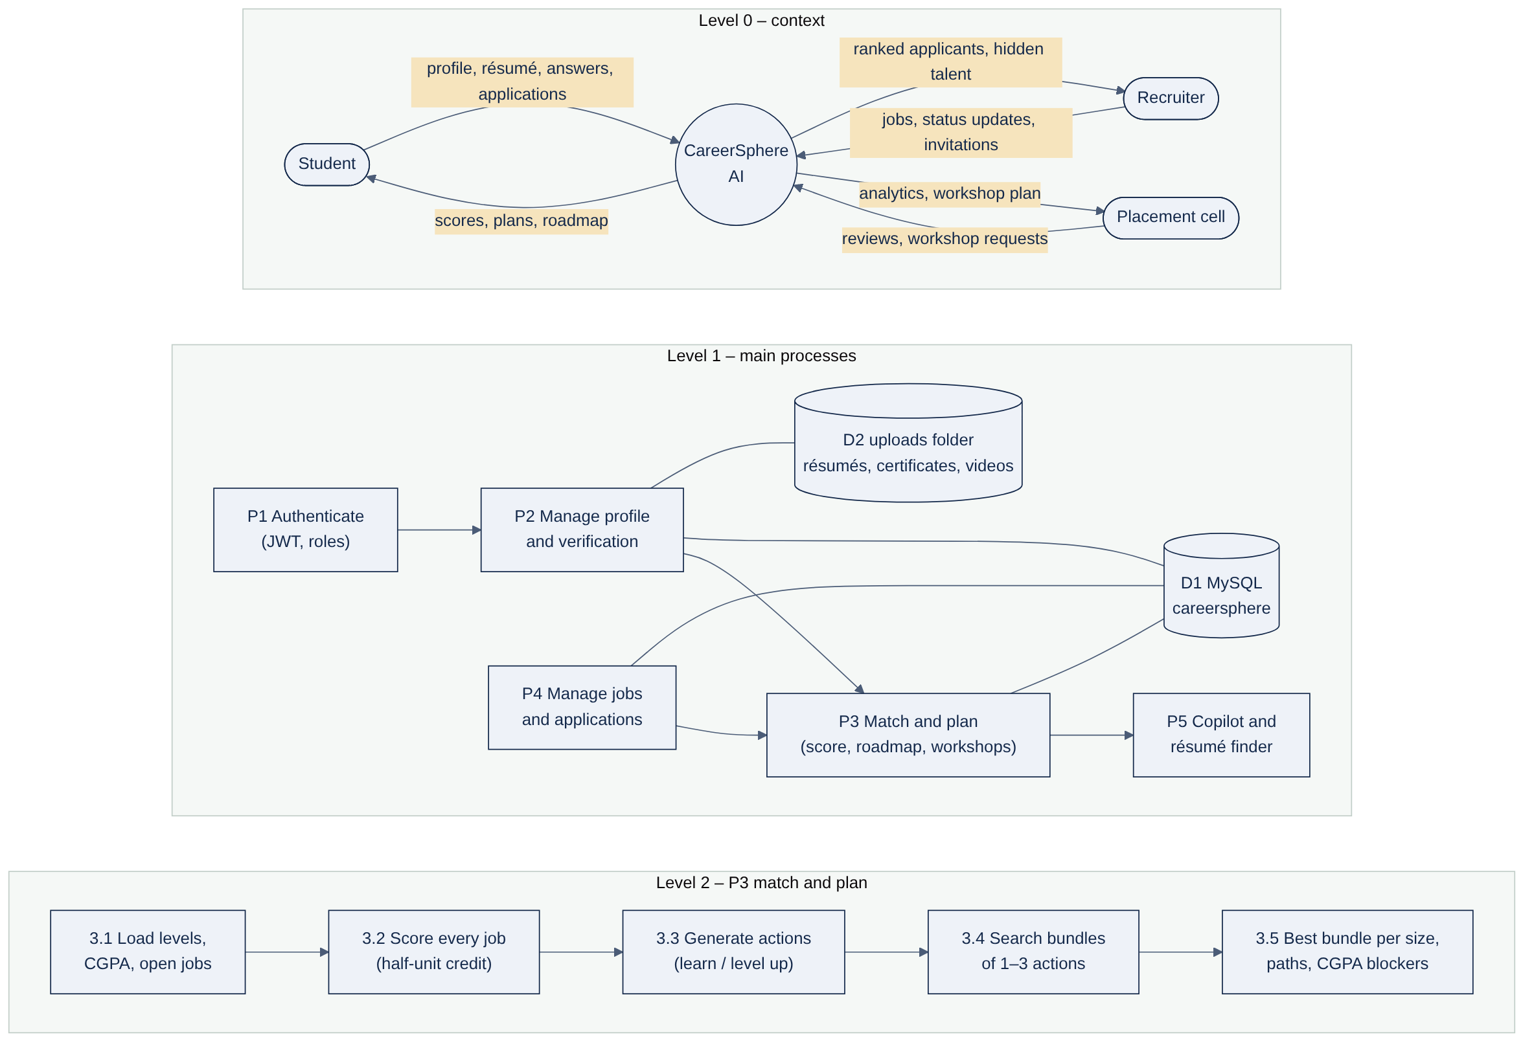
Fig 4.4: Data flow diagrams at Level 0 (context), Level 1 (processes) and Level 2 (matching and planning)

4.8 UML Design Models
Five kinds of UML diagram document the structure and behaviour of the implementation.
Use case view. The actors are the student, the recruiter and the placement cell, with the Gemini service as an external actor used by the Copilot and the résumé finder (Fig 4.5). Use cases in green are the new decision-support features.
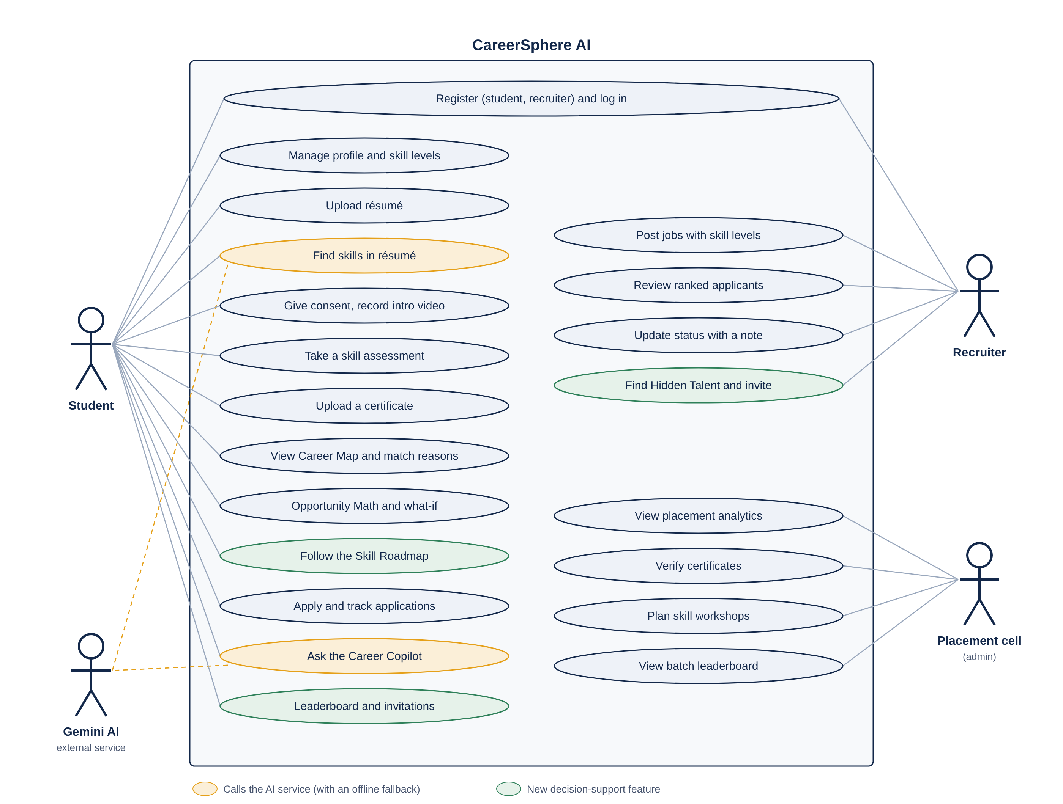
Fig 4.5: Use case diagram of CareerSphere AI
Class view. The main entities (User, StudentProfile, Job, Skill, Application, Certificate, AssessmentAttempt, Invitation) and the services of the rule engine, which all depend on MatchService, are shown in Fig 4.6.
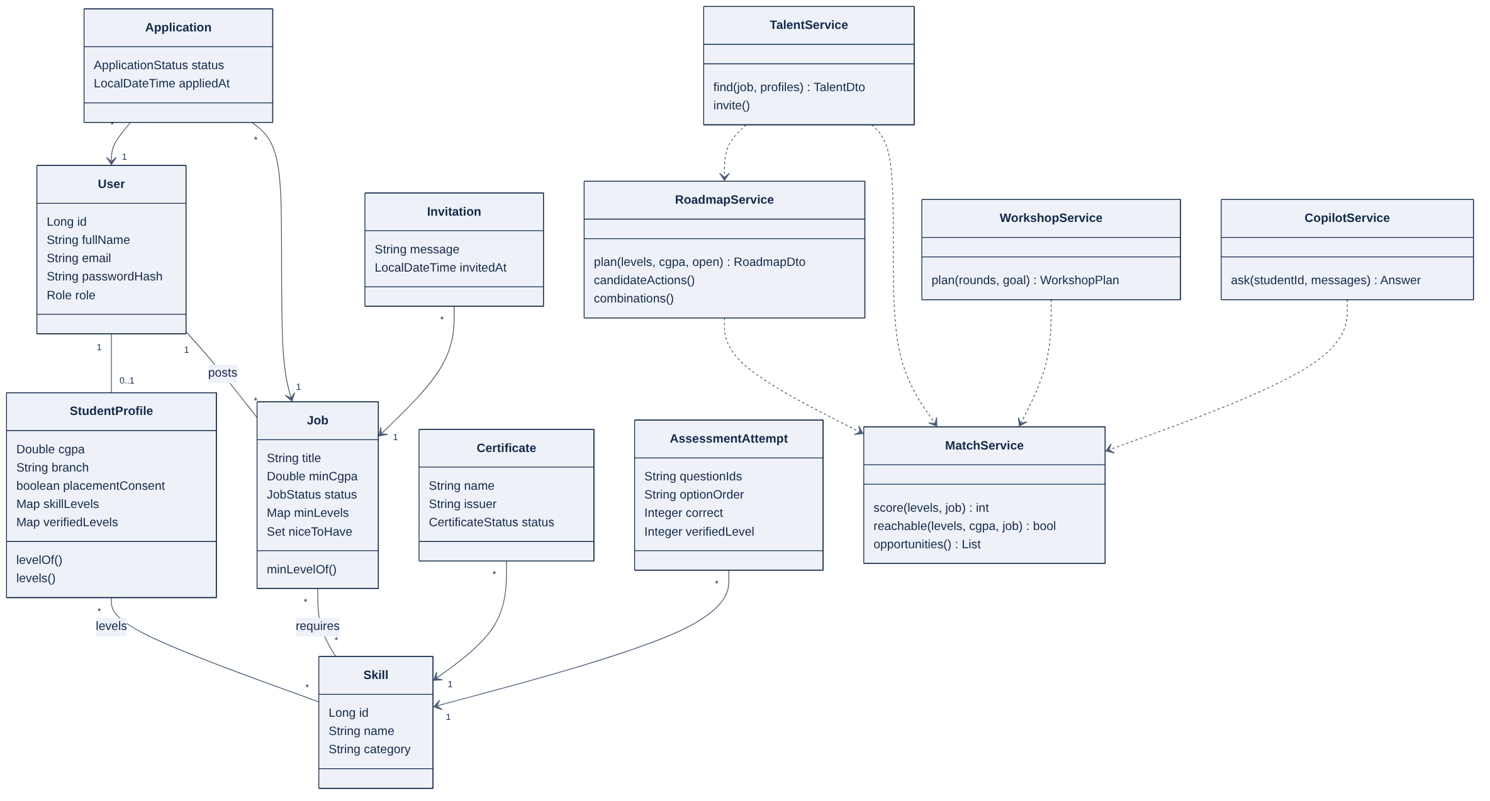
Fig 4.6: Class diagram of the principal entities and services
Sequence view. Figs 4.7 to 4.11 trace login, applying to a job, asking the Copilot, finding skills in a résumé, and building a Skill Roadmap through the layers.
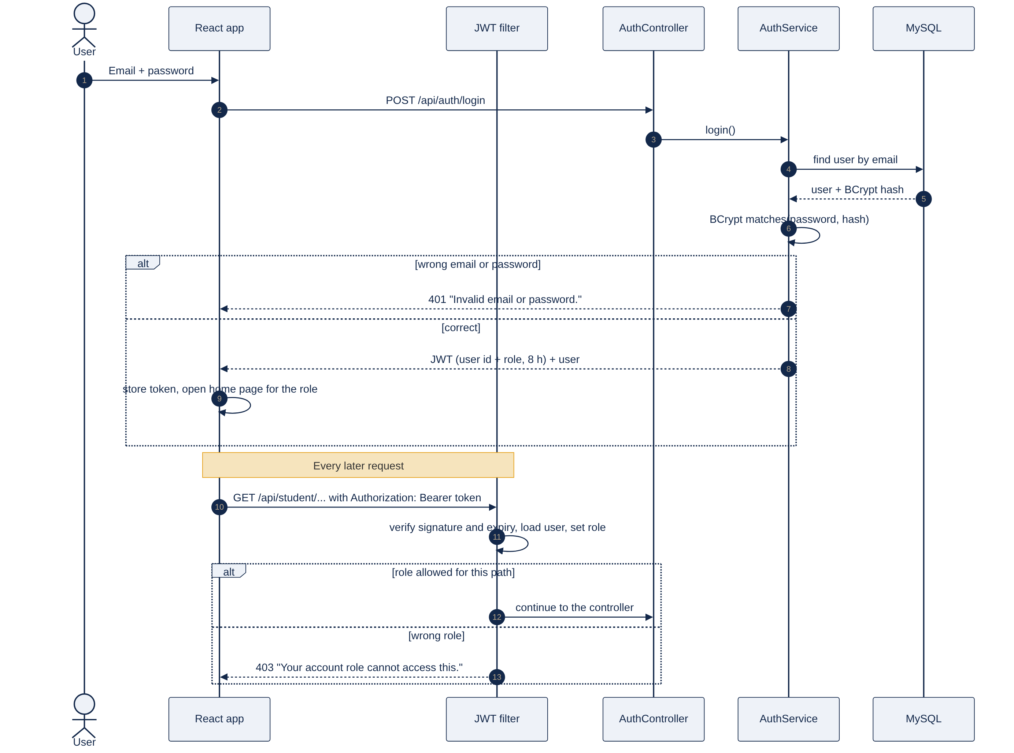
Fig 4.7: Sequence diagram of login and an authenticated request
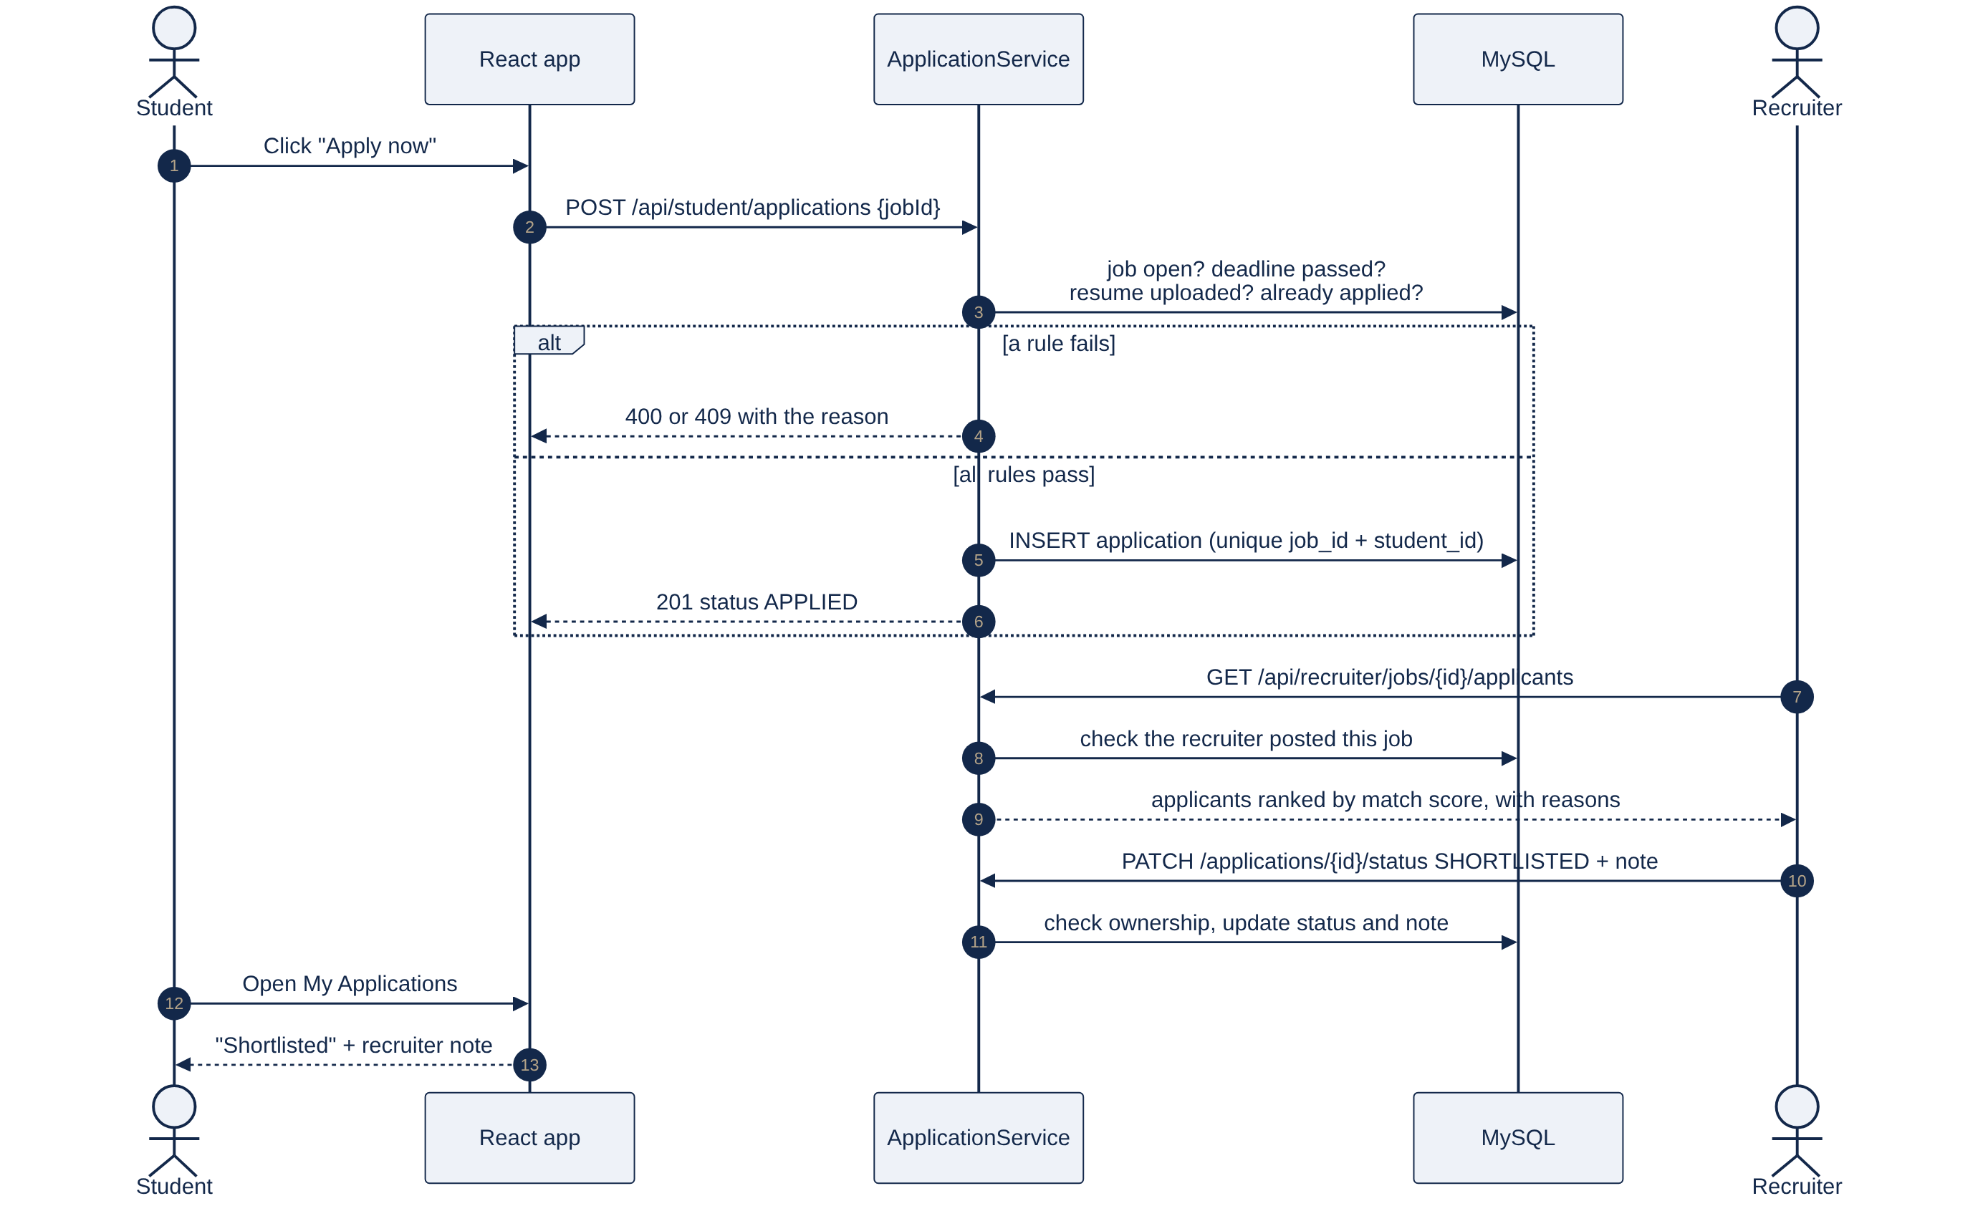
Fig 4.8: Sequence diagram of applying to a job
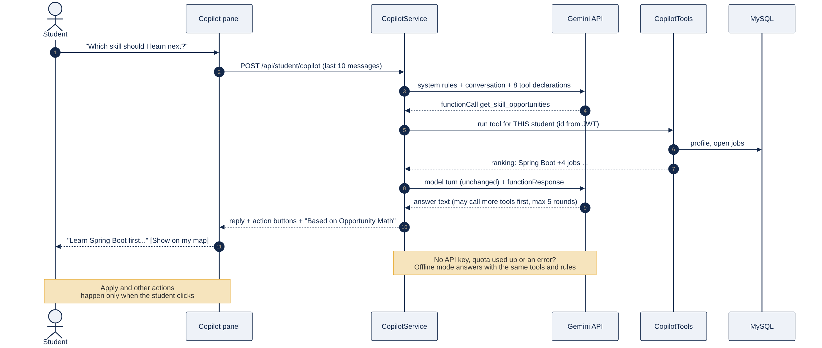
Fig 4.9: Sequence diagram of the Copilot with function calling
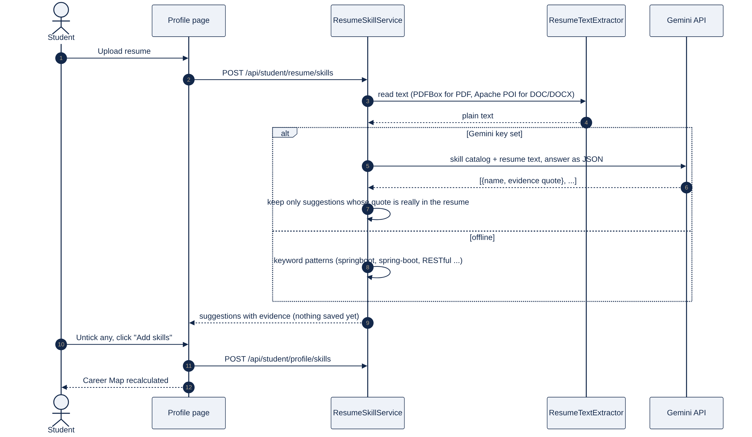
Fig 4.10: Sequence diagram of the evidence-checked résumé skill finder
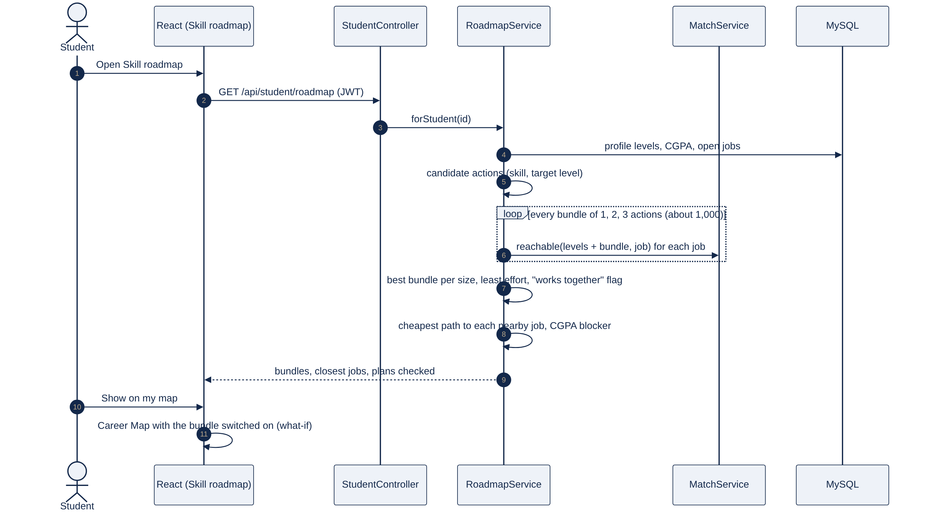
Fig 4.11: Sequence diagram of building a Skill Roadmap
Activity view. Fig 4.12 shows the student’s path from login through résumé, consent and verification to applying, with the loop back through the Skill Roadmap or a workshop when no job is within reach yet.
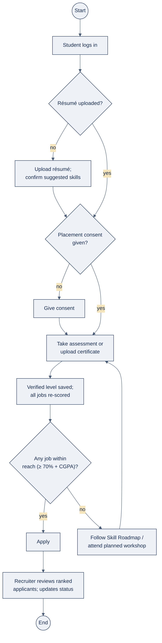
Fig 4.12: Activity diagram of the student placement flow
Deployment view. Fig 4.13 shows the development set-up on a Mac (browser or Mac app, Spring Boot on port 8080, MySQL on port 3306, the uploads folder), the Android emulator reaching the same web app, the Gemini API called from the server only, and the online deployment as one Docker image with a managed MySQL database.
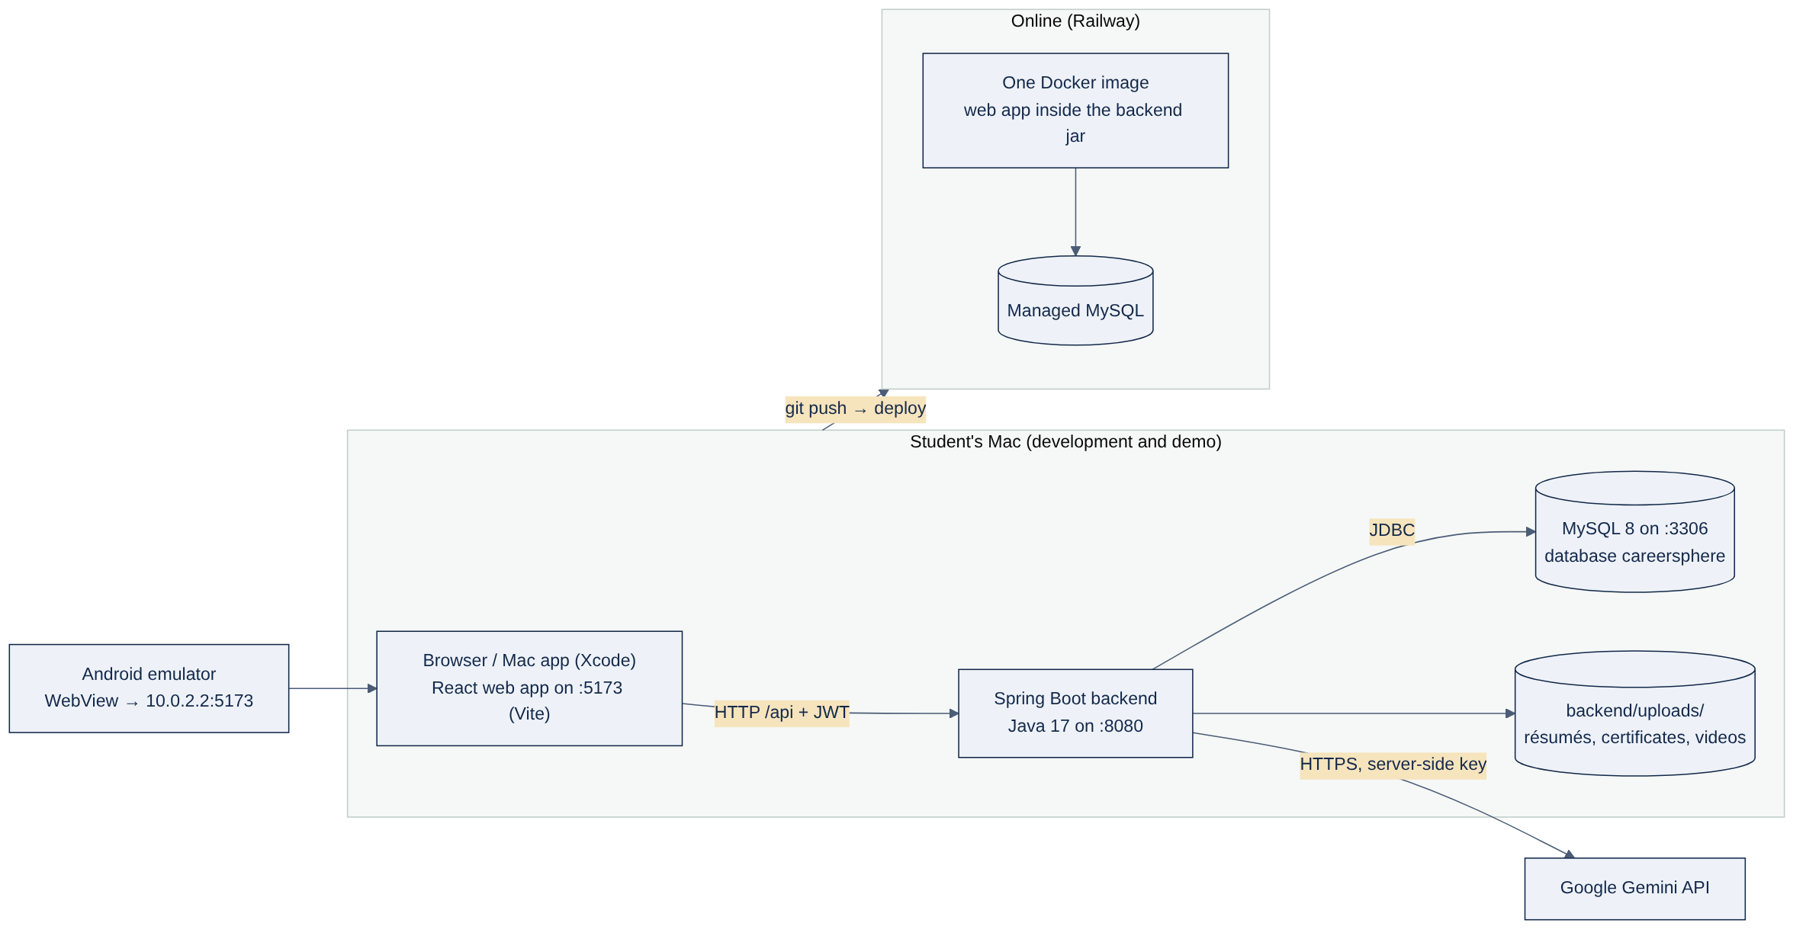
Fig 4.13: Deployment diagram of the local and online environments
Workshop planning flow. Fig 4.14 summarises the exact Workshop Planner from method (f).
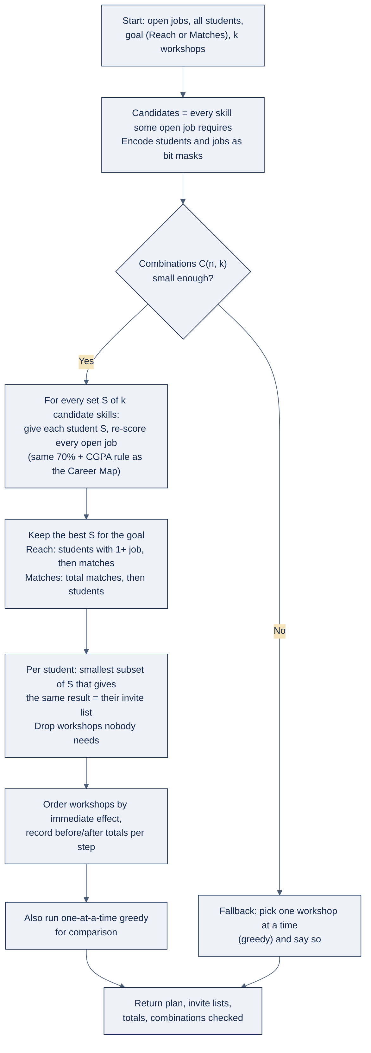
Fig 4.14: Flow of the exact Workshop Planner

CHAPTER - 5
TESTING

5.1 Need for Testing and Verification Strategy
Every number CareerSphere shows is used to make a decision: which skill to learn, whom to shortlist, which workshop to run. A wrong rule would therefore mislead students and the placement cell without any visible error. The verification strategy has three levels. Unit tests check the rules in isolation on small, hand-checkable cases, so every expected value can be worked out on paper. API tests start the whole application on an in-memory H2 database and call the real endpoints through the real security filter chain with MockMvc. User-interface checks walk through every screen in a real browser at desktop and phone widths and fail on any script error.

5.2 Unit Testing of the Rules
There are 39 unit tests in six classes (Table 7), all passing. As a check that the tests can detect a faulty rule, the threshold comparison was changed from ≥ to >; the inclusive-threshold test failed at once, and passed again when the change was reverted.
Table 7: Unit tests
Class | Tests | What they check
MatchServiceTest | 9 | Share of skills; rounding (2 of 3 = 67%); 100% case; CGPA cutoff reported separately; missing CGPA; inclusive 70% threshold; Opportunity Math ranking, CGPA exclusion, known skills never suggested
SkillLevelTest | 6 | Defaults equal the plain rule; half credit below the level; nice-to-have weight; level-up suggestions; workshop to Intermediate; what-if “Skill:2” syntax
WorkshopServiceTest | 6 | Baseline counts; first-reach ordering; three workshops reach all students; unneeded workshops dropped; no invitation for a known skill; a complementary case where greedy fails
RoadmapTalentTest | 4 | Two-step bundle when no single skill helps, marked “works together”; least effort wins ties; cheapest path and CGPA blocker; Hidden Talent excludes non-consented students and applicants
PlacementProfileTest | 8 | Résumé score adds up and never passes 100; steps in order; leaderboard privacy; grading levels; lock before consent; answers never sent; retake wait; resuming a running test
ResumeSkillServiceTest | 6 | Skills in project lines with evidence; common spellings; JavaScript is not Java; ordinary words not mistaken for skills; known skills marked; long evidence trimmed

5.3 Integration and API Testing
Table 8 lists the 17 end-to-end test cases. Each runs against a fresh in-memory database with the demo data, through the same security configuration as production, and is run with mvn test from the backend folder.
Table 8: End-to-end API test cases
ID | Test case | Expected result
TC-01 | Register; register again with the same email | Token returned; second attempt rejected (409)
TC-02 | Register with role ADMIN | Rejected (403)
TC-03 | Log in with a wrong password | 401 with a clear message
TC-04 | Call a protected API without or with a bad token | 401
TC-05 | Each role calls the other roles’ APIs | 403 for every other role’s API
TC-06 | Save profile with CGPA 11.5; save a valid profile | 400 with a field error; valid profile saved and reloaded
TC-07 | Upload a real PDF; upload other files (e.g. an .exe) | PDF accepted; other files rejected (400)
TC-08 | Run the résumé skill finder; confirm some skills | Suggestions with evidence; only confirmed skills added
TC-09 | Apply without résumé, without consent, then twice | Blocked (400), blocked (400), accepted once, then 409
TC-10 | Another recruiter updates an application | 403; the owner’s update is visible to the student
TC-11 | What-if with extra skills | Jobs within reach never decrease
TC-12 | Ask the Copilot without an AI key | Offline answer built from the student’s data
TC-13 | Admin requests a workshop plan; a student requests it | Plan returned; student gets 403
TC-14 | Post a job with levels and nice-to-have skills | Saved and used in the score
TC-15 | Consent without résumé; assessment before and after consent | Consent blocked; test locked, then graded on the server
TC-16 | Upload a certificate; admin verifies it | Skill added to the profile as verified
TC-17 | Student roadmap; recruiter talent and invite | Roadmap returned; candidate listed; invitation shown to the student; repeat invite 409

5.4 User Interface Testing and Validation
A scripted browser (Playwright with Chromium) logs in as each role and opens every screen in turn, including taking and submitting an assessment, sending a Hidden Talent invitation and checking that it appears on the student’s Jobs page, and planning workshops. The run fails on any JavaScript error. The same walk is repeated at a phone width of 390 pixels, where it also confirms that no page scrolls sideways. Every form is validated on the server as well as in the browser: invalid input returns status 400 with a message per field, business-rule violations return a plain sentence, and unexpected errors return a generic message so that no stack trace reaches the browser.

CHAPTER - 6
CODE AND IMPLEMENTATION

6.1 Technology Stack and Project Structure
Table 9: Technology stack
Layer | Technology | Use in the project
Frontend | React 18, React Router 6, Vite 5, Axios, SVG | All screens, routing by role, Career Map drawing, API calls with the token
Backend | Java 17, Spring Boot 3.3, Spring Web | REST API: controller → service → repository
Security | Spring Security, jjwt, BCrypt | Stateless login token; role rules; hashed passwords
Data | Spring Data JPA, Hibernate, MySQL 8; H2 | Persistent data; in-memory database for tests
AI | Google Gemini API, Apache PDFBox, Apache POI | Copilot and résumé skill finder; résumé text extraction
Clients | SwiftUI (Xcode), Kotlin (Android Studio), VS Code | Mac, iPhone and Android apps; tasks and debugging
Testing | JUnit 5, MockMvc, Playwright | Unit, API and browser tests
Deployment | Docker, Docker Compose, Railway | One image with the web app inside the backend jar

Fig 6.1 is a mind map of the whole project: what each user can do, the algorithms, and every technology, with where each lives in the code. The backend has 68 Java source files (about 6,400 lines) and 8 test files (about 1,270 lines); the frontend has 43 JavaScript and JSX files (about 3,900 lines); the Android app is about 270 lines of Kotlin and the Mac and iPhone app about 300 lines of Swift.
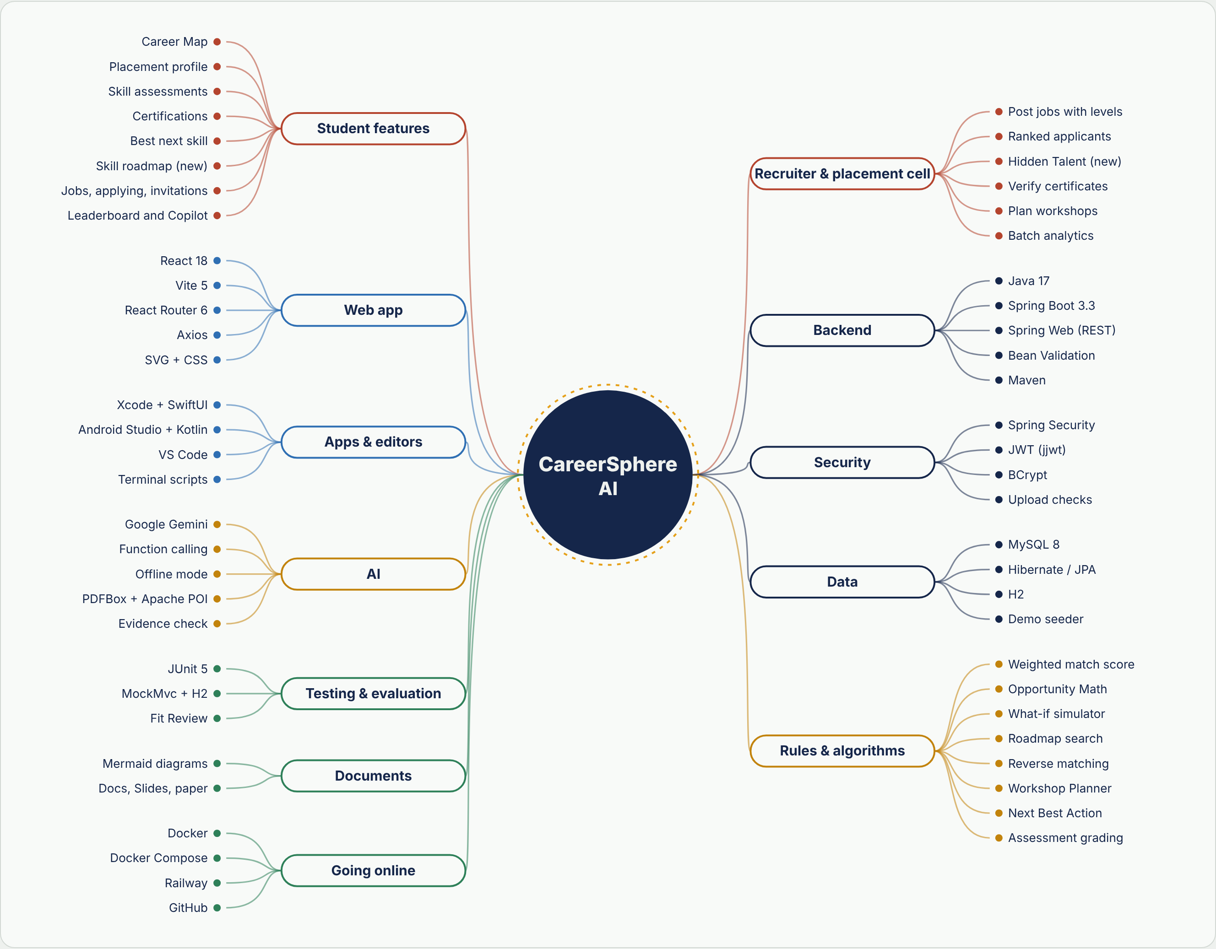
Fig 6.1: Mind map of the project: features, algorithms and technologies
Listing 6.1 – Folder structure of the project
careersphere/
├── backend/ Spring Boot API (Java 17, Maven)
│ └── src/main/java/com/careersphere/
│ ├── ai/ Copilot, Gemini client, résumé skill finder
│ ├── config/ security, uploads, demo data seeder
│ ├── controller/ REST endpoints per role
│ ├── entity/ JPA entities ├── repository/ data access
│ └── service/ match rule, roadmap, talent, workshops, ...
├── frontend/ React + Vite web app (pages/, components/, services/)
├── android/ Android Studio project (Kotlin WebView)
├── CareerSphere.xcodeproj, app/ Xcode project (SwiftUI)
├── .vscode/ tasks and debug configurations
├── docs/ diagrams, report, evaluation kit
└── run.sh, stop.sh, Dockerfile, docker-compose.yml, deploy/

6.2 Core Source Code
The listings below are the central parts of the rule engine, taken from the project source. Listing 6.2 is the match score, Listing 6.3 the bundle search of the Skill Roadmap, Listing 6.4 the Hidden Talent search, Listing 6.5 the exact workshop search and Listing 6.6 the assessment grading rule.
Listing 6.2 – Match score (service/MatchService.java)
public static int weight(Job job, Skill skill) {
return job.isNiceToHave(skill) ? 1 : 2;
}
/** Credit in half units: 2w if level >= needed, w if 0 < level < needed, 0 if missing. */
public static int halfCredit(int level, int needed, int weight) {
if (level <= 0) return 0;
return level >= needed ? 2 * weight : weight;
}
/** round(100 x half / total), half up, in integers. */
public static int percent(long half, long total) {
if (total <= 0) return 100;
return (int) ((200L * half + total) / (2L * total));
}
public int score(Map<Long, Integer> levels, Job job) {
long half = 0, total = 0;
for (Skill s : job.getSkills()) {
int w = weight(job, s);
total += 2L * w;
half += halfCredit(levels.getOrDefault(s.getId(), 0), job.minLevelOf(s), w);
}
return percent(half, total);
}
public boolean reachable(Map<Long, Integer> levels, Double cgpa, Job job) {
return cgpaEligible(cgpa, job) && score(levels, job) >= MATCH_THRESHOLD; // 70
}

Listing 6.3 – Bundle search of the Skill Roadmap (service/RoadmapService.java)
for (int k = 1; k <= Math.min(MAX_STEPS, distinctSkills(actions)); k++) {
List<Action> best = null;
int bestReach = -1, bestEffort = Integer.MAX_VALUE;
for (List<Action> combo : combinations(actions, k)) { // at most one action per skill
checked++;
int r = reach(apply(levels, combo), cgpa, open);
int effort = combo.stream().mapToInt(Action::effort).sum();
if (r > bestReach || (r == bestReach && effort < bestEffort)) {
best = combo; bestReach = r; bestEffort = effort;
}
}
// a size can gain nothing while the next size gains a lot: keep looking
if (best == null || bestReach <= lastReach) continue;
bundles.add(describe(levels, cgpa, open, before, now, best, single));
lastReach = bestReach;
}

Listing 6.4 – Hidden Talent search (service/TalentService.java, simplified)
for (StudentProfile p : all) {
if (!p.isPlacementConsent()) continue; // consent first
Long sid = p.getUser().getId();
if (applications.existsByJobIdAndStudentId(job.getId(), sid)) continue;
Map<Long, Integer> levels = p.levels();
int score = match.score(levels, job);
if (!match.cgpaEligible(p.getCgpa(), job)) continue;
if (score >= MatchService.MATCH_THRESHOLD) { reach.add(candidate(p, score, null)); continue; }
for (RoadmapService.Action a : RoadmapService.candidateActions(levels, List.of(job))) {
if (match.reachable(RoadmapService.apply(levels, List.of(a)), p.getCgpa(), job)) {
near.add(candidate(p, score, a.label())); // one step away
break;
}
}
}

Listing 6.5 – Exact workshop search with bit masks (service/WorkshopService.java)
private void search(Batch b, Goal goal, int depth, int from, int size, int[] current,
long[][] masks, int[] best, int[] bestScore) {
if (depth == size) {
int reach = 0, matches = 0;
for (int s = 0; s < b.students(); s++) {
int r = b.reach(s, masks[depth]); // bit-mask test per job
if (r > 0) reach++;
matches += r;
}
int primary = goal == Goal.REACH ? reach : matches;
int secondary = goal == Goal.REACH ? matches : reach;
if (primary > bestScore[0] || (primary == bestScore[0] && secondary > bestScore[1])) {
bestScore[0] = primary; bestScore[1] = secondary;
System.arraycopy(current, 0, best, 0, size);
}
return;
}
for (int i = from; i <= b.skills() - (size - depth); i++) {
current[depth] = i;
System.arraycopy(masks[depth], 0, masks[depth + 1], 0, b.words);
masks[depth + 1][i >>> 6] |= 1L << (i & 63);
search(b, goal, depth + 1, i + 1, size, current, masks, best, bestScore);
}
}

Listing 6.6 – Assessment grading (service/AssessmentService.java)
public static int levelFor(int correct) {
if (correct >= 8) return 3; // Advanced
if (correct >= 6) return 2; // Intermediate
if (correct >= 4) return 1; // Beginner
return 0; // nothing verified; retake after 24 hours
}

6.3 System Execution Logs and Output Verification
The following outputs were produced by running the project code on the demo batch. Listing 6.7 is the unit-test run for the match rule, the Skill Roadmap and Hidden Talent. Listing 6.8 is the output of a verification program that loads the demo data through the real DataSeeder and calls the real services; its numbers are the ones reported in Chapter 7.
Listing 6.7 – Unit-test run (excerpt)
MatchServiceTest
PASS Score is the share of required skills the student has (3 of 5 = 60%)
PASS Scores are rounded to the nearest whole percent (2 of 3 = 67%)
PASS Having every required skill gives 100% and says so
PASS CGPA below the cutoff is reported separately and blocks 'within reach'
PASS The 70% threshold is inclusive (7 of 10 is within reach, 6 of 10 is not)
PASS Opportunity Math ranks the skill that brings the most jobs within reach first
...
RoadmapTalentTest
PASS Roadmap finds a 2-step bundle when no single skill helps, and marks it as working together
PASS Roadmap prefers the bundle with less effort when two unlock the same jobs
PASS Path to a job: the cheapest steps for each nearby job, and CGPA named as the blocker
PASS Hidden Talent shows only consented students who haven't applied, within reach or one step away
...
39 passed, 0 failed

Listing 6.8 – Verification run on the demo batch
k=3 REACH EXACT now 26/44 after 35/138 skills [Spring Boot, Java, Git] greedy 32/76
k=3 MATCHES EXACT now 26/44 after 35/138 skills [Spring Boot, Git, Java] greedy 29/100
Opportunity Math top pick: mean 1.43 jobs over 35 students, 7 unlock nothing
RM Aarav Sharma now 3 +4 +5 +6 checked 575 [1:[Learn Spring Boot], 2:[Learn Spring Boot,
Learn Excel], 3:[Learn Spring Boot, Learn Excel, Learn React]]
RM Rohan Gupta now 2 +0 +3 +6 checked 833 [2*:[Learn Java, Learn SQL],
3*:[Learn Java, Learn SQL, Learn Spring Boot]] (* = works together)
Roadmap: 35 students, mean new jobs 1-step 1.43, 2-step 2.89, 3-step 4.71;
7 have no 1-step gain, 7 of them gain with 2 steps; 59 synergy bundles;
mean bundles checked 1083
TALENT total within 10 near 9 applications 14

6.4 Screens of the Application
Figs 6.2 to 6.22 show the main screens, taken from the running application with the demo data.

Fig 6.2: Login page with demo accounts for the three roles
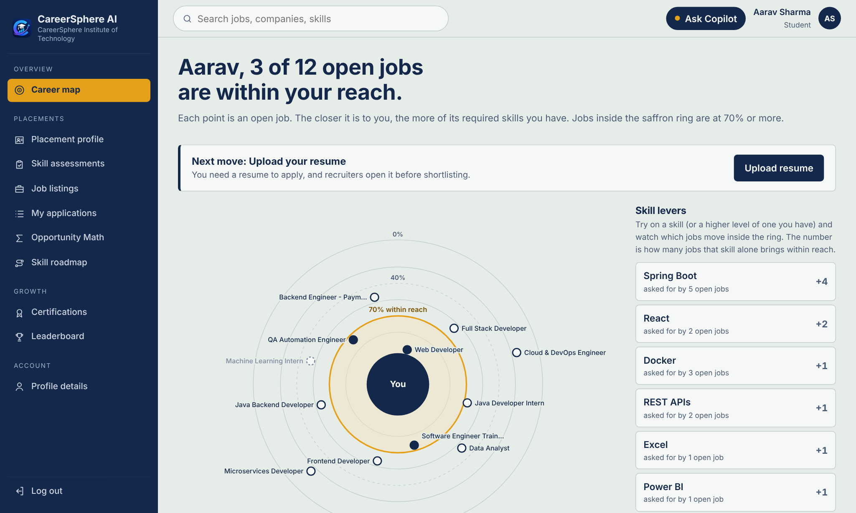
Fig 6.3: Career Map: each open job placed by match score; skill levers on the right
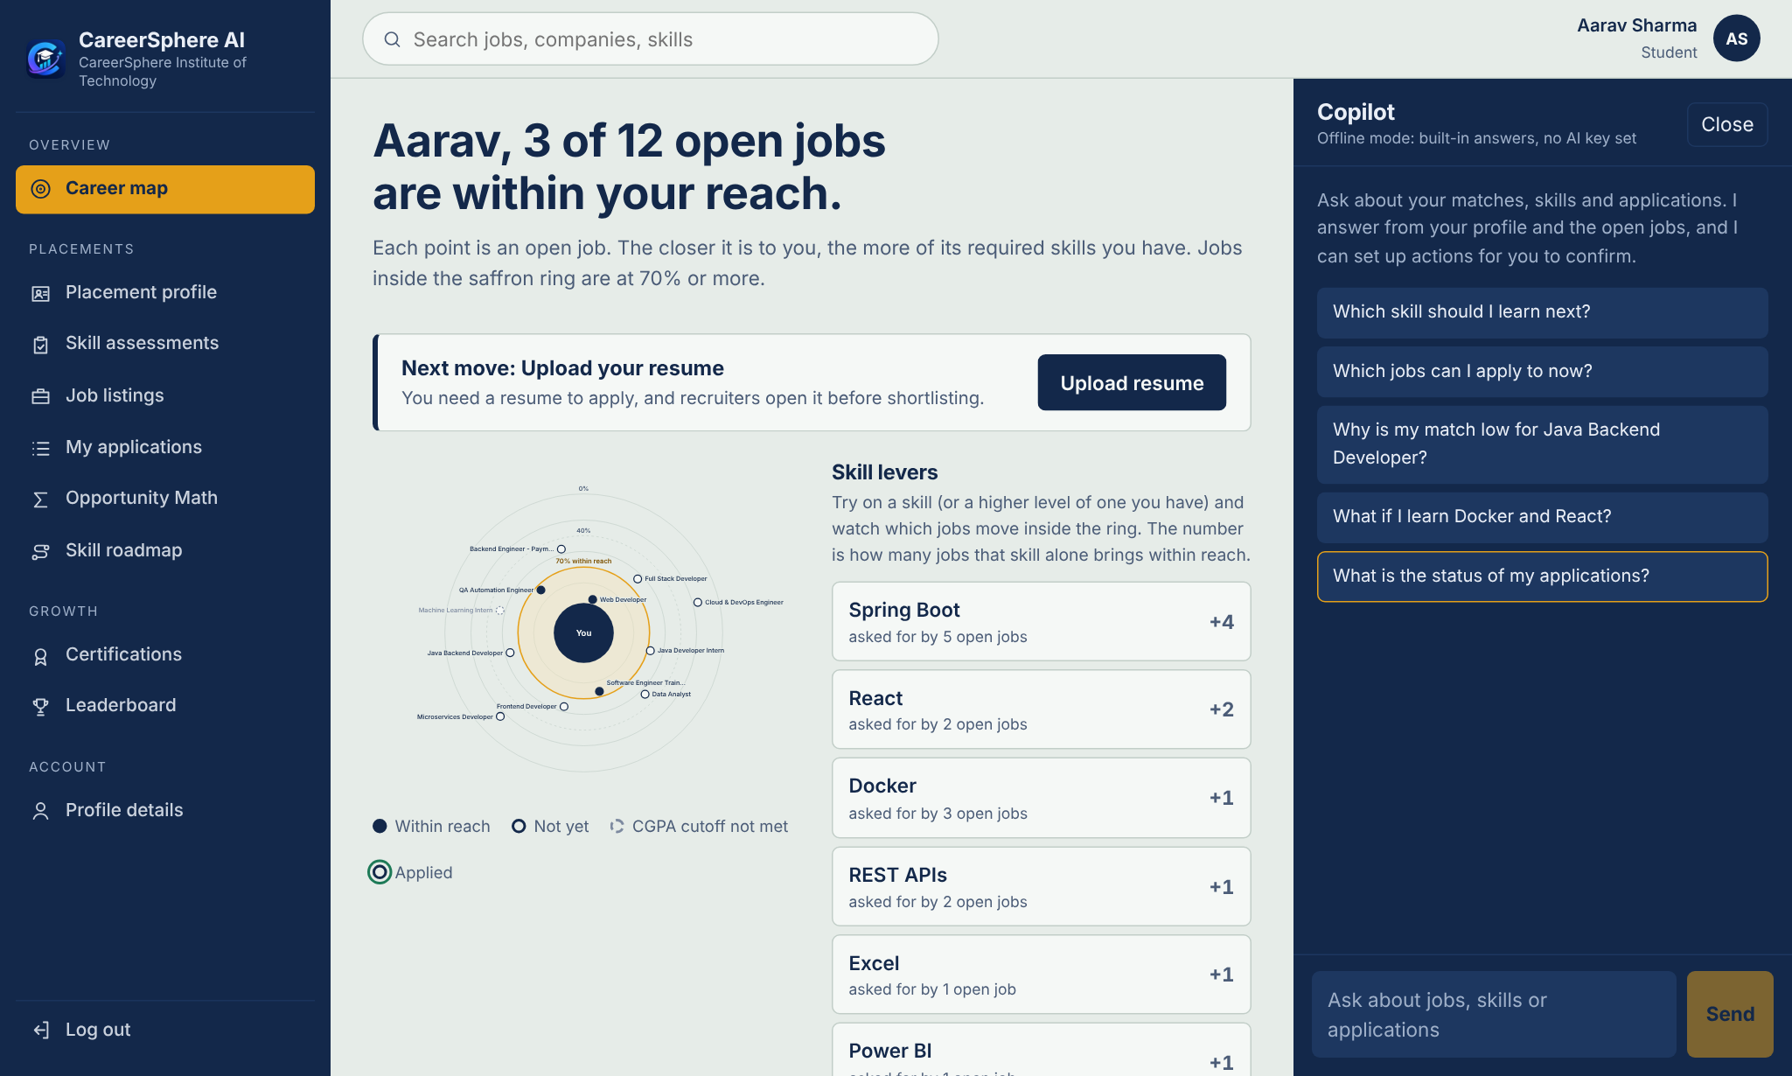
Fig 6.4: Career Map with the Copilot panel open
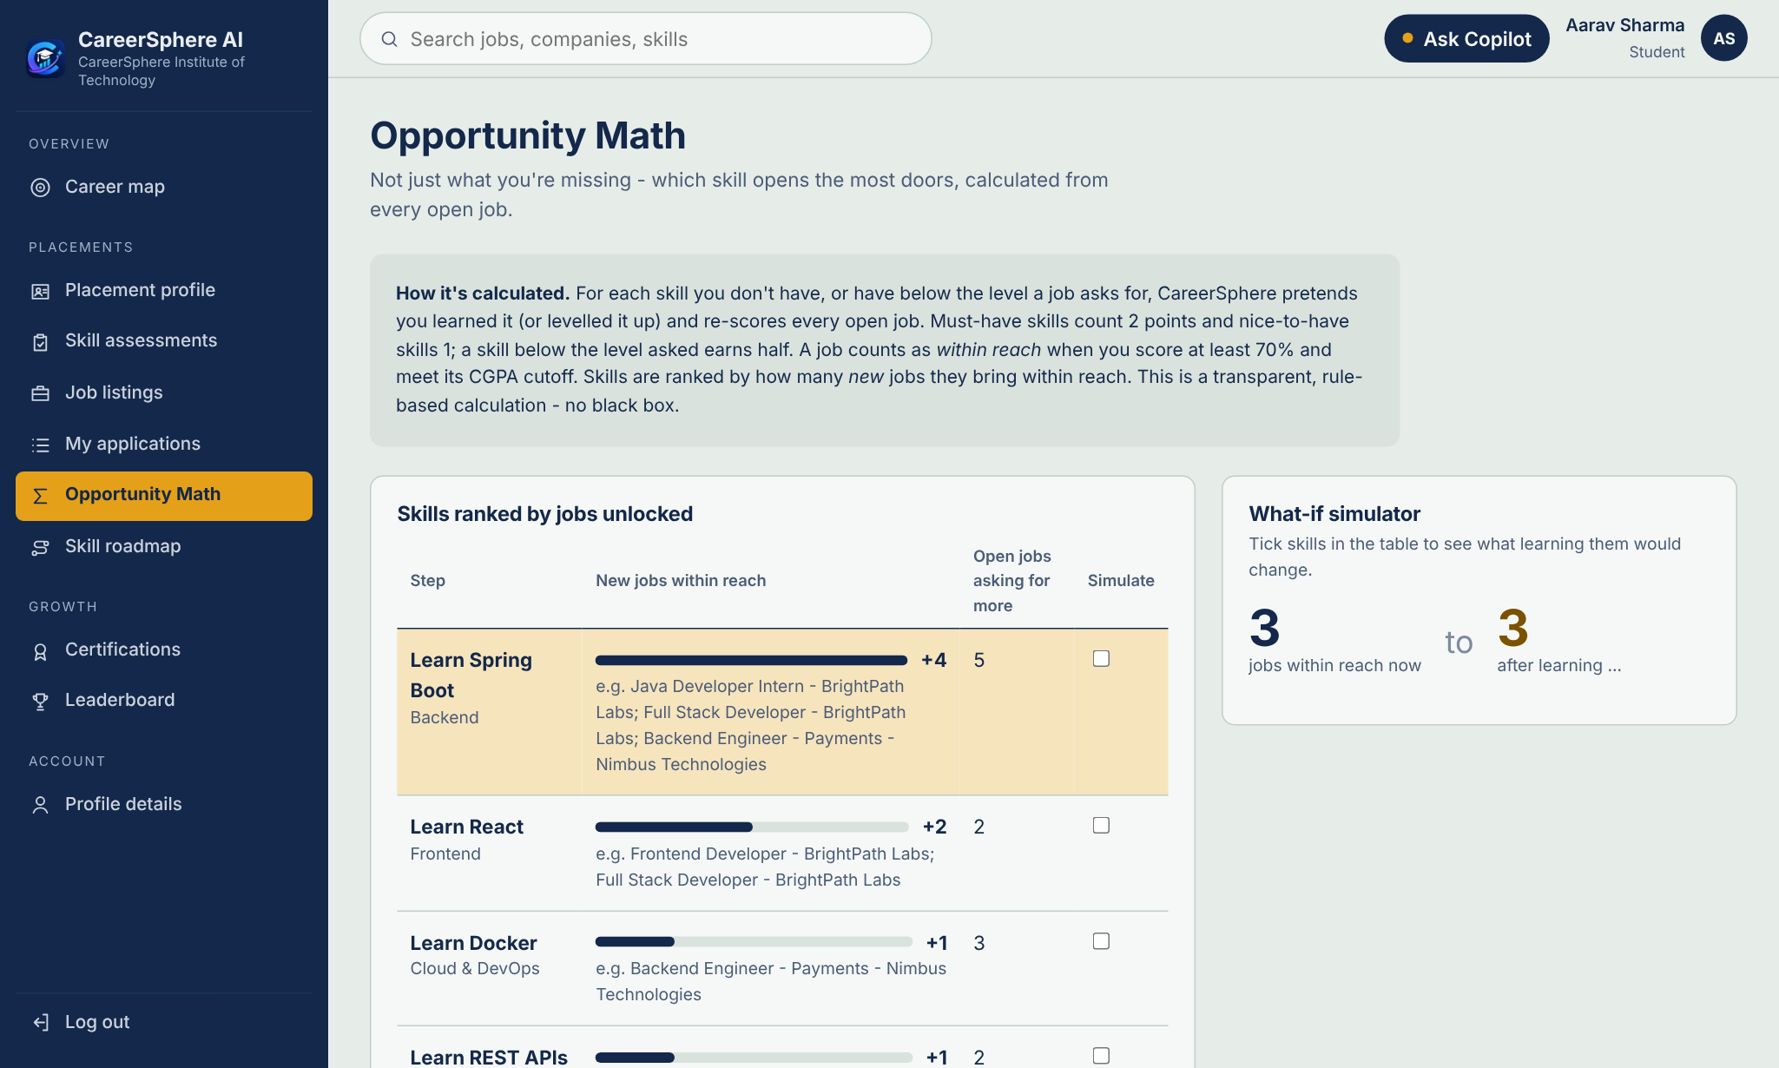
Fig 6.5: Opportunity Math: the skills that bring the most jobs within reach
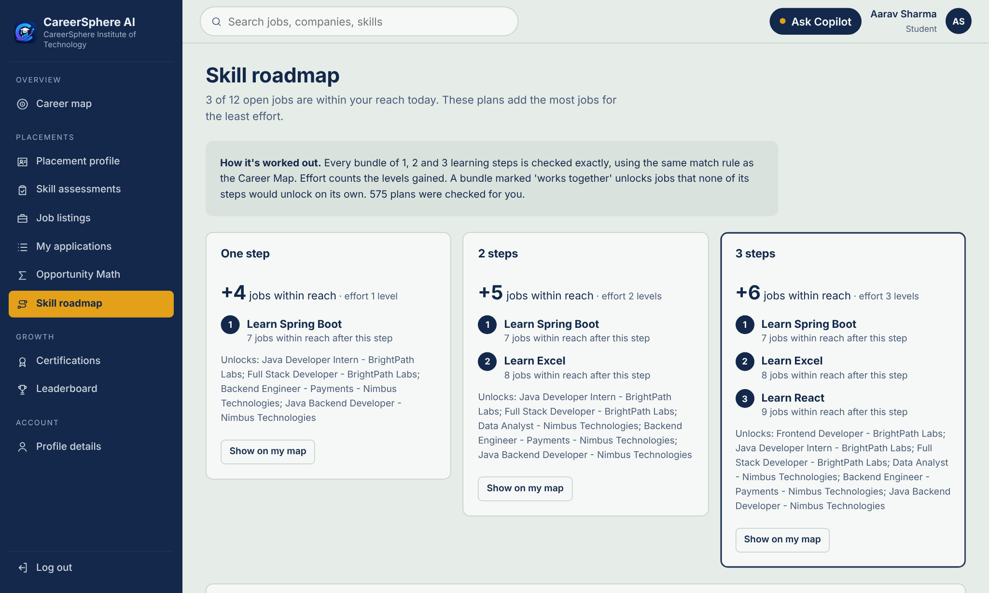
Fig 6.6: Skill Roadmap: best one-, two- and three-step plans
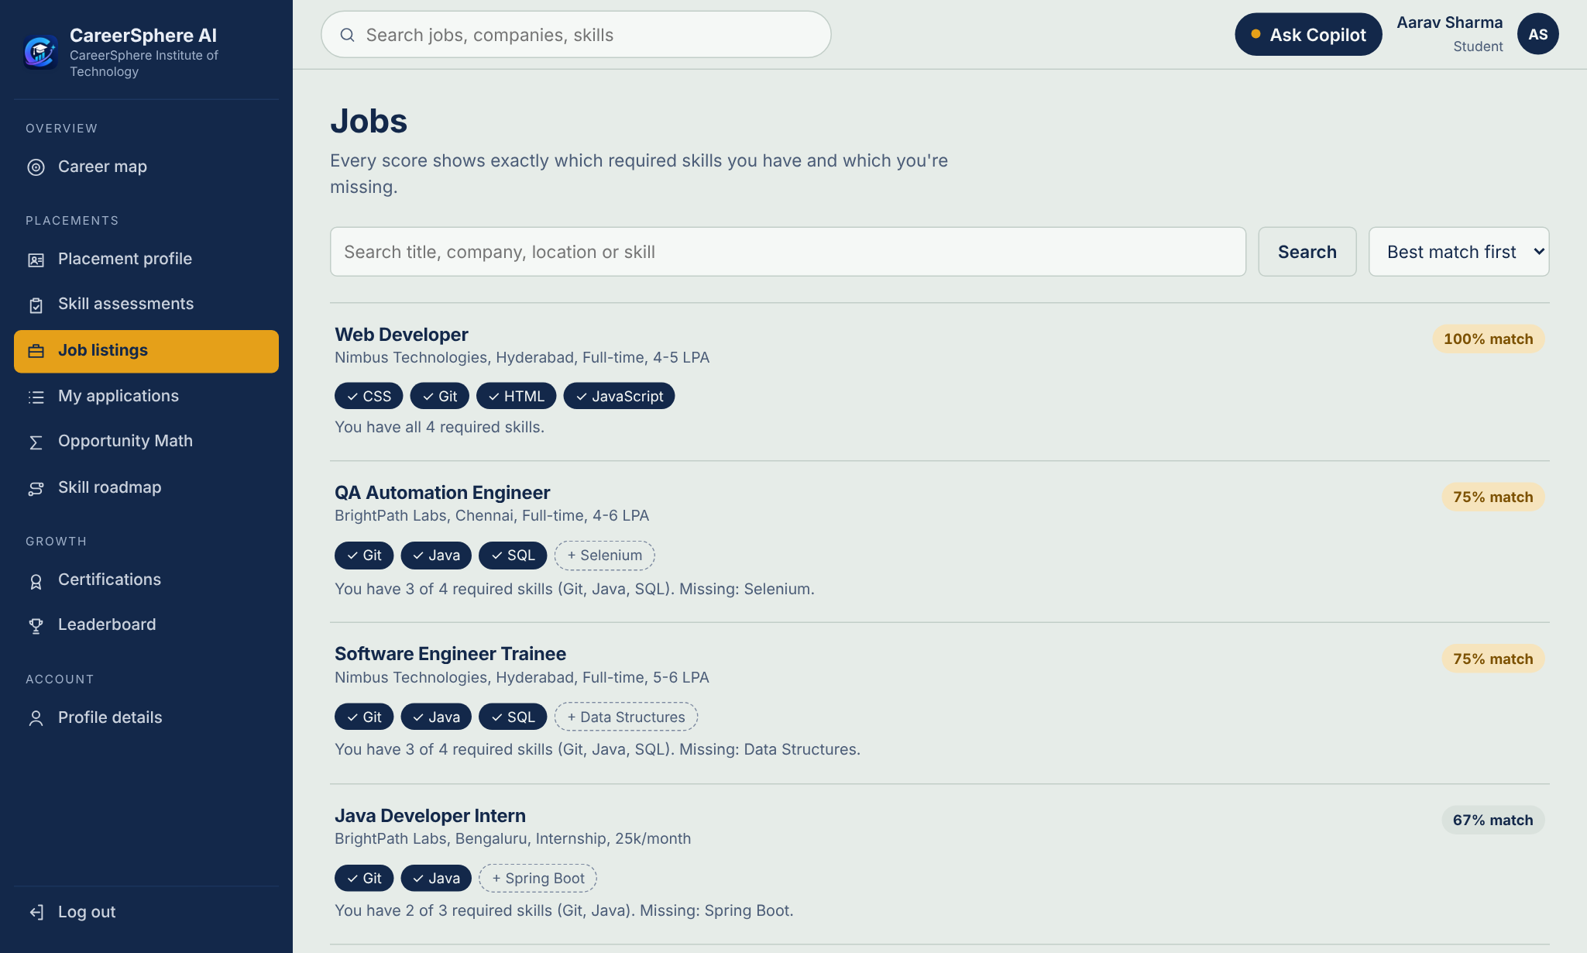
Fig 6.7: Job listings with explained match scores
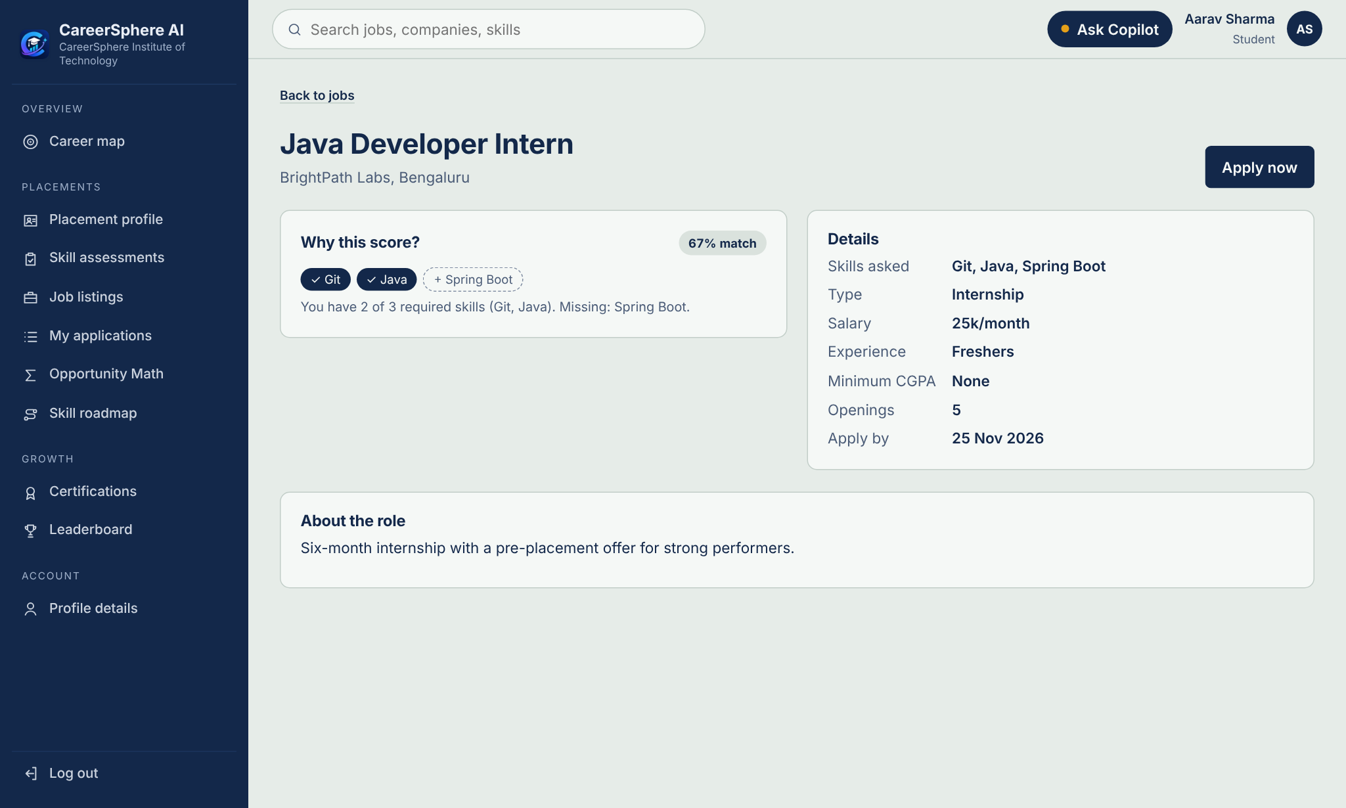
Fig 6.8: Job detail: why this score, and the job’s requirements
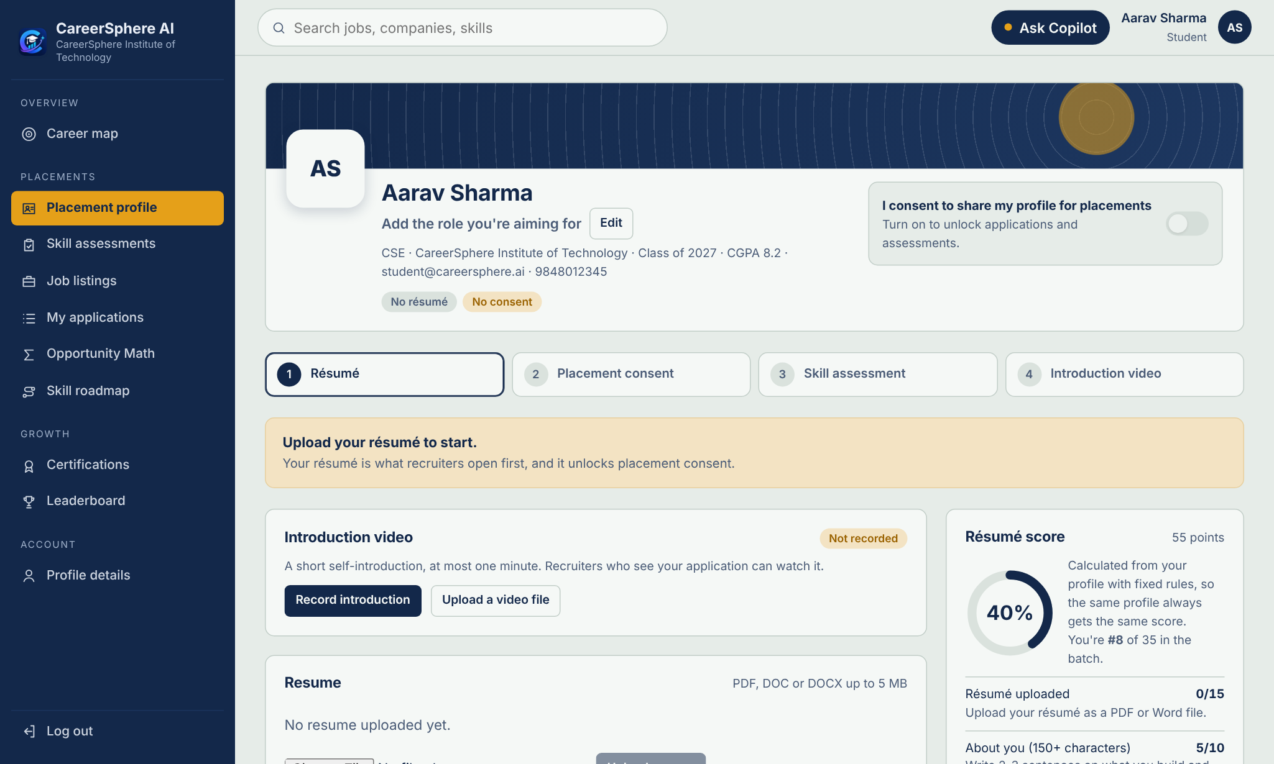
Fig 6.9: Placement profile of a new student: guided steps and résumé score
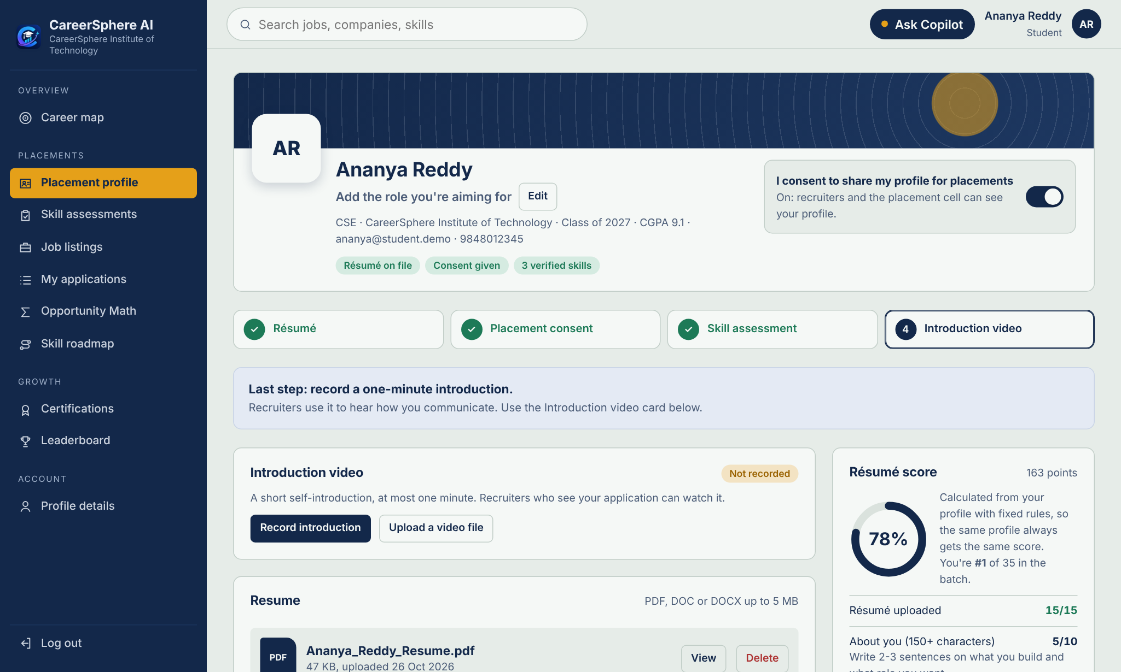
Fig 6.10: Placement profile of a student who has completed most steps
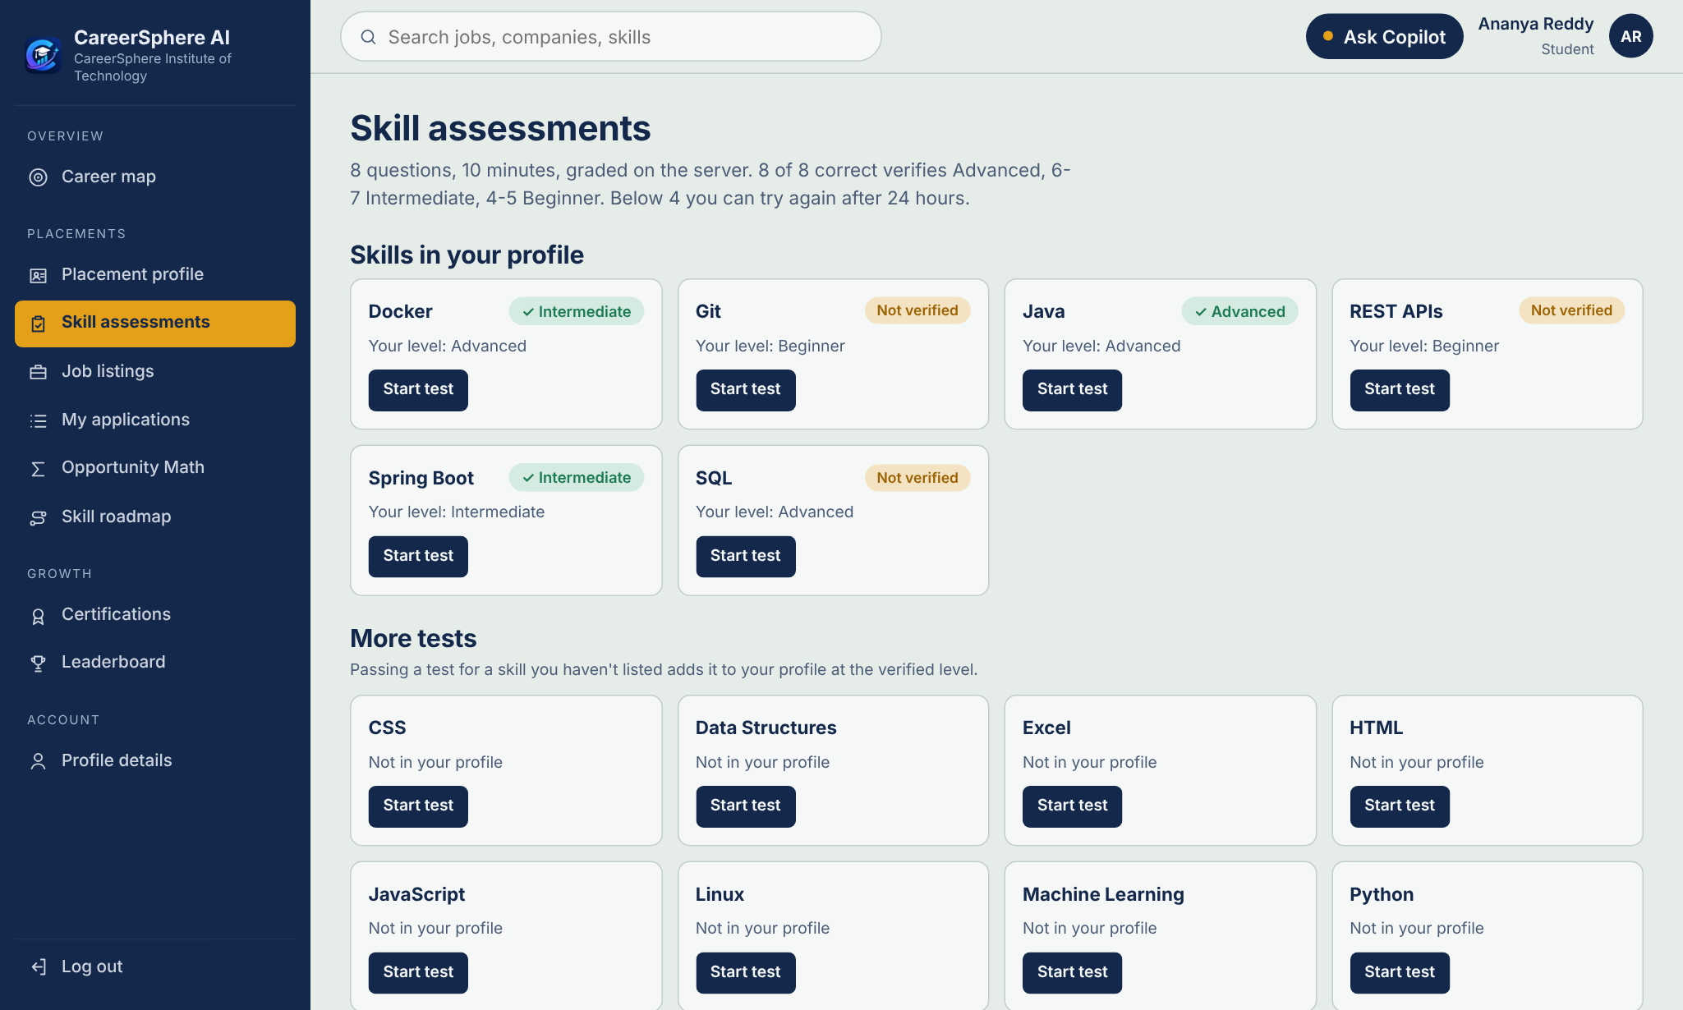
Fig 6.11: Skill assessments: verified and unverified skills
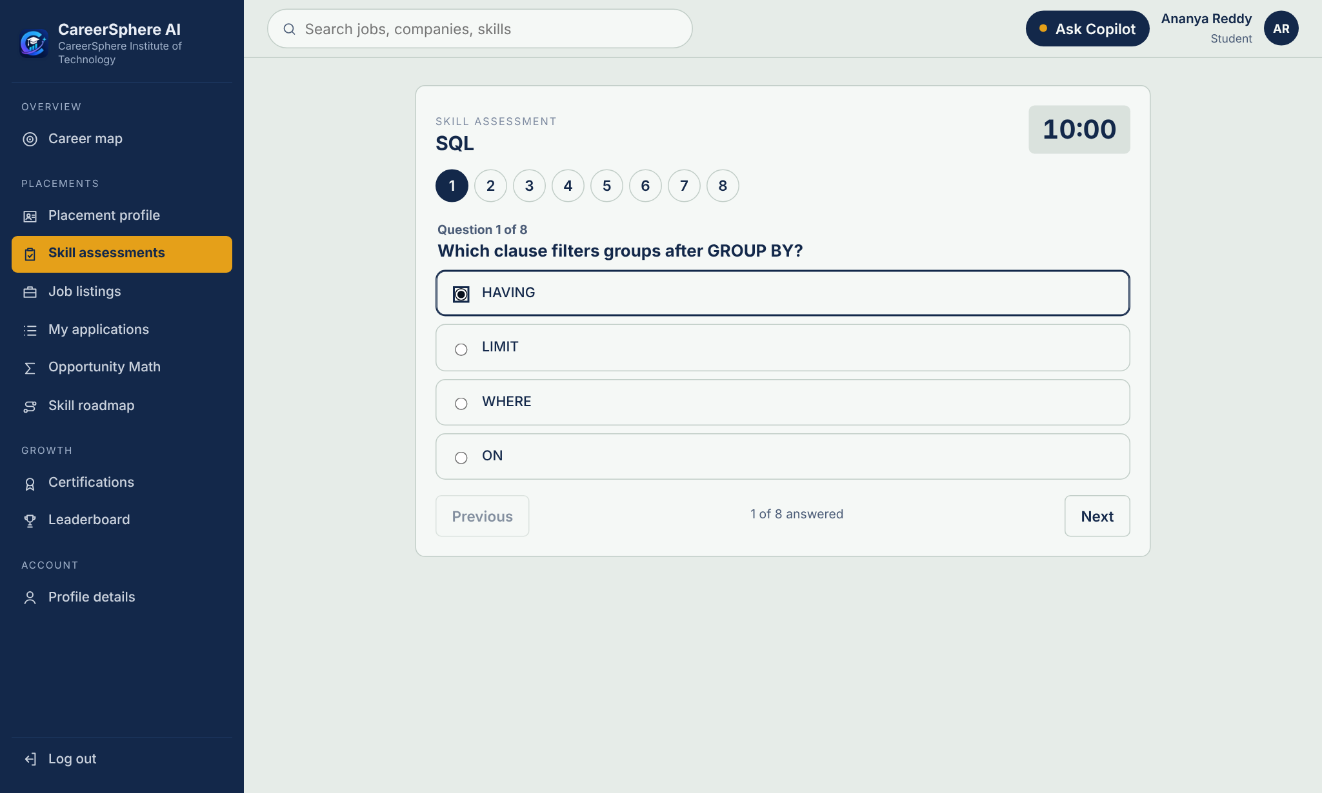
Fig 6.12: A timed assessment in progress
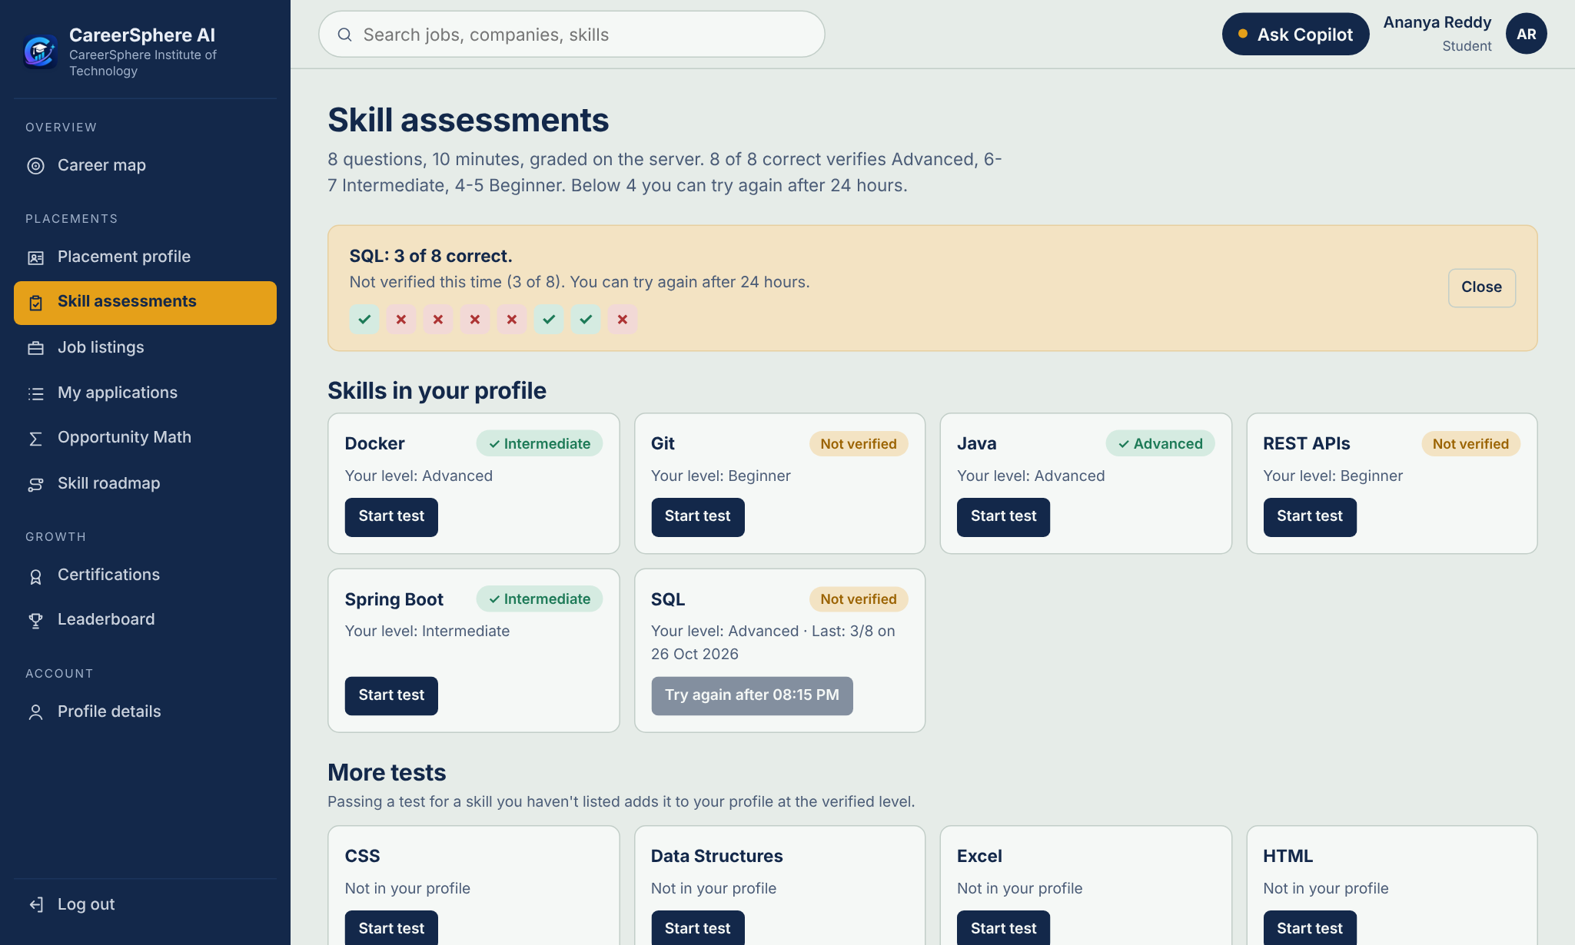
Fig 6.13: Assessment result: fewer than 4 correct verifies nothing; retake after 24 hours
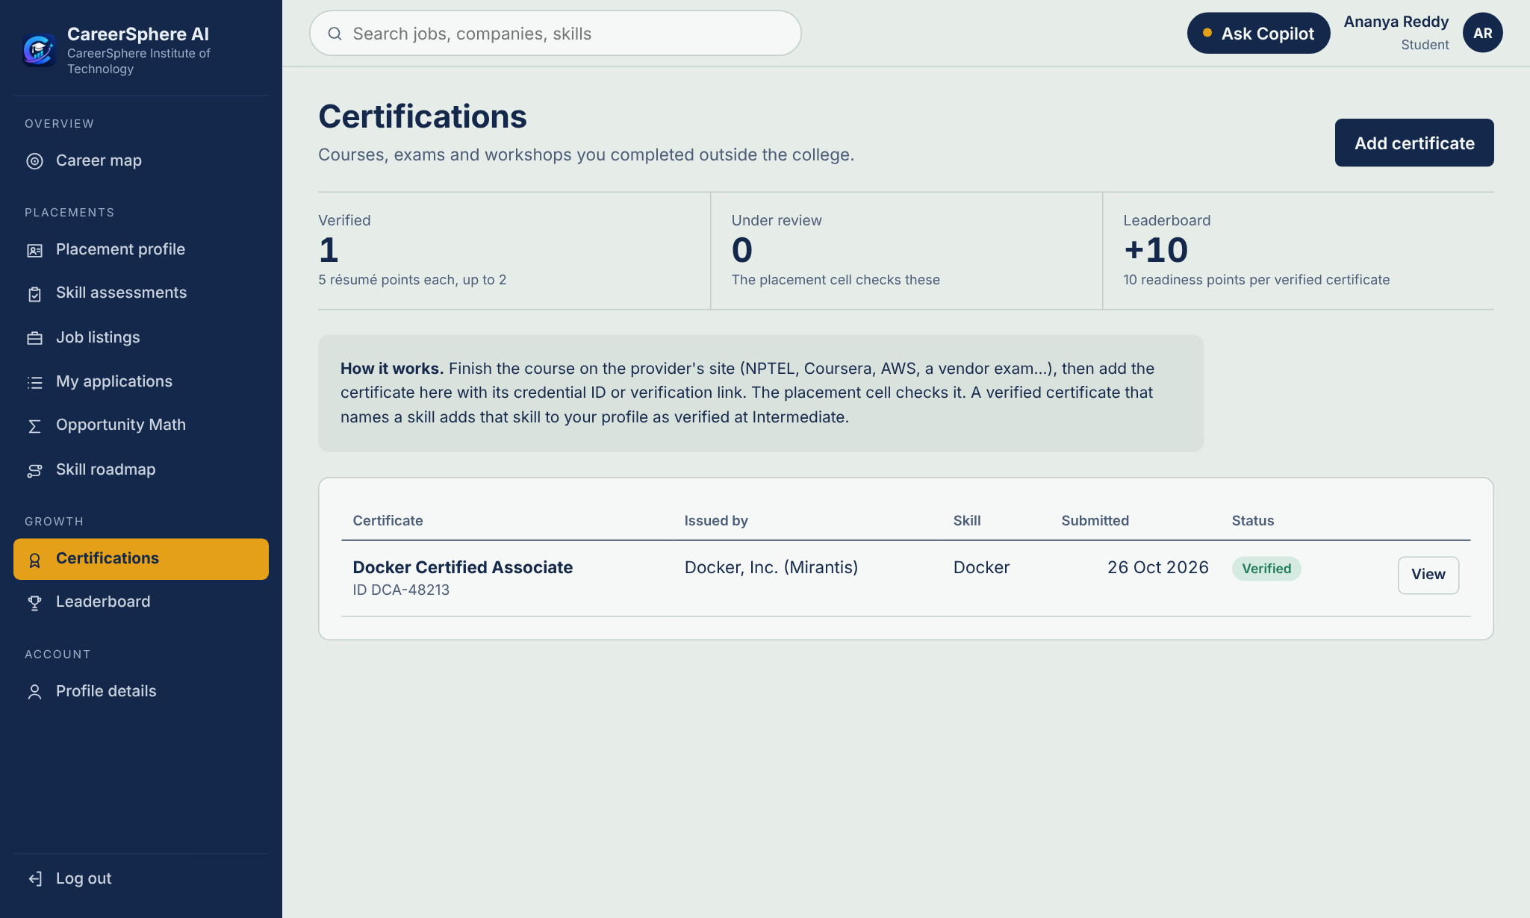
Fig 6.14: Certifications: a verified certificate and how verification works
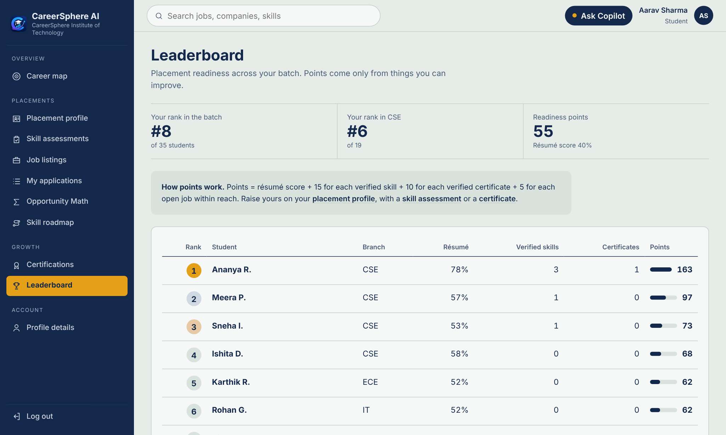
Fig 6.15: Readiness leaderboard
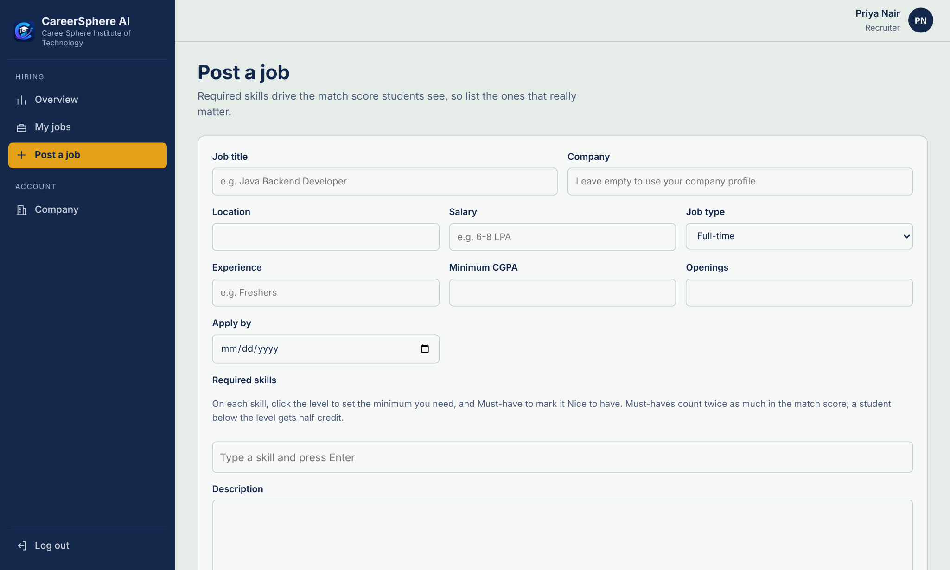
Fig 6.16: Recruiter: posting a job with skill levels and must-have or nice-to-have flags
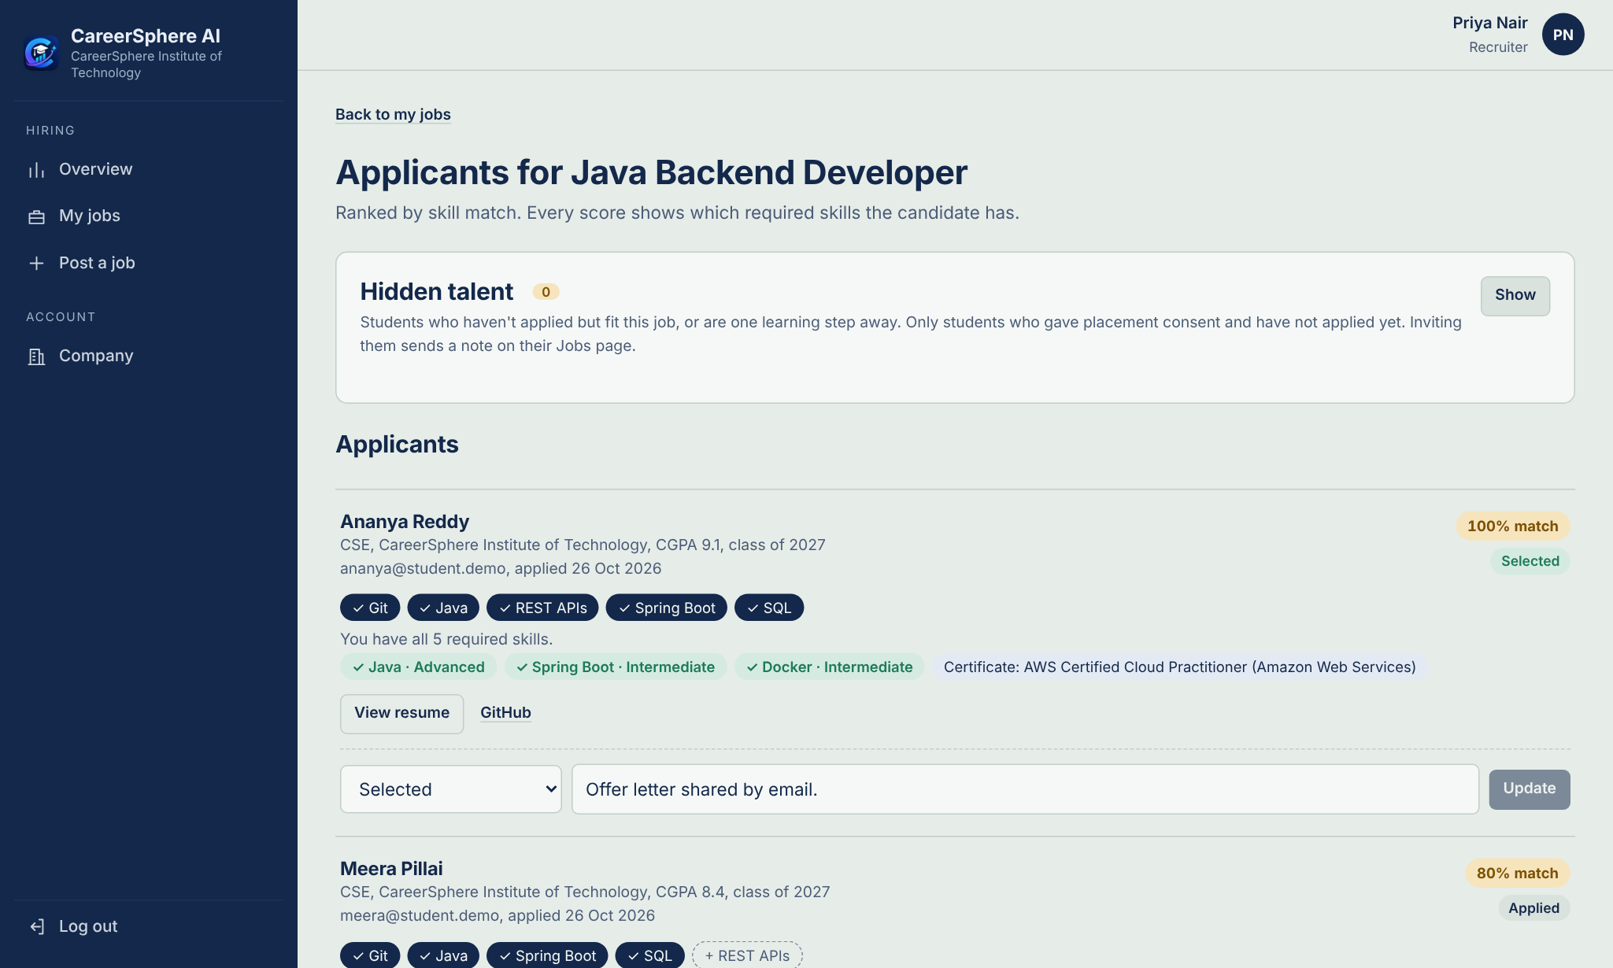
Fig 6.17: Recruiter: applicants ranked by match, with verified skills
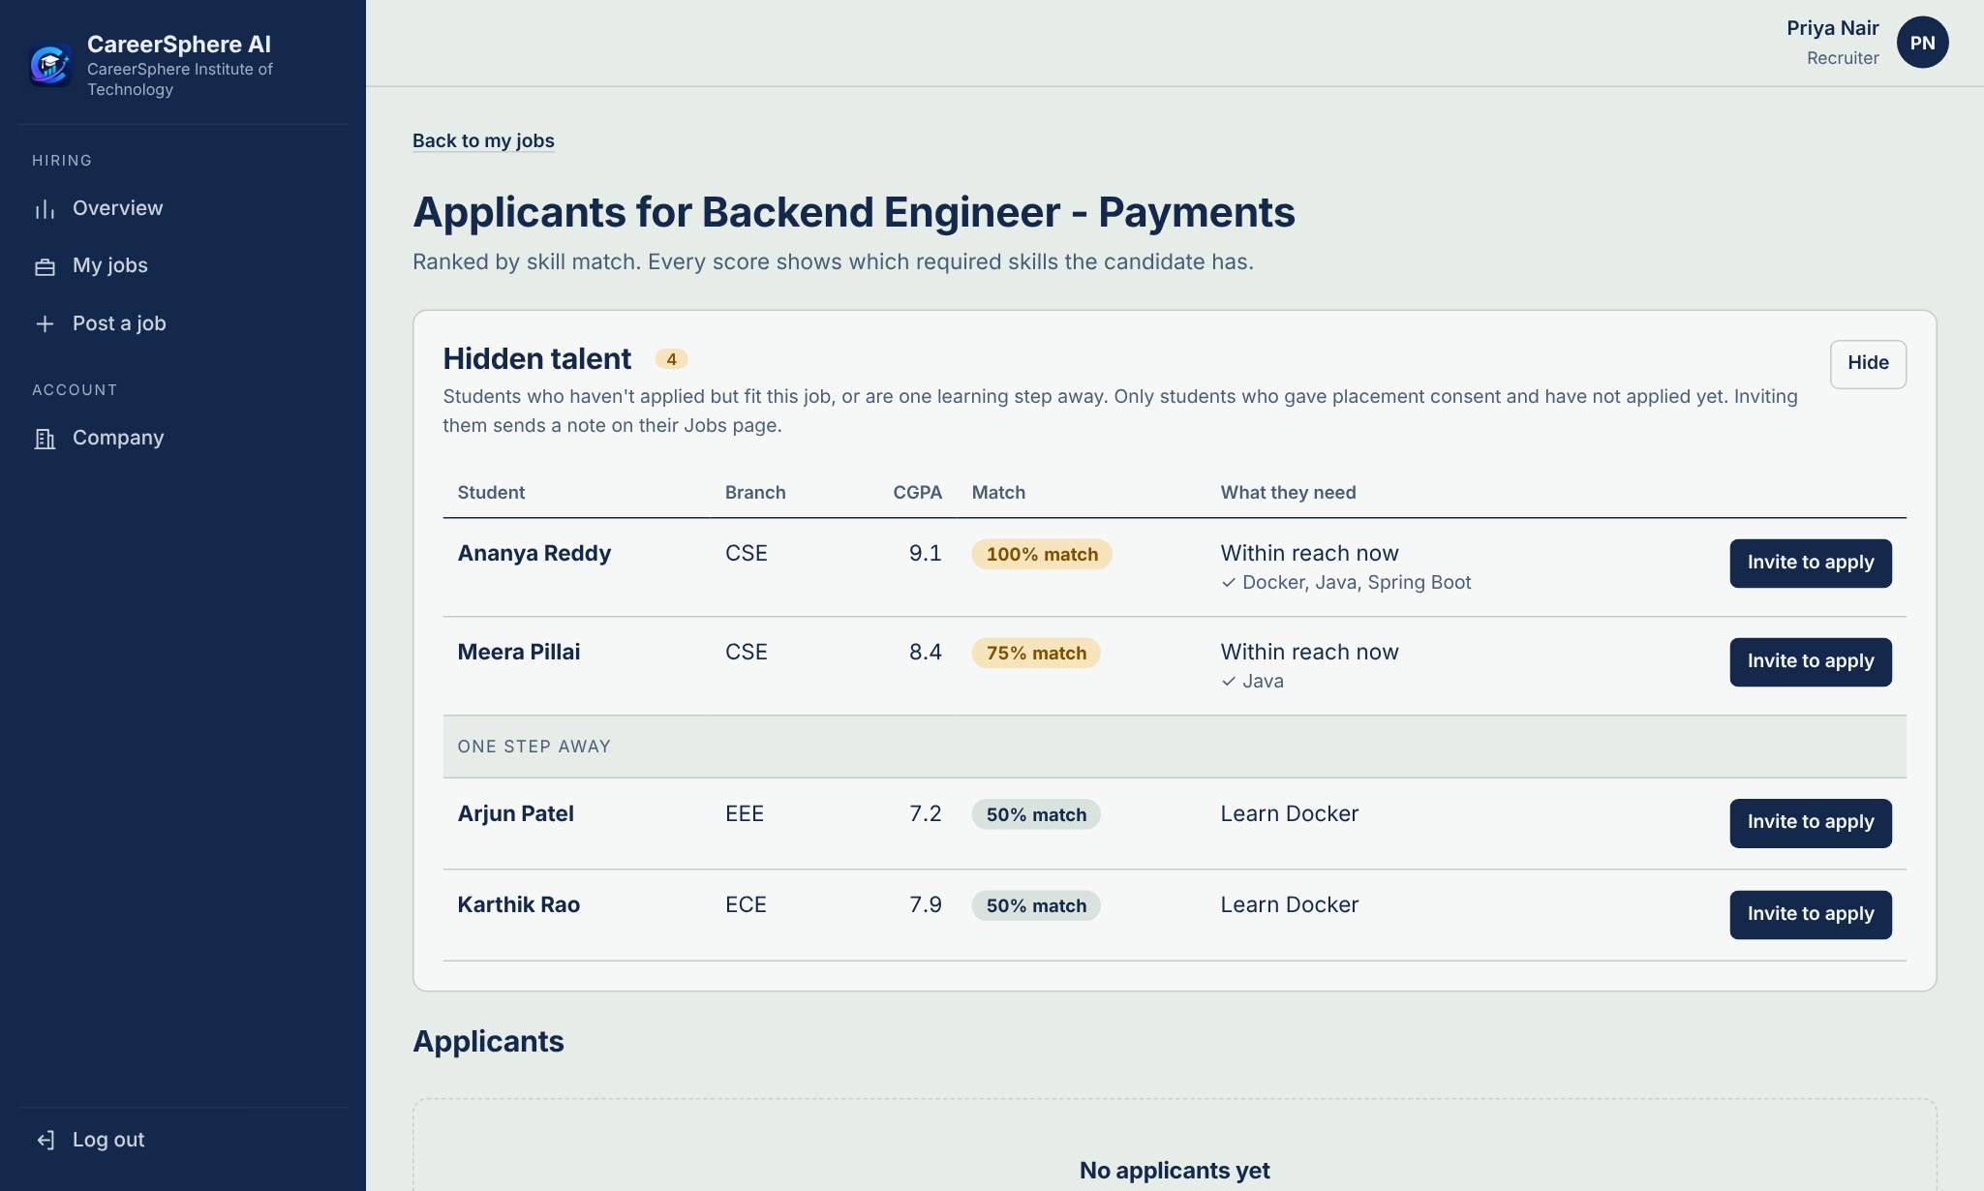
Fig 6.18: Recruiter: Hidden Talent for a job, with invitations
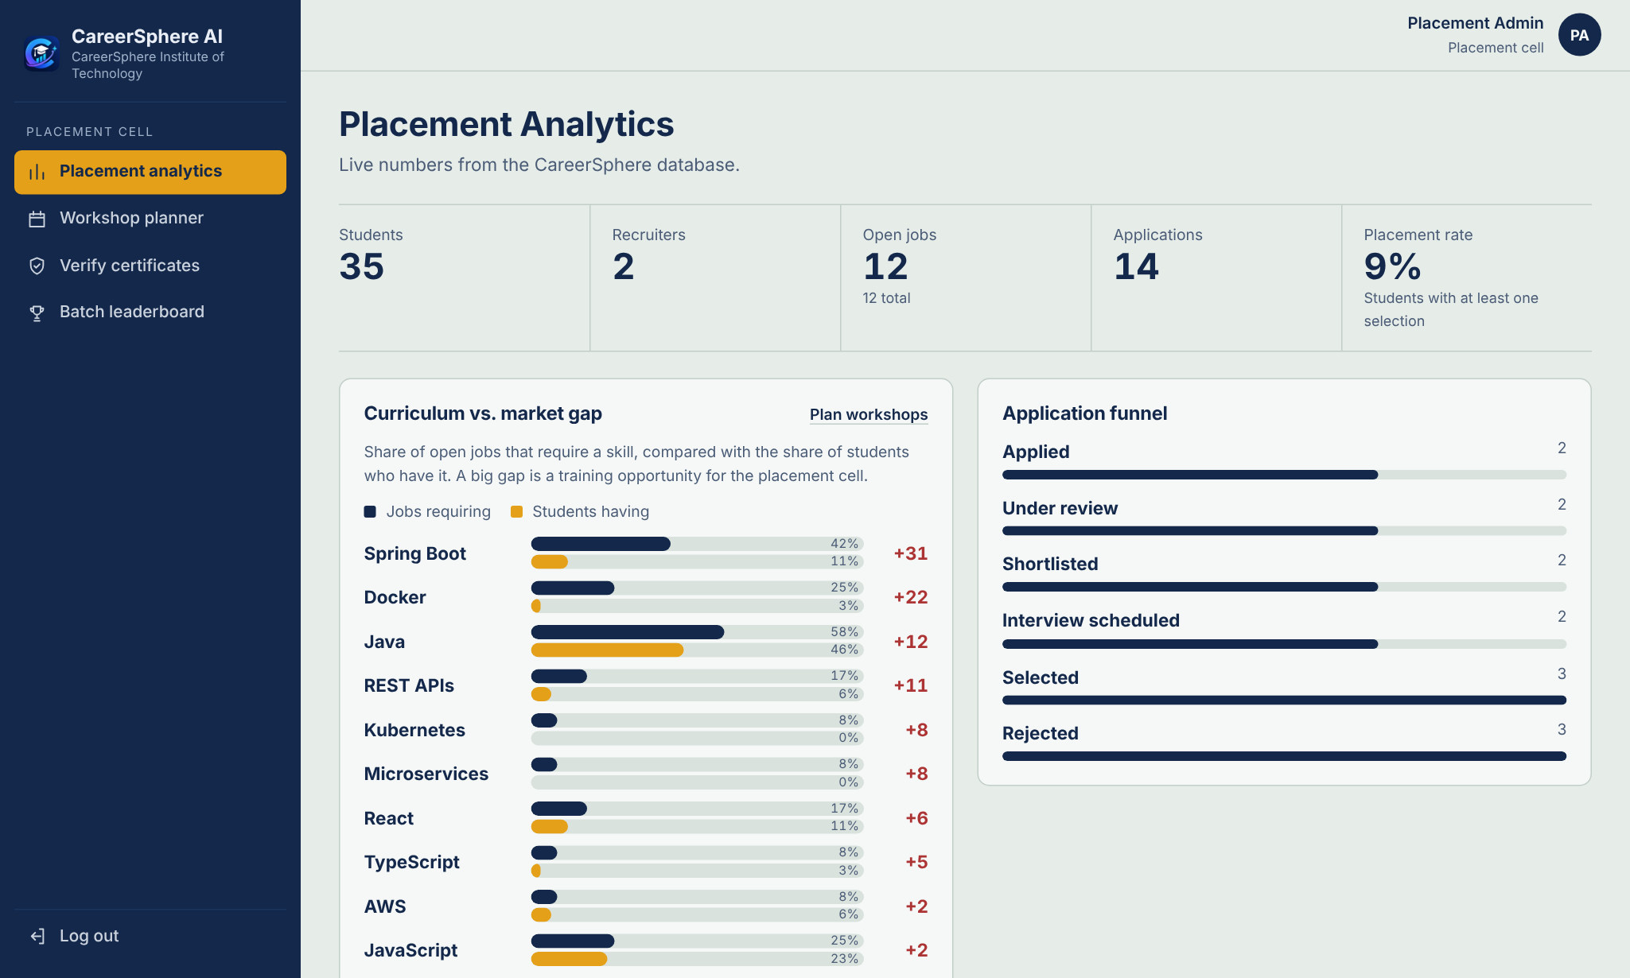
Fig 6.19: Placement cell: analytics and the curriculum–market skill gap
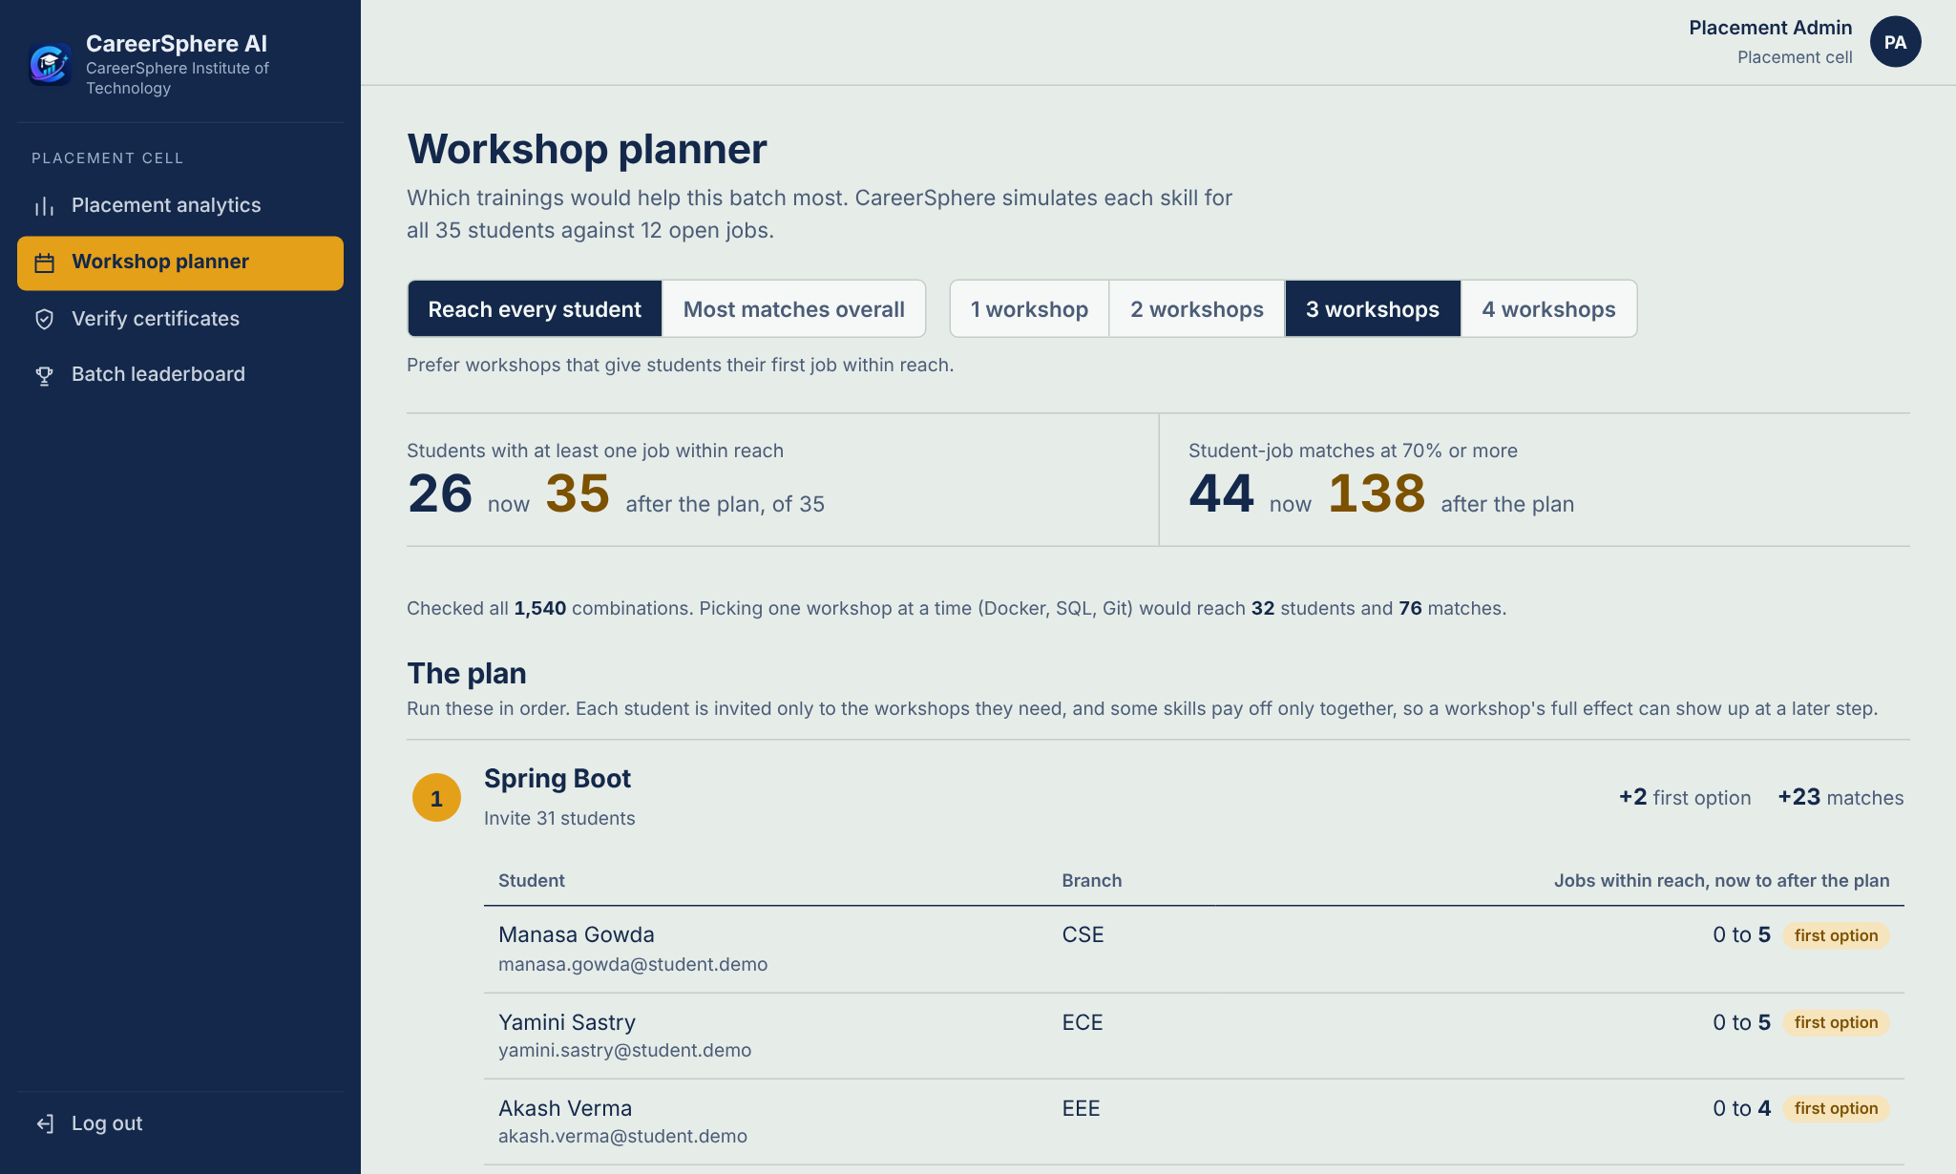
Fig 6.20: Placement cell: Workshop Planner for three workshops
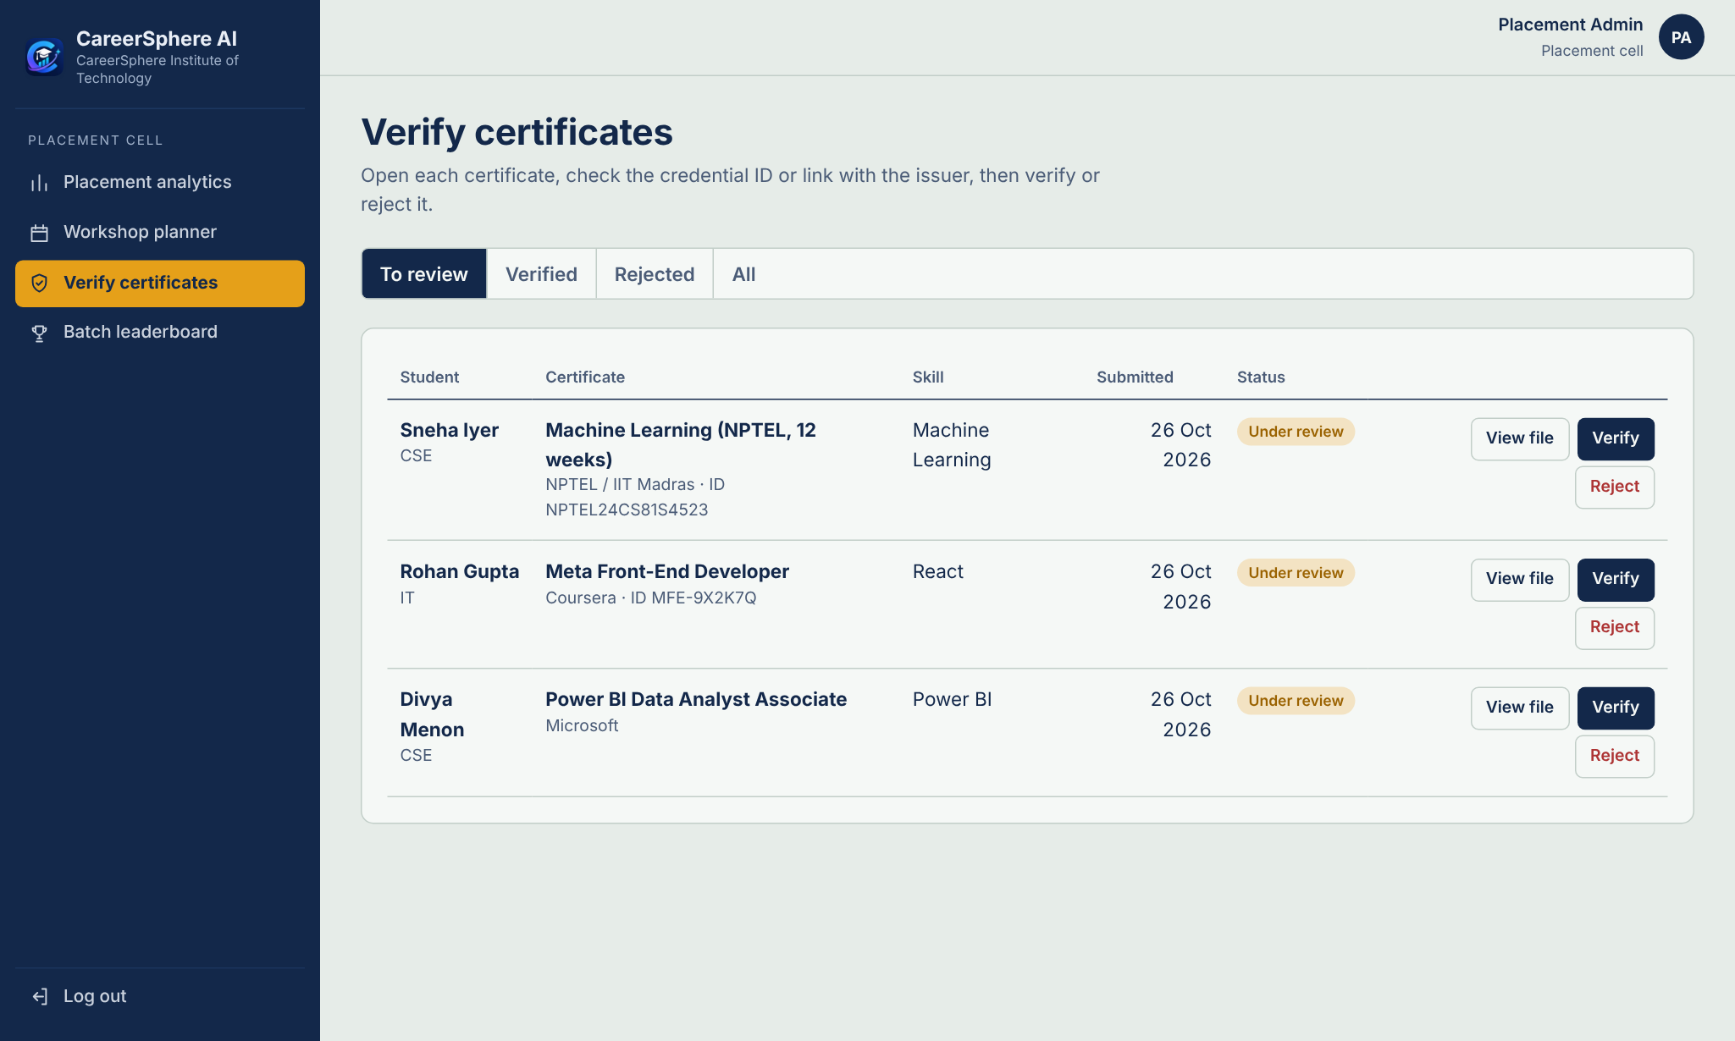
Fig 6.21: Placement cell: certificates waiting for verification
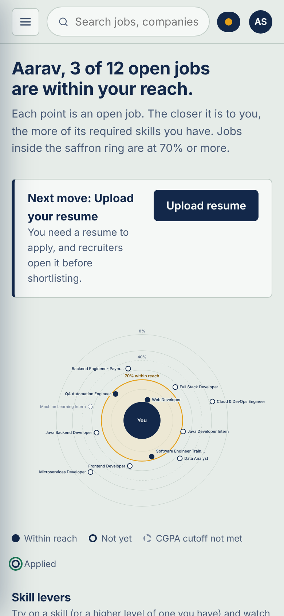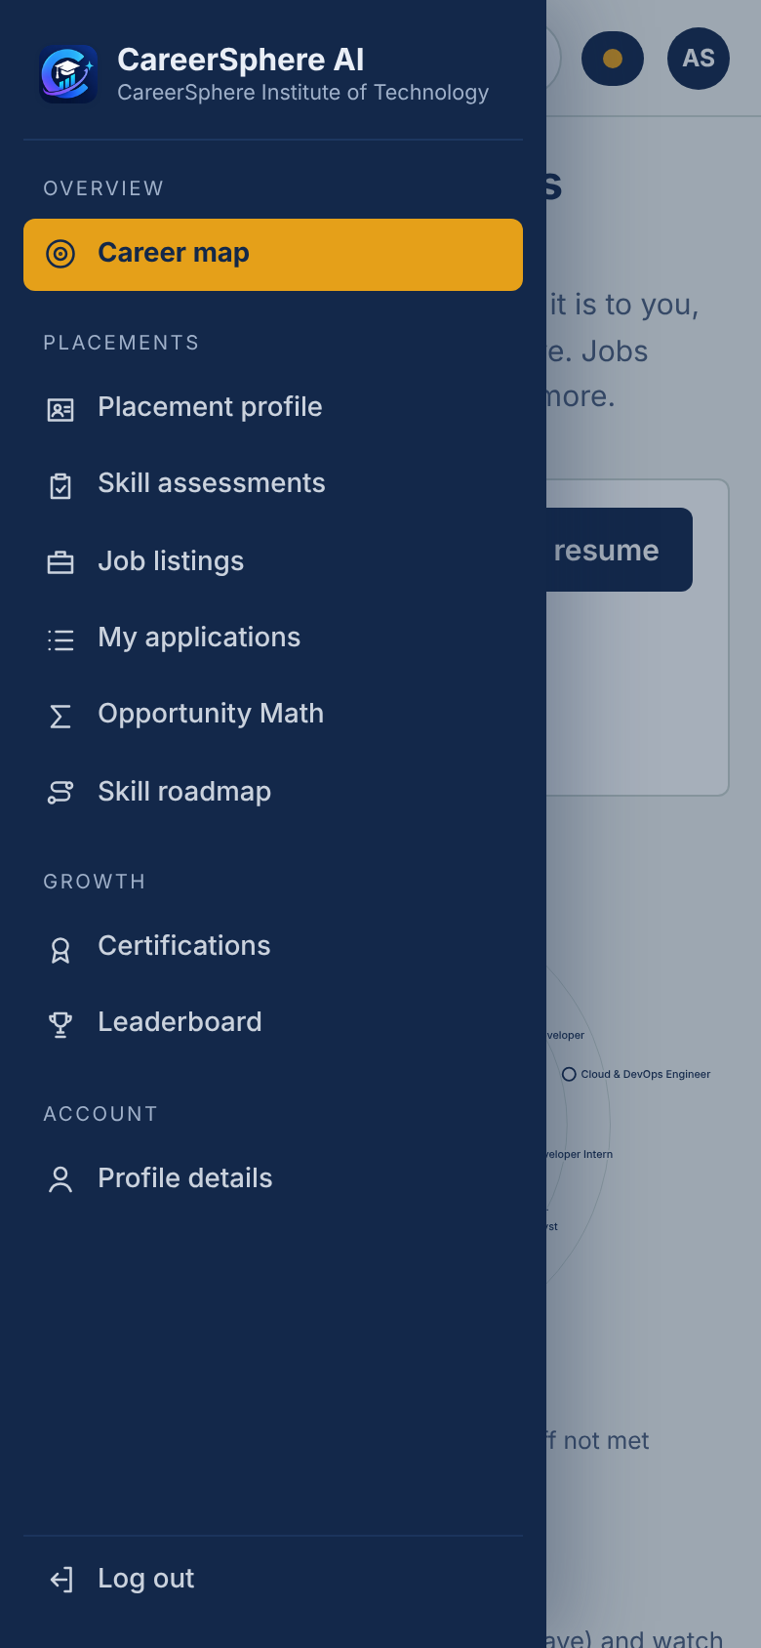
Fig 6.22: The same app on a phone: Career Map and the slide-in menu

6.5 Running on Different Platforms
- Terminal (Mac): ./run.sh starts MySQL, the backend and the web app, each in its own window, and opens the browser; ./stop.sh stops them.
- VS Code: code . in the project folder, then Cmd + Shift + B runs the task “CareerSphere: start everything”; the Run and Debug panel debugs the Java backend and the React app.
- Xcode: CareerSphere.xcodeproj builds a SwiftUI app for Mac and iPhone that shows the web app in a WKWebView; a build step starts the servers.
- Android Studio: the android folder is a Kotlin app that shows the web app in a WebView at 10.0.2.2:5173, with file upload including video capture.
- Online: one Docker image builds the web app and puts it inside the backend jar; Docker Compose runs it with MySQL, and Railway hosts it over HTTPS.

CHAPTER - 7
RESULTS AND DISCUSSION

7.1 Experimental Results
All results use the fictional demo batch: 35 students from four branches with 3.49 skills on average, and 12 open jobs from two companies requiring 4.33 skills on average, 4 of them with a CGPA cutoff. There are 22 candidate skills and 420 student–job pairs. Scores are 0% for 144 pairs, 1–39% for 141, 40–69% for 91, 70–99% for 30 and 100% for 14. Today 26 students have at least one job within reach, with 44 matches in total.
7.1.1 Next skill and the Skill Roadmap
Table 10 compares the top Opportunity Math action with the demand heuristic, the missing skill that most open jobs ask for. Table 11 and Fig 7.1 add the Skill Roadmap with two and three steps.
Table 10: Recommended next skill, 35 students
Measure | Demand heuristic | Opportunity Math
Mean jobs brought within reach | 1.03 | 1.43
Total jobs brought within reach | 36 | 50
Students whose recommendation unlocks nothing | 20 | 7
Students with a different recommendation | – | 13

Table 11: Skill Roadmap, 35 students
Steps allowed | Mean new jobs within reach | Students helped
1 (Opportunity Math) | 1.43 | 28
up to 2 | 2.89 | 35
up to 3 | 4.71 | 35

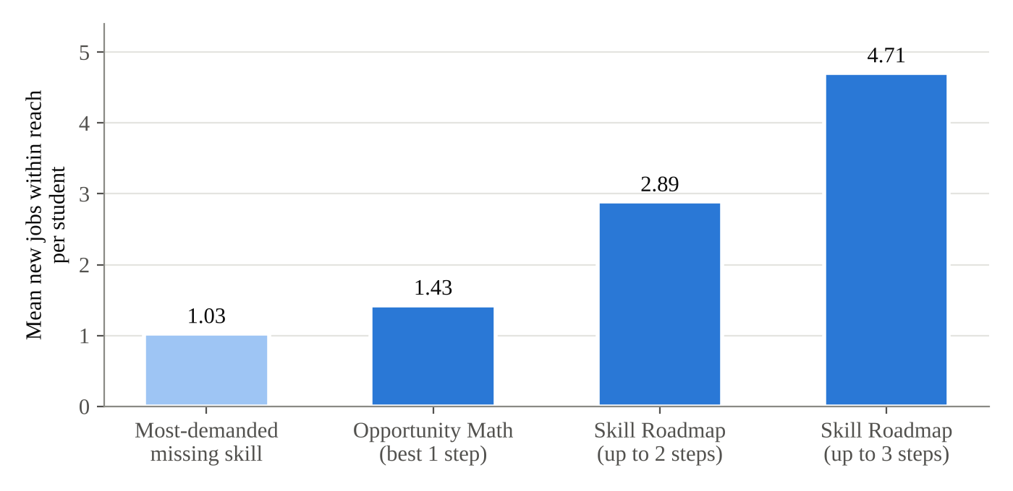
Fig 7.1: Mean new jobs within reach per student for each way of choosing what to learn
7.1.2 Workshop planning for the batch
Exact search is compared with three baselines for k = 1 to 4 workshops: greedy one-at-a-time selection under the same goal, the top-k skills by job demand, and the top-k skills by demand–supply gap. For the two top-k baselines every student lacking a chosen skill attends (Table 12, Fig 7.2). Table 13 and Fig 7.3 give the planner runtime, the median of nine calls.
Table 12: Workshop plans: students reached / matches (Reach goal)
k | Exact | Greedy | Top-k demand | Top-k gap
1 | 29 / 56 | 29 / 56 | 26 / 44 | 28 / 67
2 | 33 / 65 | 31 / 64 | 31 / 71 | 31 / 79
3 | 35 / 138 | 32 / 76 | 35 / 107 | 33 / 99
4 | 35 / 198 | 33 / 81 | 35 / 198 | 34 / 142

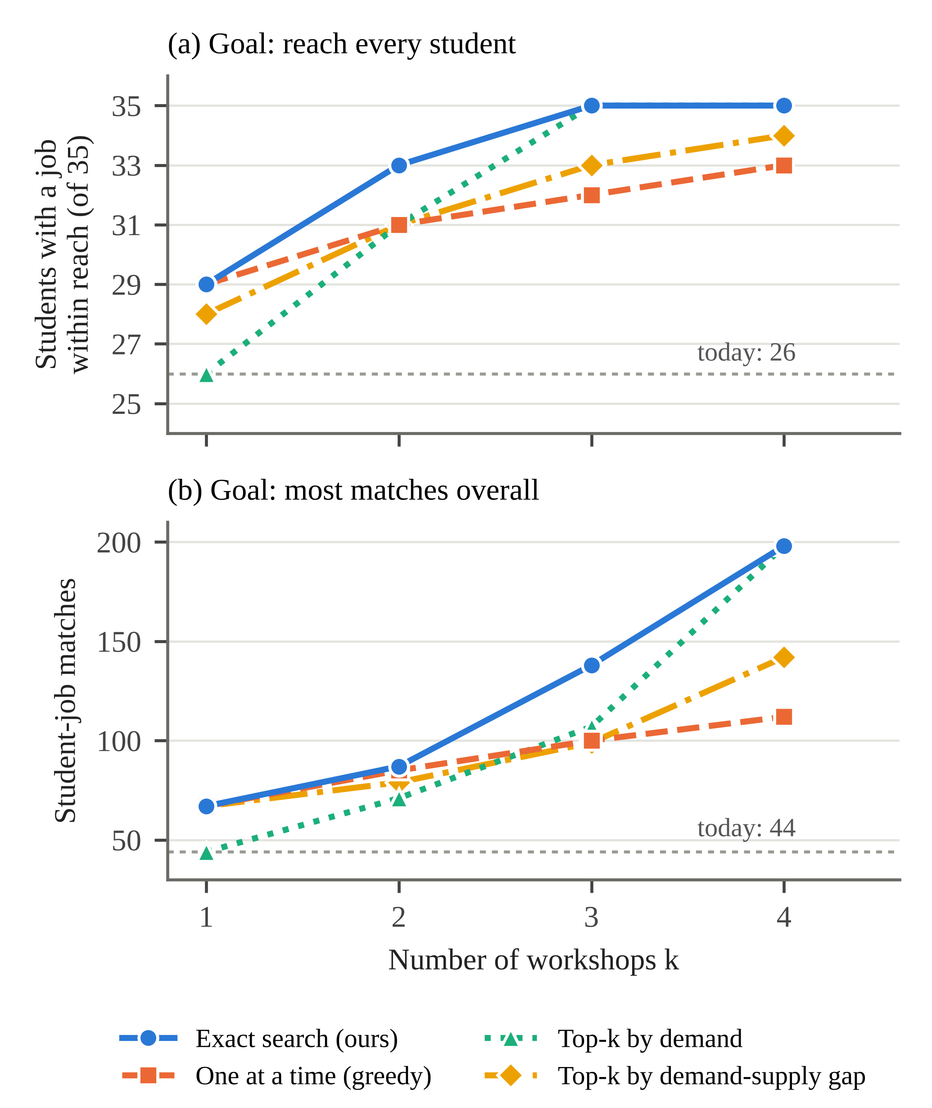
Fig 7.2: Outcome of each planning method for k = 1 to 4 workshops; dotted line: today. (a) Reach goal; (b) Matches goal
Table 13: Planner runtime, median of 9 calls
k | Combinations | Time (ms)
1 | 22 | 0.9
2 | 231 | 1.9
3 | 1,540 | 6.5
4 | 7,315 | 29.3
5 | 26,334 | 81.7
6 | 74,613 | 228.9

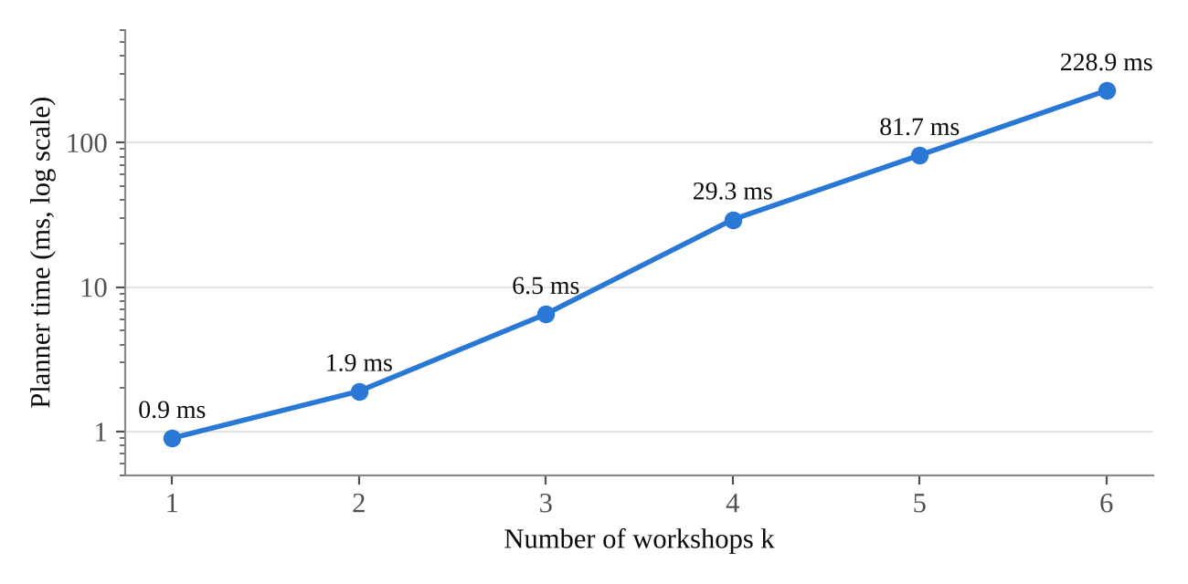
Fig 7.3: Exact Workshop Planner runtime against the number of workshops (logarithmic scale)
7.1.3 Hidden Talent and the résumé skill finder
Over the 12 jobs, Hidden Talent finds 10 cases of a consented student within reach of a job they have not applied to, and 9 more one step away, against 14 applications actually made by the 10 consented students (Fig 7.4). For “Backend Engineer – Payments” it lists two students within reach and two who need only Docker. On the demo résumé the finder reports six further skills found in project and achievement lines (Spring Boot, REST APIs, MySQL, React, Data Structures and Pandas), each with its quoted line; adding them raises the student’s jobs within reach from 3 to 8.
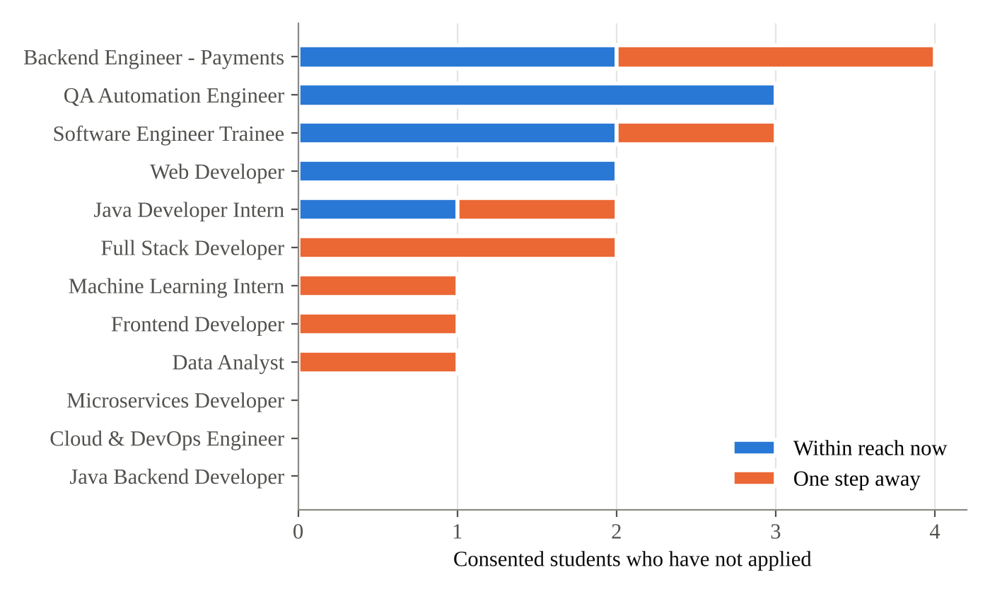
Fig 7.4: Hidden Talent per job: consented students who have not applied, within reach or one step away

7.2 Discussion and Evaluation of the Research Questions
- RQ1 – Next skill. Opportunity Math brings 1.43 jobs per student within reach against 1.03 for the demand heuristic. For 20 of 35 students the most-demanded missing skill would not bring a single job within reach. For the remaining 7 students no single skill helps at all, because every job is two or more skills away.
- RQ2 – Multi-step plans. Allowing two steps doubles the gain (2.89) and three steps more than triples it (4.71). All 7 students without a useful single skill gain at least one job with two steps; one of them gains nothing from any one skill but three jobs from Java and SQL together. Of the 65 multi-step bundles shown, 59 are marked works together, so the value of the extra steps comes mostly from combining skills. The search checks 1,083 bundles per student on average and runs on every page load.
- RQ3 – Batch planning. With three workshops exact search selects Spring Boot, Java and Git and reaches all 35 students with 138 matches, while greedy selects Docker, SQL and Git and reaches 32 with 76. Greedy falls behind even the top-k demand baseline from k = 3, because Java helps few students on its own and pays off only together with Spring Boot and Git. Exact search takes 6.5 ms for k = 3 and stays under a quarter of a second up to k = 6.
- RQ4 – Recruiter reach. Hidden Talent surfaces 19 fitting or nearly fitting consented students across the 12 jobs that a recruiter would not otherwise see, without showing any student who did not give consent.

7.3 Comparison with Existing Approaches
Table 14 places CareerSphere next to the main kinds of approach reviewed in Chapter 2.
Table 14: Comparison of existing approaches with CareerSphere AI
Dimension | Learned fit / prediction models [2], [3] | CareerSphere AI
Data needed | Large labelled histories of past placements | Skills, levels and job requirements only
Explanation | Post-hoc or none | Exact: matched, missing, level gaps, CGPA
What it answers | Fit or placement probability | Which skill(s) to learn, whom to invite, which workshops
Skill combinations | Implicit in the model | Searched exactly; synergy flagged
Batch planning | Not addressed | Exact Workshop Planner, greedy shown for comparison
AI output | Unchecked text where used | Tools over own data; evidence-checked résumé skills
Verification of claims | Self-reported | Server-graded tests and checked certificates

Limitations. All results are on fictional data, so a study over a real placement season is needed. The weights, half credit and threshold are design choices; unverified levels are self-reported; the 120-question bank supports screening rather than certification; and the planner assumes every invitee learns the skill and ignores capacity and cost. A human evaluation kit is ready (60 student–job pairs labelled blind by three people, agreement by Fleiss’ κ [15], comparison with keyword matching), but the labelling is not yet complete.

CHAPTER - 8
CONCLUSION AND FUTURE SCOPE

8.1 Conclusions and Research Contributions
This project built CareerSphere AI, a complete campus placement platform for students, recruiters and the placement cell around one transparent, level-aware match rule. The main conclusions are the following.
- Actionable guidance beats skill-gap lists. Opportunity Math brings 1.43 jobs per student within reach against 1.03 for the most-demanded missing skill.
- Skills pay off together. A three-step Skill Roadmap more than triples what the best single skill achieves (4.71 against 1.43 jobs) and helps every student, including the 7 for whom no single skill helps.
- Exact search is practical at college scale. Three exactly chosen workshops reach all 35 students where greedy selection reaches 32, in 6.5 ms.
- Reverse matching widens the pool. Hidden Talent shows recruiters 10 fitting and 9 nearly fitting consented students who did not apply.
- Grounded AI is usable and safe. The Copilot answers only through tools over the student’s own data, and the résumé finder keeps only skills whose evidence is in the résumé; both work without an AI key.
The system runs on a laptop with one command, from Xcode, VS Code and Android Studio and online with Docker, and is covered by 39 unit tests and 17 end-to-end API tests.

8.2 Future Scope
- Human evaluation and a real season. Complete the labelling study and measure the effect on a real placement season.
- Learned parameters. Learn the weights and the threshold from past outcomes, and calibrate a larger question bank by item difficulty.
- Capacity-aware planning. Plan workshops with capacities and costs as an integer program, which also scales beyond exhaustive search.
- Effort in hours. Measure roadmap effort in hours, with links to specific courses for each step.
- Notifications and wider use. Email and push notifications for status changes and invitations, interview scheduling with calendars, and separate tenants for several colleges.

REFERENCES
[1] C. de Ruijt and S. Bhulai, “Job recommender systems: A review,” arXiv:2111.13576, 2021.
[2] C. Zhu, H. Zhu, H. Xiong, C. Ma, F. Xie, P. Ding, and P. Li, “Person-job fit: Adapting the right talent for the right job with joint representation learning,” ACM Trans. Manage. Inf. Syst., vol. 9, no. 3, pp. 1–17, 2018.
[3] S. Alfana, S. K. R. Jammalamadaka, V. C. Prakash, and B. T. Reddy, “Cognitive and academic-based probability models for predicting campus placements,” IAES Int. J. Artif. Intell., vol. 11, no. 4, pp. 1239–1251, Dec. 2022, doi: 10.11591/ijai.v11.i4.pp1239-1251.
[4] Y. Zhang and X. Chen, “Explainable recommendation: A survey and new perspectives,” Found. Trends Inf. Retr., vol. 14, no. 1, pp. 1–101, 2020, doi: 10.1561/1500000066.
[5] G. L. Nemhauser, L. A. Wolsey, and M. L. Fisher, “An analysis of approximations for maximizing submodular set functions—I,” Math. Program., vol. 14, pp. 265–294, 1978.
[6] U. Feige, “A threshold of ln n for approximating set cover,” J. ACM, vol. 45, no. 4, pp. 634–652, 1998.
[7] A. Krause and D. Golovin, “Submodular function maximization,” in Tractability: Practical Approaches to Hard Problems, L. Bordeaux, Y. Hamadi, and P. Kohli, Eds. Cambridge, U.K.: Cambridge Univ. Press, 2014, pp. 71–104.
[8] T. Schick, J. Dwivedi-Yu, R. Dessì, R. Raileanu, M. Lomeli, E. Hambro, L. Zettlemoyer, N. Cancedda, and T. Scialom, “Toolformer: Language models can teach themselves to use tools,” in Proc. NeurIPS, 2023.
[9] S. Yao, J. Zhao, D. Yu, N. Du, I. Shafran, K. Narasimhan, and Y. Cao, “ReAct: Synergizing reasoning and acting in language models,” in Proc. ICLR, 2023.
[10] Z. Ji, N. Lee, R. Frieske, T. Yu, D. Su, Y. Xu, E. Ishii, Y. Bang, A. Madotto, and P. Fung, “Survey of hallucination in natural language generation,” ACM Comput. Surv., vol. 55, no. 12, pp. 1–38, 2023.
[11] T. Gao, H. Yen, J. Yu, and D. Chen, “Enabling large language models to generate text with citations,” in Proc. EMNLP, 2023, pp. 6465–6488, doi: 10.18653/v1/2023.emnlp-main.398.
[12] M. Raghavan, S. Barocas, J. Kleinberg, and K. Levy, “Mitigating bias in algorithmic hiring: Evaluating claims and practices,” in Proc. Conf. Fairness, Accountability, and Transparency (FAT)*, 2020, pp. 469–481.
[13] M. Jones, J. Bradley, and N. Sakimura, “JSON Web Token (JWT),” IETF RFC 7519, May 2015.
[14] N. Provos and D. Mazières, “A future-adaptable password scheme,” in Proc. USENIX Annu. Tech. Conf., FREENIX Track, 1999, pp. 81–91.
[15] J. L. Fleiss, “Measuring nominal scale agreement among many raters,” Psychol. Bull., vol. 76, no. 5, pp. 378–382, 1971.
[16] Google, “Function calling with the Gemini API,” Google AI for Developers. [Online]. Available: https://ai.google.dev/gemini-api/docs/function-calling (accessed Oct. 4, 2026).
[17] VMware Tanzu, “Spring Boot Reference Documentation,” version 3.3. [Online]. Available: https://docs.spring.io/spring-boot/
[18] Meta Open Source, “React documentation.” [Online]. Available: https://react.dev/
[19] Oracle, “MySQL 8.0 Reference Manual.” [Online]. Available: https://dev.mysql.com/doc/refman/8.0/en/
[20] OWASP Foundation, “OWASP Top 10: The ten most critical web application security risks,” 2021. [Online]. Available: https://owasp.org/Top10/

APPENDIX
SETUP COMMANDS, DEMO SCRIPT AND API LIST
The commands below set up the project on a Mac, run it, reset the demo data and run the tests. The data lives in the MySQL database careersphere on localhost:3306 (user root, no password by default); uploaded files are saved in backend/uploads/.
Listing A.1 – One-time setup on a Mac
/bin/bash -c "$(curl -fsSL https://raw.githubusercontent.com/Homebrew/install/HEAD/install.sh)"
brew install openjdk@17 maven node mysql
sudo ln -sfn $(brew --prefix)/opt/openjdk@17/libexec/openjdk.jdk \
/Library/Java/JavaVirtualMachines/openjdk-17.jdk
brew services start mysql

Listing A.2 – Running the project
cd careersphere
code . # then press Cmd + Shift + B in VS Code ("CareerSphere: start everything")
# or, by hand in two terminals:
cd backend && mvn spring-boot:run # API on http://localhost:8080
cd frontend && npm install && npm run dev # web app on http://localhost:5173
./run.sh # everything with one command; ./stop.sh stops it

Listing A.3 – Reset, tests, Docker and the optional AI key
mysql -u root -e "DROP DATABASE careersphere" # reset: the demo data is rebuilt on next start
cd backend && mvn test # 39 unit tests and 17 API tests
docker compose up --build # app and MySQL on http://localhost:8080
export GEMINI_API_KEY=your-key # optional; only in ~/.zshrc, never in the project

Table 15: Demo accounts
Role | Email | Password
Student | student@careersphere.ai | student123
Recruiter | recruiter@careersphere.ai | recruiter123
Placement cell | admin@careersphere.ai | admin123
Other students | ananya@student.demo, rohan@student.demo, ... | student123

Demo script (about 10 minutes). (1) Log in as the student: the Career Map shows 3 of 12 jobs within reach; switch on the Spring Boot lever and four jobs move inside the ring. (2) Opportunity Math puts Spring Boot first with +4 jobs; the Skill Roadmap gives +6 with three steps. (3) On the placement profile, upload demo/Aarav_Sharma_Resume.pdf, accept the six suggested skills and give consent: jobs within reach rise from 3 to 8. (4) Take an assessment and show that it is graded on the server. (5) Ask the Copilot “Which skill should I learn next?”. (6) Apply to a job; as the recruiter, open its applicants and change a status; open Hidden Talent on “Backend Engineer – Payments” and invite Ananya. (7) As Ananya, show the invitation on the Jobs page. (8) As the placement cell, verify a certificate and plan three workshops: all 35 students reached, against 32 one at a time.
Table 16: All REST endpoints
Prefix | Endpoints
/api (public) | GET /health; POST /auth/register; POST /auth/login; GET /auth/me; GET /skills
/api/student | GET /dashboard, /opportunities, /what-if; GET, PUT /profile; POST /profile/skills; POST, GET, DELETE /resume; GET /resume/file; POST /resume/skills; GET /jobs, /jobs/{id}; POST, GET /applications; GET /roadmap, /invitations, /readiness; PUT /consent; GET /leaderboard; POST, GET, DELETE /video; GET /video/file; GET /assessments; POST /assessments/start, /assessments/{id}/submit; POST, GET /certificates; DELETE /certificates/{id}; GET /certificates/{id}/file
/api/student/copilot | GET /status; POST (ask)
/api/recruiter | GET /dashboard; GET, PUT /profile; GET, POST /jobs; PUT, DELETE /jobs/{id}; PATCH /jobs/{id}/status; GET /jobs/{id}/applicants; PATCH /applications/{id}/status; GET /applications/{id}/resume, /applications/{id}/video; GET /jobs/{id}/talent; POST /jobs/{id}/invite/{studentId}
/api/admin | GET /stats, /users, /workshops, /certificates; PATCH /certificates/{id}; GET /certificates/{id}/file; GET /leaderboard

