Library Book Catalog

INTRODUCTION
Library Book Catalog is a full-stack web application built using the MERN stack (MongoDB, Express.js, React, Node.js). It is designed to digitize and streamline complete library operations — from cataloguing books and managing members to tracking borrows, renewals, returns, and overdue fines.
The system provides two user roles: an Admin panel for librarians to manage the collection, and a Member portal for readers to search, borrow, and track their reading activity.

SCENARIO BASED CASE STUDY
Meet Alice, a college student and avid reader who frequently visits her campus library. Managing her reading schedule, keeping track of borrowed books, and remembering due dates has always been a challenge. She discovers the Library Book Catalog application and decides to explore how it can simplify her library experience.
User Registration and Authentication: Alice registers an account by providing her name and email. She logs in securely using JWT-based authentication, ensuring her data remains private.
Book Catalogue Browsing: Alice explores the catalogue which includes detailed information on each title — author, genre, availability, and cover image. She uses search and filter tools to find books quickly.
Borrowing and Renewal: Alice borrows up to 5 books at a time with a 14-day lending period, and can renew online up to 2 times without visiting the library.
Fine Tracking: When a book is overdue, the system automatically calculates a fine of Rs.5 per day. Alice views active fines from her dashboard.
Reviews and Ratings: After finishing a book, Alice leaves a star rating and review to help other members discover good reads.
Thanks to the Library Book Catalog, Alice now manages her reading life with ease. It has become an indispensable part of her academic routine.

SYSTEM REQUIREMENTS

The following software and hardware prerequisites must be met to develop, test, and run the application.

1. Software Requirements
Operating System: Windows 10/11, macOS, or Linux
Node.js (v16+): Runtime environment for server-side logic and API routing npm (v8+): Package manager for React, Express, and related libraries
React.js: JavaScript library for building the user interface
Express.js: Lightweight framework for building the RESTful API backend
MongoDB: NoSQL database for storing users, books, borrows, reviews, and fines
Mongoose: ODM library providing schema-based modeling for MongoDB
Postman: API testing tool for verifying backend endpoints
VS Code: Code editor with built-in Git and terminal support

2. Hardware Requirements
Processor: Intel Core i5 (8th Gen or above) / AMD Ryzen 5 or better
RAM: Minimum 8 GB (16 GB recommended)
Storage: At least 1 GB free space for packages, MongoDB data, and project files
Display: 1366x768 resolution or higher

PROJECT ARCHITECTURE
The application follows a three-layer fullstack architecture. The React frontend communicates with the Node.js/Express backend via RESTful API calls. The backend processes requests through JWT authentication middleware and interacts with MongoDB via Mongoose models.

Architecture Layers
- Frontend (React): Login/Register, Book Catalogue, My Borrows, Admin Dashboard, Book Detailpages.
- Backend (Express): Auth middleware (JWT), /api/auth, /api/books, /api/borrows, /api/reviews,/api/dashboard routes.
- Database (MongoDB): users, books, borrows, reviews, and fines collections.
Transactional Layers
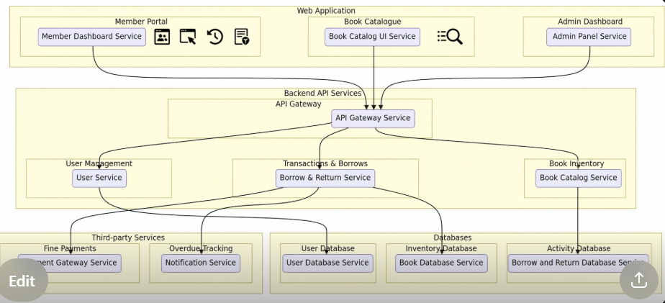

ER DIAGRAM

The Entity-Relationship diagram for the Library Book Catalog represents the key data entities and their relationships within the system.

Entities
- User: _id, name, email, password (hashed), role (admin/member), createdAt.
- Book: _id, title, author, genre, description, coverImage, totalCopies, availableCopies, createdAt.
- Borrow: _id, userId, bookId, borrowDate, dueDate, returnDate, renewalCount, status(active/returned/overdue).
- Review: _id, userId, bookId, rating (1–5), comment, createdAt.
- Fine: _id, borrowId, userId, amount, paid (boolean), createdAt.

Relationships
- User – Borrow: One user can have many borrow records (1:N).
- Book – Borrow: One book can appear in many borrow records (1:N).
- User – Review: One user can write many reviews (1:N).
- Book – Review: One book can have many reviews (1:N).
- Borrow – Fine: Each overdue borrow can generate one fine record (1:1 optional).

Primary and Foreign Keys
Each MongoDB document uses a system-generated ObjectId (_id) as its primary key. The Borrow document holds userId and bookId as references. The Review document holds userId and bookId references. The Fine document holds borrowId and userId references.

Login Page:
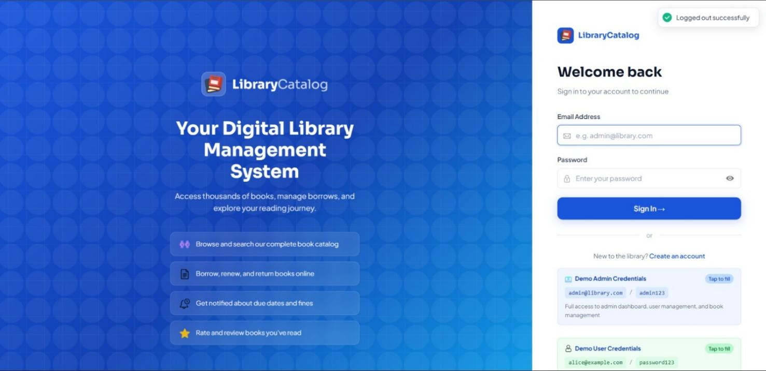
Register page:
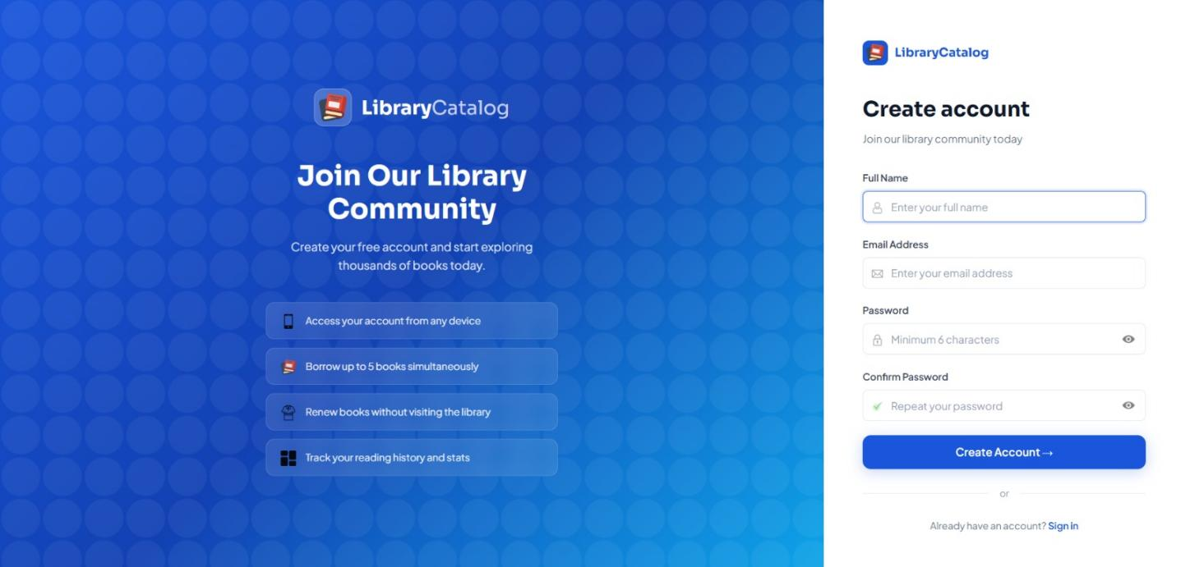
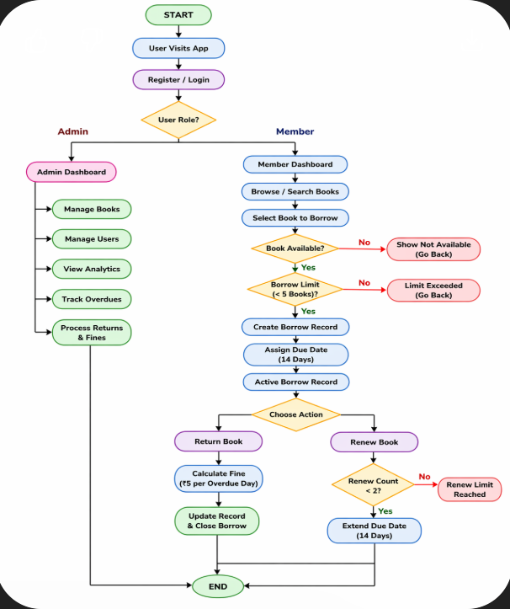

KEY FEATURES

Member Features
- Book Catalogue — Search, filter by genre/author, and browse all available books.
- Borrow Books — Borrow up to 5 books with a 14-day lending period.
- Renew Books — Renew a borrow online up to 2 times.
- Return Books — Return books online; availability updates instantly.
- Reviews and Ratings — Rate books (1–5 stars) and write reviews.
- Dashboard — View active borrows, history, due dates, and fines.
- Fine Tracking — Overdue fines calculated at Rs.5 per day.

Admin Features
- Book Management — Add, edit, and delete books with cover image upload.
- Member Management — View all registered members and their borrowing activity.
- Borrow Management — Process book returns and mark fines as paid.
- Analytics Dashboard — Charts for borrow trends and category statistics.
- Overdue Tracking — Monitor all overdue borrowings.

Admin Dashboard:
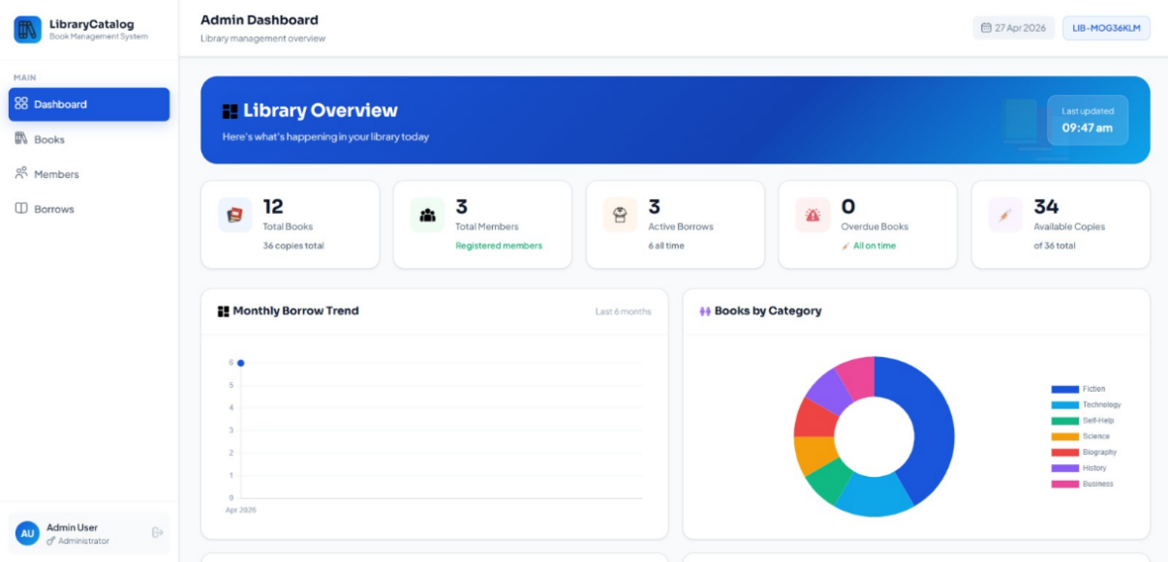

Adminbooks: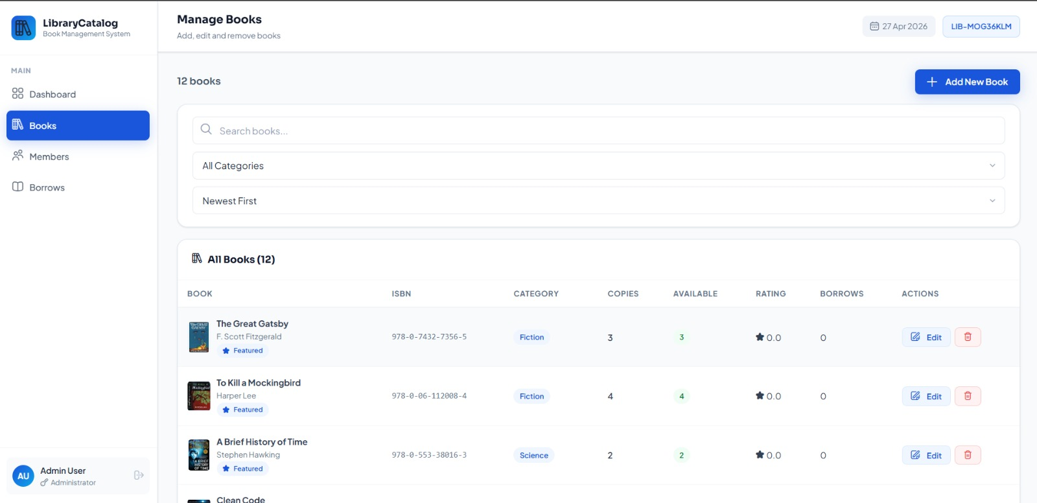

Members:
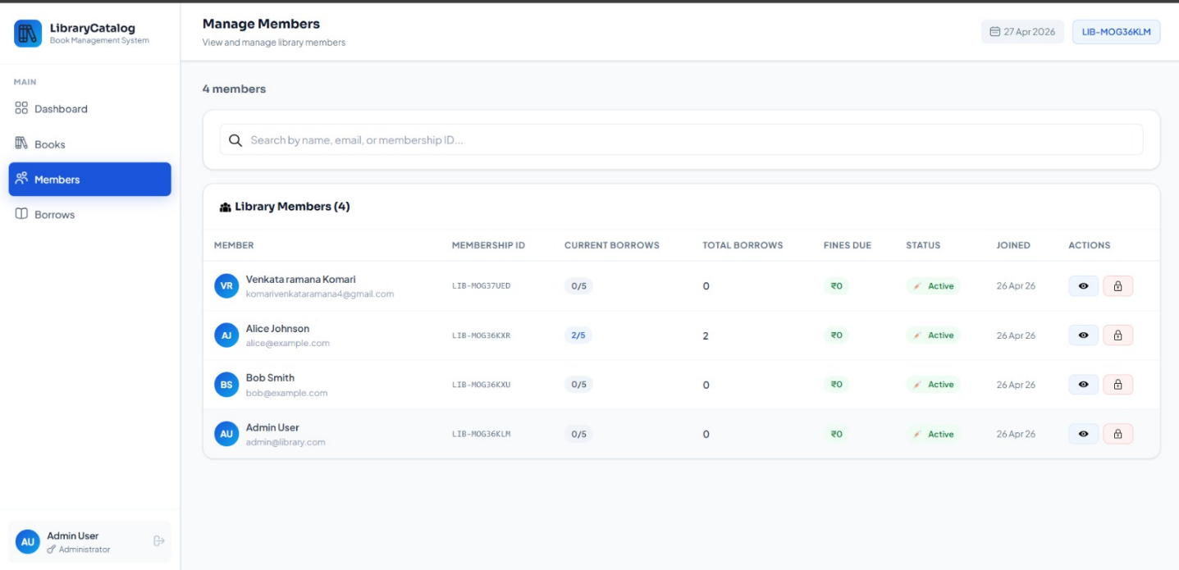

ROLES AND RESPONSIBILITIES

Member
- Registration and Account Management: Create account, manage profile, and maintain passwordsecurity.
- Book Search and Borrowing: Search and browse the catalogue, borrow available books, and manageactive borrows from the dashboard.
- Renewals and Returns: Renew borrows online (up to 2 times) and return books through the MyBorrows page before the due date.
- Fine Awareness: Return books on time to avoid overdue fines of Rs.5 per day, tracked automaticallyon the dashboard.
- Reviews and Feedback: Provide ratings and written reviews on books that have been read.

Admin
- System Management: Oversee platform health, manage configurations, and monitor borrow activityvia the analytics dashboard.
- Book Catalogue Management: Add new books with details and cover images, update existing entries,and remove outdated records.
- Member Management: View all registered members, monitor borrow histories, and take action onaccounts when needed.
- Borrow and Fine Management: Process returns, mark fines as paid, and manage overdue escalations.

User Flow
- Registration and Account — Create and manage account details securely.
- Search and Borrowing — Find books by search and filter, then borrow.
- Renewals and Returns — Renew or return books online via My Borrows page.
- Fine Tracking — View and track overdue fines on the dashboard.
- Feedback — Leave ratings and reviews on completed reads.

Admin Flow
- System Management — Oversee app performance, settings, and security.
- Book Management — Add, edit, and delete books in the catalogue.
- Member Management — Monitor and manage registered user accounts.
- Borrow and Fine Management — Process returns and mark fines as paid.

MVC PATTERN
The Library Book Catalog follows the Model-View-Controller (MVC) architectural pattern, separating the application into three clearly defined layers for modularity, maintainability, and scalability.

Model Layer (Data Layer)
The Model layer handles all data-related logic. Schemas and models are implemented using Mongoose for MongoDB. Models include User, Book, Borrow, Review, and Fine.

Controller Layer
The Controller layer acts as the intermediary between routes and models. It receives requests, applies business logic, calls the appropriate Mongoose model methods, and returns JSON responses.

View Layer (Routing Layer)
In this REST API context, the View is implemented as the Express routing layer. Routes define endpoints (GET, POST, PUT, DELETE) and invoke the corresponding controller functions.

Advantages of MVC
- Separation of Concerns: Each layer has a clearly defined responsibility.
- Scalability: New features can be added by creating new routes, controllers, and models.
- Reusability: Controller and model logic can be reused across multiple endpoints.
- Testability: Each layer can be unit tested independently.
- Collaboration-Friendly: Multiple developers can work on different layers simultaneously.
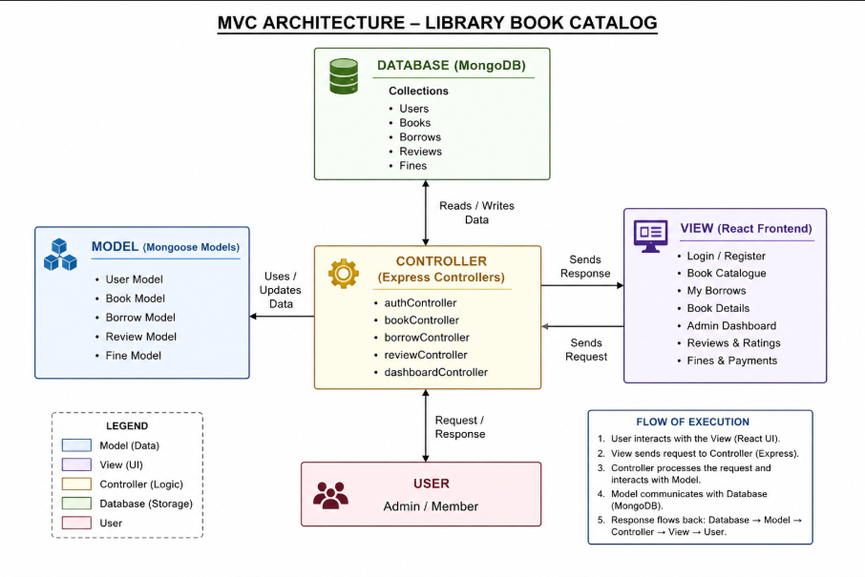

PROJECT SETUP AND CONFIGURATION

Creating the Project Folder
- Create a new folder named library-book-catalog.
- Inside it, create two subfolders: client and server.
- Open the root folder in VS Code.

Client Setup (React via Vite)
Open the client folder in the terminal and run:
npm create vite@latest . -- --template react
Select React as the framework and JavaScript as the variant. Then install dependencies and start the dev server:
npm install npm run dev
The React app will be available at http://localhost:3000

Server Setup
Open the server folder in a separate terminal and run:
npm init -y
Create the following structure inside server/:
- server.js — Express entry point
- controllers/ — authController.js, bookController.js, borrowController.js, reviewController.js,dashboardController.js
- models/ — User.js, Book.js, Borrow.js, Review.js, Fine.js
- routes/ — authRoutes.js, bookRoutes.js, borrowRoutes.js, reviewRoutes.js, dashboardRoutes.js
- middleware/ — authMiddleware.js, upload.js
- utils/ — seed.js
- .env — MONGO_URI, JWT_SECRET, PORT

Environment and Database
Set the following values in your .env file:
MONGO_URI=mongodb://localhost:27017/library JWT_SECRET=your_secret_key
PORT=5000

Seed the database with sample data by running:
cd server && npm run seed

BACKEND DEVELOPMENT

Controllers
- authController.js — Handles registration, login, and JWT token generation. Passwords are hashedwith bcrypt.
- bookController.js — Handles CRUD operations for the book catalogue including cover image uploadvia Multer.
- borrowController.js — Handles borrow creation, renewal (max 2 times), and return logic.
- reviewController.js — Handles creation and retrieval of book reviews and star ratings.
- dashboardController.js — Aggregates statistics for admin and user dashboards.

Middleware
- authMiddleware.js — Verifies JWT token on protected routes and attaches user object to req.user.
- upload.js — Multer-based middleware for handling book cover image uploads.

MongoDB Schemas

Users.js
Fields: name (String), email (String, unique), password (String, hashed), role (String: admin/member, default: member), createdAt (Date).

Book.js
Fields: title, author, genre, description, coverImage (String, file path), totalCopies (Number), availableCopies (Number), createdAt (Date).

Borrow.js
Fields: userId (ref: User), bookId (ref: Book), borrowDate (Date), dueDate (Date), returnDate (Date, optional), renewalCount (Number, default: 0), status (String: active/returned/overdue).
Review.js
Fields: userId (ref: User), bookId (ref: Book), rating (Number, 1–5), comment (String), createdAt (Date).

Fine.js
Fields: borrowId (ref: Borrow), userId (ref: User), amount (Number), paid (Boolean, default: false), createdAt (Date).

FRONT-END DEVELOPMENT

Admin Pages (src/pages/admin/)
- AdminDashboard.js — Dashboard with stats cards and Chart.js analytics charts.
- AdminBooks.js — Full book management with add, edit, delete, and image upload.
- AdminUsers.js — View and manage all registered members.
- AdminBorrows.js — Manage all borrow records, process returns, and mark fines as paid.

User Pages (src/pages/)
- Login.js — Login form. Stores JWT in Context on success.
- Register.js — Registration form with name, email, and password.
- UserDashboard.js — Dashboard showing active borrows, due dates, history, and fines.
- BookCatalogue.js — Browsable catalogue with search by title/author and genre filter.
- MyBorrows.js — Lists active and past borrows with Renew and Return action buttons.

Shared Components and Services
- Layout.jsx — Wrapper providing consistent page structure, sidebar, and header.
- Sidebar.jsx — Role-aware navigation — different links for admin vs member.
- context/AuthContext.js — Global state for authenticated user and JWT token.
- services/ — Axios API call files organized by domain with JWT interceptor.
- styles/ — Global CSS with white and blue theme, Google Fonts (Plus Jakarta Sans + Sora).

API ENDPOINTS
Method Route Description

POST /api/auth/register — Register a new user account
POST /api/auth/login — Login and receive JWT token
GET /api/books — Get all books (search & filter)
GET /api/books/:id — Get single book details
POST /api/books — Add a new book (admin only)
PUT /api/books/:id — Update book details (admin only)
DELETE /api/books/:id — Delete a book (admin only)
POST /api/borrows — Borrow a book (member)
PUT /api/borrows/return/:id — Return a borrowed book
PUT /api/borrows/renew/:id — Renew a borrow (max 2x)
GET /api/borrows — Get all borrow records
POST /api/reviews — Add a book review (member)
GET /api/reviews/:bookId — Get reviews for a book
GET /api/dashboard/admin — Admin analytics and stats
GET /api/dashboard/user — User dashboard stats

LOGIN CREDENTIALS
The following default credentials are created when the database seeder is run:
Role Email Password

Admin admin@library.com — admin123
Member alice@example.com — password123

CONCLUSION

The Library Book Catalog is a complete fullstack web application demonstrating the practical application of the MERN stack in solving real-world library management challenges.
The project implements industry-standard practices including JWT-based authentication, role-based access control, MVC architecture, RESTful API design, and responsive UI design. Members benefit from a seamless borrowing experience with online renewals, return tracking, and fine visibility. Admins gain full control through a comprehensive dashboard with analytics and book management.
Key technical achievements include secure password hashing with bcrypt, protected routes enforced on both frontend and backend, automated fine calculation for overdue items, file upload handling with Multer, and real-time data visualization with Chart.js.
Future enhancements could include email notifications for due dates, a book reservation and waitlist system, barcode scanning for physical book management, integration with external book APIs (Google Books), and a mobile-responsive PWA version.

Githhub Repo Link: https://github.com/charanbalaji2005/Library-Book-Catelog

video link: https://youtu.be/o4X8YpwEQWw

