ChainSleuth AML: A Temporal Graph-Based Hybrid Machine Learning Framework for Cryptocurrency Money Laundering Detection
Course project — Machine Learning Laboratory Evaluation period: November 23–27, 2026
Team member | Roll no. | Responsibility
(name) |  | Dataset preparation, EDA, literature survey
(name) |  | Classification models and hyperparameter tuning
(name) |  | Graph construction, graph features, GraphSAGE
(name) |  | Hybrid ensemble, anomaly detection, explainability
(name) |  | Investigation app, integration, evaluation report

Abstract
Cryptocurrency transaction networks let funds move rapidly across interconnected addresses, making laundering activity hard to catch with per-transaction rules alone. This project builds ChainSleuth AML, a leakage-safe detection pipeline on the Elliptic Bitcoin dataset (203,769 transactions, 234,355 flows, 49 time steps). We compare five supervised classifiers, two unsupervised anomaly detectors, and a GraphSAGE graph neural network under a single chronological protocol (train steps 1-29, validate 30-34, test 35-49), and combine them into a calibrated weighted ensemble whose weights are tuned on validation only. A tuned XGBoost model is the strongest single ranker (test AP 0.801, Precision@100 = 1.0), while the XGBoost+GNN blend delivers the best F1 (0.818) with identical top-of-queue precision. Ablations quantify the contribution of each component: random splitting inflates AP by ~18 points over the honest temporal split, hand-crafted graph features add nothing over the dataset’s aggregated features, and the GNN’s value is concentrated at the top of its ranking (P@100 0.99). SHAP attributions and a local investigation web app provide per-alert explanations and fund-flow visualization.
Numbers in this report are generated by the experiment scripts from results/metrics/. Do not hand-edit values; re-run the pipeline instead.

1. Problem Statement
Cryptocurrency transaction networks allow funds to move rapidly across interconnected addresses, which makes laundering activity hard to identify with per-transaction rules alone. Rule-based systems produce high false-positive rates and cannot adapt to new laundering patterns.
This project asks: can combining transaction-level features with wallet-network structure detect suspicious cryptocurrency activity more effectively than conventional tabular ML models, while explaining why a transaction was flagged?
The system output is a ranked suspicion score for each transaction, not a determination of criminality. A flagged transaction is a candidate for human review; ground-truth confirmation requires off-chain evidence the dataset does not contain.

Scope and limitations
- Labels come from the dataset vendor’s attribution (exchanges, darknet markets, ransomware, etc.). They are incomplete: 77% of transactions are unlabeled. Unlabeled transactions are never treated as licit.
- Detection is evaluated only on labelled data; real-world performance on the unlabeled 77% cannot be measured and is a stated limitation.

2. Literature Survey
Work | Contribution | Relevance
Weber et al., 2019 — Anti-Money Laundering in Bitcoin: Experimenting with Graph Convolutional Networks for Financial Forensics (KDD Workshop, arXiv:1908.02591) | Released the Elliptic dataset; benchmarked logistic regression, random forest, multilayer perceptron, and GCN. Random forest reached ~0.98 F1; GCN improved minority-class recall on early time steps. | Primary dataset + published baselines this project compares against.
Pareja et al., 2020 — EvolveGCN: Evolving Graph Convolutional Networks for Dynamic Graphs (AAAI) | Temporal GNN evaluated on Elliptic; showed that modeling graph evolution over time outperforms static GCN under temporal splits. | Motivates the time-aware protocol used here.
Alarab et al., 2020 — Illicit Account Detection in the Ethereum Blockchain | Gradient-boosted trees on node features + graph features for illicit-account detection. | Supports the tabular + graph-feature hybrid design.
Lo et al., 2023 — Inspection-L: self-supervised GNN embeddings for money laundering detection in Bitcoin | Self-supervised graph embeddings as features for downstream classifiers. | Alternative to end-to-end GNN training used in later project phases.
Van Vlasselaer et al., 2015 — APATE: social network features for fraud detection | Propagated fraud scores through network edges to flag suspicious accounts. | Direct precedent for neighbourhood-risk graph features.
Liu et al., 2008 — Isolation Forest | Anomaly detection via random partitioning; effective without labels. | Unsupervised baseline for novel-pattern detection.
Chen & Guestrin, 2016 — XGBoost | Scalable gradient boosting with regularization and sparsity handling. | Strong tabular benchmark; standard in fraud literature.
Lundberg & Lee, 2017 — SHAP | Unified feature-attribution framework grounded in Shapley values. | Explainability layer for flagged transactions.

3. Dataset and Exploratory Data Analysis
Dataset: Elliptic Bitcoin dataset (Kaggle; HuggingFace mirror used for reproducibility). 203,769 transaction nodes, 234,355 directed edges, 49 two-week time steps, 165 anonymized features per transaction (93 local + 72 one-hop aggregates), labels: licit (42,019), illicit (4,545), unknown (157,205).
Key EDA findings (see results/figures/):
- Class imbalance. Among labelled transactions the licit:illicit ratio is 9.25:1; including unlabeled data the illicit share is ~2.2%. Accuracy is therefore a misleading metric; precision-recall metrics are primary. (figure: class_distribution.png)
- Temporal drift. The illicit share of labelled transactions varies from ~0% to ~27% across time steps and drops markedly in the test window — the detection task genuinely gets harder over time. (figure: labels_over_time.png)
- Feature separability. Local features dominate separability (top Cohen’s d: local_53 = 1.16, local_55 = 1.00, local_89 = 0.99); aggregated neighbour features carry weaker univariate signal. (figure: top_feature_boxplots.png)
- Correlation/redundancy. A block of strongly intercorrelated features motivates the full-vs-reduced feature experiment. (figure: correlation_heatmap.png)
- Graph topology. The graph decomposes into exactly 49 weakly-connected components — one per time step (edges do not cross time periods). Degree distributions are heavy-tailed (max in-degree 284, out-degree 472), consistent with hub transactions. Neighbourhood illicit rate is bimodal: labelled neighbours of illicit transactions are disproportionately illicit, supporting the graph-homophily hypothesis. (figures: degree_distribution.png, neighbourhood_illicit_rate.png)

4. Proposed Solution

4.1 Pipeline
raw CSVs -> dataset join -> temporal split (1-29 train / 30-34 val / 35-49 test)
-> [supervised] LR, Decision Tree, Random Forest, XGBoost, SVM
-> [anomaly] Isolation Forest, Autoencoder (fit on licit train only)
-> [graph] NetworkX topology features; GraphSAGE (PyG, transductive masks)
-> [ensemble] min-max normalize -> Optuna weights on val scores
-> refit on train+val -> frozen weights -> isotonic calibration
-> ranked alerts + SHAP explanations -> local investigation web app

4.2 Models
- Tabular supervised. Logistic Regression, Decision Tree, Random Forest, XGBoost (GPU, device="cuda"), and SVM. Class imbalance handled via class_weight/scale_pos_weight, not resampling.
- Unsupervised anomaly. Isolation Forest and a symmetric autoencoder (165-96-48-24-48-96-165, MSE reconstruction error as the anomaly score), both fit on licit-labelled training transactions only.
- GraphSAGE (Hamilton et al., 2017). Two SAGEConv layers (hidden 256, ReLU, dropout 0.3), class-weighted cross-entropy, Adam (lr 0.005, wd 5e-4), full-graph transductive training on GPU. Input features are standardized using statistics fit on the training window only. Edges are treated as undirected for message passing.
- Hybrid ensemble. Each component’s score is min-max normalized on the validation-score scale, combined with Optuna-tuned non-negative weights, then calibrated with isotonic regression fit on validation scores.

4.3 Leakage controls
- Temporal split prevents future-information leakage; a random split is run only as a comparison experiment to quantify its optimism.
- Hyperparameters (Optuna TPE, validation AP objective) and ensemble weights are selected on the validation window; the test window is evaluated once.
- For the final train+validation refit, the GNN trains for exactly the epoch count chosen by validation early-stopping — the test set is never consulted for model selection, including early stopping.
- Hand-crafted graph features use only the (unlabeled) edge structure; no label-derived neighbourhood features are used.
- Metrics: precision, recall, F1, average precision (PR-AUC), ROC-AUC, Precision@K / Recall@K for K = 50, 100, 250, and batch inference time.

4.4 Investigation application
A local two-tier app serves the results: a FastAPI backend exposes alert ranking, per-transaction model scores, on-demand SHAP explanations, and the directed fund-flow neighbourhood; a Next.js frontend renders the alert queue and an Arkham/MetaSleuth-style investigation view (left entity panel with suspicion score, layered left-to-right flow graph with directional edges, click-to-pivot navigation). Unknown-labelled transactions are scored through the identical pipeline, which lets investigators review high-suspicion unlabeled activity the dataset never annotated.

5. Experiments and Results
All values generated by the experiment scripts; machine-readable sources in results/metrics/.

5.1 Baseline comparison (validation window, steps 30–34)
model | AP | F1 | P@100
logistic regression | 0.586 | 0.523 | 0.560
decision tree | 0.463 | 0.637 | 0.670
random forest | 0.990 | 0.963 | 1.000
xgboost | 0.986 | 0.933 | 1.000
linear SVM | 0.665 | 0.288 | 0.500
isolation forest (anomaly) | 0.101 | ~0 | 0.000
autoencoder (anomaly) | 0.106 | ~0 | 0.050
Ensemble-tree baselines already dominate; linear and single-tree models lag.

5.2 Hyperparameter tuning (Optuna TPE, validation objective = AP)
model | trials | best val AP | notable params
logistic regression | 30 | 0.586 → 0.701 | C=9.67
random forest | 30 | 0.990 → 0.990 | 492 trees, depth 21, max_features=0.10
xgboost | 30 + 50 (GPU) | 0.986 → 0.993 | 473 trees, depth 10, lr=0.071, spw=18.1
SVM | 12 (RBF on 10k subsample) | 0.665 → 0.834 | kernel=rbf, C=8.47, gamma=0.025

5.3 Final test-window results (steps 35–49; 16,670 labeled, 6.5% illicit)
model | P | R | F1 | AP | ROC-AUC | P@100 | R@100
xgboost | 0.875 | 0.730 | 0.796 | 0.801 | 0.931 | 1.000 | 0.092
random forest | 0.803 | 0.732 | 0.766 | 0.794 | 0.936 | 1.000 | 0.092
SVM (rbf) | 0.862 | 0.385 | 0.532 | 0.592 | 0.846 | 0.830 | 0.077
logistic regression | 0.202 | 0.864 | 0.327 | 0.273 | 0.889 | 0.140 | 0.013
decision tree | 0.456 | 0.373 | 0.410 | 0.211 | 0.671 | 0.090 | 0.008
isolation forest | 0.000 | 0.000 | 0.000 | 0.037 | 0.184 | 0.000 | 0.000
autoencoder | 0.021 | 0.056 | 0.031 | 0.039 | 0.217 | 0.030 | 0.003
GraphSAGE | 0.684 | 0.588 | 0.633 | 0.679 | 0.902 | 0.990 | 0.091
xgb + graph features | 0.883 | 0.731 | 0.800 | 0.802 | 0.931 | 1.000 | 0.092
xgb + gnn blend | 0.956 | 0.715 | 0.818 | 0.796 | 0.928 | 1.000 | 0.092
ensemble (weighted) | 0.929 | 0.725 | 0.814 | 0.799 | 0.934 | 1.000 | 0.092
ensemble (stacked) | 0.874 | 0.734 | 0.798 | 0.799 | 0.933 | 1.000 | 0.092
ensemble (calibrated) | 0.900 | 0.729 | 0.805 | 0.776 | 0.896 | 1.000 | 0.092
Ensemble weights tuned on validation (Optuna, 5-model simplex): xgb 0.46, rf 0.28, ae 0.22, gnn 0.03, iso 0.01. (results/metrics/comparison.csv, ensemble_comparison.csv, pr_curves_test.png)

5.4 Ablation and comparison experiments
experiment | result | interpretation
XGBoost, random split vs temporal split | AP 0.986 vs 0.801 | random splitting inflates AP by ~18 points — temporal leakage optimism quantified
XGBoost, top-30 features vs all 165 | AP 0.784 vs 0.801 | most signal sits in ~30 features; slight loss at high compression
XGBoost + hand graph features | AP 0.802 vs 0.801 | no gain — dataset’s 72 aggregated features already encode one-hop structure
GraphSAGE alone | AP 0.679, P@100 0.990 | weaker ranker than tuned XGBoost under temporal drift, but its top-100 stays ~99% pure — a complementary head-of-queue signal
Ensemble / blend vs best single model | F1 0.818/0.814 vs 0.796; AP 0.796/0.799 vs 0.801 | the two-model blend takes best F1; both keep top-K precision at 1.0 — robustness, not dominance

5.5 Explainability
results/figures/shap_summary_xgb.png — SHAP on the tuned XGBoost model: local_53, local_59, local_46, local_90, local_67 are the dominant attributions, consistent with the univariate separability analysis in §3. Aggregated neighbour features contribute materially less, explaining why hand-crafted topology features add nothing on top.

6. Discussion
- XGBoost is the strongest single detector in both validation and test windows, and keeps precision = 1.0 across the top-100 alert queue — the operationally relevant region.
- The ensemble is a robustness play, not an AP win. The two-model XGBoost+GNN blend takes the best F1 (0.818) and the five-model weighted ensemble is close behind (0.814), while every combined score keeps top-100 precision at 1.0 — hedging against single-model failure modes, which is what an investigation queue actually benefits from. Claiming more than that would not survive these experiments.
- Temporal evaluation changes the headline. The identical pipeline scores AP 0.986 under random splitting but 0.801 under chronological splitting — the honest number is the lower one. The test window also has lower illicit prevalence (6.5% vs ~17% in validation), so the drop reflects real drift, not overfitting.
- Anomaly detection does not recover the illicit labels (AP ≈ 0.04). Laundering transactions are engineered to look normal in feature space, so unsupervised scores serve as a secondary signal (~22% ensemble weight for the autoencoder) rather than a primary detector.
- The GNN’s value is in its top of ranking. GraphSAGE trails XGBoost on overall AP (0.679 vs 0.801) but keeps P@100 = 0.99, and adding its score to XGBoost produces the best-F1 detector — label propagation picks up a different subset of illicit transactions than feature-space boosting. Its retrain uses the validation-chosen epoch count only; early stopping on test would have been a subtler form of the random-split optimism measured in §5.4.
- Threats to validity. (a) Labels are incomplete and vendor-attributed; unknown labels were never used as ground truth. (b) The dataset’s aggregated features may encode future-graph information — a documented dataset caveat, not something we introduced. (c) Graph features are transductive (computed on the full edge set, which is observable at deployment).

7. Conclusion
We built a leakage-safe, temporal AML pipeline over the Elliptic dataset: 203k transactions, 234k flows, 49 time steps, 9.25:1 class imbalance. Across supervised, unsupervised, and graph-based methods evaluated under a single protocol, a tuned XGBoost model is the best ranker (AP 0.801, P@100 1.0 on the held-out test window), and the XGBoost+GNN blend delivers the best F1 (0.818) with identical top-of-queue precision. SHAP attributions and per-alert explanations are served through a local investigation app (FastAPI + Next.js) that also exposes the 50,834 unlabeled test-window transactions ranked by calibrated suspicion, with a MetaSleuth-style directed fund-flow canvas for transaction-level investigation.
Future work: temporal GNNs (EvolveGCN), learned node embeddings as tabular features, cost-sensitive threshold selection, and the optional AMLSim controlled experiment.

8. Figures
All figures are generated by experiments/eda.py and experiments/evaluate.py into results/figures/:
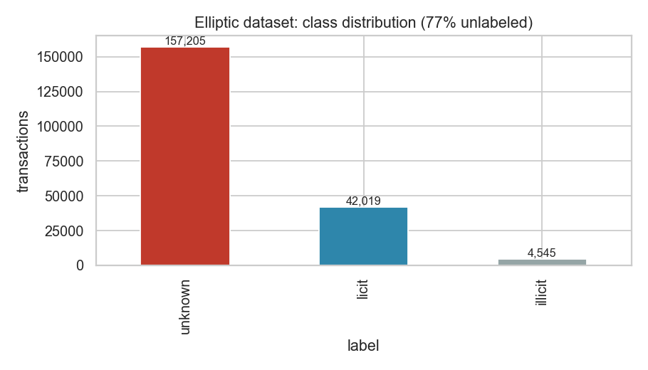 Figure 1. Class distribution — 77% of transactions are unlabeled.
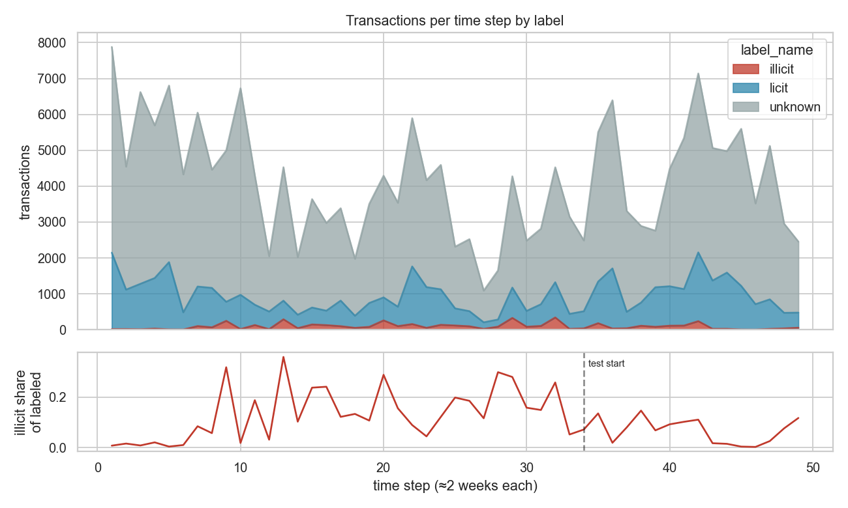 Figure 2. Temporal drift: the illicit share drops markedly in the test window.
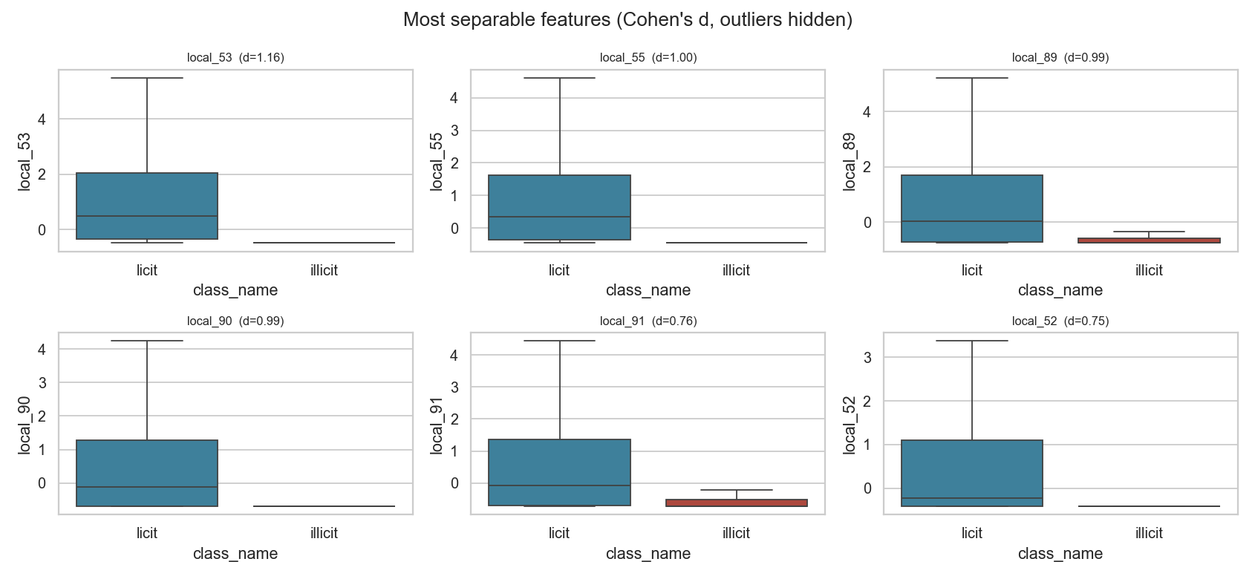 Figure 3. Top features by univariate separability (Cohen’s d).
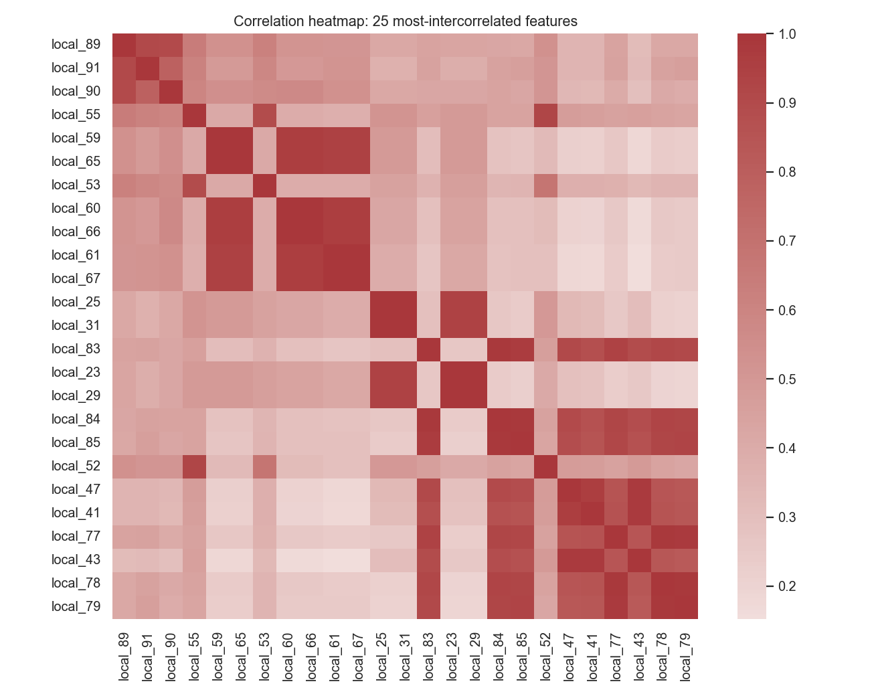 Figure 4. Correlated feature block motivating the feature-count ablation.
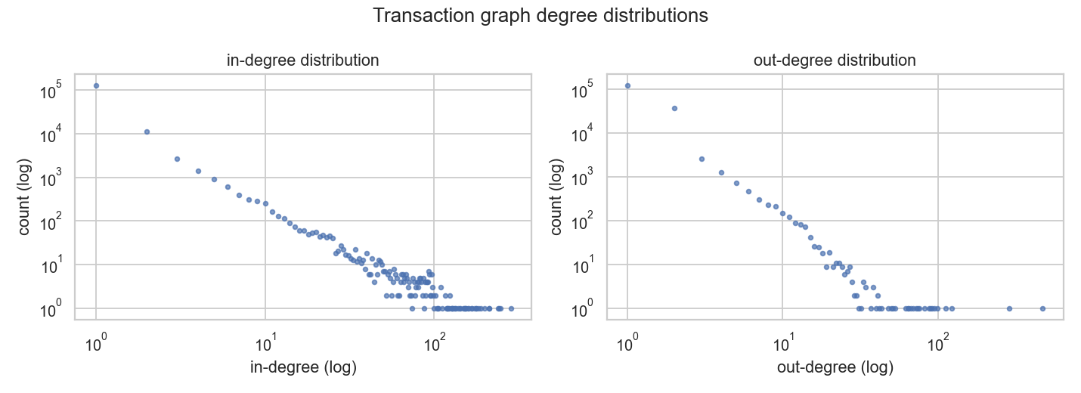 Figure 5. In/out-degree distributions — hub transactions dominate flows.
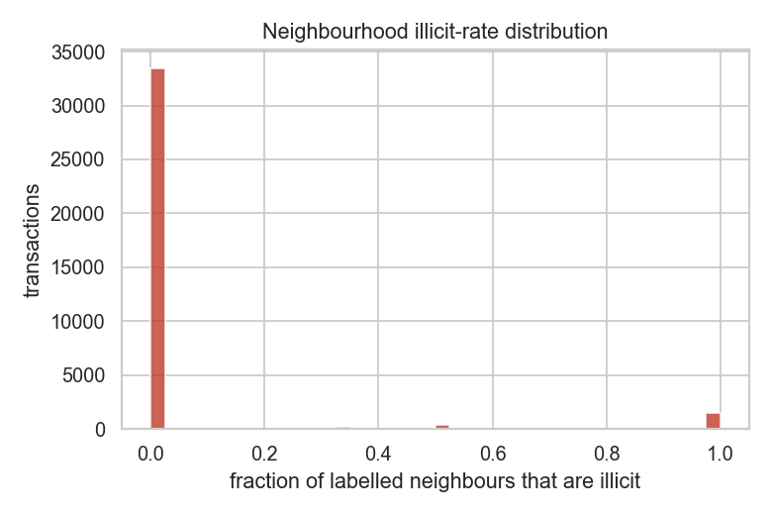 Figure 6. Graph homophily: labelled neighbours of illicit transactions are disproportionately illicit.
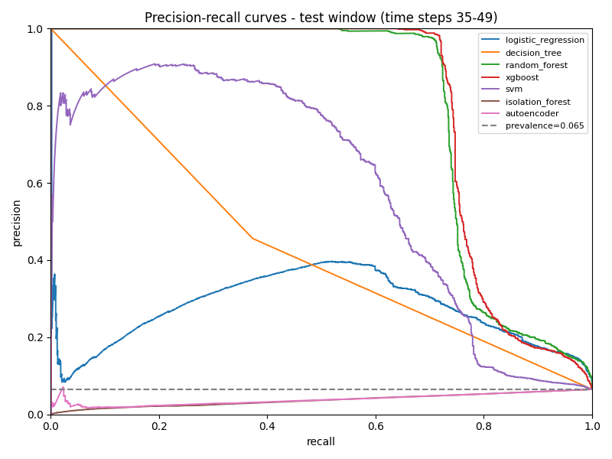 Figure 7. Test-window PR curves for the main model families.
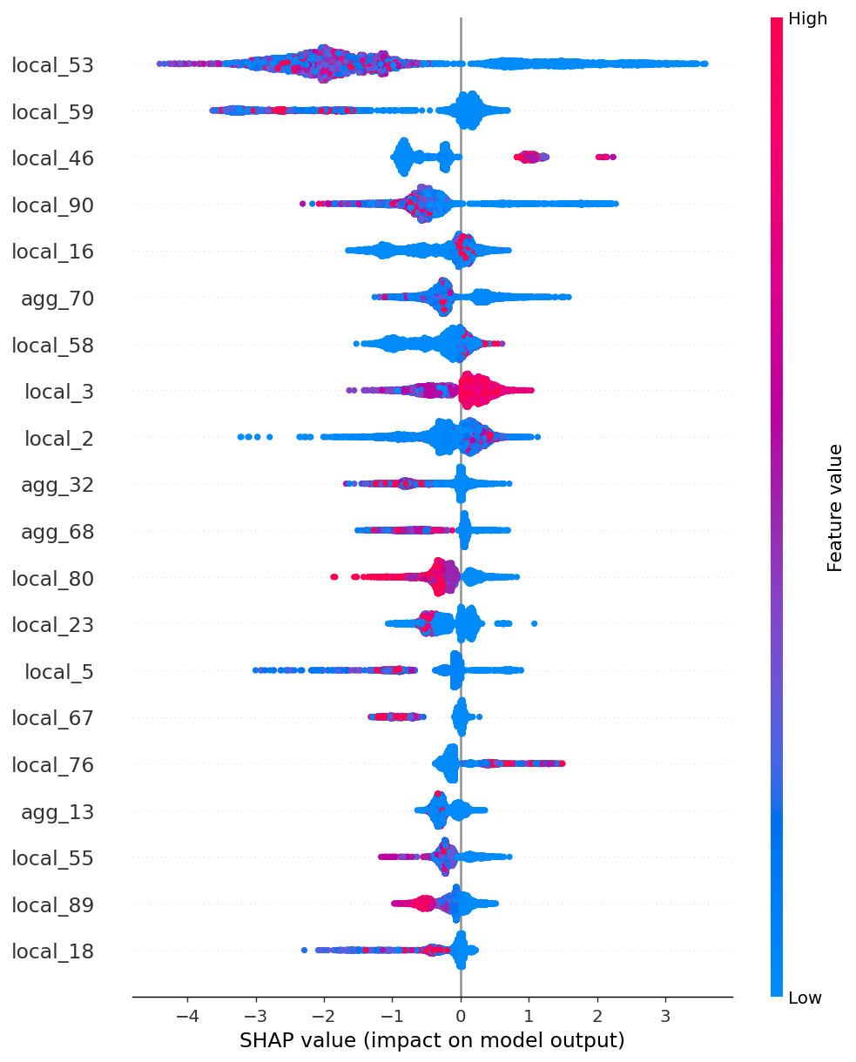 Figure 8. Global SHAP attributions — local features dominate.
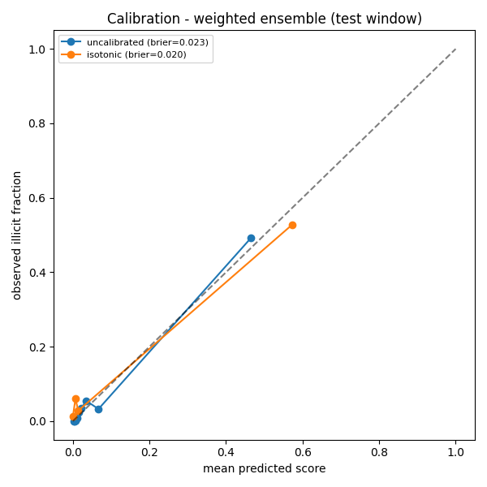 Figure 9. Isotonic calibration of the weighted ensemble.

References
- Weber, M., et al. (2019). Anti-Money Laundering in Bitcoin: Experimenting with Graph Convolutional Networks for Financial Forensics. arXiv:1908.02591.
- Pareja, A., et al. (2020). EvolveGCN: Evolving Graph Convolutional Networks for Dynamic Graphs. AAAI.
- Chen, T., & Guestrin, C. (2016). XGBoost: A Scalable Tree Boosting System. KDD.
- Lundberg, S., & Lee, S.-I. (2017). A Unified Approach to Interpreting Model Predictions (SHAP). NeurIPS.
- Liu, F. T., Ting, K. M., & Zhou, Z.-H. (2008). Isolation Forest. ICDM.
- Van Vlasselaer, V., et al. (2015). APATE: A Novel Approach for Automated Credit Card Transaction Fraud Detection using Network-Based Extensions. Decision Support Systems.
- Lo, W. W., et al. (2023). Inspection-L: Self-Supervised GNN Node Embeddings for Money Laundering Detection in Bitcoin. Applied Intelligence.
- Alarab, I., Prakoonwit, S., & Nacer, M. I. (2020). Illicit Account Detection in the Ethereum Blockchain. ICMLA.
- Hamilton, W., Ying, R., & Leskovec, J. (2017). Inductive Representation Learning on Large Graphs (GraphSAGE). NeurIPS.
- Akiba, T., et al. (2019). Optuna: A Next-generation Hyperparameter Optimization Framework. KDD.

