Industrial Internship Report on
Prediction of Agriculture Crop Production in India
Prepared by
[Venkatesh Pamudurti]

Executive Summary
This report provides details of the Industrial Internship provided by upskill Campus and The IoT Academy in collaboration with Industrial Partner UniConverge Technologies Pvt Ltd (UCT).
This internship was focused on a project/problem statement provided by UCT. We had to finish the project including the report in 6 weeks’ time.
My project was Prediction of Agriculture Crop Production in India. Crop yield prediction is an important aspect of agriculture that helps farmers make informed decisions about their crops. It involves estimating the number of crops that will be produced in a given area based on various factors such as soil type, weather conditions, and crop management practices. In recent years, machine learning (ML) has emerged as a powerful tool for predicting crop yields. Machine learning is a branch of artificial intelligence (AI) that allows computers to learn from data without being explicitly programmed. This makes it ideal for crop yield
prediction because it can identify patterns and relationships in large amounts of data and make predictions
based on these relationships.
This internship gave me a very good opportunity to get exposure to Industrial problems and design/implement solution for that. It was an overall great experience to have this internship.

TABLE OF CONTENTS
1 Preface 3
2 Introduction 7
2.1 About UniConverge Technologies Pvt Ltd 7
2.2 About upskill Campus 11
2.3 Objective 13
2.4 Reference 13
2.5 Glossary Error! Bookmark not defined.
3 Problem Statement 14
4 Existing and Proposed solution 15
5 Proposed Design/ Model 17
6 Performance Test 18
6.1 Test Plan/ Test Cases 18
6.2 Test Procedure 18
6.3 Performance Outcome 18
7 My learnings 19
8 Future work scope 20

Preface

This internship report encapsulates the enriching journey of a six-week intensive training program on Python, undertaken with the goal of enhancing both theoretical understanding and practical application skills in one of the most versatile programming languages. The structured curriculum aimed to cover foundational concepts, delve into advanced topics, and provide hands-on experience through project-based learning. The following report outlines the weekly breakdown of the internship, detailing the topics covered and the projects completed.
Week 1: Basics of Python and One Project
The first week served as an introduction to the fundamentals of Python. Key concepts such as data types, control structures, functions, and error handling were explored. A project was undertaken to apply these basics, focusing on building a simple, functional Python application.
Week 2: Python Packages and One Project
In the second week, the emphasis shifted to Python packages, exploring the vast array of libraries that extend Python’s functionality. The projects involved implementing these packages to solve real-world problems, demonstrating the practical use of libraries such as NumPy, Pandas, and Matplotlib.
Week 3: Flask and Django Frameworks and One Project
The third week introduced web development with Python, specifically focusing on the Flask and Django frameworks. Both frameworks were studied in depth to understand their capabilities in building web applications. A project was completed to showcase the development of a web application using these frameworks.
Week 4: Advanced Topics in Python
Week four delved into advanced topics in Python, including decorators, generators, context managers, and asynchronous programming. This week was crucial for understanding the more complex features of Python that contribute to writing efficient and effective code.
Week 5: Training a Machine Learning Model Using Python and OOP Concepts
The fifth week combined the knowledge of Python with object-oriented programming (OOP) principles to train a machine learning model. This involved understanding the basics of machine learning, data preprocessing, model training, and evaluation, all implemented using Python’s OOP capabilities.

Week 6: Final Project
The final week was dedicated to a comprehensive project that encapsulated all the knowledge gained throughout the internship. This project aimed to integrate various concepts, from basic Python to advanced topics, web development, and machine learning, demonstrating the holistic understanding and application of Python.
This report not only documents the technical knowledge acquired but also reflects on the learning process, challenges faced, and the strategies employed to overcome them. The internship experience has been a transformative journey, significantly enhancing my proficiency in Python and preparing me for future endeavors in the field of software development and data science.
About need of relevant Internship in career development.
Internship is crucial for career development as it provides practical experience and bridges the gap between academic knowledge and real-world application. It allows individuals to gain hands-on skills, understand industry practices, and build a professional network. Internships also enhance a resume, making candidates more attractive to potential employers. They offer a platform to apply theoretical concepts, solve real-world problems, and develop critical thinking and problem-solving skills. Ultimately, an internship lays a strong foundation for a successful and fulfilling career.
Brief about My Project/Problem Statement
My project focuses on the Prediction of Agriculture Crop Production in India, aiming to forecast crop yields using advanced data analysis and machine learning techniques. Agriculture plays a vital role in India's economy, and accurate predictions can help optimize resource allocation, improve supply chain management, and support policy-making decisions. The project involves collecting historical data on weather patterns, soil conditions, crop types, and past production yields. By analyzing this data, the goal is to build predictive models that can accurately forecast future crop production, thereby aiding farmers, agribusinesses, and government agencies in making informed decisions to enhance agricultural productivity and sustainability.
Opportunity given by USC/UCT.
This internship gave me a very good opportunity to get exposure to Industrial problems and design/implement solution for that. It was an overall great experience to have this internship.

How Program was planned
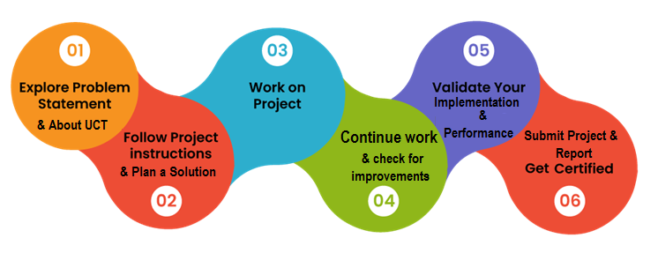
Your Learnings and overall experience.
The internship experience has been immensely rewarding, providing a wealth of knowledge and practical skills that have significantly enriched my understanding of Python and its applications. I have gained a strong foundation in basic and advanced Python programming, explored the extensive library ecosystem, and developed proficiency in web frameworks like Flask and Django. Additionally, the exposure to machine learning and object-oriented programming has been particularly enlightening, allowing me to apply theoretical concepts to real-world problems effectively.
Working on the project "Prediction of Agriculture Crop Production in India" was a highlight of my internship. It honed my data analysis skills and deepened my appreciation for the power of predictive modeling in addressing critical challenges in agriculture. Collaborating with experienced mentors and peers fostered a collaborative learning environment that enhanced my problem-solving abilities and critical thinking skills.
Overall, this internship has been a transformative journey, equipping me with valuable technical expertise and practical experience. It has strengthened my confidence in tackling complex problems and has prepared me for future professional endeavors in the fields of software development and data science.

I would like to extend my heartfelt gratitude to everyone who has supported and guided me throughout this internship journey.
First and foremost, I thank Madhu Parvathaneni sir, my mentor, for their invaluable guidance, insightful feedback, and unwavering support. Your expertise and encouragement have been instrumental in my learning and development.
I am also grateful to Siva Shankar sir, my guide, for providing me with this incredible opportunity and for your continuous support and motivation.
Special thanks to Lakshmi Sesha Sai Maddineni, for your collaboration and assistance during various stages of the project. Your inputs and teamwork have greatly enriched my experience.
I extend my sincere appreciation to UpSkill Campus for providing this internship opportunity. Your commitment to fostering learning and growth has been truly commendable.
Lastly, I thank my family and friends for their unwavering support and encouragement, which has been a constant source of motivation throughout this internship.
Your collective contributions have made this learning experience immensely fulfilling and successful. Thank you all for your guidance and support.
Message to juniors and peers.
To my juniors and peers,
As I reflect on my internship journey, I'm compelled to share a message with you all. Embrace every opportunity with an open mind and a thirst for knowledge. Seize every chance to learn, grow, and challenge yourself. Remember that setbacks are opportunities for growth, and every obstacle you overcome makes you stronger.
Seek guidance from mentors and peers, and never hesitate to ask questions. Collaboration is key to success, so foster a spirit of teamwork and support one another along the way. Remember to celebrate not only your victories but also the lessons learned from your failures.
Stay curious, stay hungry, and stay humble. The journey ahead may be filled with obstacles, but with determination and perseverance, you can overcome them all. Believe in yourself, trust in your abilities, and never stop striving for excellence.
Above all, cherish every moment of this journey. Your internship experience will shape not only your professional growth but also your personal development. Embrace the challenges, savor the successes, and cherish the memories.

Introduction

About UniConverge Technologies Pvt Ltd
A company established in 2013 and working in Digital Transformation domain and providing Industrial solutions with prime focus on sustainability and RoI.
For developing its products and solutions it is leveraging various Cutting Edge Technologies e.g. Internet of Things (IoT), Cyber Security, Cloud computing (AWS, Azure), Machine Learning, Communication Technologies (4G/5G/LoRaWAN), Java Full Stack, Python, Front end etc.
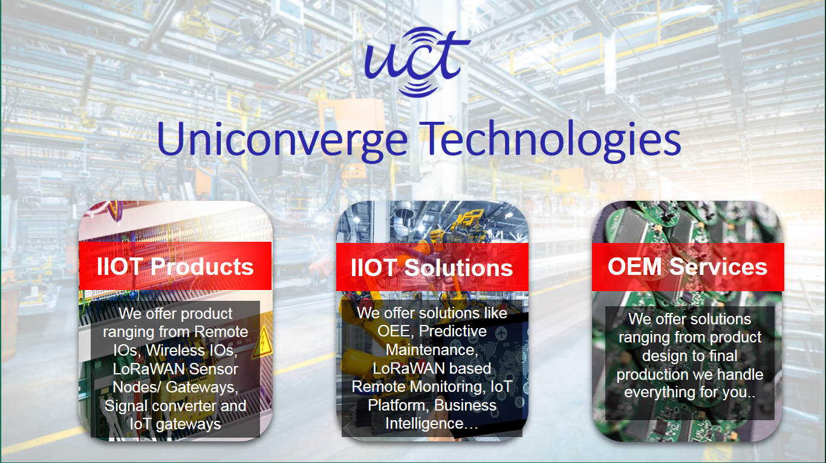
- UCT IoT Platform ()
UCT Insight is an IOT platform designed for quick deployment of IOT applications on the same time providing valuable “insight” for your process/business. It has been built in Java for backend and ReactJS for Front end. It has support for MySQL and various NoSql Databases.
- It enables device connectivity via industry standard IoT protocols - MQTT, CoAP, HTTP, Modbus TCP, OPC UA
- It supports both cloud and on-premises deployments.
It has features to
• Build Your own dashboard
• Analytics and Reporting
• Alert and Notification
• Integration with third party application(Power BI, SAP, ERP)
• Rule Engine

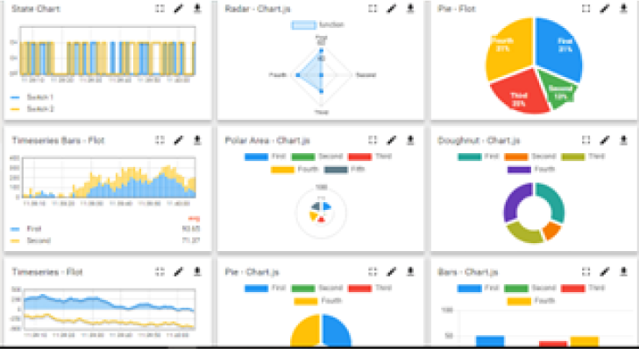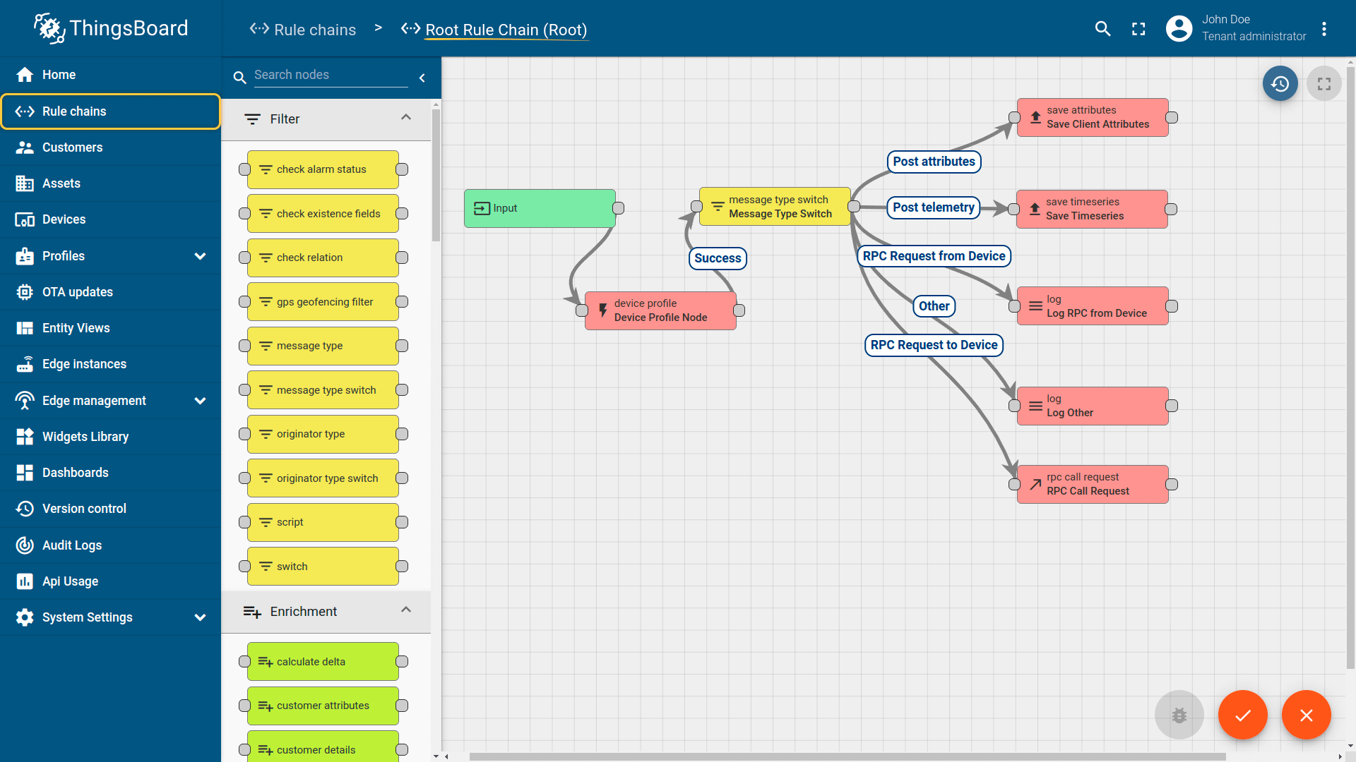

- Smart Factory Platform ()
Factory watch is a platform for smart factory needs.
It provides Users/ Factory
- with a scalable solution for their Production and asset monitoring
- OEE and predictive maintenance solution scaling up to digital twin for your assets.
- to unleased the true potential of the data that their machines are generating and helps to identify the KPIs and also improve them.
- A modular architecture that allows users to choose the service that they what to start and then can scale to more complex solutions as per their demands.
Its unique SaaS model helps users to save time, cost and money.
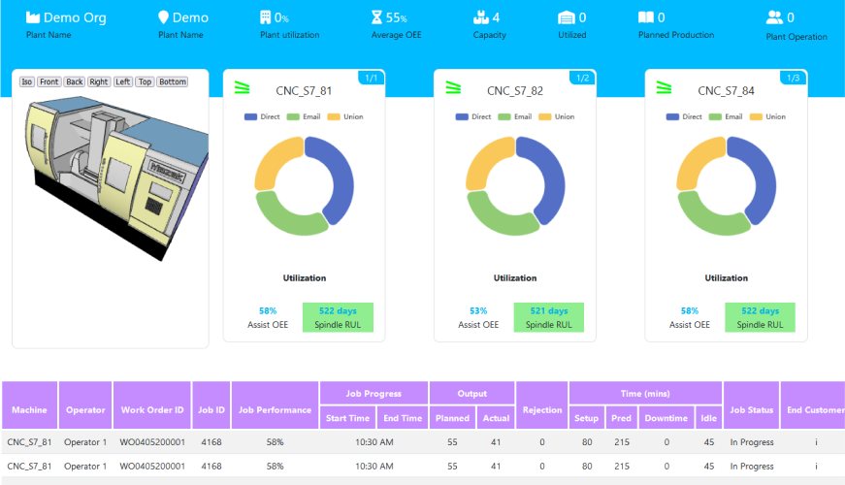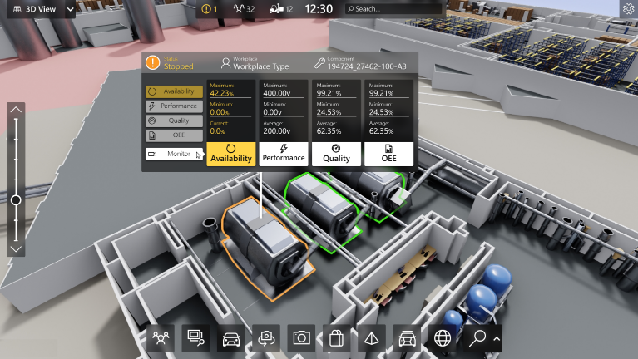

- 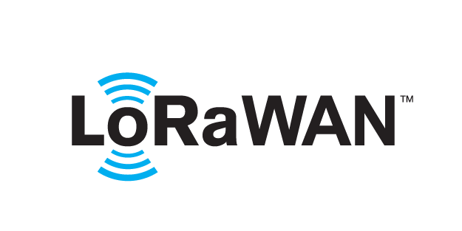 based Solution
UCT is one of the early adopters of LoRAWAN teschnology and providing solution in Agritech, Smart cities, Industrial Monitoring, Smart Street Light, Smart Water/ Gas/ Electricity metering solutions etc.
- Predictive Maintenance
UCT is providing Industrial Machine health monitoring and Predictive maintenance solution leveraging Embedded system, Industrial IoT and Machine Learning Technologies by finding Remaining useful life time of various Machines used in production process.
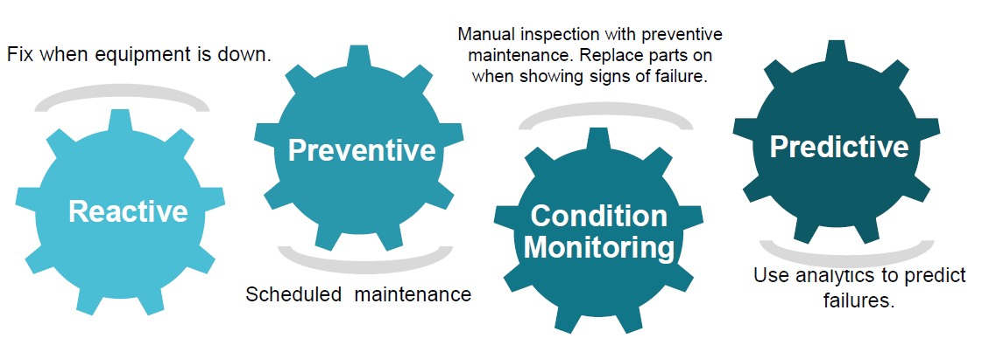

About upskill Campus (USC)
upskill Campus along with The IoT Academy and in association with Uniconverge technologies has facilitated the smooth execution of the complete internship process.
USC is a career development platform that delivers personalized executive coaching in a more affordable, scalable and measurable way.




Seeing need of upskilling in self paced manner along-with additional support services e.g. Internship, projects, interaction with Industry experts, Career growth Services
https://www.upskillcampus.com/
upSkill Campus aiming to upskill 1 million learners in next 5 year

The IoT Academy
The IoT academy is EdTech Division of UCT that is running long executive certification programs in collaboration with EICT Academy, IITK, IITR and IITG in multiple domains.

Objectives of this Internship program
The objective for this internship program was to
☛ get practical experience of working in the industry.
☛ to solve real world problems.
☛ to have improved job prospects.
☛ to have Improved understanding of our field and its applications.
☛ to have Personal growth like better communication and problem solving.

Reference
[1]produce.csv
[2]datafile.csv
[3] https://learn.upskillcampus.com/s/courses/656d72afe4b0c8074bb749cb/take

Problem Statement
The agriculture sector serves as a crucial source of income in India, playing a vital role in the economic and agricultural welfare of the nation. However, the sustainability of agriculture is increasingly under threat, evidenced by the rising rate of farmer suicides attributed to crop failure, low yields, and financial losses. Addressing these challenges is imperative to ensure the stability and prosperity of India's agricultural communities and the broader economy. Consequently, there is a pressing need to enhance the sustainability of agriculture practices in India to mitigate these risks and promote the well-being of farmers and the agricultural sector as a whole.
The problem of predicting agriculture crop production in India is a multifaceted challenge with significant implications for food security, economic stability, and sustainable development. India's agriculture sector is vast and diverse, comprising numerous crops cultivated across various regions with distinct climatic conditions and soil types. However, the unpredictability of factors such as weather patterns, pest infestations, and soil health often leads to fluctuations in crop yields, posing challenges for farmers, policymakers, and stakeholders across the supply chain.
One of the primary issues is the lack of accurate forecasting models to predict crop production with precision. Traditional methods of crop yield estimation rely heavily on historical data and subjective assessments, resulting in limited reliability and accuracy. This inadequacy hampers the ability of farmers to make informed decisions regarding crop selection, resource allocation, and risk management. Additionally, it impedes the efforts of government agencies and policymakers to formulate effective agricultural policies and interventions to address food security and mitigate the impact of crop failures.
Furthermore, the problem extends beyond mere yield prediction to encompass broader issues such as optimizing resource utilization, promoting sustainable agricultural practices, and ensuring equitable distribution of agricultural produce. Without reliable forecasting models, it becomes challenging to implement targeted interventions to address specific challenges faced by farmers, such as water scarcity, soil degradation, or pest outbreaks. Addressing these issues requires innovative approaches that leverage advanced data analysis techniques, machine learning algorithms, and interdisciplinary collaboration to develop robust predictive models that can accurately forecast crop production and support informed decision-making in India's agriculture sector.

Existing and Proposed solution

Existing Solution
Currently, farmers in India rely on traditional methods and anecdotal knowledge to make decisions regarding crop selection and cultivation practices. These methods often lack precision and are susceptible to the uncertainties of weather patterns, soil conditions, and other environmental factors. As a result, farmers face challenges in maximizing crop yields and profitability, leading to instances of crop failure, financial losses, and even farmer suicides.
Proposed Solution
The proposed solution involves the development and implementation of advanced predictive models for crop yield estimation in India. Leveraging techniques from data science, machine learning, and agricultural science, these models will analyze historical data on weather patterns, soil conditions, crop types, and past production yields to generate accurate forecasts of future crop yields. Additionally, the models will consider various attributes such as temperature, rainfall, humidity, soil pH, and nutrient levels to provide comprehensive insights into crop performance under different climatic conditions.
By integrating these predictive models into user-friendly platforms accessible to farmers, agricultural extension workers, and policymakers, the proposed solution aims to democratize access to timely and actionable information that can inform decision-making at every stage of the agricultural value chain. Farmers will be able to use these insights to select the most suitable crops for cultivation based on their specific agro-climatic conditions, thereby optimizing resource allocation, minimizing risks, and maximizing profitability.
Furthermore, the proposed solution will facilitate knowledge sharing and capacity building among stakeholders through training programs, workshops, and extension services. By empowering farmers with the skills and tools to interpret and apply predictive analytics in their farming practices, the solution seeks to foster a culture of data-driven decision-making and innovation within India's agriculture sector.
Overall, the proposed solution represents a transformative approach to addressing the challenges of crop yield prediction in India. By harnessing the power of data and technology, it has the potential to revolutionize agricultural practices, enhance resilience to climate change, and improve the livelihoods of millions of farmers across the country.

Code submission (Github link)
https://github.com/Venkat5674/Upskill-Campus-UCT-Prediction-of-Agriculture-Crop-Production-in-India

Report submission (Github link) :

https://github.com/Venkat5674/Upskill-Campus-UCT-Prediction-of-Agriculture-Crop-Production-in-India

Proposed Design/ Model

In this project, the system makes use of the Machine Learning techniques to predict rate of crop yield. The programming language used is Python as it is widely accepted for new idea implementations in the field of Machine Learning. In this project, collected data set will be uploaded and prediction for crop yield will be generated by applying Machine Learning techniques like Random Forest Regressor and Decision Tree Regressor. The results depend on the information present in the collected data set. Accurate the information about the parameters in the collected datasets, better the results will be.

Performance Test

Test Plan/ Test Cases
The implementation of the project was divided into two i.e crop yield prediction and rainfall prediction (for fertilizers module).
Crop Yield Prediction: This module returns the predicted production of crops based on the user's input. If the user wants to know the production of a particular crop, the system takes the crop as the input as well. Else, it returns a list of crops along with their production as output.
Fertilizers Module: This module is used to suggest the farmer on usage of fertilizer based on the rainfall in next few days. To predict the rainfall for the next 15 days we are using an API service provided by Open Weather. If it is likely to rain we suggest the farmer not to use the fertilizer.

Test Procedure
Step 1: Choose the functionality i.e., crop prediction or yield prediction.
Step 2: If the user chooses crop prediction: Take soil type and area as inputs. These values are given as input to the random forest implementation in the backend and the corresponding are returned. The algorithm returns a list of crops along with their production predicted.
Step 3: If the user chooses yield prediction: Take crop, soil type and area as inputs. These values are given as input to the random forest implementation in the backend and the corresponding crop yield prediction is returned. The algorithm returns the predicted production of the given crop.

Performance Outcome
In the final implementation of the application the first screen the user can view is the login page. Here, the user can register or login using his/her credentials into the application.
The system provides three main functionalities:
i) Yield Prediction: The system takes the required inputs to predict the yield of the given crop.
ii) Crop Prediction: For this module the system takes the required inputs i.e., soil type and area.

My learnings

My learnings from the project have been profound and multifaceted. Firstly, I gained hands-on experience in collecting, processing, and analyzing diverse datasets related to agriculture, including information on weather patterns, soil characteristics, and crop yields. This allowed me to appreciate the complexity of agricultural systems and the multitude of factors that influence crop production.
Moreover, I developed proficiency in utilizing machine learning algorithms and statistical techniques to build predictive models for crop yield estimation. This involved preprocessing data, selecting appropriate features, training and evaluating models, and fine-tuning parameters to improve predictive accuracy. Through this process, I gained insight into the practical applications of data science in addressing real-world challenges in agriculture.
Additionally, collaborating with mentors, peers, and domain experts provided me with invaluable opportunities for knowledge exchange and skill development. By working closely with stakeholders from the agriculture sector, I gained a deeper understanding of the needs and priorities of farmers and agricultural communities, which informed the development of our predictive models and decision-support tools.
Furthermore, the project reinforced the importance of interdisciplinary collaboration and effective communication in driving innovation and achieving impactful outcomes. By leveraging the expertise of individuals from diverse backgrounds, we were able to integrate insights from agronomy, data science, and technology to develop holistic solutions that address the multifaceted challenges of crop yield prediction in India.
Overall, my learnings from the project have equipped me with a comprehensive skill set and a nuanced understanding of the complexities of agricultural systems. I am grateful for the opportunity to contribute to meaningful work that has the potential to improve the livelihoods of farmers and enhance the sustainability of agriculture in India.

Future work scope

In the future, there are several promising avenues for advancing the scope and impact of our work on crop yield prediction in India. Firstly, we can broaden our data collection efforts to encompass a wider range of variables, including satellite imagery, market prices, and socio-economic indicators. By integrating diverse data sources, we can enhance the robustness and accuracy of our predictive models. Additionally, there is a need to continuously refine and optimize these models using advanced machine learning techniques such as ensemble methods and deep learning. Exploring innovative approaches to address challenges such as data scarcity and spatial variability will be critical in improving the reliability of predictions.
Furthermore, developing region-specific predictive models tailored to the unique agro-climatic conditions and cropping patterns prevalent in different states and regions of India holds great promise. By incorporating localized knowledge and expertise, we can enhance the relevance and accuracy of predictions at the sub-regional level, thereby providing more actionable insights to farmers and policymakers. Additionally, building user-friendly decision support systems that offer crop suitability mapping, risk assessment, and scenario analysis features can empower stakeholders to make informed decisions regarding crop planning, resource allocation, and risk management.
Moreover, community engagement and capacity building will be essential for promoting the adoption of data-driven agricultural practices among farming communities. By organizing outreach programs, workshops, and training sessions, we can raise awareness and build the necessary skills and confidence among farmers to leverage predictive analytics effectively. Furthermore, forging partnerships with government agencies, research institutions, and technology companies can help us scale up our efforts and address broader challenges in agricultural development. Through rigorous impact assessments and monitoring, we can evaluate the effectiveness and socio-economic impact of our interventions, thereby ensuring that our work contributes to sustainable agricultural development and food security in India.

