29. Design DFA using simulator to accept the input string “bc” ,”c”,and ”bcaaa”.

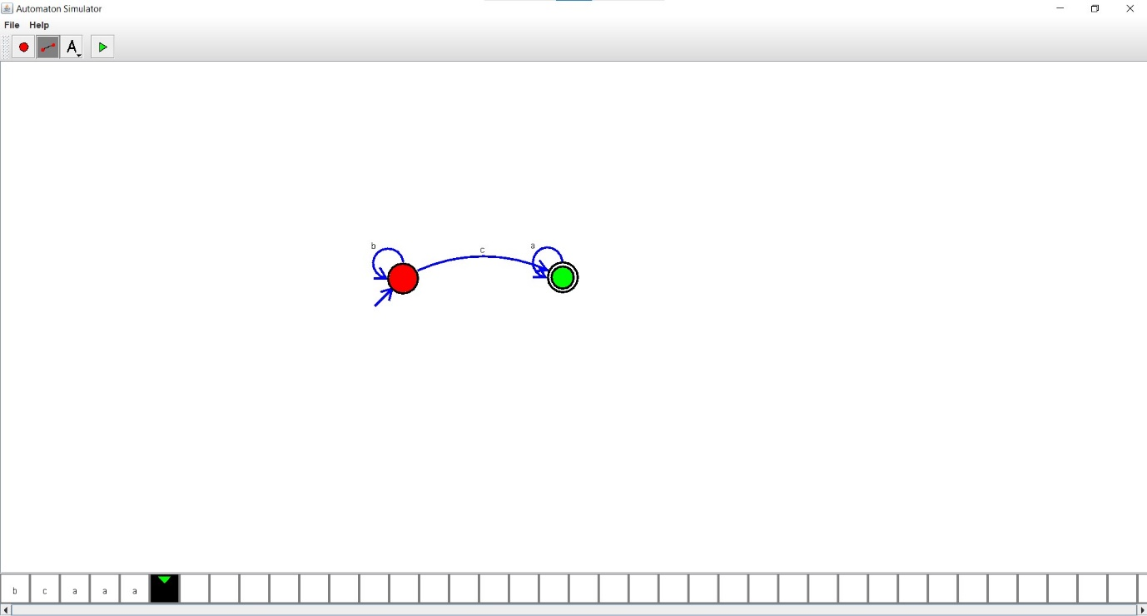

Result:

Hence, we successfully designed and implemented DFA to accept string.