39.Design DFA using simulator to accept the string the end with abc over set {a,b,c)

W= abbaababc

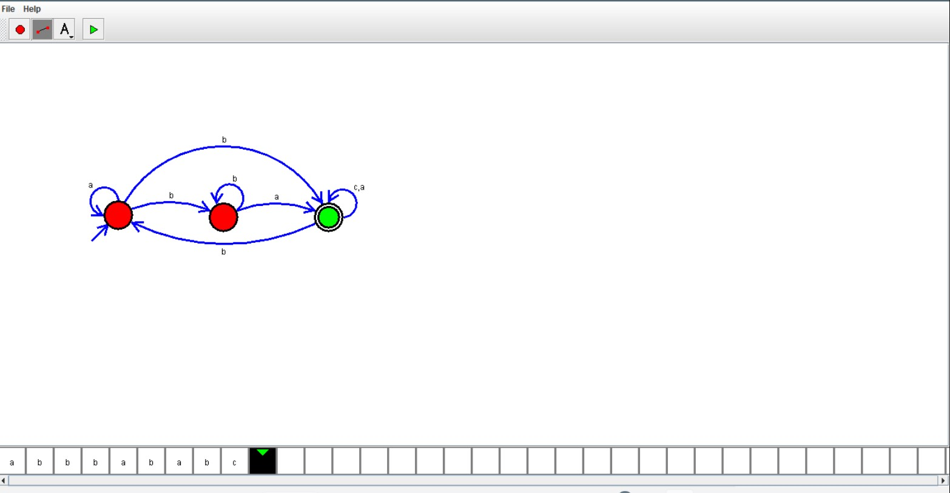

Result:

Hence , successfully designed and implemented DFA to accept string abc.