12.Design DFA using simulator to accept the input string “a” ,”ac”,and ”bac”.

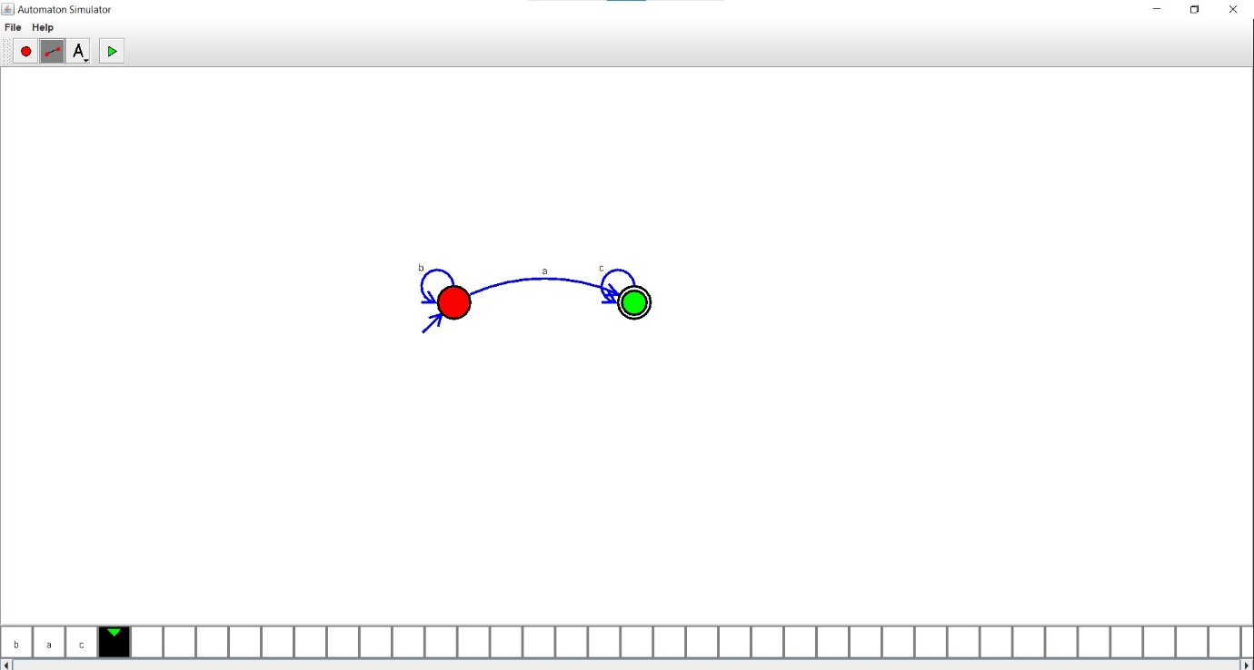

Result:

Hence ,we successfully designed and implemented DFA to accept string.