14.Design PDA using simulator to accept the input string anb2n

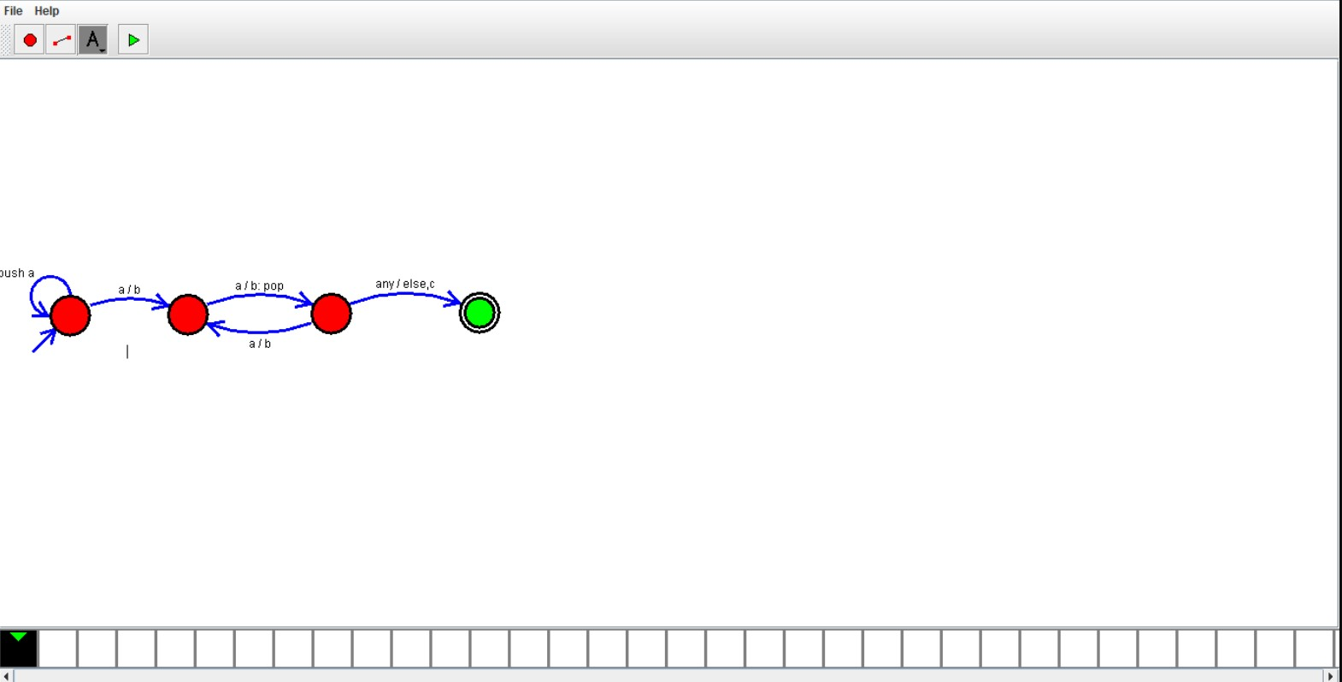

Result:

Hence ,we successfully designed and implemented PDA to accept string.