17.Design TM using simulator to accept the input string Palindrome ababa

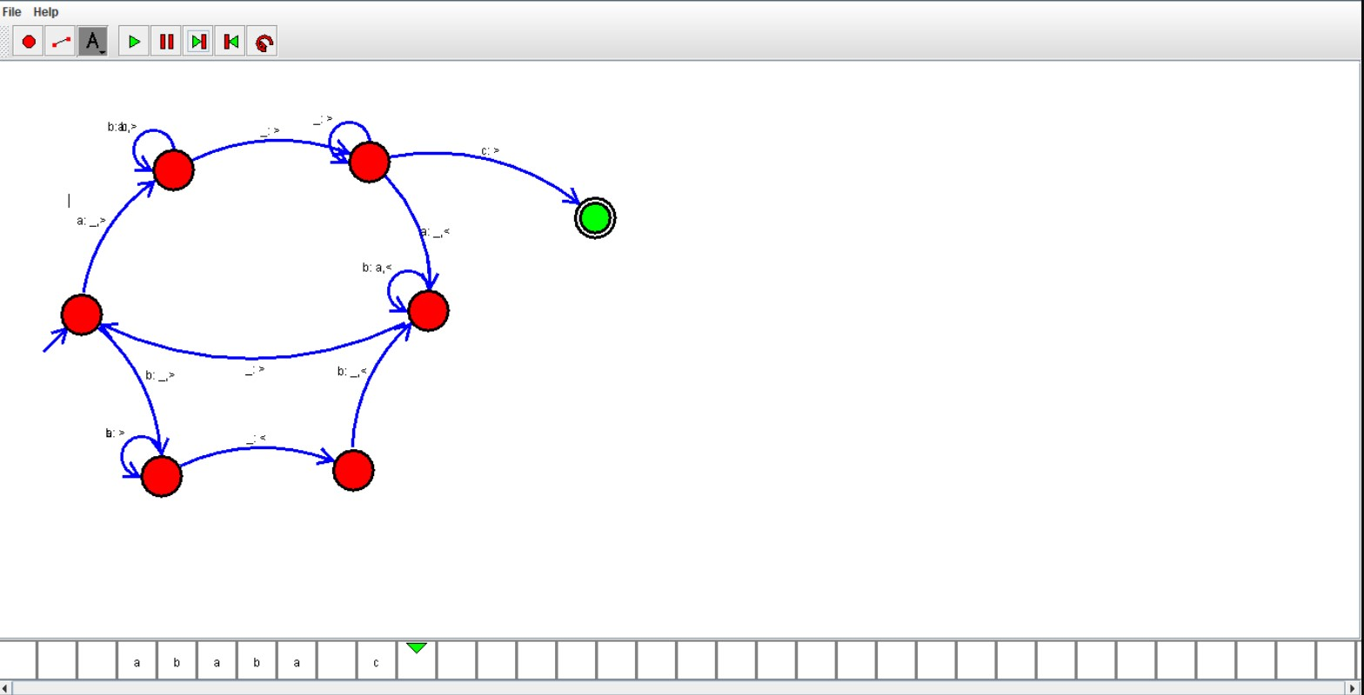

Result:

Hence ,we successfully designed and implemented TM to accept string.