18.Design TM using simulator to accept the input string ww

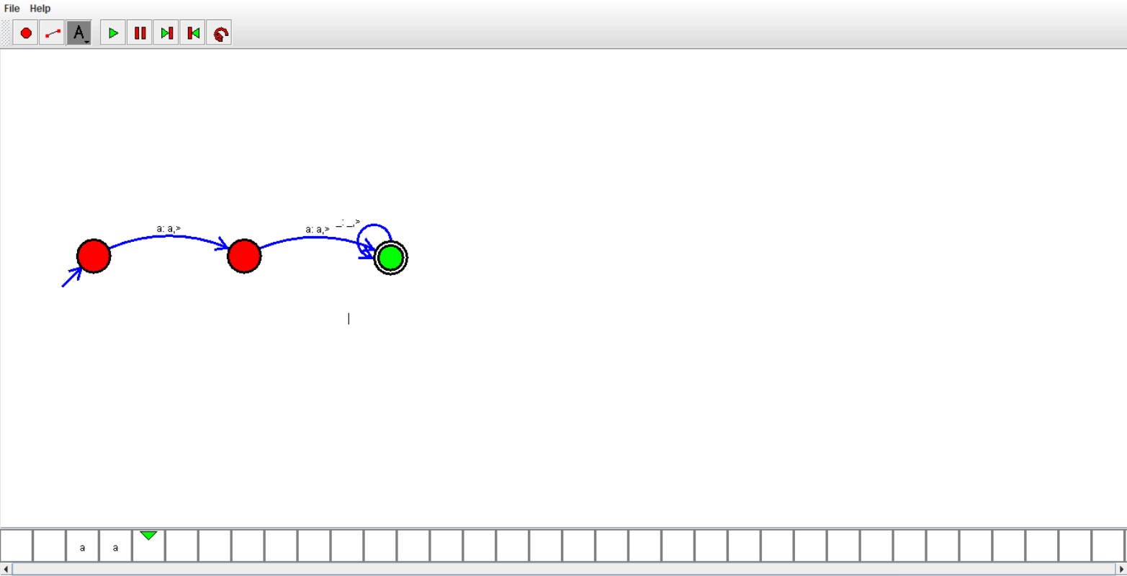

Result:

Hence ,we successfully designed and implemented TM to accept string.