20. Design TM using simulator to perform subtraction of aaa-aa.

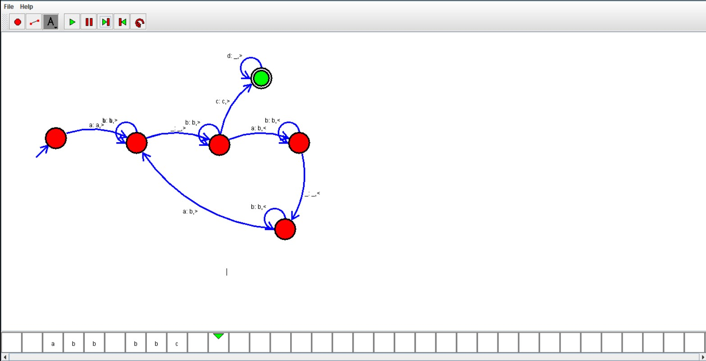

Result:

Hence ,we successfully designed and implemented TM to accept string.