21. Design DFA using simulator to accept even number of a’s.

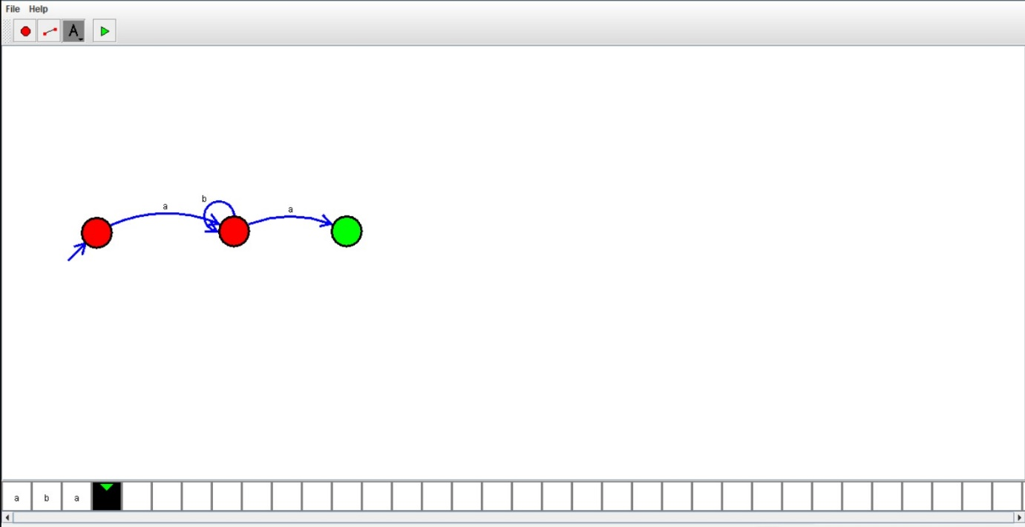

Result:

Hence ,we successfully designed and implemented DFA to accept string.