22.Design DFA using simulator to accept odd number of a’s

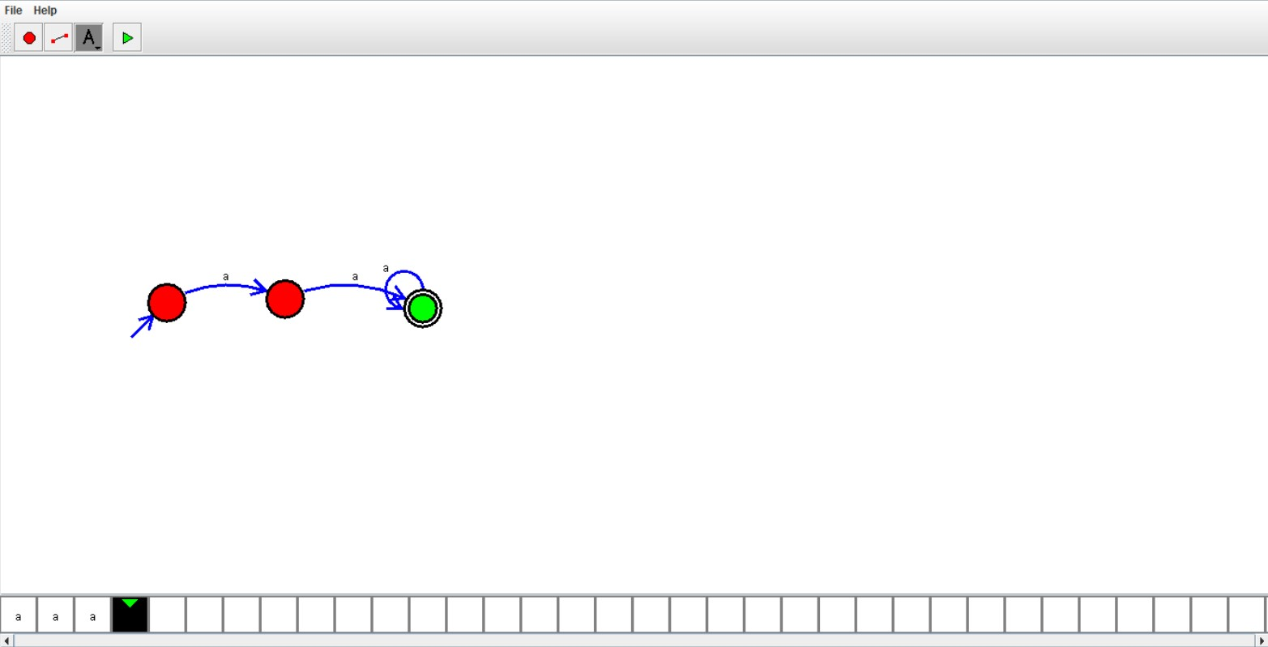

Result:

Hence ,we successfully designed and implemented DFA to accept string.