1. 24. Design DFA using simulator to accept the string having ‘ab’ as substring over the set {a,b}

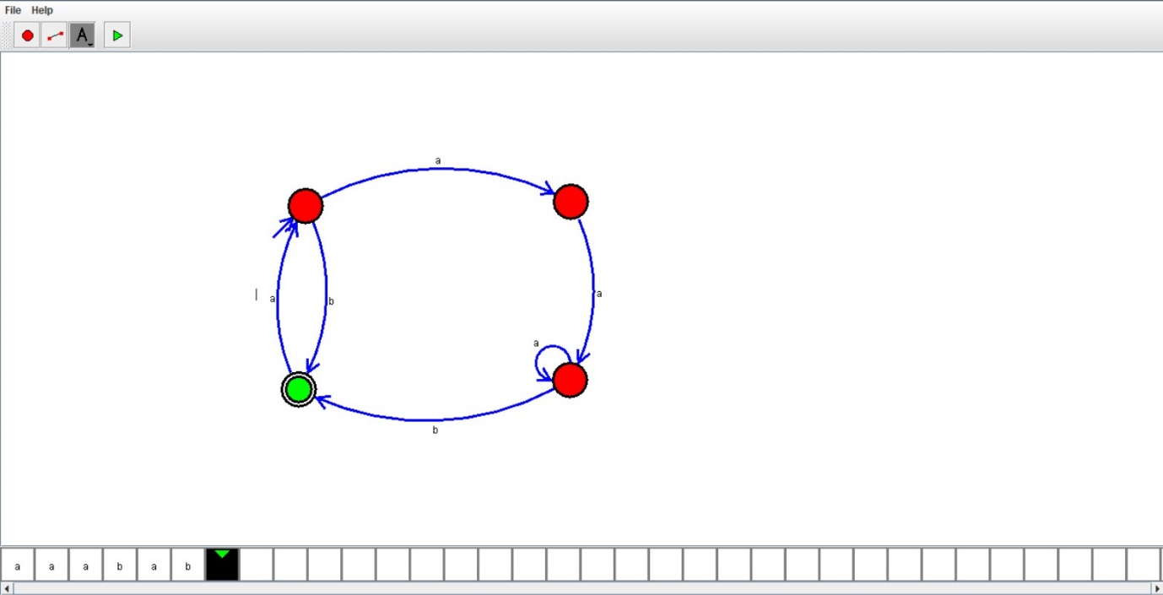

Result:

Hence ,we successfully designed and implemented DFA to accept string having ab.