26.Design TM using simulator to accept the input string Palindrome bbabb

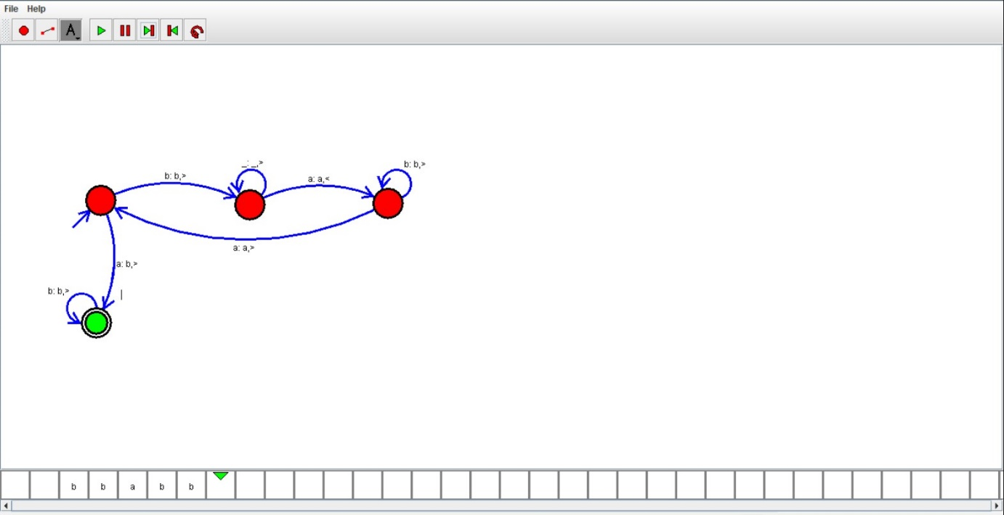

Result:

Hence ,we successfully designed and implemented TM to accept string palindrome.