27.Design TM using simulator to accept the input string wcw

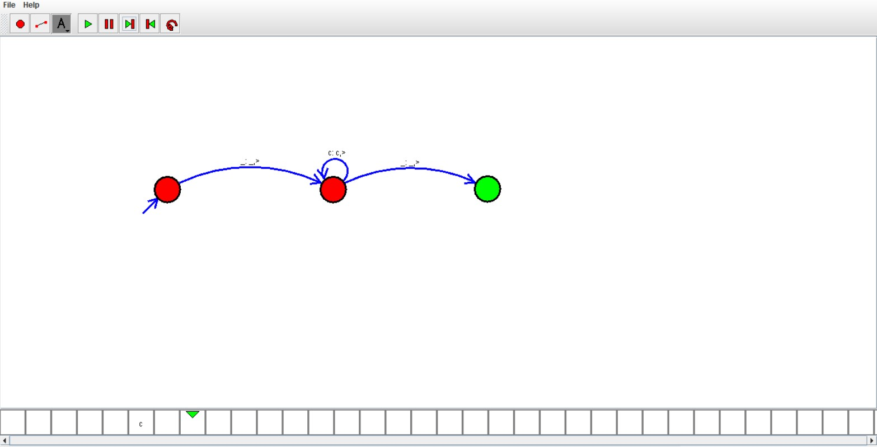

Result:

Hence ,we successfully designed and implemented DFA to accept string