31.Design PDA using simulator to accept the input string anbn

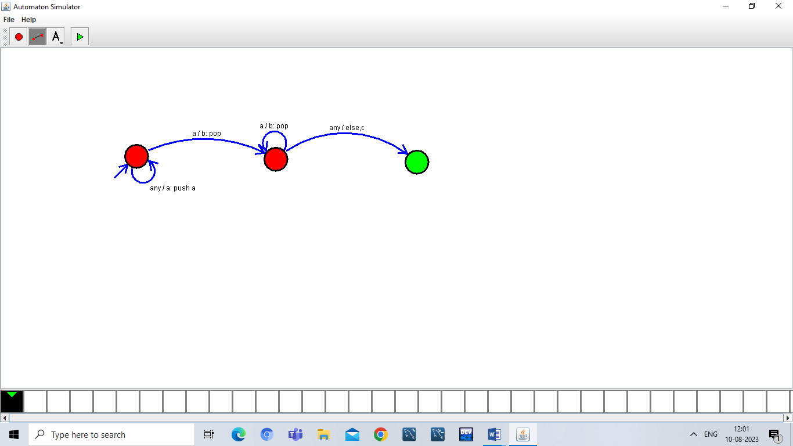

Result:

Hence , successfully designed and implemented PDA to accept string