34.Design DFA using simulator to accept even number of c’s over the set {a,b,c}

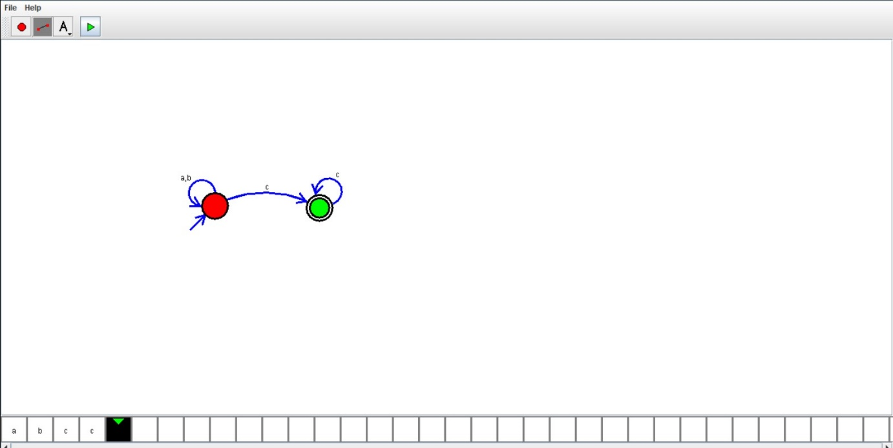

Result:Hence , successfully designed and implemented DFA to accept string.