35.Design DFA using simulator to accept strings in which a’s always appear tripled over input {a,b}

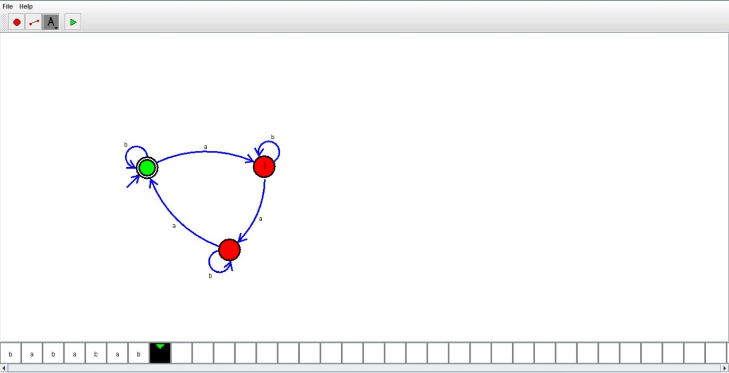

Result:

Hence , successfully designed and implemented DFA to accept string.