37.Design NFA using simulator to accept the string that start and end with different symbols over the input {a,b}.

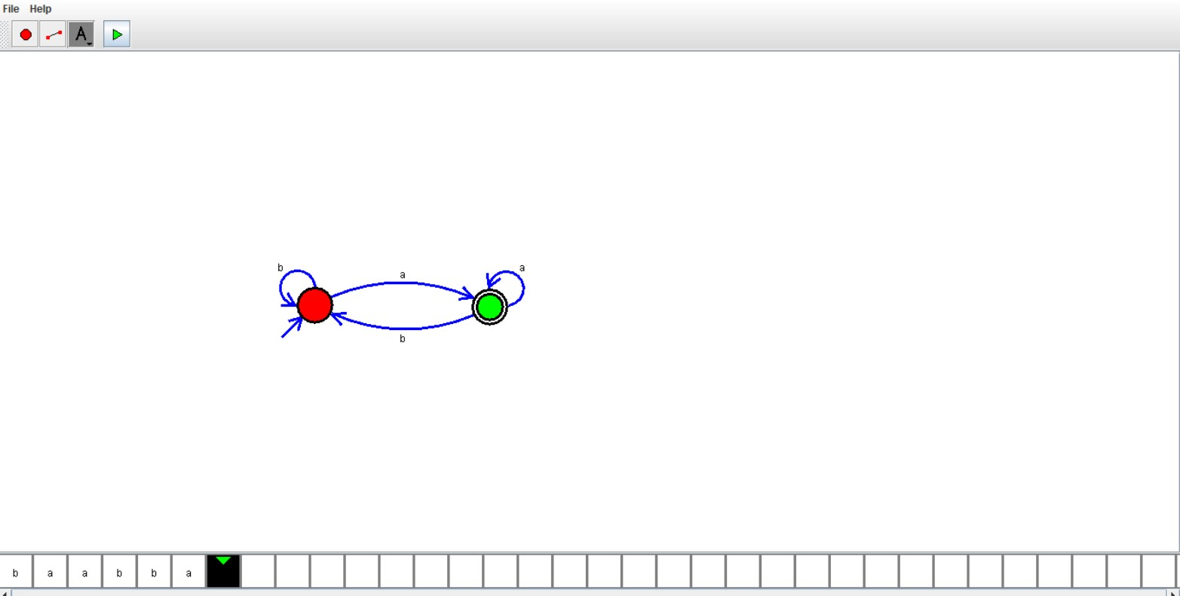

Result:

Hence , successfully designed and implemented NFA to accept string.