38.Design NFA using simulator to accept the input string “bbc” ,”c”,and ”bcaaa”.

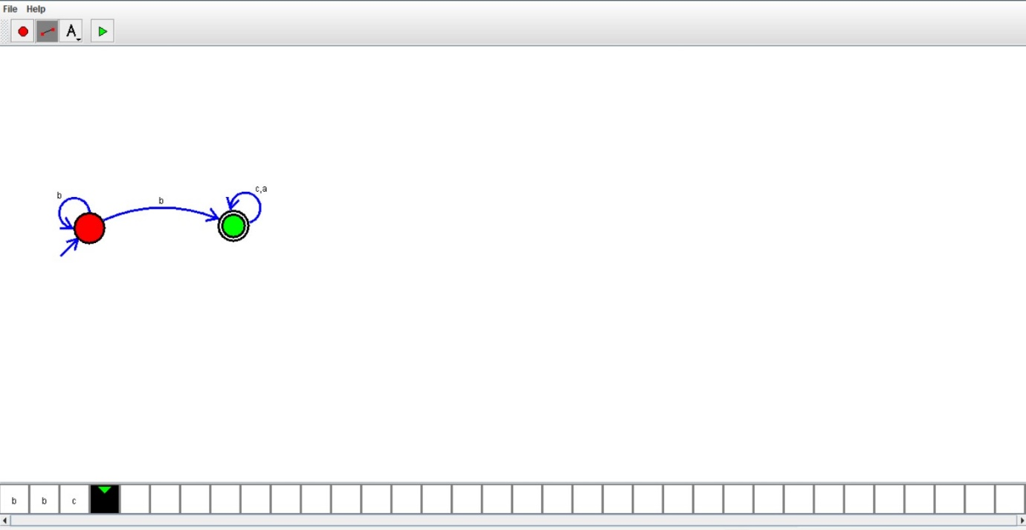

s

Result:

Hence , successfully designed and implemented NFA to accept string “bbc” “c” and “bcaaa”sss.