40.Design NFA to accept any number of b’s where input={a,b}.

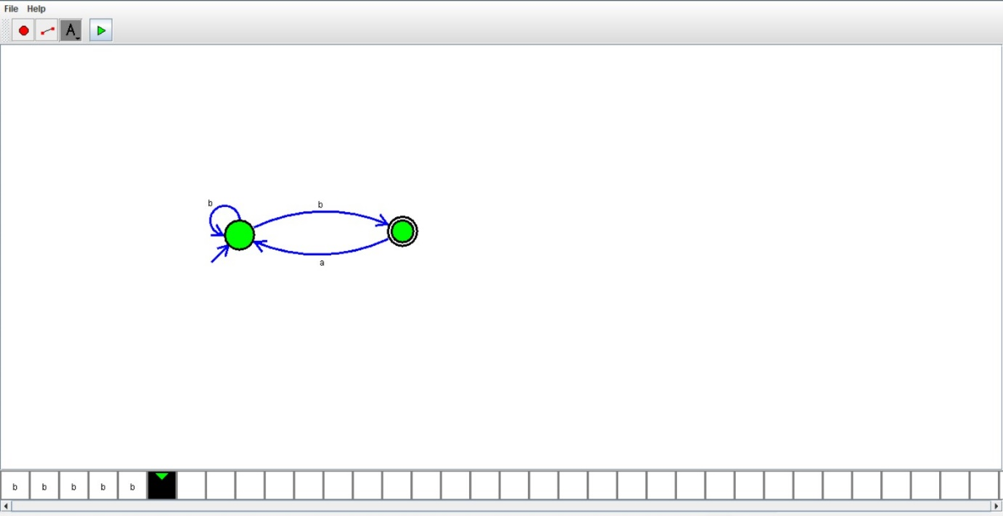

Result:

Hence , successfully designed and implemented NFA to accept number b’s .