**Venkata Sannakkayala**

**141068**

**Develop the project schedule showing dependencies**

Project: To build a new website

Assigned resources and developed a project schedule with time frames for each task, and dependencies logged in

Gantt chart with tasks added, resources assigned and duration of the tasks specified

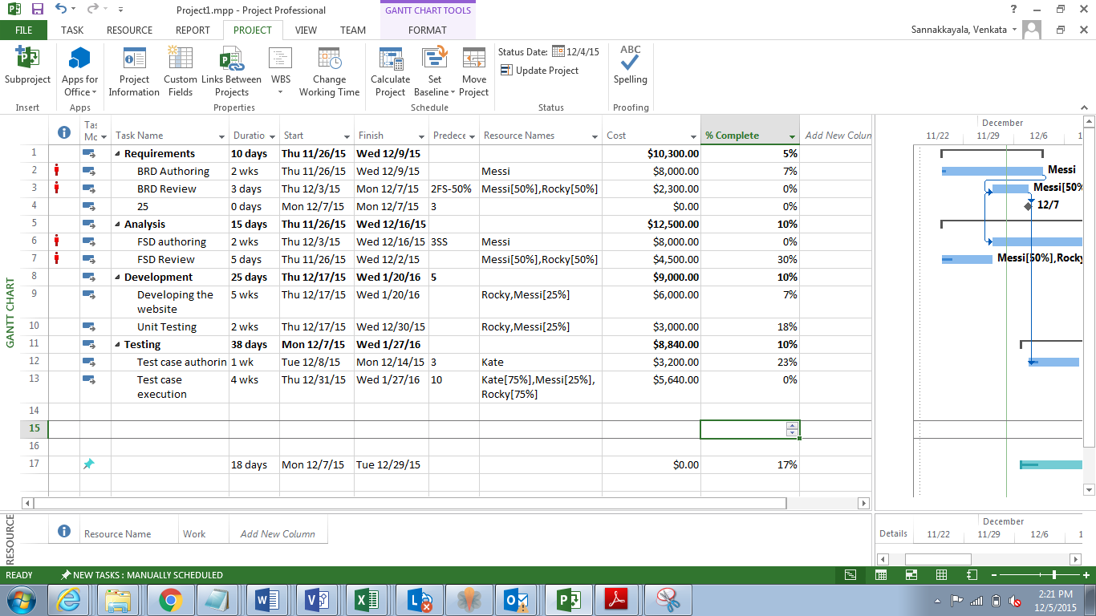

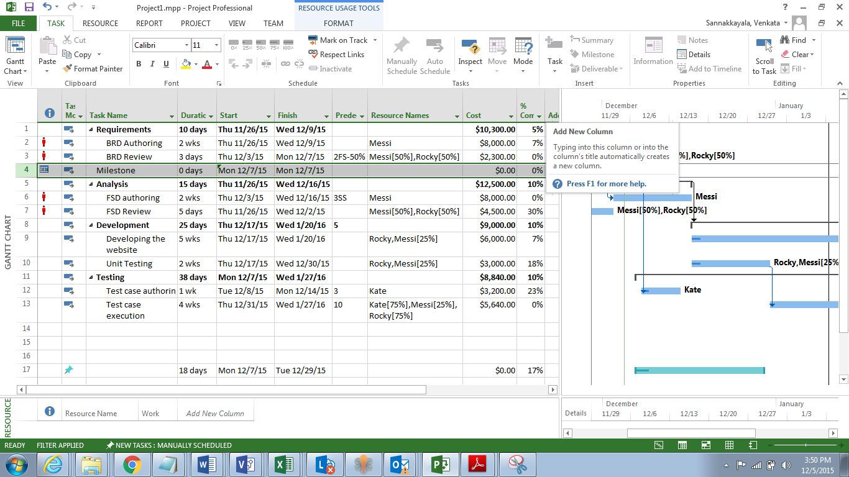

**Critical path**

The critical path is a chain of linked tasks that directly affects the project finish date. If any task on the critical path is late, the whole project is late.

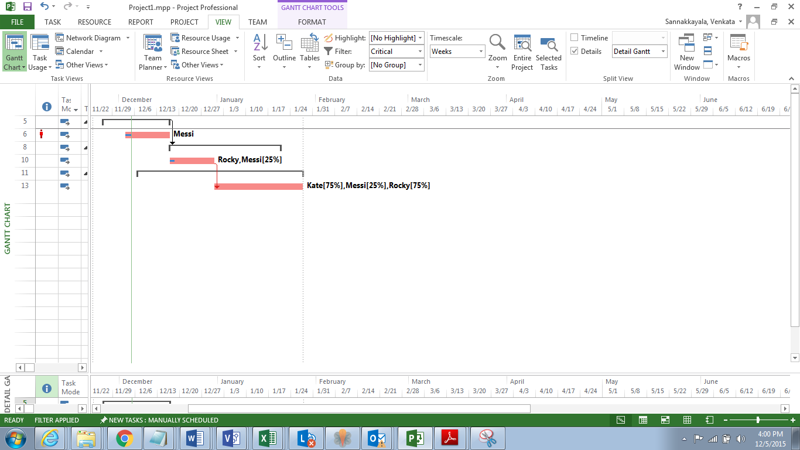

**Resource levelling**

If any of the team members are over allocated, then resource levelling can be performed to remove the over allocation. But doing so will increase the duration of the project I have 2 persons on the project who are over allocated and before resource levelling the project is completing by 01/27

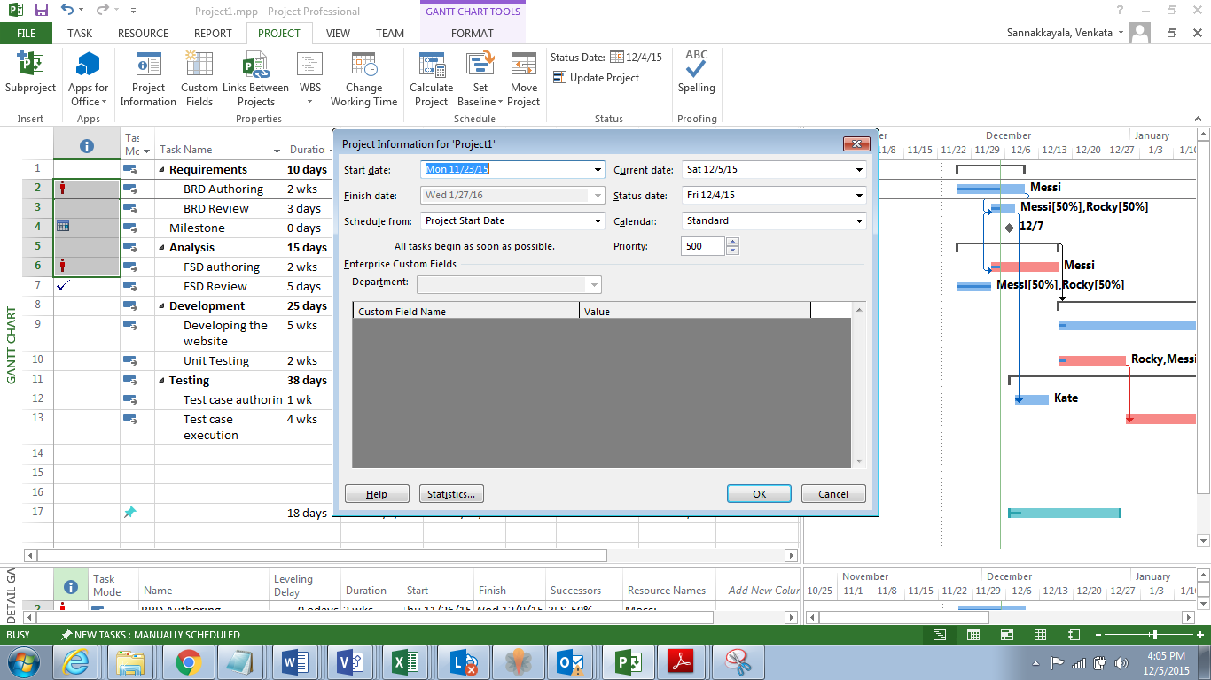

After resource levelling the project end date has shifted to 02/01

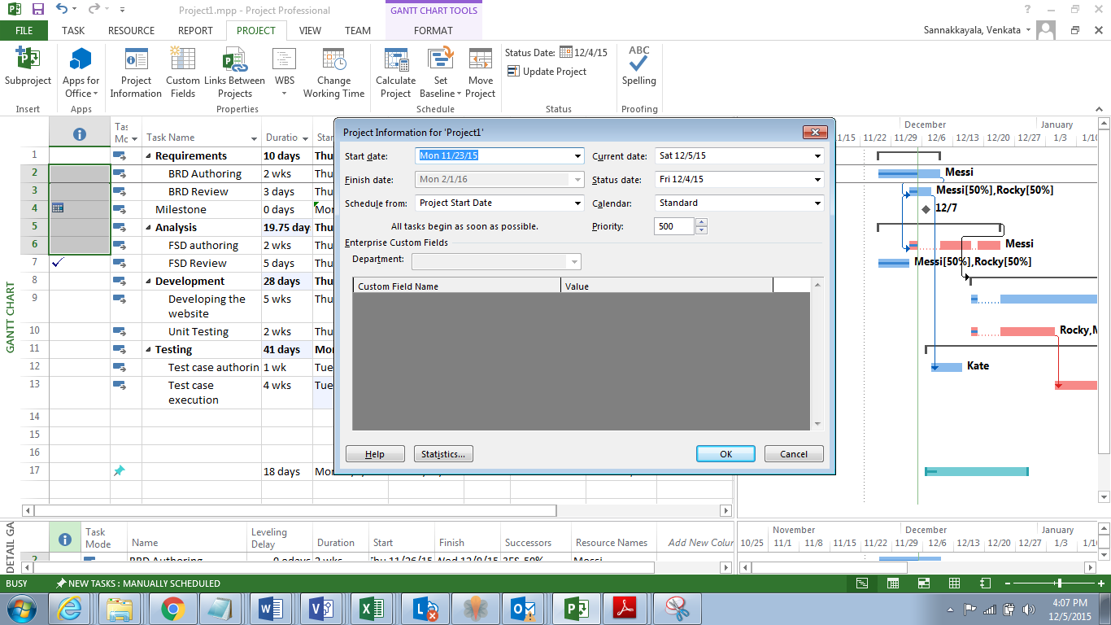

**Setting project baseline** – Setting a baseline will help the Project Manager to compare how the project is doing compared to your original plan. 11 baseline can be set during the duration of the project. If any new tasks are added while the project is in progress, a new baseline can be set to accommodate the new task

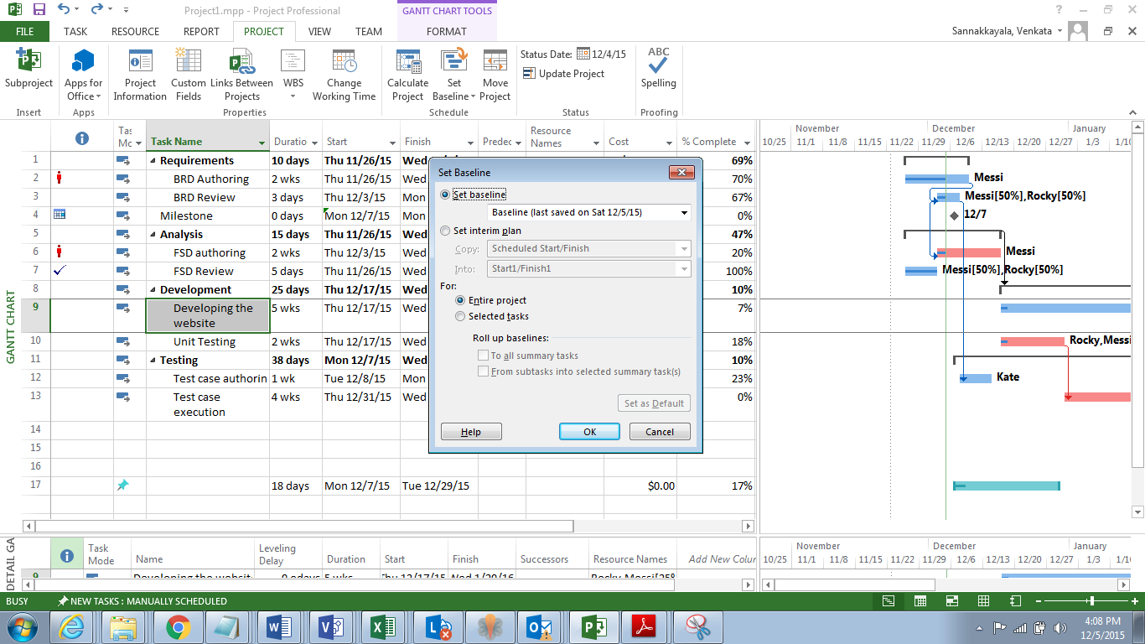

**Earned value cost indicators**

Baseline should be set and Status date should be chosen before Earned value cost indicators can calculated

Before calculating the earned value cost and schedule indicators, the chart should be updated with the percent completion for various tasks on the project. My project is going is going according to plan. My planned value and earned value are the same. And also CPI is 1

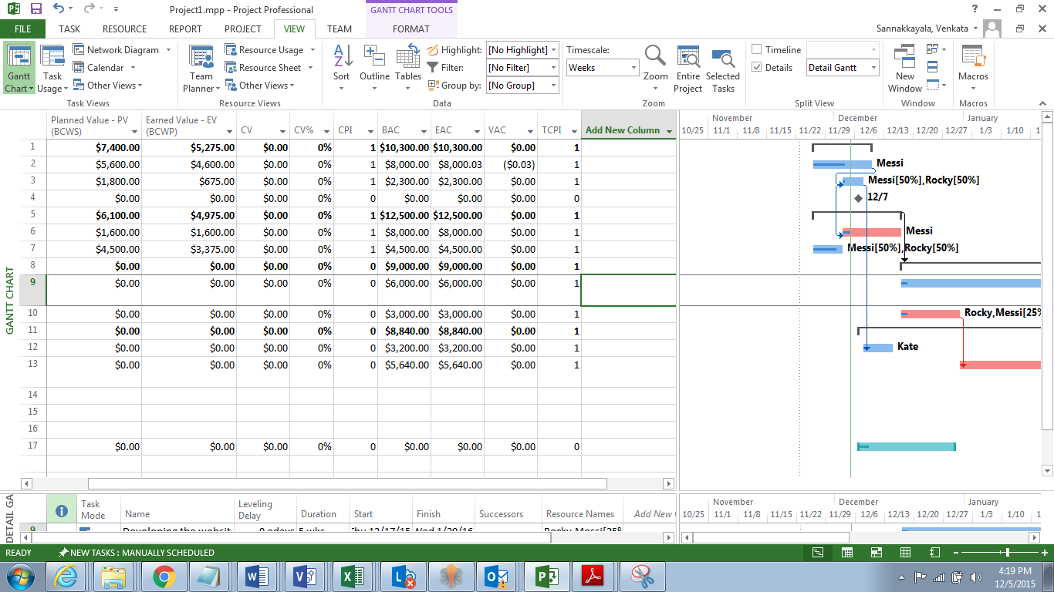

**Earned value schedule indicator**

My project is progressing ahead of schedule. SPI is below 1

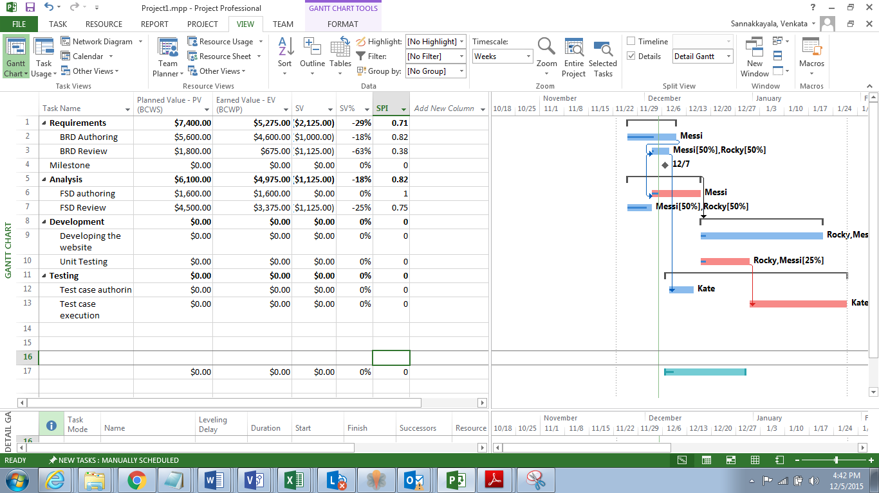

**Slack**

Slack (Float) is the amount of time that a task can slip before it affects another task or the project's finish date, If we know where slack occurs in the schedule, tasks can be moved around between phases of the schedule with no slack and other phases with too much slack. Slack appears as thin lines and actual value of the Slack next to them

Detail Gantt- View-Table-Schedule

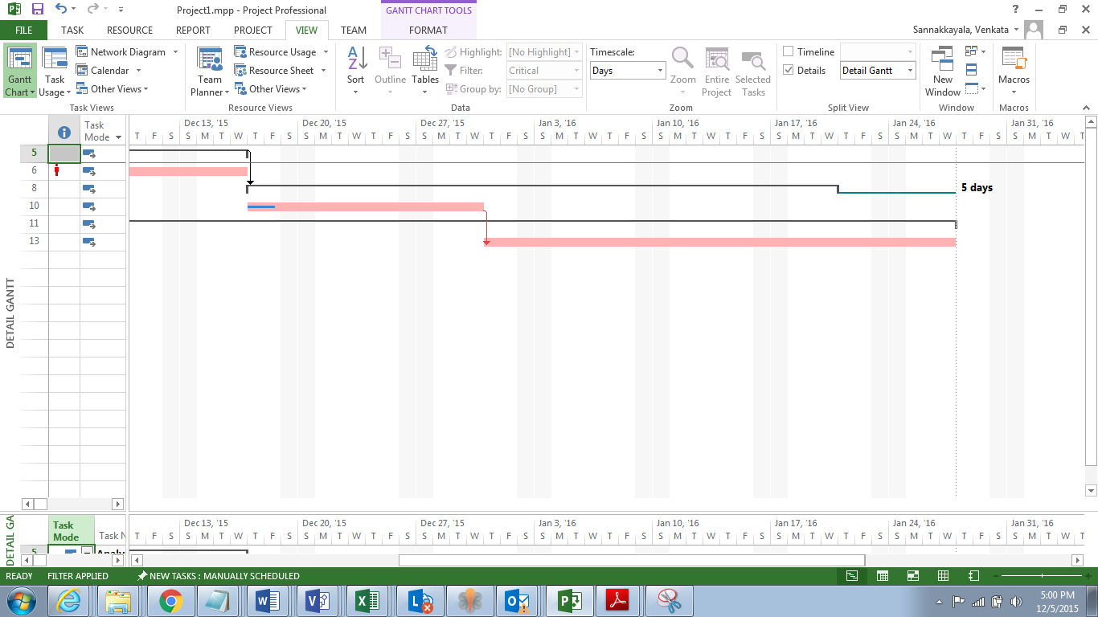

**Milestone**

A milestone is a reference point that marks a major event in a project and is used to monitor the project's progress. Any task with zero duration is automatically displayed as a milestone. Add a task (Requirements complete) and input 0 in the duration field. Now the milestone symbol is part of the Gantt Chart

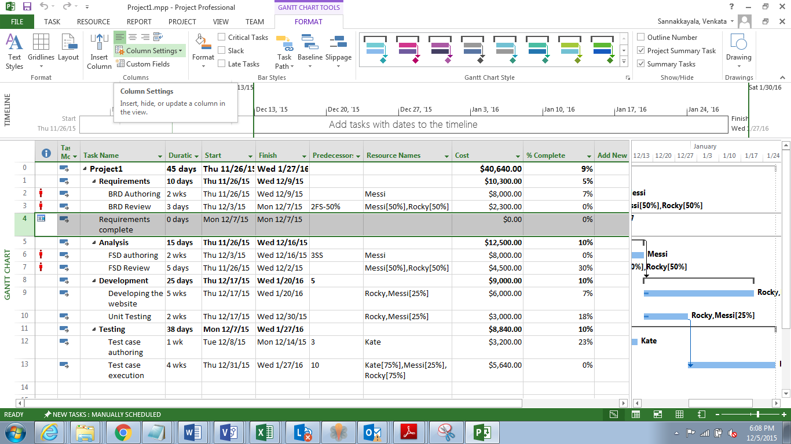

**Custom chart**

Below report shows the cash flow

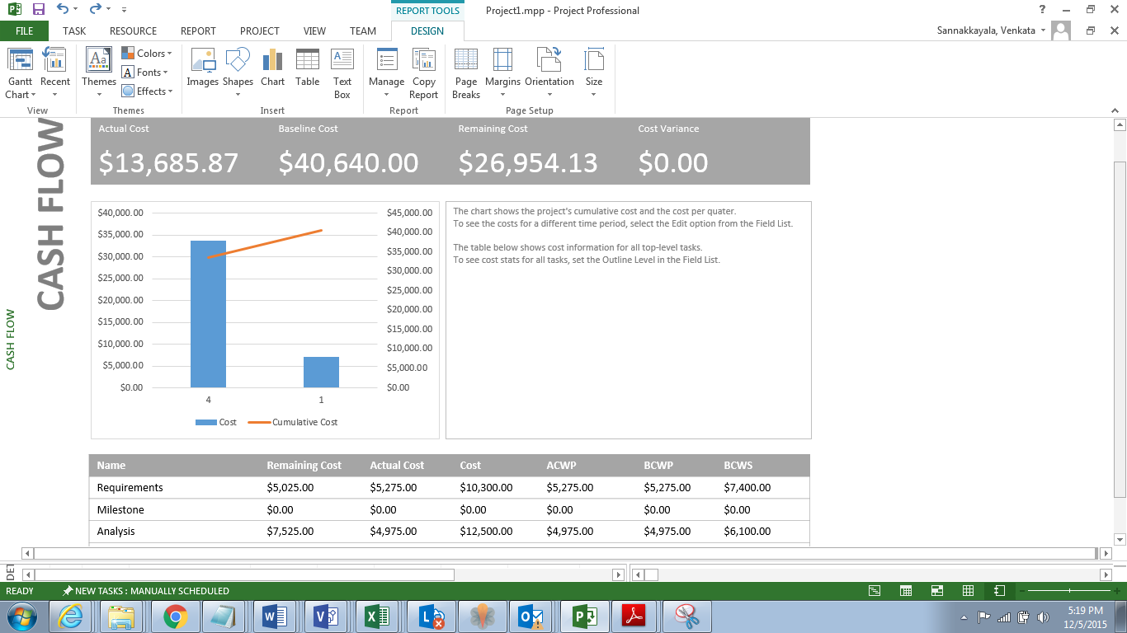

**Timeline**

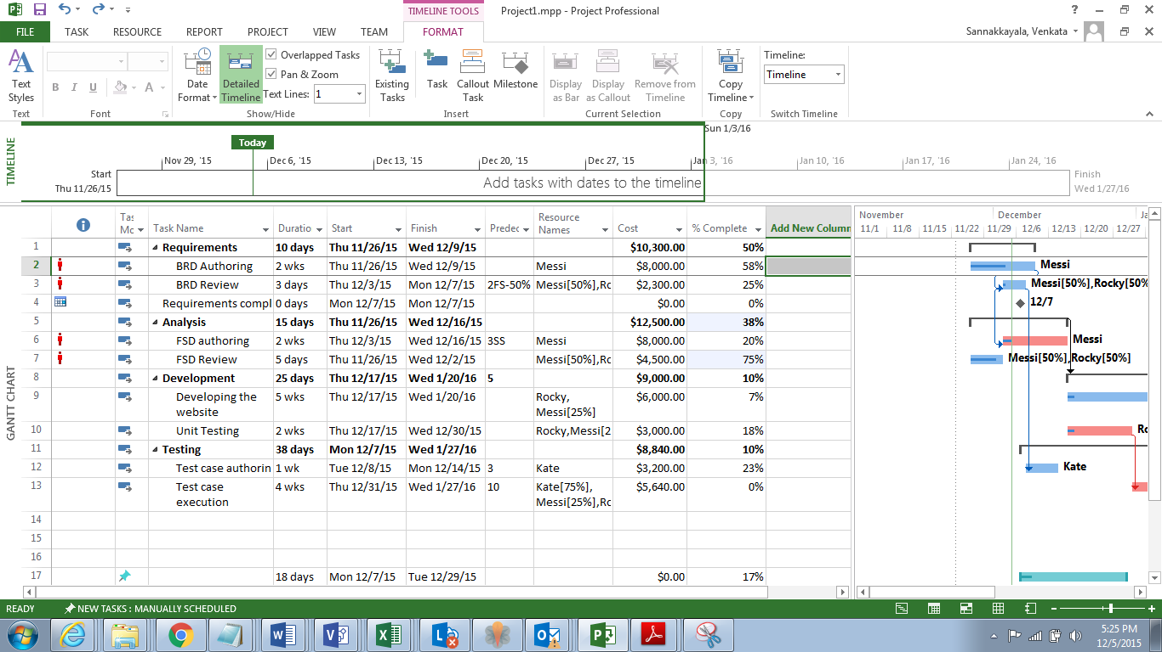

Timeline can added to the presentation/emailed

Start  
Thu 11/26/15

Finish  
Wed 1/27/16

Nov 29, '15

Dec 6, '15

Dec 13, '15

Dec 20, '15

Dec 27, '15

Jan 3, '16

Jan 10, '16

Jan 17, '16

Jan 24, '16

**Today**

A particular task can be added to the timeline

Start  
Thu 11/26/15

Finish  
Wed 1/27/16

Nov 29, '15

Dec 6, '15

Dec 13, '15

Dec 20, '15

Dec 27, '15

Jan 3, '16

Jan 10, '16

Jan 17, '16

Jan 24, '16

**Development**  
Thu 12/17/15 - Wed 1/20/16

**Today**

**Calculate budget**

In the format tab select the project summary field. The total cost of the project will be shown

