**Experiment No :1**

**Design of different icons in Graphical user Interface ( a minimum of four different icons)**

Aim :

IFitts’s Law - Modeling Target Movement Time in HCI

Procedure:

Fitts's law is a model of speed-accuracy tradeoffs used in human–computer interaction and ergonomics. It predicts time required to acquire a target on screen as a function of the distance to the target and the size of the target. Fitts's law is used to model the act of pointing, either by physically touching an object with a hand,finger or virtually or by pointing to an object on a computer monitor using a pointing device. It was proposed by Paul Fitts in 1954.

Mathematically it can be written as

MT = a + b log 2 ( 2A / W )

MT : Movement time (average) taken to complete the movement or point the target.

a : Start / Stop time of the device (y intercept)

b : Inherent speed of the device (slope of line)

W : Width of the target measured along the axis of motion, which corresponds to accuracy

A : Distance from the starting point to the center of the target

The term log 2 ( 2A / W ) is called the index of difficulty (ID). It describes the difficulty of the motor tasks. 1/b is also called the index of performance (IP) and measures the information capacity of the human motor system.

Thus MT= a+b ID = a + ID / IP

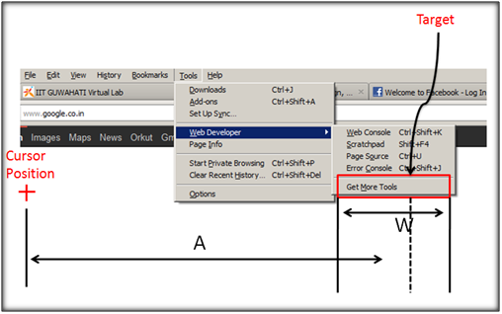

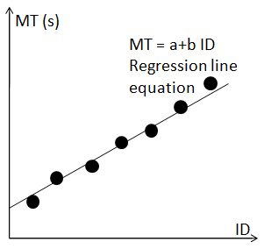

Application of Hicks Law

Figure 1. below shows an example of a bad web-page design which ignores Hick’s Law. The web-page has too many choices and scrollbars without proper blocking of contents due to which user’s reaction time is extremely compromised.

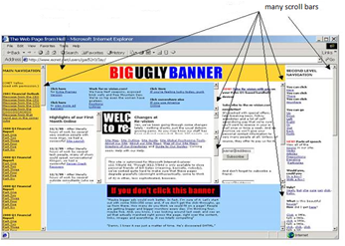

Figure 2. below shows Google website as an example of a good web-page design. It presents few and clearly distinguished choices that obeys the Hick’s Law. Layout is simple, color choices and graphics are limited thereby reducing the reaction time to a large extent.

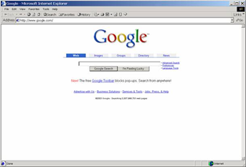

Design a Folder Icon in Graphical User Interface

Procedure:

1. Open a paint application
2. Select the appropriate shapes and tools to create the Folder icon like this



1. Save the file using image format .jpg

**Design of different icons in Graphical user Interface ( a minimum of four different icons)**

Floppy disk (Save)

Find and Replace

Open a folder

Copy and paste

Work in Progress

Print

Network disconnected

Announcement

Academics

Examination

Process

Login failed

File not found

Low battery power

Access denied

Access restricted