INTERACTIVE DESIGN ANALYSIS BASED ON PRINCIPLES OF UNIVERSAL DESIGN

Aim:

To perform interactive design analysis based on principles of universal design.

Analyzing Google Play's design based on the principles of Universal Design, we can see how well it aligns with the goal of creating an accessible and inclusive user experience for a diverse range of users.

1. **Equitable Use**:
   * **Positive**: Google Play aims to provide the same means of accessing and discovering apps, games, movies, and books for all users, regardless of their abilities.
   * **Consideration**: The platform offers a wide variety of content, catering to different preferences and interests, which promotes equity in use.
2. **Flexibility in Use**:
   * **Positive**: Google Play offers multiple ways for users to find content. It provides search functionality, recommendations, and categorized sections, allowing users to choose how they explore the platform.
   * **Consideration**: It could further enhance flexibility by allowing users to customize the app's interface based on their needs or preferences.
3. **Simple and Intuitive Use**:
   * **Positive**: Google Play tends to follow Material Design principles, which generally prioritize simplicity and intuitive interactions.
   * **Consideration**: The platform's search and navigation are relatively straightforward, but there may be areas for improvement in making complex actions, such as account management, even more intuitive.
4. **Perceptible Information**:
   * **Positive**: Google Play typically provides clear visual and textual information about apps, games, movies, and books. This is essential for users with different sensory abilities.
   * **Consideration**: It's essential to ensure that the information is presented in a way that is accessible to users with visual impairments or those who rely on screen readers.
5. **Tolerance for Error**:
   * **Positive**: Google Play generally allows users to preview app details and read reviews before downloading, which helps reduce the risk of errors or unwanted installations.
   * **Consideration**: Enhancements can be made to error prevention, such as providing clearer cues for actions and reducing the likelihood of accidental purchases.
6. **Low Physical Effort**:
   * **Positive**: Google Play's design is mainly touch-based, which is user-friendly and accommodates users with varying physical abilities.
   * **Consideration**: The platform can continually optimize its touch interactions, taking into account users with motor impairments who may need more precise touch targets.
7. **Size and Space for Approach and Use**:
   * **Positive**: The overall layout of Google Play provides ample space for users to interact with content.
   * **Consideration**: The app could further ensure that buttons and interactive elements have sufficient spacing to accommodate users with limited dexterity.

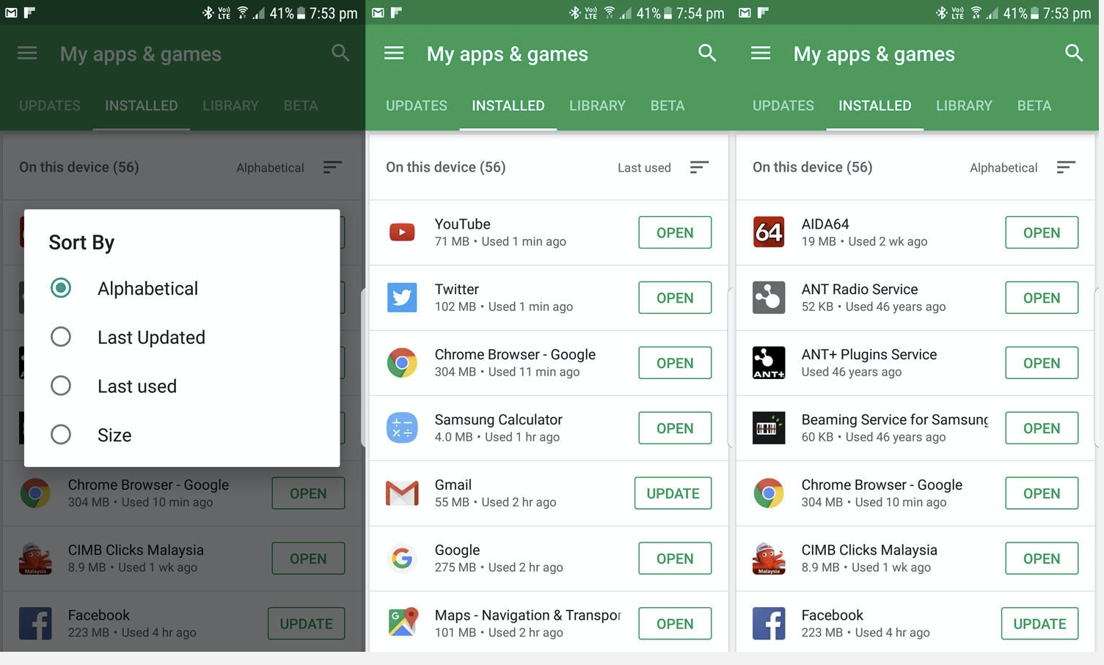

Thus Google play store has been analysed and designed.