Final Insights, Recommendations, and Analysis of Medicare Part B Drug Spending Using Data Mining Techniques
Asha Kilaru
Venkatappareddy Manukonda
Department of Computer Science, Cumberlands University
Advanced Big Data and Data Mining
Satish Penmatsa
July 26, 2026

Introduction
Healthcare datasets contain large volumes of utilization and spending information that can be analyzed to support evidence-based decision-making. Rather than relying solely on descriptive statistics, data mining techniques enable analysts to identify relationships, develop predictive models, discover natural groupings, and uncover patterns that may not be apparent through traditional analysis. Applying multiple analytical methods to the same dataset provides a more comprehensive understanding of the factors associated with healthcare expenditures.
This project analyzes the CMS Medicare Quarterly Part B Spending by Drug dataset using an end-to-end data mining workflow. The analysis began with data preparation and exploratory data analysis to improve data quality and understand the dataset's characteristics. Feature engineering was then performed to create variables that supported predictive modeling and pattern discovery. Building on this foundation, regression, classification, clustering, and association rule mining techniques were applied to examine Medicare drug utilization from complementary perspectives.
Each analytical approach addressed a different objective. Regression models evaluated relationships between utilization measures and spending; classification models predicted high-spending drugs; clustering identified groups with similar utilization characteristics; and association rule mining revealed recurring relationships among utilization and spending indicators. Evaluating these methods together provided a broader understanding of Medicare spending patterns than any individual technique could offer.
The final stage of the project synthesizes the findings from each analytical phase, translates the results into practical recommendations, and considers the ethical implications of applying data mining techniques to healthcare data. The objective is not only to assess model performance but also to demonstrate how analytical results can support informed decision-making while recognizing the limitations and responsibilities associated with data-driven healthcare analysis.
Dataset Description
The analysis was conducted using the CMS Medicare Quarterly Part B Spending by Drug dataset, which summarizes Medicare utilization and spending for physician-administered drugs on a quarterly basis. The dataset includes variables describing beneficiary counts, claim volumes, total spending, average spending per beneficiary, and average spending per claim. Together, these measures provide a detailed view of how individual drugs contribute to Medicare expenditures.
This dataset was selected because it represents a practical healthcare analytics problem that combines financial and utilization information within a structured format. The availability of multiple quantitative variables makes it well-suited for applying a range of data mining techniques, including predictive modeling, clustering, and association rule mining. Using a single dataset across all analytical tasks also enabled meaningful comparisons between different modeling approaches.
A cleaned version of the dataset produced during the earlier project phases was used throughout the analysis to ensure consistency. Data preparation included handling missing values, verifying for duplicates, standardizing variable formats, and creating derived features to improve model development and interpretation. Maintaining a consistent analytical dataset ensured that differences in model performance reflected methodological differences rather than inconsistencies in the underlying data.
Although the dataset contains detailed spending information, it consists of aggregated Medicare records rather than patient-level observations. Consequently, the analysis supports conclusions about overall utilization and spending trends while avoiding the use of personally identifiable health information.
Data Preparation and Feature Engineering
The analysis began with a review of the dataset to evaluate its overall quality and suitability for modeling. The dataset structure, variable types, missing values, and duplicate records were examined before any analytical methods were applied. This preliminary assessment confirmed that the dataset was generally well structured, with only a limited number of missing values requiring attention.
Data preprocessing focused on creating a consistent analytical dataset rather than making extensive modifications. Missing values were handled using appropriate preprocessing techniques, duplicate records were verified, and variable formats were standardized to ensure compatibility with machine learning algorithms. These steps reduced the likelihood of errors during model training and provided a reliable foundation for subsequent analyses.
Feature engineering was performed to derive variables that better represented utilization behavior. Additional attributes, including Year_Value, Quarter, and Claims_per_Beneficiary, were generated from the original data. These features introduced temporal information and utilization measures that were not explicitly available in the raw dataset, allowing the models to capture relationships beyond the original variables.
For the classification task, a binary target variable named High_Spending was created using the upper quartile of total spending as the decision threshold. Drugs with spending above the 75th percentile were classified as high spending, while the remaining observations formed the second class. This approach produced a meaningful prediction problem based on the observed spending distribution rather than an arbitrary threshold.
To prevent information leakage, variables directly derived from total spending, including Total Spending, Log Total Spending, Average Spending per Beneficiary, and Average Spending per Claim, were excluded from the classification predictors. Retaining these variables would have given the models direct knowledge of the target outcome, leading to overly optimistic performance estimates. Removing them ensured that model evaluation reflected the predictive value of utilization characteristics rather than information already contained in the target variable.
Overall, the preprocessing and feature engineering stages established a consistent and reliable dataset for regression, classification, clustering, and association rule mining. By improving data quality and carefully selecting predictive features, these steps enhanced the validity and interpretability of the analytical results.
Exploratory Data Analysis
Exploratory data analysis (EDA) was performed to understand the distribution of key variables and identify patterns that could influence model development. Summary statistics and visualizations were used to examine Medicare spending, beneficiary counts, claim volumes, and relationships among the numerical variables.
The distribution of total Medicare spending exhibited substantial variability, indicating that a relatively small number of drugs accounted for disproportionately high expenditures. Similar variability was observed in beneficiary counts and claim volumes, suggesting that drug utilization differed considerably across the dataset. These findings supported the use of predictive modeling techniques capable of capturing non-uniform spending behavior.
A correlation analysis was conducted to evaluate relationships among the numerical variables. Strong positive associations were observed between beneficiary counts, claim volumes, and total spending, indicating that drugs serving larger patient populations generally generated higher Medicare expenditures. While these relationships were expected, the correlation analysis also confirmed that no single utilization measure fully explained spending, reinforcing the value of applying multiple analytical techniques throughout the project.
The insights obtained during EDA influenced the subsequent modeling process. The observed spending variability supported the creation of a high-spending classification target, while the identified relationships among utilization variables guided feature selection for regression and classification models. In addition, understanding the underlying data structure provided a stronger basis for interpreting the clustering and association rule mining results presented later in the analysis.
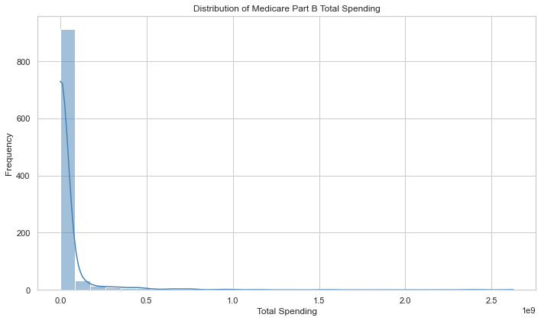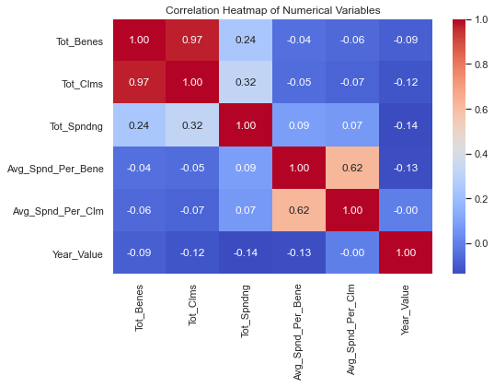

Regression Analysis
Regression analysis was performed to examine the relationship between Medicare drug spending and utilization-related variables. Multiple regression models were evaluated to determine how effectively the available predictors explained variations in total spending. Comparing different models provided insight into the impact of model complexity on predictive performance while highlighting the variables most strongly associated with Medicare expenditures.
The regression results demonstrated that utilization measures, particularly beneficiary counts and claim volumes, were strongly associated with total spending. As expected, drugs with greater utilization generally generated higher Medicare expenditures, although the relationship was not perfectly linear across all observations. This finding indicates that spending is influenced by multiple interacting factors rather than by utilization alone.
Model evaluation showed that incorporating multiple predictors produced more reliable estimates than relying on individual variables. The regression analysis established an important baseline for the remainder of the project by quantifying the relationship between utilization characteristics and spending. These findings also provided evidence that the selected features contained meaningful predictive information for the subsequent classification analysis.
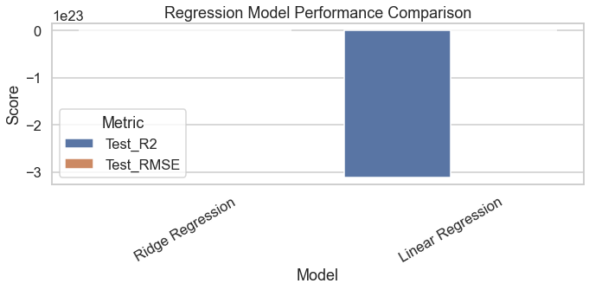
Classification Analysis
The classification phase focused on identifying drugs with relatively high Medicare spending using utilization characteristics as predictors. Four supervised learning algorithms—Decision Tree, K-Nearest Neighbors (KNN), Naive Bayes, and Support Vector Machine (SVM)—were evaluated using identical training and testing datasets to enable a consistent comparison.
Although several models achieved comparable accuracy, model selection was primarily based on the F1-score because the dataset contained substantially fewer high-spending observations than lower-spending ones. Under these conditions, accuracy alone may yield an overly optimistic assessment of model performance, favoring the majority class.
Among the evaluated models, Naive Bayes achieved the best balance between precision and recall, producing the highest overall F1 Score. The model successfully identified a large proportion of high-spending drugs while maintaining reasonable predictive stability. The ROC analysis further demonstrated that the classifier performed better than random prediction, indicating that utilization characteristics contained useful information for distinguishing higher-spending drugs from the remaining observations.
These findings suggest that relatively simple probabilistic models can provide effective decision-support capabilities when predicting high-cost utilization patterns. While classification models cannot fully explain the underlying causes of spending, they can assist analysts by identifying observations that warrant additional investigation.
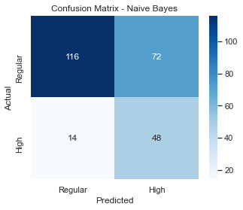
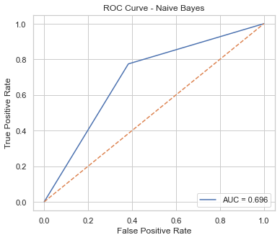

Clustering Analysis
Clustering was used to identify natural groupings within the dataset without relying on predefined spending categories. K-Means clustering was applied to utilization and spending variables to determine whether drugs with similar characteristics formed distinct groups.
The clustering results produced a silhouette score of 0.663, indicating that the identified clusters were reasonably well separated. Visualization using Principal Component Analysis (PCA) revealed one large cluster representing the majority of observations and two smaller clusters, each containing drugs with distinct utilization and spending characteristics. These smaller clusters likely represent medications with unique prescribing patterns or unusually high utilization relative to the rest of the dataset.
Unlike classification, clustering does not predict predefined outcomes. Instead, it provides an exploratory view of the data that can reveal groups requiring additional analysis. In this project, the clustering results complemented the regression and classification findings by highlighting structural differences within the Medicare spending data that were not immediately apparent through supervised learning methods.
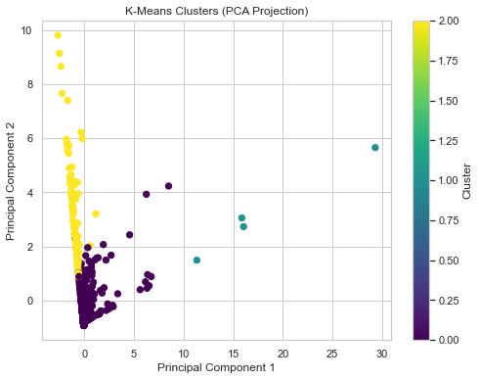
Association Rule Mining
Association rule mining was performed to identify frequent relationships among utilization and spending characteristics. Unlike regression and classification, which focus on prediction, this technique was used to discover patterns that appeared consistently across the dataset without specifying a target variable.
Several meaningful associations were identified during the analysis. The strictest rules showed that drugs with higher beneficiary counts were frequently associated with higher claim volumes, while higher overall spending commonly occurred alongside higher average spending measures. The most informative rules produced lift values greater than one, indicating that these relationships occurred more frequently than expected by chance.
These results complement the predictive models by providing additional insight into how utilization characteristics interact within the Medicare dataset. Rather than examining variables independently, association rule mining identified combinations of factors that commonly co-occurred, offering a broader understanding of spending behavior.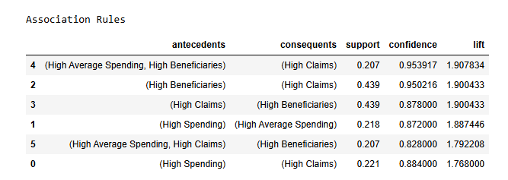
Key Insights
Applying multiple analytical techniques to the same dataset provided a more comprehensive understanding of Medicare Part B drug spending than any individual method alone. Data preparation and feature engineering established a reliable analytical dataset, while exploratory analysis demonstrated that beneficiary counts, claim volumes, and spending exhibited substantial variability across drugs.
The regression analysis confirmed that utilization measures were strongly associated with Medicare expenditures, providing quantitative evidence that spending generally increases as utilization grows. Classification extended this analysis by identifying drugs likely to belong to the high-spending category, with the Naive Bayes classifier achieving the strongest balance between precision and recall. Clustering revealed distinct utilization groups that were not apparent through supervised learning methods, while association rule mining uncovered recurring relationships among utilization characteristics.
Taken together, these findings demonstrate that Medicare spending is influenced by multiple interconnected factors. Combining predictive and descriptive analytical methods produced a more complete understanding of spending behavior than relying on a single modeling approach.
Practical Recommendations
The findings of this project suggest several practical applications for healthcare administrators and policymakers. Predictive classification models could be incorporated into analytical workflows to identify drugs with characteristics commonly associated with higher Medicare spending, allowing analysts to prioritize detailed reviews of emerging utilization trends.
The clustering results may also support resource planning by grouping drugs with similar utilization patterns. Rather than evaluating each drug independently, healthcare organizations could analyze groups of comparable drugs when forecasting expenditures or monitoring utilization changes.
Association rule mining provides an additional layer of decision support by identifying patterns of co-occurrence. These relationships may help analysts identify spending patterns warranting further investigation and design monitoring strategies for high-utilization drug categories.
Although the models developed in this project demonstrate practical value, they should be viewed as decision-support tools rather than automated decision-making systems. Analytical results should always be interpreted alongside clinical expertise, healthcare policy, and operational considerations.

Ethical Considerations
Although the analysis was conducted using publicly available CMS data, responsible use of healthcare information remains an important consideration. The dataset contains aggregated spending and utilization statistics rather than patient-level records, reducing concerns related to personal privacy while still requiring careful interpretation of the results.
Potential bias may also affect model outcomes, as the dataset reflects historical Medicare utilization patterns. Predictive models learn from existing data and may reproduce historical trends without considering changes in clinical practice, prescribing guidelines, or policy updates. Consequently, model predictions should be interpreted as statistical estimates rather than objective measures of future healthcare spending.
During model development, several steps were taken to support responsible analysis. Data preprocessing was applied consistently across the dataset; variables that could introduce target leakage were excluded from classification models; and multiple evaluation metrics were used, rather than relying solely on accuracy. These decisions improved the reliability of the analysis while reducing the risk of misleading conclusions arising from class imbalance or overly optimistic model performance.
Project Limitations and Future Improvements
Several limitations should be considered when interpreting the findings. The analysis was performed using a cleaned subset of the CMS Medicare dataset and therefore may not capture every factor influencing national Medicare expenditures. In addition, the available variables primarily describe utilization and spending, limiting the ability to evaluate clinical outcomes or patient characteristics that could influence healthcare costs.
Future work could extend the analysis by incorporating multiple years of Medicare data, evaluating additional machine learning algorithms, and integrating external healthcare datasets that provide demographic or clinical information. These enhancements would support more comprehensive predictive models and enable a broader evaluation of factors associated with Medicare drug spending.

Conclusion
This project demonstrated how multiple data mining techniques can be integrated within a single analytical workflow to investigate Medicare Part B drug spending. Beginning with data preparation and exploratory analysis, the project progressed through regression, classification, clustering, and association rule mining, with each method contributing a distinct perspective on utilization and spending patterns.
The results showed that utilization measures were strongly associated with Medicare expenditures; classification models successfully identified high-spending drugs; clustering revealed meaningful utilization groups; and association rule mining uncovered recurring relationships among utilization characteristics. Collectively, these methods produced a more comprehensive understanding of the dataset than any individual analytical approach.
Beyond evaluating model performance, the project emphasized the practical interpretation of analytical results. The findings illustrate how data mining techniques can support healthcare planning, resource allocation, and decision-making while highlighting the importance of ethical data use and careful interpretation of predictive models. Overall, the project demonstrates the value of combining multiple analytical methods to transform healthcare data into actionable insights.

References
Centers for Medicare & Medicaid Services. (2024). Medicare Part B drug spending dashboard.
Han, J., Kamber, M., & Pei, J. (2012). Data mining: Concepts and techniques (3rd ed.). Morgan Kaufmann.
Pedregosa, F., Varoquaux, G., Gramfort, A., Michel, V., Thirion, B., Grisel, O., Blondel, M., Prettenhofer, P., Weiss, R., Dubourg, V., Vanderplas, J., Passos, A., Cournapeau, D., Brucher, M., Perrot, M., & Duchesnay, É. (2011). Scikit-learn: Machine learning in Python. Journal of Machine Learning Research, 12, 2825–2830.
Agrawal, R., Imieliński, T., & Swami, A. (1993). Mining association rules between sets of items in large databases. Proceedings of the 1993 ACM SIGMOD International Conference on Management of Data, 207–216.
Tan, P.-N., Steinbach, M., & Kumar, V. (2019). Introduction to data mining (2nd ed.). Pearson.

