***Sample Flask App***

***Statement:*** *A sample web application using Flask framework ,which takes UserID as input through html webpage and display the reviews and ratings of that user which was scrapped from “BookmyShow” using BeautifulSoup library.*

***Step1:*** *Create 2 html pages one to accept USerId and another one to display reviews and ratings.*

1. *UserId.html*
2. *Results.html*

***Step2:*** *Create a* ***project folder*** *in file system , inside that create* ***templates*** *folder and place those html pages inside that.*

***Step3:*** *Create a python file “ex: app.py” inside project folder and write the code according to the requirement.*

***Project Structure:***

**Project Folder**

**templates**

***UserId.html***

***Results.html***

***app.py***

***Step4:*** *Open Anaconda Prompt and change directory to the project folder.*

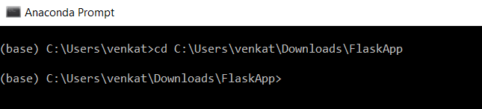

***Step5:*** *Run the Python file using python command, and once you execute the command the flask app will run in “localhost:5000” .*

*Ex: $> python app.py*

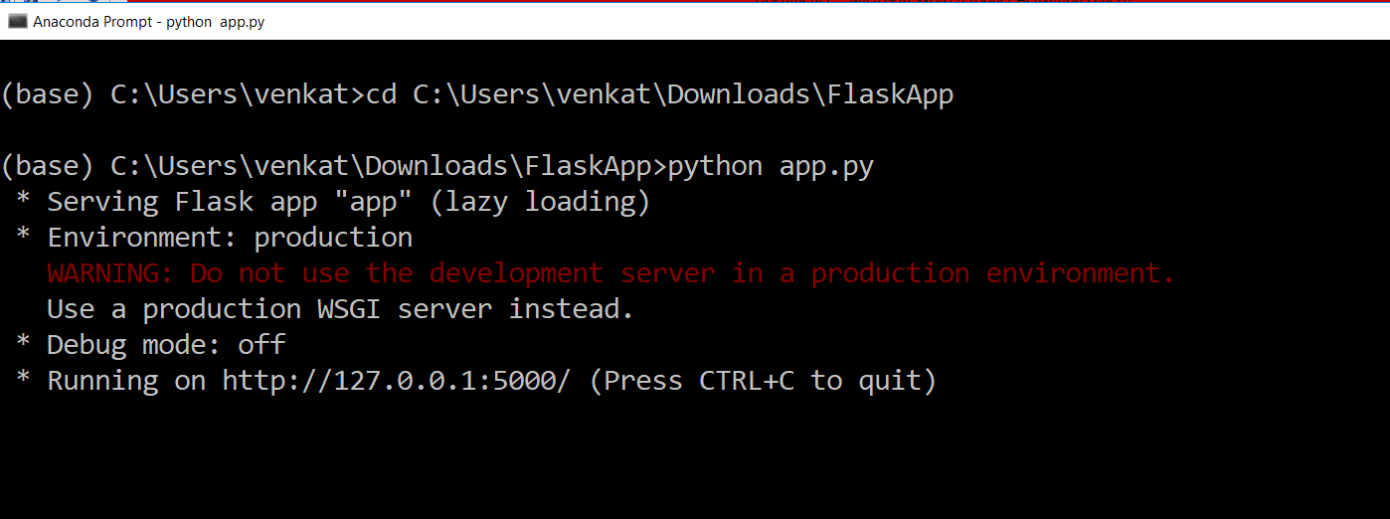

***Step6:*** *Open the browser and go to “localhost:5000” .*

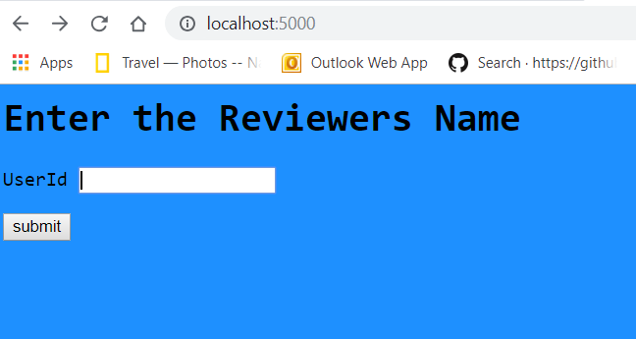

***Step7:*** *Input the Reviewers name” .*

***Positive Case:*** *Input -> BMS Reviewer*

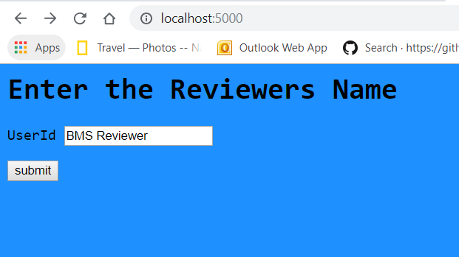

***Output:***

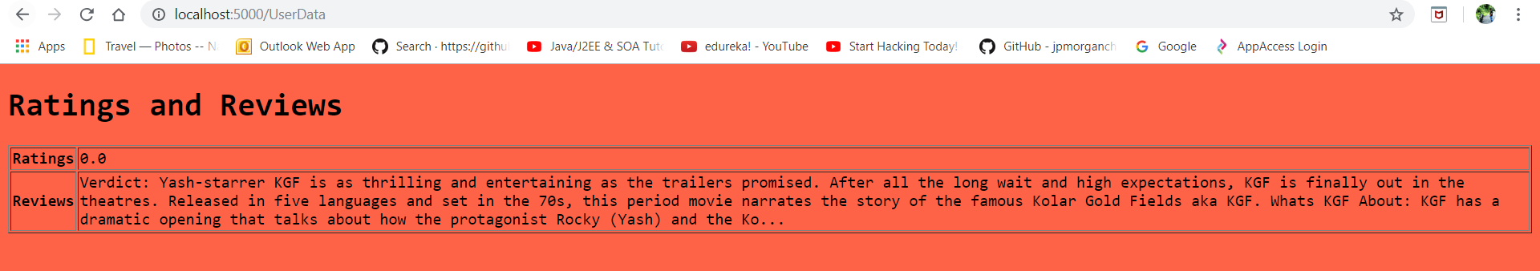

***Negative Case:*** *Input -> xyz*

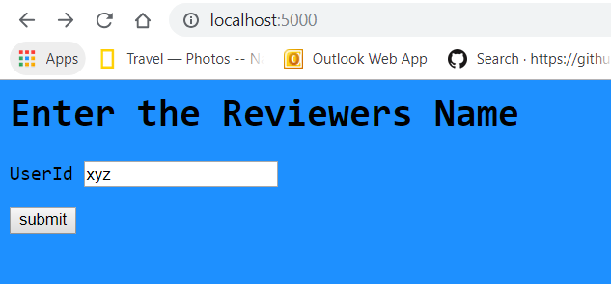

***Output:***

