**Course-end Project 2 - Call Data Distribution in MongoDB cluster**

* **Install mongo v3.2 on the virtual machine from apt repo.**

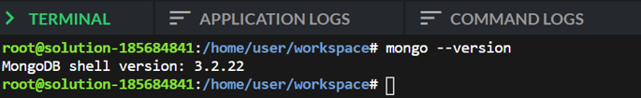

* **Create the data directories at the below locations:**

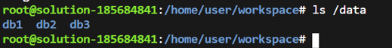

* **All the three mongod processes should be running using supervisord. This is required to ensure that the mongod processes start at the boot time.**

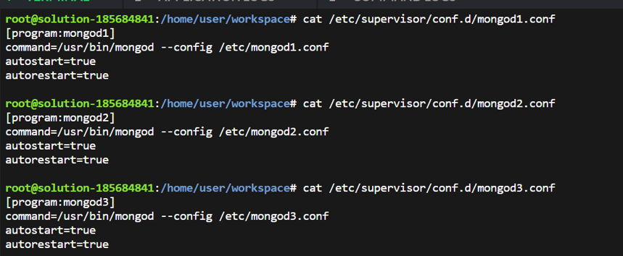

* **Deploy a replica set. The above mongod processes should have the replica set name as configReplSet**

* **Connect to an instance and check output of 'rs.status()'. It should return an array of three nodes.**

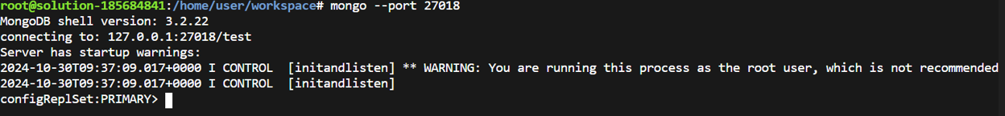

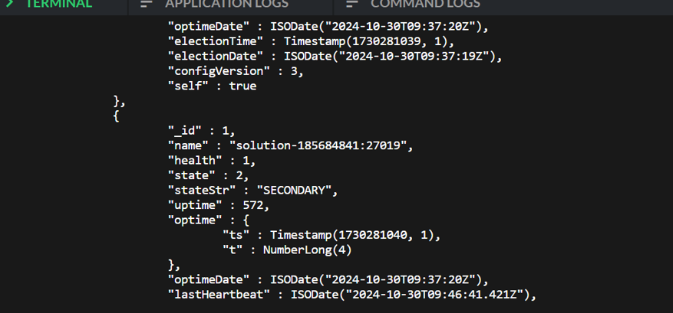

* **All three nodes should be healthy, two should be SECONDARY and one should be PRIMARY.**

Above screenshots clearly mention One primary node and two secondary nodes and they are in healthy state.

* **If the current node is not primary, disconnect and connect to primary node**

We are connected to port 27018 which happens to be the primary node. 27019 and 27020 are secondary nodes.

* **Import the data dump in the cluster and check the  count of documents in the collection.**

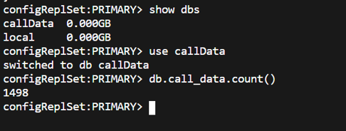

**We can see the count of records in call_data collection: 1498**