**MongoDB Developer and Administrator Project - Employee Training Score Analysis**

1. ***Find count and percentage of employees who failed in term 1, the passing score being 37***

**Step1: Finding Count of employees who failed in term1**

**db.pqrCorp.aggregate([{$match: {"results": {$elemMatch: {"evaluation": "term1", score: {$lt:37}}}}},{$count: "count_term1_fail"}])**



**Step2: Finding Percentage of employees who failed in term1**

**db.pqrCorp.aggregate([{$addFields: {"total_count":db.pqrCorp.count()}},{$unwind: "$results"},{$match: {"results.evaluation":"term1"}},{$match: {"results.score":{$lt:37}}},{$addFields: {"percent_fail":{$multiply:[{$divide:[3,"$total_count"]},100]}}},{$project: {"total_count":1,"percent_fail":1,"_id":0}},{$limit:1}])**



1. ***Find employees who failed in aggregate (term1 + term2 + term3)***

**Note: Considered aggregate as adding all term scores and total <37**

**db.pqrCorp.aggregate([{$unwind:"$results"},{$group: {"_id":"$name","sum_scores": {$sum: "$results.score"}}},{$match: {"sum_scores":{$lt:37}}}])**



1. ***Find the Average score of trainees for term1***

**db.pqrCorp.aggregate([{$unwind: "$results"},{$match: {"results.evaluation":"term1"}},{$group: {_id:null,avg_term1: {$avg: "$results.score"}}}])**

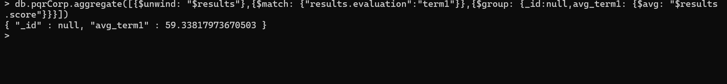

1. ***Find the Average score of trainees for aggregate (term1 + term2 + term3)***

**Note: Considered aggregate as adding all the term scores for each trainee and finding the average**

**db.pqrCorp.aggregate([{$unwind:"$results"},{$group: {_id:"$name",avg_score: {$avg: "$results.score"}}}])**

1. ***Find number of employees who failed in all the three (term1 + term2 + term3)***

**db.pqrCorp.aggregate([{$match: {"results": {$elemMatch: {"evaluation": "term1", score:{$lt:37}}}}},{$match:{"results": {$elemMatch: {"evaluation": "term2", score:{$lt:37}}}}},{$match:{"results": {$elemMatch: {"evaluation": "term3", score: {$lt:37}}}}}])**

1. ***Find the number of employees who failed in any of the three (term1 + term2 + term3)***

**db.pqrCorp.aggregate([{$unwind:"$results"},{$match: {"results.score":{$lt:37}}}])**

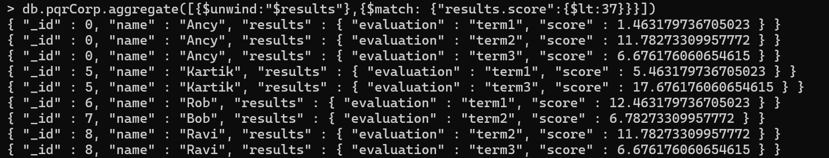

**db.pqrCorp.aggregate([{$match: {"results.score":{$lt:37}}},{$count: "failed_atleast_oneTerm"}])**

