GROUP - 3
Student Marks Analysis System
1. Introduction
The Student Marks Analysis System is a Python-based program designed to manage and analyze the academic performance of multiple students. The system accepts student details and subject-wise marks, calculates the total marks and percentage, assigns a grade based on predefined criteria, and stores the results permanently in a text file.
2. Objectives
- To accept details of multiple students
- To read subject-wise marks
- To calculate total marks
- To calculate percentage
- To determine grade based on percentage
- To store student results in a text file
- To display results on the screen

3. Problem Statement
Design and implement a program that takes marks of five subjects for multiple students, calculates their total marks and percentage, determines grades based on performance, and stores all results in a text file for record-keeping.

4. Grade Criteria
Percentage Range | Grade
≥ 90% | A
80% – 89% | B
70% – 79% | C
60% – 69% | D
50% – 59% | E
< 50% | Fail

5. Flow Chart
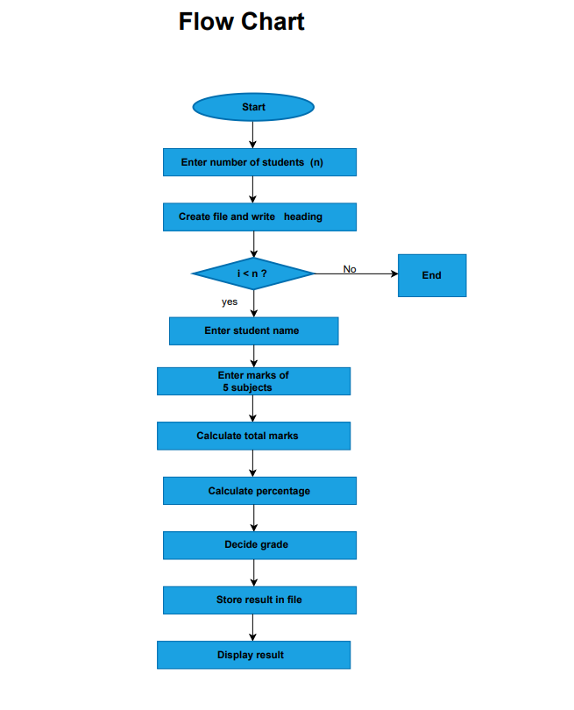

6. Algorithm
- Start the program
- Read total number of students
- Create/Open a text file and write report heading
- Repeat for each student:
  - Read student name
  - Read marks of five subjects
  - Calculate total marks
  - Calculate percentage
  - Determine grade using conditions
  - Append student details to file
  - Display student result
- Display confirmation message
- End the program
7. Source Code in Python
n=int(input("Total number of students : "))
with open("Student_Results.txt","w") as file:
file.write("students marks report\n")
for i in range (n):
#Student Name
Name = str(input("Student Name : "))
#SubjectWise Marks
Maths = float(input("Maths : "))
Python = float(input("Python : "))
Automata = float(input("Automata : "))
ML = float(input("ML : "))
DataAnalytics = float(input("Data Analytics : "))

#Total
Total = sum([Maths,Python,Automata,ML,DataAnalytics])
#Percentage
Percentage = (Total/500)*100
#Grade
if Percentage >= 90:
Grade = "A"
elif Percentage >= 80:
Grade = "B"
elif Percentage >= 70:
Grade = "C"
elif Percentage >=60:
Grade = "D"
elif Percentage >=50:
Grade = "E"
else:
Grade = "Fail"
with open("Student_Results.txt","a") as file:
file.write(f"Student: {Name}\n")
file.write(f"Maths : {Maths}\n")
file.write(f"Python : {Python}\n")
file.write(f"Automata : {Automata}\n")
file.write(f"ML : {ML}\n")
file.write(f"Data Analytics : {DataAnalytics}\n")
file.write(f"Total Marks : {Total}\n")
file.write(f"Percentage : {Percentage}\n")
file.write(f"Grade : {Grade}\n")
print("Student Name : ", Name)
print("Total Marks Scored : ", Total)
print("Percentage Scored : ", Percentage)
print("Grade Scored : " , Grade)
print("Results Stored Succenfully in StdResults Text file")
8.OUTPUT
Total number of students : 3
Student Name : Ramesh
Maths : 85
Python : 90
Automata : 78
ML : 88
Data Analytics : 92
Student Name : Ramesh
Total Marks Scored : 433.0
Percentage Scored : 86.6
Grade Scored : B
Student Name : Rahul
Maths : 72
Python : 68
Automata : 70
ML : 75
Data Analytics : 73
Student Name : Rahul
Total Marks Scored : 358.0
Percentage Scored : 71.6
Grade Scored : C
Student Name : Arjun
Maths : 45
Python : 50
Automata : 48
ML : 52
Data Analytics : 46
Student Name : Arjun
Total Marks Scored : 241.0
Percentage Scored : 48.199999999999996
Grade Scored : Fail
Results Stored Succenfully in StdResults Text file
9.RESULT STORED IN TEXT FILE
Student_Results.txt
students marks report
Student: Ramesh
Maths : 85.0
Python : 90.0
Automata : 78.0
ML : 88.0
Data Analytics : 92.0
Total Marks : 433.0
Percentage : 86.6
Grade : B
Student: Rahul
Maths : 72.0
Python : 68.0
Automata : 70.0
ML : 75.0
Data Analytics : 73.0
Total Marks : 358.0
Percentage : 71.6
Grade : C
Student: Arjun
Maths : 45.0
Python : 50.0
Automata : 48.0
ML : 52.0
Data Analytics : 46.0
Total Marks : 241.0
Percentage : 48.199999999999996
Grade : Fail
10.COMPILER SNIPPET
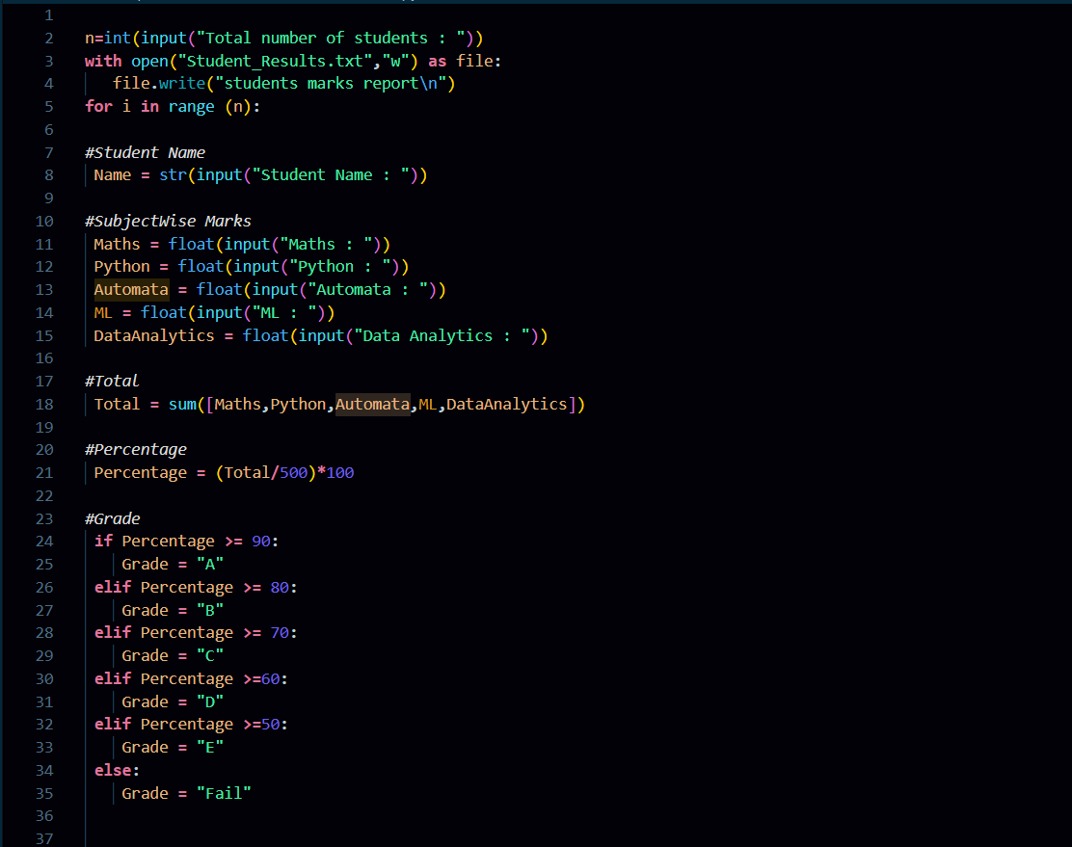
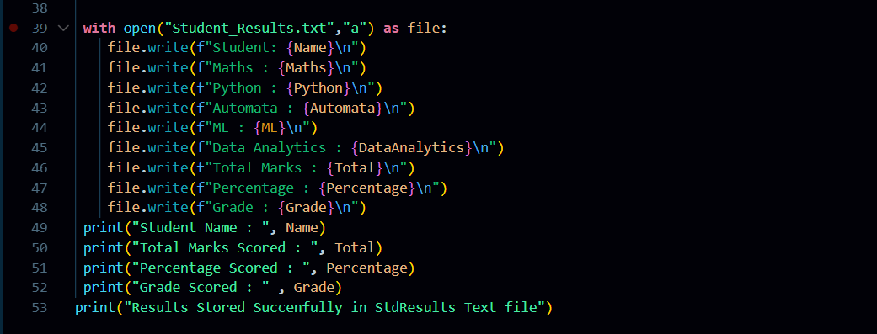

11.OUTPUT SNIPPET
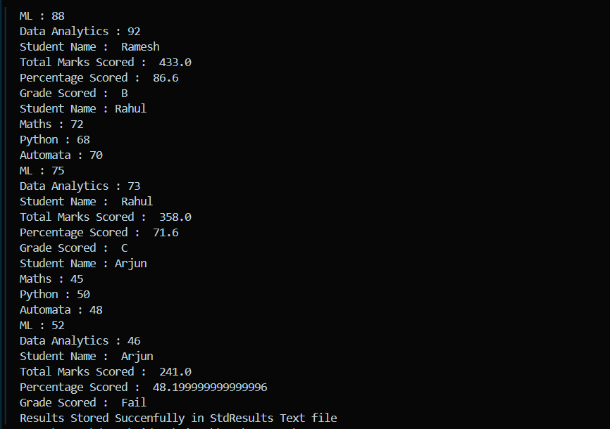
12.TEXTFILE SNIPPET
