**HIVE and Sqoop**

* Initially mount folder with vm to transfer file from local machine.

Mount vboxsf -t shared shared

* After receiving file into vm, create table “customers” under antwak database in mysql

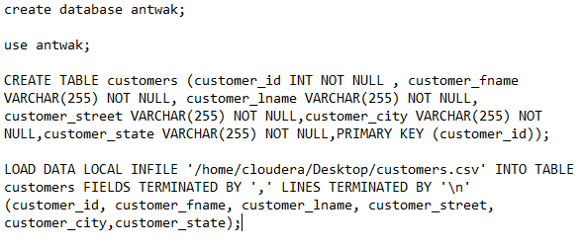

* Now move data into warehouse which will be acting as a staging table/file.

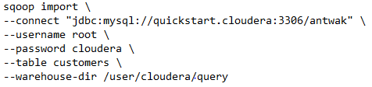

* We will be creating hive table “customers” under antwak database with exact schema of sql table.

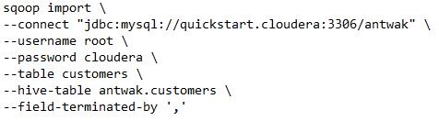

* After creation of table in hive, we will loading table from warehouse. After data is loaded in hive table, data will be not present in warehouse directory.



1.How many records are present?

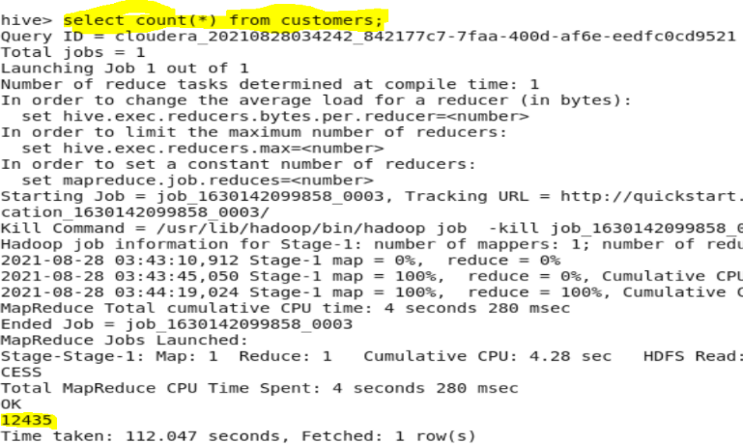

2. How many customers stay in the state TX

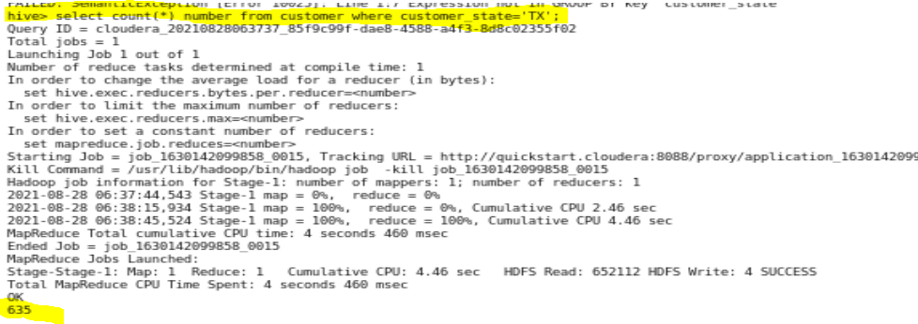

3. Which state has the lowest customer count

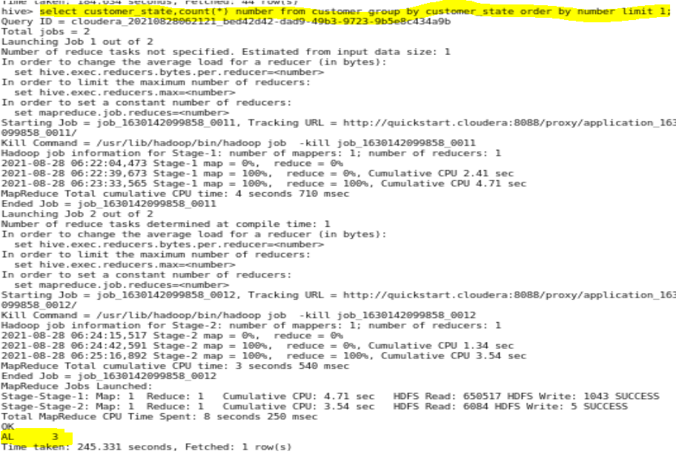

4. Which state has the highest customer count

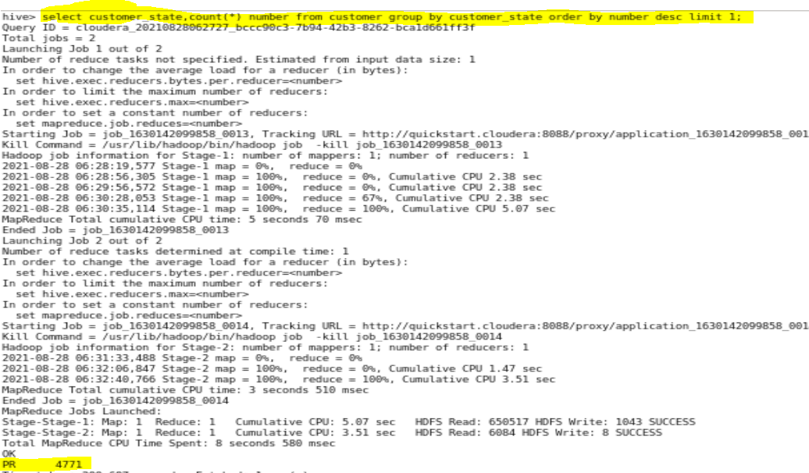

5. How many customers are present with the First Name 'Mary’

