Weather classification using single image by fusion of features.
Ganesh Deepak Valmiki¹[0000-0001-8574-0128] and Venkat Siddish Gudla¹[0000-0002-2967-053X]
¹ Indian Institute of Technology Kharagpur
¹ v.ganeshdeepak@iitkgp.ac.in
²durgajp94@iitkgp.ac.in
Abstract. Vision based driver assistance systems are required to perform well even under adverse weather conditions. This in turn requires an automated accurate multi-class weather classification system using single images. The weather classification system sense the environment conditions, which will be used by the autonomous ground platforms to select the right set of sensor for environment perception. Self driving cars are equipped with multi model sensors for environment perception which include camera, Li-DAR and RADAR for handling adverse weather conditions. Most of the papers takes the streams of camera, Li-DAR and RADAR, detect obstacle and carry out late fusion them to detect obstacles, without sensing the environment. In order to improve the detection of obstacle in adverse weather conditions, a reliable weather detection/classification system is essential. This paper presents a method which uses single image to detect the weather, which will be used in conjunction with environment perception module using multi-model sensors. Using weather classification module proper weightages can be assigned to sensor, which will improved the obstacle detection system accuracy. The proposed method uses the combination of Histogram of Gradient (HOG) \& deep features, feature reduction and classification. High dimensional feature vector were subjected to dimensionality reduction before feeding to classifiers. Extensive experiments on the bench-mark dataset using various features extraction and selection methods were carried out in conjunction with various classifiers. The proposed method uses fusion of Histogram of Gradient (HOG) & DenseNet-161 features and SVM classifier to achieve the classification accuracy of 99.65% which outperforms other methods trained on the same dataset.
Keywords: HOG, DenseNet, ResNet, Support Vector Machine, PCA, Mutual Information
- Introduction
Self-driving cars or autonomous ground platform perceive their surrounding by combining information from a variety of sensors. These sensors work well under good weather conditions and fails to perform under adverse weather conditions. The weather condition plays critical role in functioning of self driving car, a robust weather classification system is critical, which provide valuable information. The output of weather classification can be utilized to assign proper weightages to sensors to improve cognition.

- Related Work
Weather image classification has been a prominent area of research for quite some time. Including the first proposed primitive mathematical models to the ever-evolving use of Deep Convolutional Neural Networks (CNN) in the field of object recognition and classification. This section discusses the previous approaches made in recognizing weather conditions from images.
Like our work, Zhang et al. tackled the weather image classification using Histogram of Oriented Gradients for their feature extraction method [1,2]. Then combining that with a combination of dictionary learning and multiple kernel learning which attempts to reduce the feature space using feature selection methods and improves the learning capacity of models like SVM. They went on to create their own dataset, the Multi-class Weather Image (MWI) containing 20K images, which we have deployed our model on as well [3]. Their proposed model achieved a classification accuracy of 71.39% on the four classes in the dataset.
Delving into the CNN approach, Al-Haija et al. proposed a deep CNN classification model using ResNet-18 architecture [4]. They employed the use of transfer learning for feature extraction and customized the input and output layers (fine-tuning). Then used SoftMax probability distribution as the activation function. The obtained fully connected neural network was run through this activation which outputs the numerical probabilities of each class. They deployed their model on the same dataset as the one used in this paper. Their proposed model achieved a classification accuracy of 98.22%.
Another Deep CNN approach was proposed by Xiao et al. in which they develop a model called MeteCNN [5]. They created their own dataset by combining a few of the already available ones which has 11 classes. The CNN was developed as an optimized version of the VGG-16 which is easy to train and occupies small amount of memory. Their framework consisted of 13 convolutional layers, 6 pooling layers and a SoftMax classifier which was trained on the 6,877 images belonging to 11 classes. The accuracy achieved by the MeteCNN was 92.68%.
Developing their own framework Ibrahim et al. proposed WeatherNet which consisted of parallel Deep CNN models which were used to analyses street-level images of urban scenes [6]. The WeatherNet comprised of four models which were used to detect dawn/dusk, day, night-time, glare, rain, snow, and fog, respectively. These models were NightNet which detected the differences between dawn/dusk, day and night-time, GlareNet which detected images with glare, PreciptationNet detected clear, rainy, or snowy weather and FogNet detected the occurrence of fog. Training this parallel model on their curation of images from various sources, they achieved class accuracies ranging from 91.6-95.6%.
A new and improved model by Al-Haija et al. was proposed in which they used the framework which characterized the performance of 3 different CNNs namely: SqueezeNet CNN, ResNet-50 CNN and EfficientNet-b0 CNN [7]. For their model, they combined two popular datasets in the field of weather image classification which gave them a dataset of 6 classes containing 1656 images. Using transfer learning and fine tuning of the fully connected output layers of the 3 CNNs, SoftMax classifier was used on the feature vectors obtained. The accuracies of the 3 models ranged from 95.68-98.44% in which the ResNet-50 CNN had the highest accuracy of the three.

- Methodology
In this paper we propose a model which uses a fusion of features and subsequent feature transformation techniques to achieve a very high accuracy on the used dataset. We employ the use of transfer learning to import models pretrained on the ImageNet [8] dataset and fuse those features with features obtained through Histogram of Oriented Gradients (HOG). This proved to give higher accuracies than if the model classified using only the features obtained from the pretrained models.

  - Dataset used
For the purpose of our experiment, we used the Multi Class Weather Recognition Dataset (MCWRD) which consists of 1125 images of classes Cloudy, Shine, Sunrise and Rain [9]. We also tested our model on the Multi Weather Image (MWI) dataset to compare with other prominent classification models in the field of weather image classification. For the sake of simplicity, we considered a total images of 2000 from the MWI dataset. The dataset consists of 500 images each of classes Haze, Rainy, Snowy , Sunny.

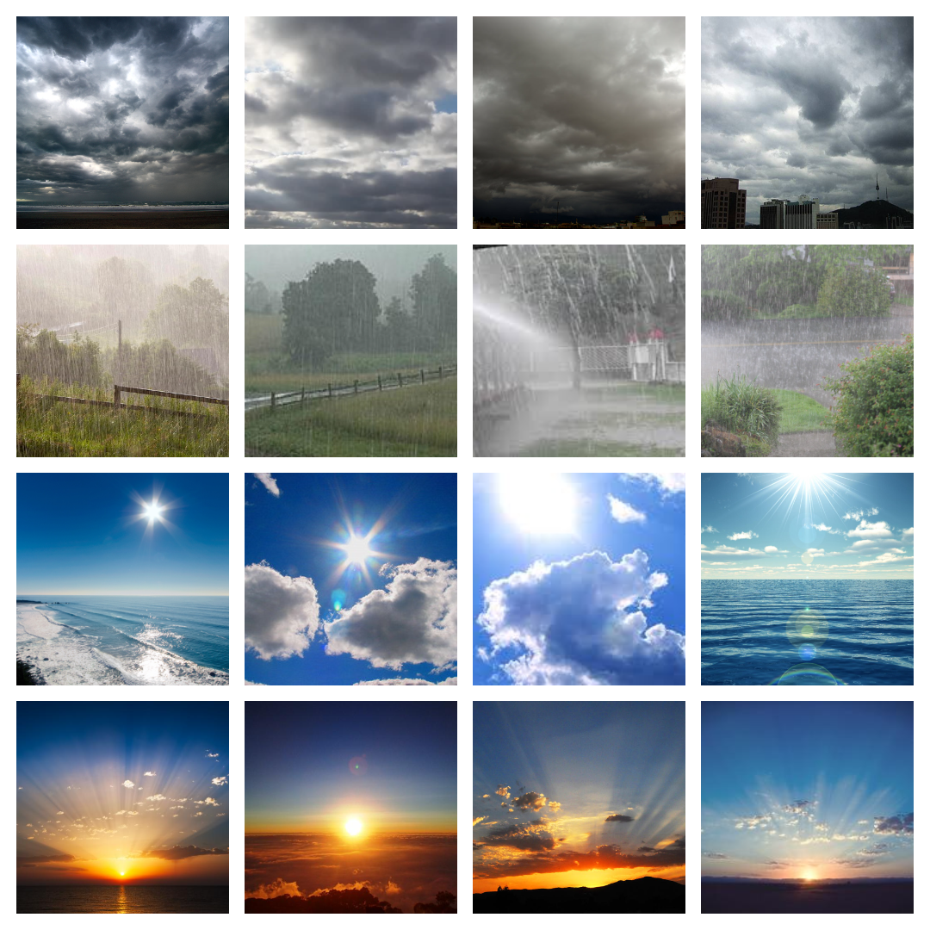
  - Image Preprocessing module
Loading the images. We loaded the images using Python Image Library (PIL). Converted all the images to RGB for uniformity.

Resizing the images. This is required to convert all the images into the same dimension. In order to do this, we used the inbuilt function, Resize in Torchvision module. This converts all the RGB images to a size of 224*224*3.

Label encoding. Classification deals with numerical labels. In order to change categorical labels to numerical labels, we assigned integral labels as follows, Cloudy:0, Rain:1, Shine:2, Sunrise:3.
  - Feature Extraction.
Feature descriptor. It is a simplified representation of the image the contains only the most important information about the image.

Histogram of Oriented Gradients (HOG). The HOG descriptor focuses on the structure or the shape of an object. In case of edge features, we only identify if a pixel is an edge or not. HOG is able to provide the edge direction as well. This is done by extracting gradients and orientation of the edges.
To obtain features using HOG, the images are first resized into the shape of where the ratio of height is to width is 1:2. (Preferably 64*128). Before extracting features, all the images undergo preprocessing process. In order to obtain HOG features of an image, we use hog function in skimage.features. When passed along with the parameters, it returns a feature vector of size 3780.
One drawback with HOG features is that it is very senstitve to image rotation.
To improve the results, deep learning methods were used to extract features. The introduction of very Deep Convolutional Neural Networks helped the models to achieve state-of-art results on the tasks like image recognition and image classification.
Over the years, the deep neural networks got deeper and deeper to solve more complex tasks.
Deep neural networks are hard to train because of the vanishing gradient problem. Models like ResNet, DenseNet were introduced to reduce this issue.

Residual Networks (ResNet). In order to solve the problem of vanishing gradient, this architecture introduced the concept called residual blocks. In this network, we use a technique called skip connections. The skip connection connects activations of a layer to further layers by skipping some layers in between. This forms a residual block. Resnets are made by stacking these residual blocks together.
The approach behind this network is instead of layers learning the underlying mapping, we allow the network to fit the residual mapping.
So, instead of say H(x), initial mapping, let the network fit,
F(x) := H(x) - x which gives H(x) := F(x) + x. (1)
. 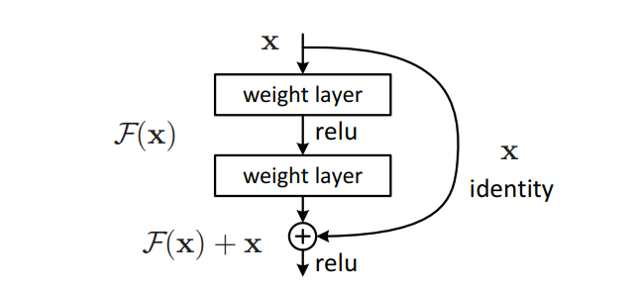
Fig. 1: Skip connections.([10])
To extract features from ResNet models, we imported the five pretrained ResNet models from Pytorch. After importing the models, we replaced model.fc with nn.Identity. Identity() will just return the input without any clone usage or manipulation of the input and since the features are its input, the output of the entire model will be the features. We gave the dataset as the input to our ResNet models and obtained the corresponding feature vectors.
The pretrained ResNet models are:
  - ResNet-18
  - ResNet-34
  - ResNet-50
  - ResNet-101
  - ResNet-152
Densely Connected Networks (DenseNet). A DenseNet is a type of convolutional neural network that utilizes dense connections between layers, through Dense Blocks, where we connect all layers (with matching feature-map sizes) directly with each other. To preserve the feed-forward nature, each layer obtains additional inputs from all preceding layers and passes on its own feature-maps to all subsequent layers.
To extract features from DenseNet models, we imported the four pretrained DenseNet models from Pytorch. After importing the models, we replaced model.classifier with nn.Identity. Using a similar approach as used in extracting features from ResNet models, we extracted the corresponding feature vectors from DenseNet models.
The pretrained DenseNet models are:
  - DenseNet-121
  - DenseNet-161
  - DenseNet-169
  - DenseNet-201
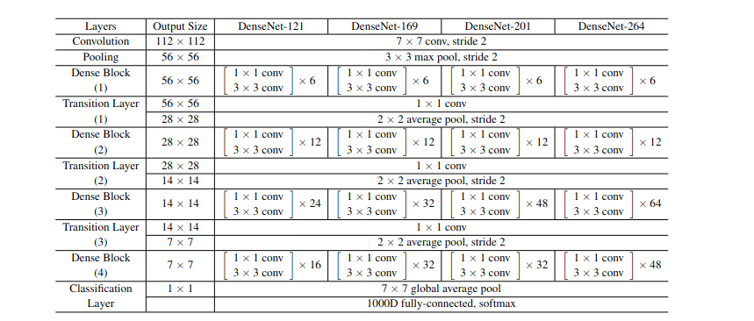
Fig. 1. DenseNet layers ([11])
Vision Image Transformers (ViT). The Vision Transformer, or ViT, is a model for image classification that employs a Transformer-like architecture over patches of the image. An image is split into fixed-size patches, each of them are then linearly embedded, position embeddings are added, and the resulting sequence of vectors is fed to a standard Transformer encoder. In order to perform classification, the standard approach of adding an extra learnable “classification token” to the sequence is used.
To extract features from ViT models, we imported the four pretrained ViT models from Pytorch. After importing the models, we replaced model.head with nn.Identity. Again, using the similar approach, we extracted the feature vectors from ViT models.
The pretrained ViT models are:
  - Vit_b_16
  - Vit_b_32
  - Vit_l_16
  - Vit_l_32

Fig. 1. Overview of the ViT model ([12])
  - Feature selection and dimensionality reduction.
Mutual information based feature selection. Feature selection is used to choose a subset of relevant features for effective classification of data. In high dimensional data classification, the performance of a classifier often depends on the feature subset used for classification. This method utilizes feature–feature mutual information to find an optimal subset of features to minimize redundancy and to maximize relevance among features. The effectiveness of the selected feature subset is evaluated using multiple classifiers on the datasets used in this paper.
The mutual information between two random variables X and Y can be stated formally as follows:
I (X: Y) = H(X) – H (X | Y) (1)
Where I (X: Y) is the mutual information for X and Y, H(X) is the entropy of X and H(X|Y) is the conditional entropy for X given Y. Mutual information is a measure of dependence between two random variables [13].

Dimensionality reduction using PCA. The curse of dimensionality basically means that the error increases with the increase in the number of features. It refers to the fact that algorithms are harder to design in high dimensions and often have a running time exponential in the dimensions.
Principal Component Analysis (PCA) helps us to identify patterns in data based on the correlation between features. In a nutshell, PCA aims to find the directions of maximum variance in high-dimensional data and projects it onto a new subspace with
equal or fewer dimensions than the original one [14].
In our extensive experiments, we found that the dimensions of the raw features were quite high owing to the fact that the features obtained through HOG were of the dimension 3780. This contributed to a high dimension feature space which slows the execution of the classification model.
Over the course of our research, we found out that the best results were obtained when we fused the features obtained through a Deep learning method and a non-DL method. The non-DL features obtained through HOG were able to enrich the information of the feature space which previously contained the feature vectors from the DL models.
We used different approaches to reduce dimensionality and apply feature selection. First was to apply PCA to the individual feature vectors from DL models and HOG and thereby concatenating them to obtain the final features.
The second approach was to apply feature selection to the individual features after applying PCA and then concatenating them.
A different approach was to first apply feature selection and concatenating them to obtain the final features. Also, a variation of this would be to apply PCA after feature selection and finally concatenating them to obtain the fourth feature space.
  - Data shuffling and splitting
All the different feature spaces obtained through the mentioned methods were shuffled randomly to reduce the model bias towards a particular class. For the features obtained through fusion of two different kinds of features, shuffling was performed after the fusion of features.
We split the data into training and testing set in a 75-25% train-to-test fashion. We did this so that our model could be tested first on unseen data before being deployed into real-world scenarios.
  - Classification model
Combining the features of the base DL models, base DL models and HOG along with the four aforementioned feature spaces, we trained our classifier models on these six feature spaces.
We trained classical Machine learning models and obtained the results. In our experiments, we found out that the classifier with the highest accuracy was a Support Vector (Machines) classifier which outperformed Random Forest, K-Nearest Neighbors, Decision Tree and Naive Bayes Classifiers.
- Experiment Results

From our research on various classifiers with different feature extraction techniques, we concluded that Support Vector Classifier was giving the best results.
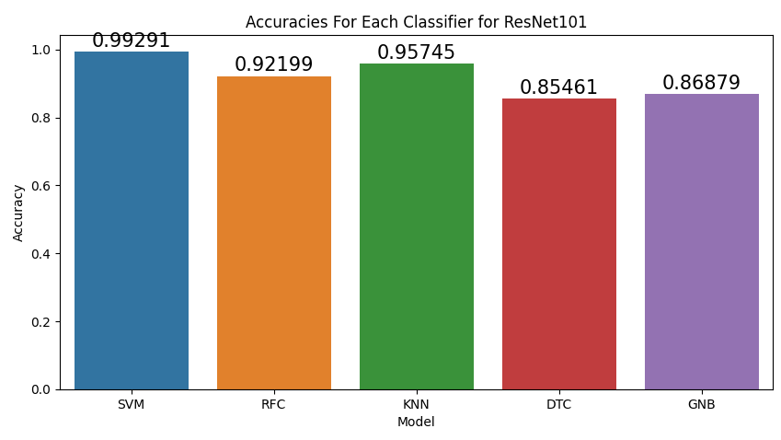
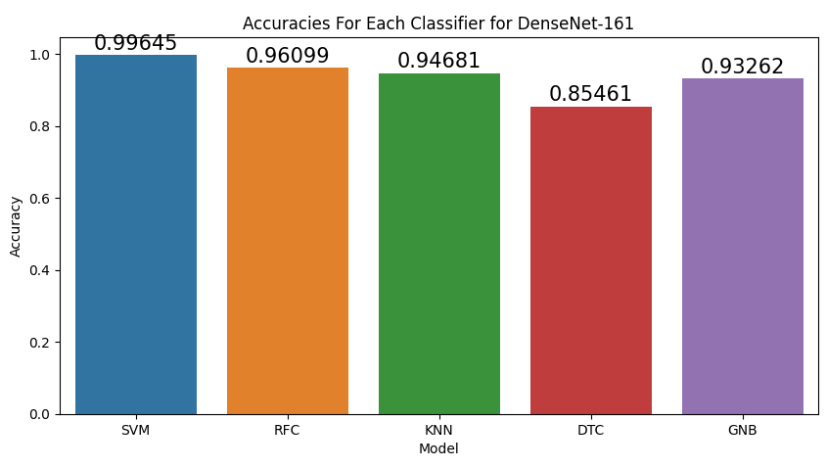
The above accuracy plot were made to compare different classifier’s test accuracy with a particular feature extraction, selection, reduction techniques..

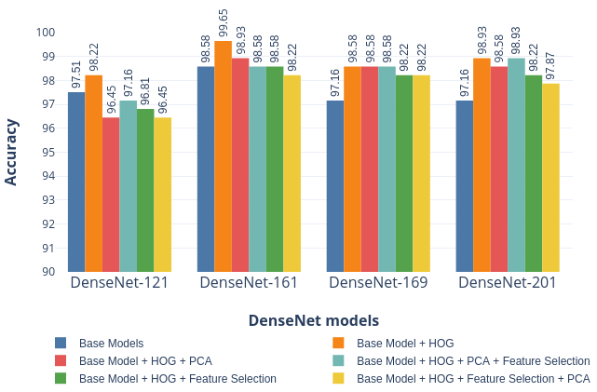
Fig. 1. Accuracies of DenseNet models with SVM on MCWRD Dataset
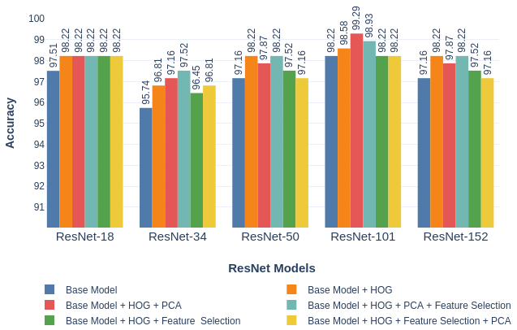
Fig. 1. Accuracies of ResNet models with SVM on MCWRD Dataset
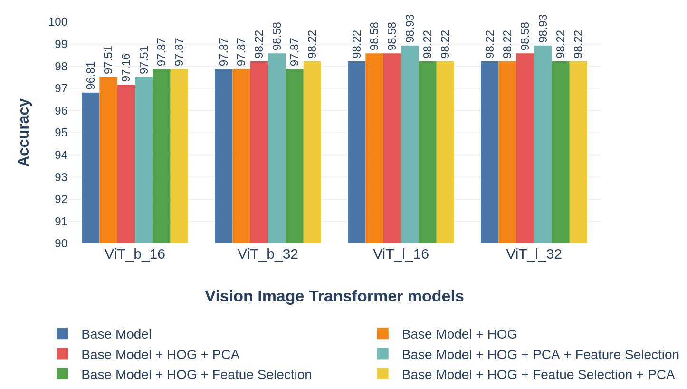
Fig. 1. Accuracies of ViT models with SVM on MCWRD Dataset

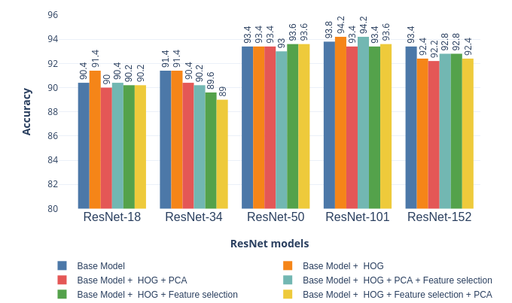
Fig. 1. Accuracies of ResNet models with SVM on MWI Dataset

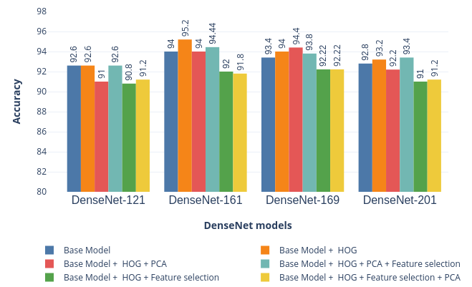
Fig. 1. Accuracies of DenseNet models with SVM on MWI Dataset

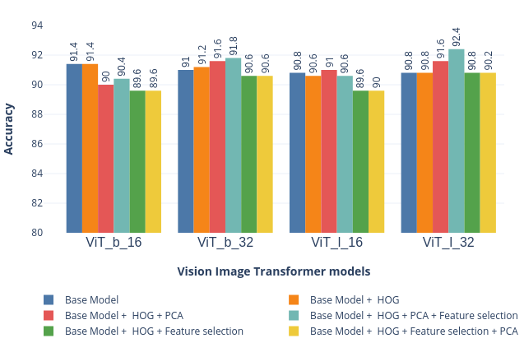
Fig. 1. Accuracies of ViT models with SVM on MWI Dataset
The table below shows the number of features the classifier model is trained with in different approaches as discussed in the previous sections.

Table 1.1 Features fed into the classifier at different stages of feature fusion and transformation
Total Number OF Features
Model | Base Model | Base Model + HOG | Base Model + HOG + PCA
ResNet-18 | 512 | 512+3780=4292 | 181+556=737
ResNet-34 | 512 | 512+3780=4292 | 184+556=740
ResNet-50 | 2048 | 2048+3780=5828 | 204+556=760
ResNet-101 | 2048 | 2048+3780=5828 | 201+556=757
ResNet-152 | 2048 | 2048+3780=5828 | 192+556=748
DenseNet-121 | 1024 | 1024+3780=4804 | 216+556=772
DenseNet-161 | 2208 | 2208+3780=5988 | 297+556=853
DenseNet-169 | 1664 | 1664+3780=5444 | 282+556=838
DenseNet-201 | 1920 | 1920+3780=5700 | 298+556=854
ViT_b_16 | 768 | 768+3780=4548 | 274+556=830
ViT_b_32 | 768 | 768+3780=4548 | 273+556=829
ViT_l_16 | 1024 | 1024+3780=4804 | 353+556=909
ViT_l_32 | 1024 | 1024+3780=4804 | 319+556=875

Table 1.2 (contd.)
Total Number OF Features
Model | Base Model + HOG + PCA + F. S | Base Model + HOG + F. S | Base Model + HOG + F.S + PCA
ResNet-18 | 90+288=378 | 256+1890=2146 | 114+397=511
ResNet-34 | 92+288=380 | 256+1890=2146 | 116+397=513
ResNet-50 | 102+288=390 | 1024+1890=2914 | 153+397=550
ResNet-101 | 100+288=388 | 1024+1890=2914 | 151+397=548
ResNet-152 | 96+288=384 | 1024+1890=2914 | 145+397=542
DenseNet-121 | 108+288=396 | 512+1890=2402 | 79+397=476
DenseNet-161 | 148+288=436 | 1104+1890=2994 | 103+397=500
DenseNet-169 | 141+288=429 | 832+1890=2722 | 105+397=502
DenseNet-201 | 149+288=437 | 960+1890=2850 | 103+397=500
ViT_b_16 | 137+278=415 | 384+1890=2274 | 185+397=582
ViT_b_32 | 136+278=414 | 384+1890=2274 | 185+397=582
ViT_l_16 | 176+278=454 | 512+1890=2402 | 247+397=644
ViT_l_32 | 159+278=437 | 512+1890=2402 | 222+397=619
  - Classification report and confusion matrices of the 2 best performing models
Classes | Precision | Recall | F1-score | Support
Cloudy | 1 | 0.99 | 0.99 | 80
Rain | 0.98 | 1 | 0.99 | 46
Shine | 1 | 1 | 1 | 65
Sunrise | 1 | 1 | 1 | 91
Average | 0.995 | 0.9975 | 0.995
Table 2. Classification performance of SVM with DenseNet-161+HOG features on MCWRD
Classes | Precision | Recall | F1-score | Support
Cloudy | 0.99 | 0.99 | 0.99 | 80
Rain | 1 | 1 | 1 | 46
Shine | 0.98 | 0.98 | 0.98 | 65
Sunrise | 1 | 1 | 1 | 91
Average | 0.9925 | 0.9925 | 0.9925
Table 3. Classification performance of SVM with ResNet-101+HOG features after PCA on MCWRD
We summarize the classification performance of SVM on the two best performing feature spaces with the confusion matrices in Fig x. The analysis was done on the MCWRD.
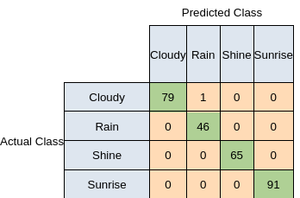
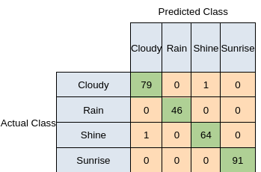
Fig 1. Confusion matrix analysis for fusion of DenseNet-161 and ResNet-101 with HOG features
  - Table for comparison of various proposed models
Model year | Proposed method | Dataset used | Accuracy
2016 | SVM+ Histogram of Oriented Gradients | MWI  (4 classes-Haze,Cloudy,Rainy,Sunny) | 71.39%
2019 | WeatherNet | Created their own dataset | 95.60%
2020 | ResNet-18+ SoftMax classifier | MCWRD  (4 classes- Cloudy,Rain,Shine,Sunrise) | 98.22%
2021 | Mete-CNN | Weather phenomenon database (WEAPD)  (11 classes) | 92.68%
2022 | SqueezeNet, ResNet-50 and Effiecient-b0 CNN | MCWRD+DAWM  (6 classes- Cloudy,Rain,Shine,Sunrise,Sandy,Snowy) | 98.44%
Proposed | Fusion of features | MCWRD  (4 classes- Cloudy,Rain,Shine,Sunrise) | 99.65%
Proposed | Fusion of features | MWI  (4 classes-Haze,Cloudy,Rainy,Sunny) | 95.2%
Table 4. Comparison of accuracies of the proposed model with existing related work methods.
- Conclusions.
A highly accurate weather classification module was discussed in this paper. We proposed a model which uses a fusion of features in order to improve model performance and deploy it in real world scenarios especially in the context of autonomous self driving vehicles where such a system is of paramount importance. The models have been evaluated on the MCWRD and MWI datasets which have 4 classes each. The fusion of features include those of various Residual Networks (ResNet), various Densely connected networks (DenseNet) and Vision Image Transformers (ViT) with Histogram of Oriented Gradients (HOG). A variety of features selection and dimensionality reduction techniques were used in conjunction with these fused features and classified using different classifiers and it was noted that an SVM classifier performed the best among others. This gave state-of-art results with accuracies as high as 99.65% on a particular configuration of features.
The proposed method can be extended to various other image recognition avenues such as traffic sign detection, street signs and other areas which could prove useful for an autonomous self driving vehicle.

6 Model Evaluation Metrics.

The intent of the ROC Curve is to show how well the model works for every possible threshold, as a relation of TPR vs FPR [15,16].

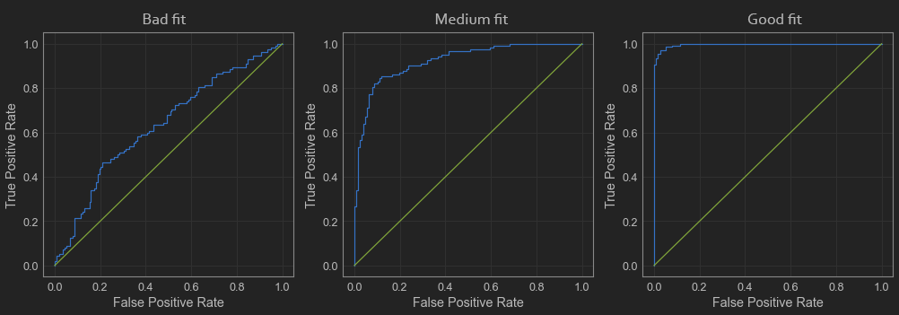
On the left plot the blue line is relatively close to the green one, which means that the classifier is bad. The rightmost plot shows a good classifier, with the ROC curve closer to the axes and the “elbow” close to the coordinate (0,1). The middle one is a good enough classifier, closer to what is possible to get from real-world data.
Another way to interpret the ROC curve is by thinking about the separation of the classes, and we can illustrate that with histograms, as below.
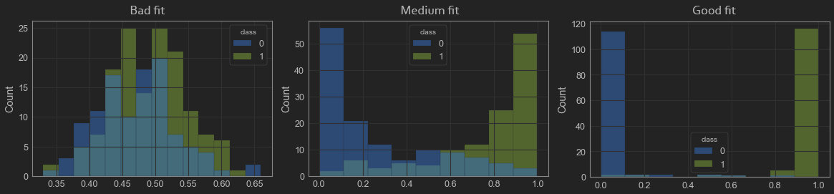
Additional evaluation metrics like precision-recall curves, roc curves and histograms were plotted to test model performance. These metrics are calculated for the two best models as defining earlier.
The AUROC Curve (Area Under ROC Curve) or simply ROC AUC Score, is a metric that allows us to compare different ROC Curves.
The green line is the lower limit, and the area under that line is 0.5, and the perfect ROC Curve would have an area of 1. As closer as our model’s ROC AUC is from 1, the better it is in separating classes and making better predictions.
ROC curve and precision recall curve for our best model (SVM classifier on the fusion of DenseNet-161 and HOG features).

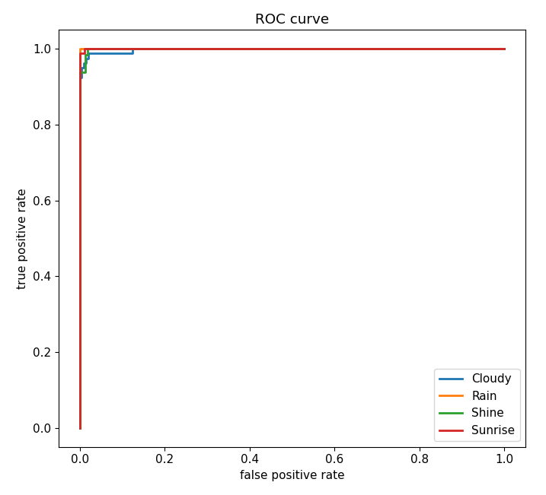
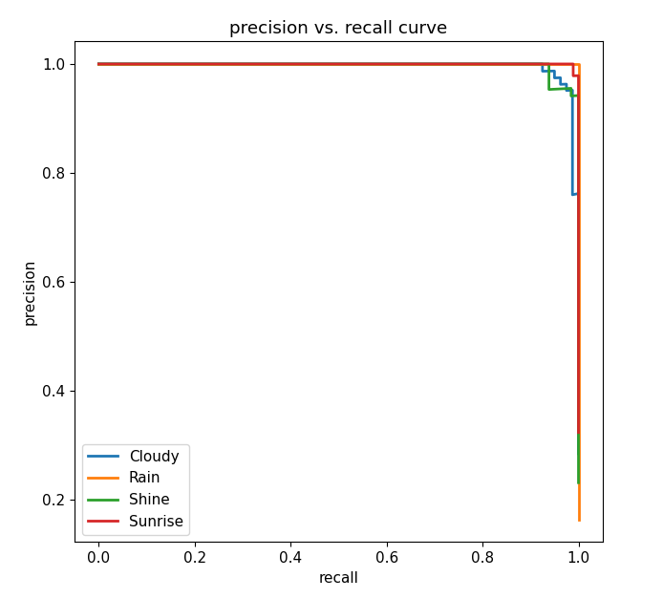

The table below illustrates the Area Under the ROC curve for each class (one vs rest) and the average of the same.

One vs Rest | ROC-AUC Value
Cloudy | 0.9996
Rain | 1.0000
Shine | 0.9999
Sunrise | 1.0000
Average AUC-ROC for one vs rest | 0.9999

The plots below denote (a) class-separation and (b) ROC curves for each class.
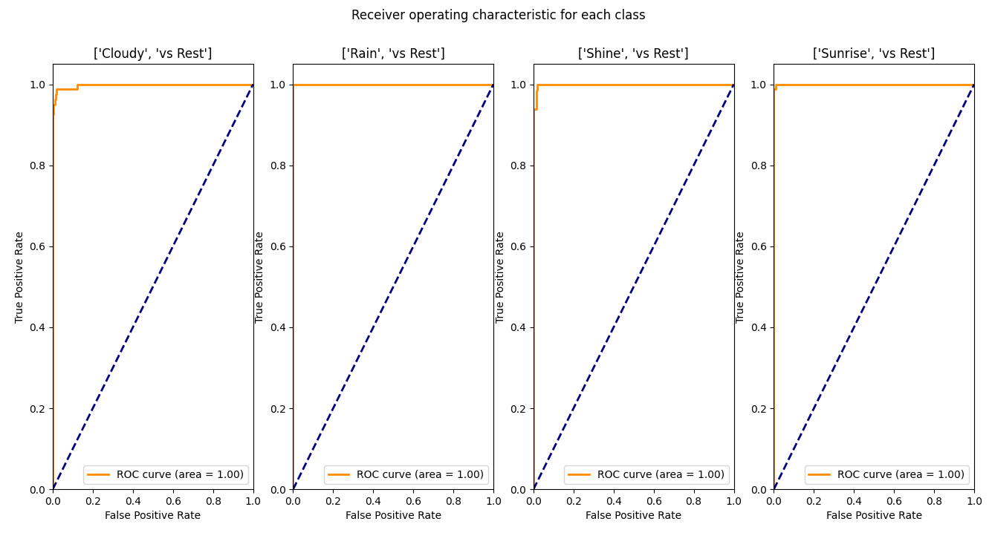
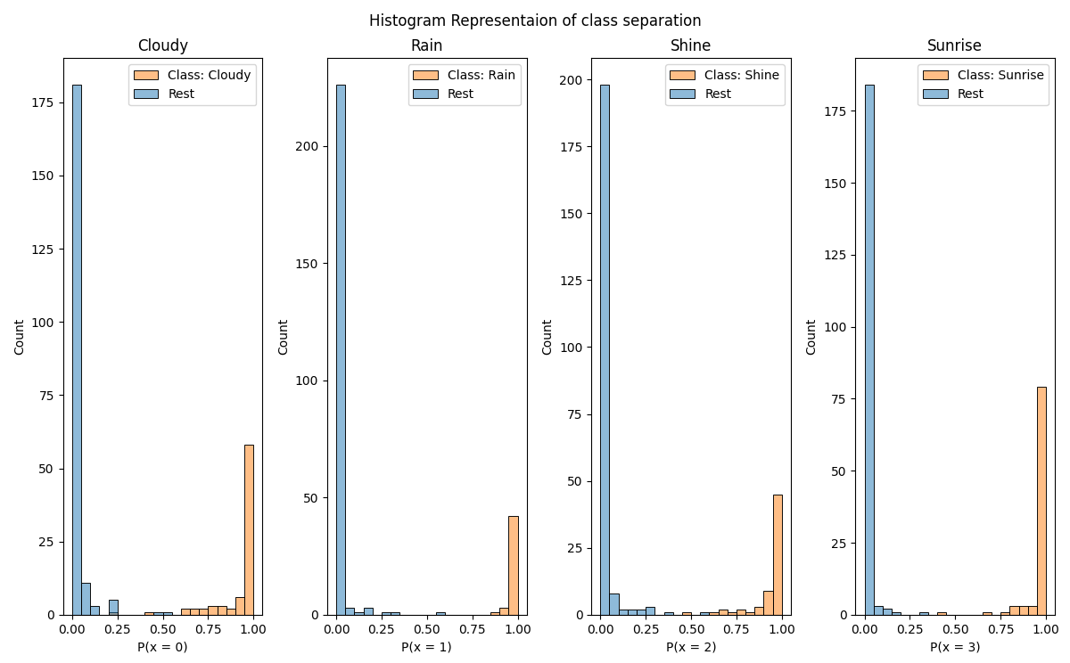

References
- Singh, Aishwarya. “Feature Descriptor | Hog Descriptor Tutorial.” Analytics Vidhya, www.analyticsvidhya.com, 4 Sept. 2019, https://www.analyticsvidhya.com/blog/2019/09/feature-engineering-images-introduction-hog-feature-descriptor/.
- Zhang, Zheng & Ma, Huadong & Fu, Huiyuan & Zhang, Cheng. (2016). Scene-free Multi-class Weather Classification on Single Images. Neurocomputing. 207. 10.1016/j.neucom.2016.05.015.
- Zheng Zhang, Huadong Ma. Multi-class weather classification on single images. Proc. of IEEE International Conference on Image Processing, 2015.
- Abu Al-Haija, Qasem & Smadi, M. & Zein-Sabatto, Saleh. (2020). Multi-Class Weather Classification Using ResNet-18 CNN for Autonomous IoT and CPS Applications. 10.1109/CSCI51800.2020.00293.
- Xiao, Haixia & Zhang, Feng & Shen, Zhongping & Wu, Kun & Zhang, Jinglin. (2021). Classification of Weather Phenomenon From Images by Using Deep Convolutional Neural Network. Earth and Space Science. 8. 10.1029/2020EA001604.
- Ibrahim, Mohamed & Haworth, James & Cheng, T.. (2019). WeatherNet: Recognising weather and visual conditions from street-level images using deep residual learning.
- Al-Haija, Q.A.; Gharaibeh, M.; Odeh, A. Detection in Adverse Weather Conditions for Autonomous Vehicles via Deep Learning. AI 2022, 3, 303-317. https://doi.org/10.3390/ai3020019
- J. Deng, W. Dong, R. Socher, L. -J. Li, Kai Li and Li Fei-Fei, "ImageNet: A large-scale hierarchical image database," 2009 IEEE Conference on Computer Vision and Pattern Recognition, 2009, pp. 248-255, doi: 10.1109/CVPR.2009.5206848.
- Ajayi, Gbeminiyi, “Multi-class Weather Dataset for Image Classification”, Mendeley Data, V1, doi: 10.17632/4drtyfjtfy.1, 2018.
- He, Kaiming & Zhang, Xiangyu & Ren, Shaoqing & Sun, Jian. (2016). Deep Residual Learning for Image Recognition. 770-778. 10.1109/CVPR.2016.90.
- G. Huang, Z. Liu, L. Van Der Maaten and K. Q. Weinberger, "Densely Connected Convolutional Networks," 2017 IEEE Conference on Computer Vision and Pattern Recognition (CVPR), 2017, pp. 2261-2269, doi: 10.1109/CVPR.2017.243.
- Dosovitskiy, Alexey & Beyer, Lucas & Kolesnikov, Alexander & Weissenborn, Dirk & Zhai, Xiaohua & Unterthiner, Thomas & Dehghani, Mostafa & Minderer, Matthias & Heigold, Georg & Gelly, Sylvain & Uszkoreit, Jakob & Houlsby, Neil. (2020). An Image is Worth 16x16 Words: Transformers for Image Recognition at Scale.
- Brownlee, Jason. “Information Gain and Mutual Information for Machine Learning - Machine Learning Mastery.” Machine Learning Mastery, machinelearningmastery.com, 15 Oct. 2019, https://machinelearningmastery.com/information-gain-and-mutual-information/.
- Li, Lorraine. “Principal Component Analysis for Dimensionality Reduction | by Lorraine Li | Towards Data Science.” Medium, towardsdatascience.com, 27 May 2019, https://towardsdatascience.com/principal-component-analysis-for-dimensionality-reduction-115a3d157bad.
- Trevisan, Vinícius. “Interpreting ROC Curve and ROC AUC for Classification Evaluation | by Vinícius Trevisan | Towards Data Science.” Medium, towardsdatascience.com, 25 Mar. 2022, https://towardsdatascience.com/interpreting-roc-curve-and-roc-auc-for-classification-evaluation-28ec3983f077.
- Trevisan, Vinícius. “Multiclass Classification Evaluation with ROC Curves and ROC AUC | by Vinícius Trevisan | Towards Data Science.” Medium, towardsdatascience.com, 24 Mar. 2022, https://towardsdatascience.com/multiclass-classification-evaluation-with-roc-curves-and-roc-auc-294fd4617e3a.

