Classification Assignment

**Identify your problem statement.**

* AI -----> Prediction
* Stage 1: Domain Selection – Machine Learning.
* Stage 2: Learning Selection – Supervised Learning

Requirement is clear -Create a predictive model which will predict the chronic kidney disease (CKD)

Dataset i/p & o/p – Clearly mentioned.

* Stage 3: Classification

**Finally ML ---SL----** Classification

**Tell basic info about the dataset (Total number of rows, columns)**

* Rows – 399
* Columns – 25 (13 numerical column & 12 categorical column), Input – 24, Output – 1.

**Pre- Processing Methods:**

* Since we have categorical column (Nominal) , by using One hot encoding has been done to numerical column.

**Model creation & Evaluation metrics:**

* Model has been created by using the below algorithms & respective Confusion matrix has been published below:

1. **SVC : 0.99%**

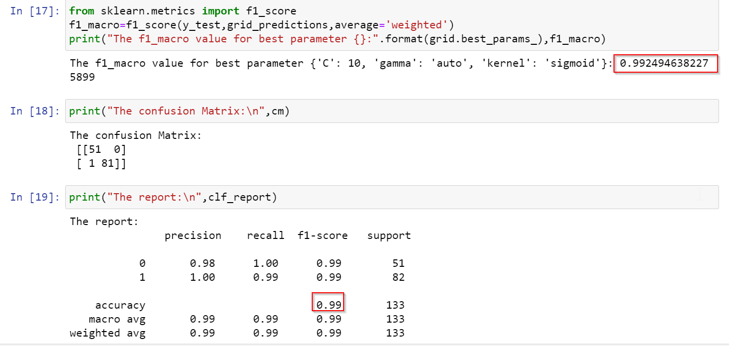

1. Decision Tree: 0.93%

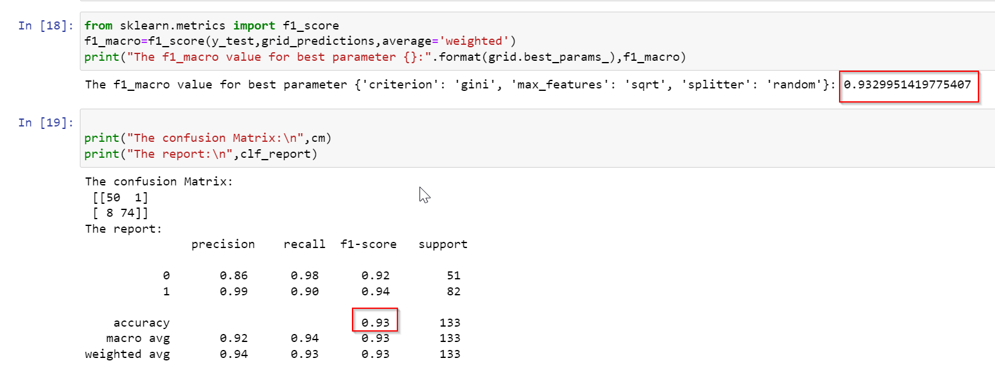

1. Random Forest: 0.99%

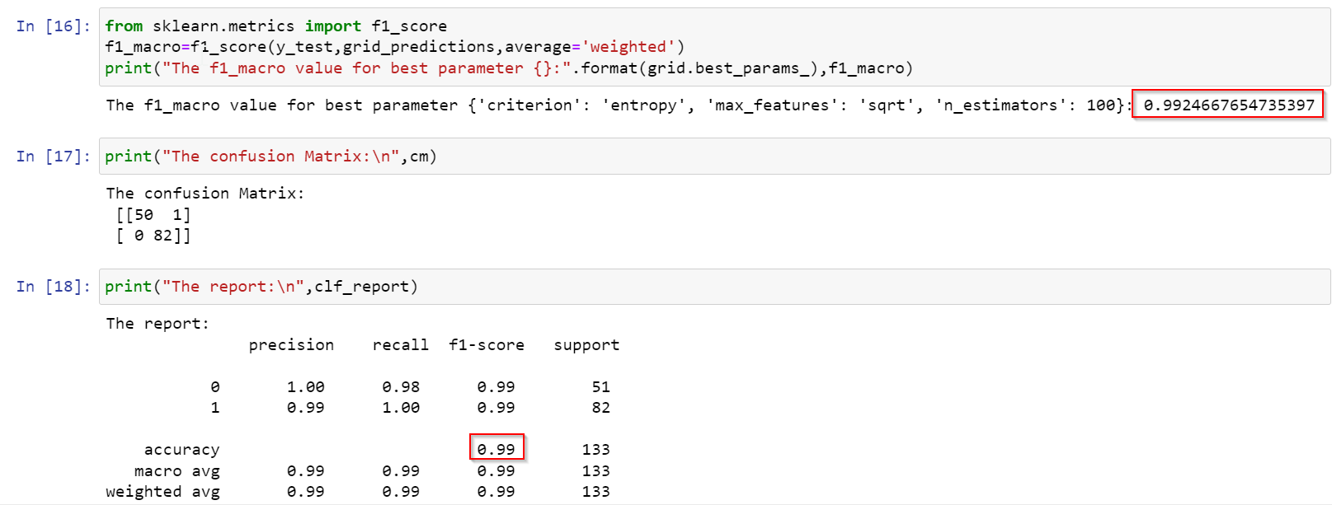

1. Logistic Regression: 0.98%

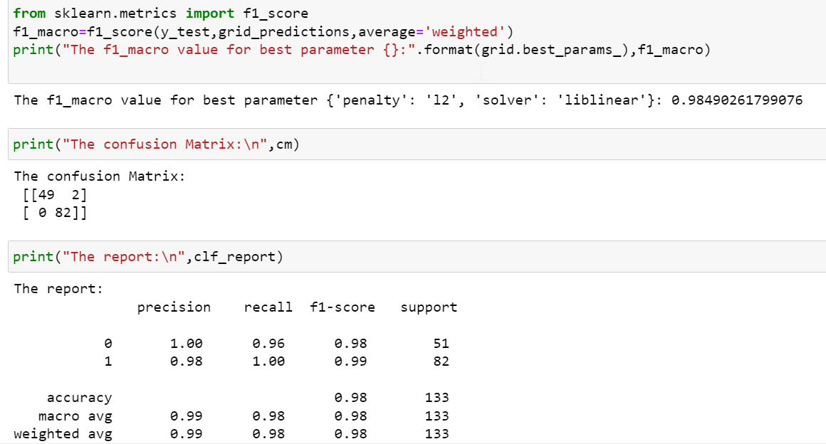

**Final model:**

**SVC & RF are the best algorithm models among all other algorithm models because of the f1_macro value is 99%**