
S.No. | Concept | Description
CO1 | Data Cleaning | Data cleaning organizes patient records by removing errors and duplicates.
CO2 | Classification | Classification groups patients according to age, illness, and season.
CO3 | Bar Charts | Bar charts compare illnesses across different seasons and age groups.
CO4 | Heatmaps | Heatmaps visualize seasonal illness patterns and patient visit frequencies.
CO5 | Time-Series Analysis | Time-series analysis identifies trends and predicts future patient demand.

DSA-0606 DATA HANDLING AND VISULAIZATION
Exploratory Data Analysis of Seasonal Disease Patterns in Hospital Outpatient Visits

ABSTRACT
Hospital outpatient departments generate a large amount of information during routine patient visits. When this information is properly cleaned and analyzed, it can reveal useful patterns in disease occurrence, patient demographics, and seasonal demand. This project focuses on an anonymized outpatient visit dataset containing symptoms, diagnosis codes, age groups, and visit dates collected over a period of two years. The objective is to perform exploratory data analysis, identify seasonal and age-related illness patterns, and create visual summaries that can support hospital administrators in planning staff and resources.
The proposed analysis begins with data quality assessment and preprocessing. Missing values, duplicate records, inconsistent diagnosis labels, invalid dates, and inconsistent age-group categories are identified and handled using suitable methods. After cleaning, diseases are categorized into meaningful groups and visit dates are transformed into seasons and other useful time-based variables. Grouping the records by season and age group makes it possible to compare disease burden across different periods and demographic categories.
The project uses descriptive statistics and visualizations such as bar charts, line charts, stacked charts, heatmaps, and other suitable plots. These visualizations are intended to make patterns easy to understand for hospital administrators. The findings can help the hospital anticipate periods of increased outpatient demand, prepare appropriate staffing levels, allocate resources, and improve operational readiness. The analysis is designed as a decision-support exercise rather than a clinical diagnostic system.
1. INTRODUCTION
Healthcare organizations continuously collect operational data from patient visits. Outpatient departments are especially data-rich because they receive patients with a wide range of symptoms and diagnoses every day. A two-year record of outpatient visits can therefore provide an opportunity to understand how illnesses vary over time and across different age groups.
Seasonality is an important factor in healthcare planning. Some illnesses may become more common during particular seasons because of weather conditions, environmental exposure, infectious disease transmission, or changes in human activity. If administrators can recognize recurring seasonal patterns, they can prepare staff and resources before demand increases rather than responding only after the surge occurs.
Exploratory Data Analysis provides a systematic approach for discovering such patterns. EDA combines data cleaning, descriptive statistics, grouping, comparison, and visualization. Instead of starting with a complex predictive model, the project first establishes what the historical data contains and what meaningful relationships can be observed.
The dataset considered in this project contains anonymized patient visit records. The available attributes include symptoms, diagnosis codes, age groups, and visit dates. Since the records are anonymized, the analysis does not require personally identifying information. The emphasis is on aggregate patterns and operational insights.

1.1 Problem Statement
A hospital's outpatient department has anonymized patient visit records containing symptoms, diagnosis codes, age groups, and visit dates over two years. The team must clean the dataset, group and categorize illnesses by season and age group, and create visualizations that help hospital administrators anticipate seasonal disease surges and plan staff and resource allocation accordingly.
1.2 Aim
The aim of this project is to analyze historical outpatient visit records and identify meaningful seasonal and age-group patterns in illnesses so that hospital administrators can make better-informed decisions about staffing and resource allocation.
1.3 Objectives
- Inspect and understand the structure and quality of the outpatient dataset.
- Identify and handle missing, duplicate, inconsistent, and invalid records.
- Standardize diagnosis codes, illness categories, age groups, and date formats.
- Categorize outpatient visits according to seasons and age groups.
- Measure the frequency and distribution of illnesses across different seasons.
- Analyze which age groups experience higher proportions of particular illness categories.
- Identify recurring periods of increased outpatient visits.
- Create clear and meaningful visualizations for administrative decision-making.
- Develop practical recommendations for seasonal staffing and resource planning.
2. DATA DESCRIPTION AND UNDERSTANDING
The dataset represents anonymized outpatient department visits recorded over a two-year period. Each row represents a patient visit, while columns describe selected characteristics of that visit. The exact column names may differ depending on the source file, but the analysis can be organized around the core variables given in the problem statement.
2.1 Important Variables
Variable | Description | Role in Analysis
Visit Date | Date on which the outpatient visit occurred. | Seasonal and time-based analysis
Symptoms | Reported symptoms associated with the visit. | Symptom frequency and grouping
Diagnosis Code | Code representing the recorded diagnosis. | Illness categorization
Age Group | Age category of the patient. | Demographic comparison
Visit ID | Anonymized identifier for a visit, if available. | Duplicate checking and record tracking

2.2 Data Understanding Process
The first stage is to inspect the dataset before performing any transformation. The team should determine the number of rows and columns, identify data types, examine unique values, and calculate the number of missing observations in each variable. Frequency tables can be used to identify uncommon or inconsistent diagnosis labels and age-group values.
- Check the number of records and variables.
- Inspect data types for every column.
- Check missing-value counts and percentages.
- Check for duplicate visit records.
- Review unique diagnosis codes and symptom labels.
- Check whether age groups follow one consistent naming convention.
- Verify that all visit dates fall within the expected two-year period.
- Look for impossible or suspicious values that require investigation.

2.3 Data Quality Challenges
Healthcare datasets can contain inconsistencies because information may be entered by different staff members or collected from different systems. For example, the same illness could appear under different spellings or diagnosis descriptions. Date fields may also use different formats. Age groups may contain values such as 'Child', 'children', '0-12', or 'Pediatric' even when they represent a similar category. These issues must be resolved before reliable grouping and visualization.
The project should avoid silently changing records without documenting the rule used. Every major cleaning decision should be recorded so that the analysis remains understandable and reproducible.
3. DATA CLEANING AND PREPROCESSING
Data cleaning is a major part of this project because the quality of the final findings depends on the quality of the input records. The objective is not simply to remove problematic rows but to preserve useful information wherever possible while preventing unreliable records from distorting the analysis.
3.1 Handling Missing Values
Missing values should first be quantified rather than immediately deleted. If a small number of visit dates are missing and the date cannot be reliably recovered, those records should be excluded from seasonal analysis because assigning a season without a date would be inappropriate. Missing symptoms may be represented as 'Not recorded' when the visit itself remains useful for diagnosis-based analysis. Missing diagnosis codes should be treated carefully because they affect illness categorization.
3.2 Removing Duplicate Records
Duplicate visits can artificially increase disease counts. The team should identify exact duplicate rows and, where a visit identifier is available, check repeated identifiers. A duplicate should only be removed when there is sufficient evidence that it represents the same record rather than two legitimate visits by the same patient.
3.3 Standardizing Diagnosis Categories
Diagnosis codes or descriptions should be mapped to broader illness categories. For example, individual diagnosis codes may be grouped into categories such as respiratory illnesses, gastrointestinal illnesses, vector-borne illnesses, skin-related illnesses, and other relevant groups. The exact categories should be determined from the actual dataset rather than invented after viewing the results.
3.4 Standardizing Age Groups
Age groups should be represented using consistent labels. A possible structure is: children, adolescents, young adults, adults, middle-aged adults, and older adults. If the source dataset already provides age groups, those categories should be retained where practical. The key requirement is that each record belongs to one clearly defined category.
3.5 Date Processing
Visit dates should be converted to a proper date format. Additional variables can then be derived, including year, month, month number, and season. The analysis should use a clearly documented season definition. For a local hospital, the most appropriate seasons should reflect the regional climate rather than automatically using a four-season model designed for another country.
4. SEASONAL AND AGE-GROUP CATEGORIZATION
After cleaning, the dataset can be transformed into analytical categories. The purpose of categorization is to convert individual outpatient records into groups that can be compared meaningfully.
4.1 Seasonal Grouping
Each visit date can be mapped to a season using a predefined calendar or climate-based rule. For example, the project may use a three-season framework such as summer, monsoon, and winter when that is appropriate for the hospital's region. Alternatively, a four-season framework can be used if the dataset and local context support it. The selected method must be applied consistently to both years.
The analysis should compare total visits as well as individual illness categories. A seasonal increase in total visits is useful, but administrators may need more specific information about which illness categories are responsible for the increase.
4.2 Age-Group Analysis
Age groups allow the team to determine whether specific illnesses are concentrated in particular populations. The objective is not to make clinical conclusions from limited historical data, but to identify patterns that may be relevant to service planning.

4.3 Cross-Tabulation
A cross-tabulation can combine season and age group with illness category. For example, the number of respiratory-related visits can be compared across children, adults, and older adults during each season. This provides a more detailed view than examining season or age group independently.
4.4 Key Questions
- Which season has the highest number of outpatient visits?
- Which illness categories increase most during each season?
- Which age group contributes the greatest number of visits in each season?
- Are seasonal patterns similar across both years?
- Are some illness categories concentrated strongly within particular age groups?
- Do peaks recur at approximately the same time each year?
- Which periods may require additional staff or resources?

5. EXPLORATORY DATA ANALYSIS
EDA will be performed using descriptive statistics and grouped summaries. The purpose is to understand the data before drawing conclusions. Measures such as total visits, average monthly visits, maximum monthly visits, and percentage contribution of illness categories can be calculated.
5.1 Descriptive Statistics
- Total number of outpatient visits.
- Number of visits by year and month.
- Number and percentage of visits by illness category.
- Number and percentage of visits by age group.
- Season-wise visit counts.
- Season-wise illness distribution.
- Age-group-wise illness distribution.
- Monthly and seasonal peak values.

5.2 Trend Analysis
Monthly visit counts can be plotted across the complete two-year period. A line chart is suitable because the order of months is important. The chart can reveal recurring peaks, gradual changes, or unusual periods. Comparing the same months across the two years can help determine whether an apparent peak is consistent or isolated.
5.3 Correlation and Association
This project primarily focuses on categorical and time-based analysis, so simple frequency comparisons are especially important. If numerical variables are available, appropriate correlation analysis may also be performed. For categorical variables such as season and illness category, cross-tabulation and percentage comparisons are generally more informative than applying a numerical correlation measure without justification.
6. VISUALIZATION PLAN
Visualization is essential because hospital administrators may not have time to inspect large tables of individual records. The project therefore converts important findings into concise visual summaries.
6.1 Monthly Outpatient Visit Trend
A line chart should display the number of visits for each month across the two-year period. This visualization can highlight seasonal peaks and show whether similar patterns occur in both years.
6.2 Visits by Season
A bar chart can compare the total number of visits in each season. This gives administrators an immediate view of which periods have the highest outpatient demand.
6.3 Illness Category by Season
A stacked bar chart can display illness categories within each season. This helps show both total demand and the composition of illnesses contributing to that demand.
6.4 Age Group by Season
A grouped bar chart can compare visits across age groups for each season. This can help identify which patient groups contribute most strongly to seasonal workload.
6.5 Season–Illness Heatmap
A heatmap can display illness categories on one axis and seasons on the other, with cell intensity representing visit counts or percentages. This makes concentrated seasonal patterns easy to identify.
6.6 Age Group–Illness Comparison
A bar chart or heatmap can compare illness categories across age groups. This may help administrators anticipate which outpatient services could experience greater demand from specific demographic groups.
6.7 Recommended Visualization Summary
Visualization | Purpose | Administrative Use
Line chart | Show monthly visit trends | Identify timing of demand peaks
Bar chart | Compare seasonal totals | Plan staffing by season
Stacked bar chart | Show illness composition | Prepare relevant resources
Grouped bar chart | Compare age groups | Anticipate demographic workload
Heatmap | Show concentrated patterns | Quickly identify high-demand combinations

7. IMPLEMENTATION METHODOLOGY
The project can be implemented using Python because it provides suitable libraries for data cleaning, statistical analysis, and visualization. Pandas can be used for data manipulation, NumPy for numerical operations, Matplotlib and Seaborn for visualization, and Jupyter Notebook or another Python environment for documenting the analysis.
7.1 Proposed Workflow
- Load the anonymized outpatient dataset.
- Inspect columns, dimensions, data types, and missing values.
- Remove confirmed duplicate records.
- Clean and standardize diagnosis and symptom labels.
- Standardize age-group categories.
- Convert visit dates into a consistent date format.
- Create year, month, and season variables.
- Map diagnosis codes into meaningful illness categories.
- Generate grouped summaries by season and age group.
- Create visualizations for trends and comparisons.
- Interpret the results and identify recurring seasonal patterns.
- Prepare recommendations for staffing and resource allocation.

7.2 Example code

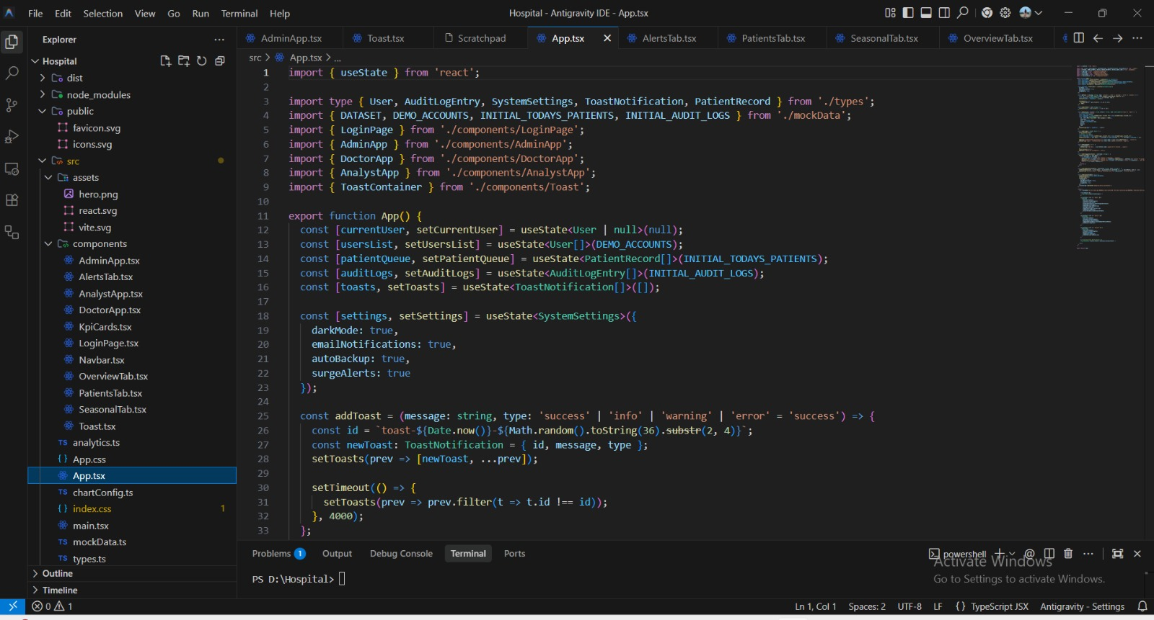.
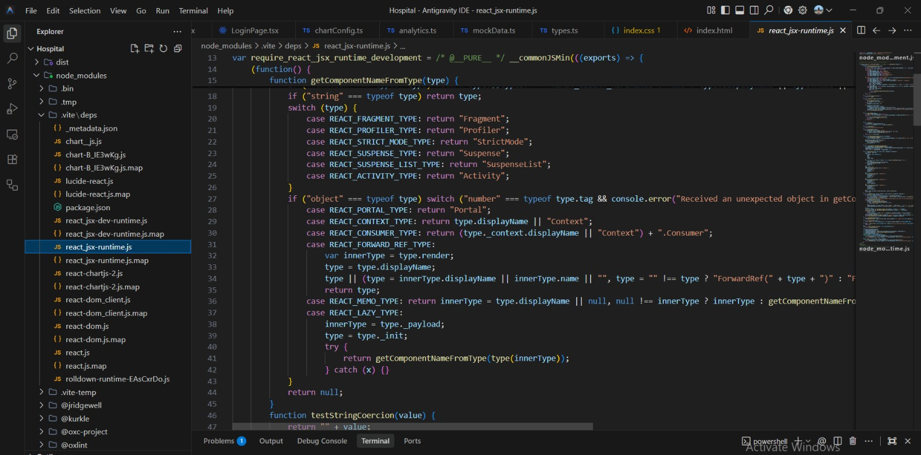

7.3 Data Validation
After preprocessing, validation should be performed to ensure that the transformation has not introduced errors. The team should verify that the number of records before and after cleaning is understood, that dates are within the expected period, that every included visit has a valid season, and that age-group and illness categories contain no unexpected labels.
7.4 Ethical and Privacy Considerations
Because the dataset contains anonymized patient visit records, the analysis should preserve privacy throughout the project. Personally identifying information should not be added to the dataset or displayed in charts. Results should be presented in aggregate form. The project should not attempt to identify individual patients or make clinical decisions about specific people. Its purpose is operational planning and exploratory analysis.

8. EXPECTED RESULTS AND FINDINGS
The analysis is expected to produce a clear summary of outpatient demand over two years. The exact findings must be obtained from the actual dataset and should not be assumed in advance. The expected outputs include seasonal visit totals, illness distributions, age-group comparisons, and identification of recurring high-demand periods.
8.1 Expected Pattern Identification
- Identification of seasons with relatively high outpatient attendance.
- Identification of illness categories that contribute strongly to seasonal increases.
- Identification of age groups with higher visit frequencies for selected illness categories.
- Identification of recurring peaks across the two-year period.
- Identification of unusual increases that may require further investigation.

8.2 Interpreting Seasonal Surges
A seasonal surge should be interpreted as a historical pattern in the dataset rather than proof of a specific cause. For example, if a particular illness category shows consistently higher visit counts during one season in both years, the hospital can consider preparing for increased demand during that period. However, external factors, reporting practices, population changes, outbreaks, and other operational events may also influence the observed pattern.
8.3 Example Findings Format
After the actual analysis is completed, findings can be written in a format such as: 'The highest outpatient demand was observed during [season], with [value] recorded visits. The most frequent illness category during this period was [category]. The [age group] group contributed the largest share of visits for this category. A similar pattern was observed in [year/season], suggesting a recurring seasonal pattern.' All bracketed values must be replaced using the actual dataset results.
9. RESOURCE AND STAFF ALLOCATION STRATEGY
The major practical value of this project is its ability to translate historical data into planning information. Hospital administrators can use seasonal and demographic patterns to prepare staffing schedules, supplies, outpatient counters, consultation capacity, and other resources.
9.1 Staffing
If historical data indicates that outpatient demand increases during a particular period, administrators can consider scheduling additional staff during that period. Staffing decisions should consider both the number of visits and the illness categories responsible for the increase.
9.2 Resource Planning
Resource requirements can differ depending on the types of illnesses observed. A general increase in visits may require additional registration and consultation capacity, while an increase in a specific illness category may require preparation of the relevant clinical and support resources.

9.3 Queue and Service Capacity
Seasonal demand information can support planning for waiting areas, appointment slots, registration counters, and consultation schedules. If peak periods are predictable, operational adjustments can be planned in advance rather than made reactively.
9.4 Monitoring Dashboard
A future dashboard can provide administrators with monthly and seasonal trends, illness category distributions, age-group patterns, and historical comparisons. The dashboard can include filters for year, season, age group, and illness category. Such an interface would allow users to explore the dataset without manually creating separate reports.
9.5 Early Warning Approach
Historical peaks can be used as reference points for monitoring current outpatient activity. When current visit volumes begin to exceed normal historical levels, administrators can investigate whether additional operational capacity may be required. This should be treated as an administrative alert rather than a medical diagnosis or outbreak confirmation.
10. LIMITATIONS
- The dataset covers only two years, so longer-term seasonal patterns may not be captured.
- Anonymized records may not contain all factors that influence outpatient demand.
- Missing or inconsistent records may reduce the reliability of some analyses.
- Diagnosis codes may not always represent the full clinical context of a visit.
- Seasonal categories depend on the definition selected for the hospital's region.
- Visit frequency does not necessarily measure disease severity.
- Historical patterns cannot guarantee that the same pattern will occur in the future.
- External events such as outbreaks, environmental changes, or operational changes may affect visit counts.

11. FUTURE ENHANCEMENTS
The current project focuses on exploratory data analysis and visualization. Several enhancements can be added in future work. A larger dataset covering more years could improve the assessment of recurring seasonal patterns. Additional variables such as department, consultation type, waiting time, treatment category, or resource usage could provide deeper operational insights if they are available and appropriately anonymized.
- Develop an interactive dashboard using Streamlit or Power BI.
- Add real-time or near-real-time outpatient monitoring.
- Use longer historical records to improve seasonal comparisons.
- Develop forecasting models for expected monthly outpatient demand.
- Add automated alerts when current visits exceed historical thresholds.
- Compare seasonal patterns across hospital departments.
- Integrate resource-utilization information with patient visit trends.
- Evaluate forecasting accuracy using historical holdout periods.

12. CONCLUSION
This project demonstrates how exploratory data analysis can be applied to anonymized hospital outpatient records to support practical administrative decision-making. By cleaning patient visit data, standardizing diagnosis and age-group categories, and converting visit dates into meaningful seasonal groups, the team can transform raw records into understandable information.
The analysis focuses on identifying when outpatient demand increases, which illness categories contribute to those increases, and which age groups are most represented during different periods. Visualizations such as line charts, bar charts, stacked charts, and heatmaps make these patterns easier for hospital administrators to interpret.
The most important outcome is not simply a collection of graphs, but a structured approach for turning historical outpatient data into planning information. If recurring seasonal patterns are identified, administrators can use them to consider staffing, service capacity, and resource allocation before expected high-demand periods.
The project also demonstrates the importance of responsible data handling. Since healthcare information is sensitive, anonymization, aggregation, privacy protection, and careful interpretation are essential. The results should be treated as operational insights rather than individual clinical recommendations.
Overall, the proposed EDA framework provides a practical foundation for understanding seasonal disease patterns and improving hospital preparedness. Future work can extend the analysis into interactive dashboards and forecasting systems that provide more proactive support for outpatient department planning.

13. REFERENCES
- Wickham, H., & Grolemund, G. (2017). R for Data Science: Import, Tidy, Transform, Visualize, and Understand Data. O'Reilly Media.
- McKinney, W. (2022). Python for Data Analysis: Data Wrangling with pandas, NumPy, and Jupyter. O'Reilly Media.
- VanderPlas, J. (2016). Python Data Science Handbook: Essential Tools for Working with Data. O'Reilly Media.
- Wes McKinney (2010). Data Structures for Statistical Computing in Python. Proceedings of the 9th Python in Science Conference.
- Hunter, J. D. (2007). Matplotlib: A 2D Graphics Environment. Computing in Science & Engineering, 9(3), 90–95.
- Pedregosa, F., et al. (2011). Scikit-learn: Machine Learning in Python. Journal of Machine Learning Research, 12, 2825–2830.
- World Health Organization. Health data and digital health resources for strengthening health information systems.
- Pandas Documentation. Data analysis and manipulation using Python.
- Matplotlib Documentation. Visualization with Python.

IMPLEMENTATION

