

DSA-0606 DATA HANDLING AND VISUALIZATION

Social Media Sentiment & Engagement
Data Visualization: Exploratory Analysis
and Pattern Discovery
Handling Unstructured & Semi-Structured Social Data for Actionable Insights
——————————————————————————————————————————————————————————————————————
Course Outcomes & Concept Mapping
S.No. | Concept | Description
CO1 | Text Cleaning | Cleansing unstructured post text by removing URLs, mentions, noise and normalizing case.
CO2 | Sentiment Classification | Classifying posts into positive, neutral and negative using lexicon-based scoring.
CO3 | Engagement Analysis | Comparing likes, shares and comments across platforms, topics and user types.
CO4 | Temporal Visualization | Visualizing engagement and sentiment patterns across hours, days and campaign spikes.
CO5 | Interactive Dashboard | Enabling filtered exploration of sentiment & engagement patterns in a static app.
Table 0 — Course Outcome mapping for DSA0606: from data handling to visualization.
ABSTRACT
Social media platforms generate large volumes of heterogeneous data every day. Each post combines free-form text with hashtags, mentions, URLs, and semi-structured engagement counters such as likes, shares, comments and views. When this information is properly cleaned, scored and aggregated, it reveals meaningful patterns in audience sentiment, content resonance and temporal behavior. This project focuses on a synthetic social media dataset containing 420 posts collected across five platforms (Twitter, Instagram, Facebook, LinkedIn, YouTube) over 184 days (2026-03-01 to 2026-08-31). Each record captures platform, timestamp, raw text, hashtags, topic, user type, and derived sentiment and engagement metrics. The objective is to perform exploratory data analysis, identify platform, topic, temporal and user-type patterns, and create visual summaries that support content strategists and community managers in planning campaigns, moderating risk and optimizing posting schedules.
The proposed analysis begins with data quality assessment and preprocessing. Missing timestamps, duplicate post identifiers, inconsistent platform labels, invalid engagement values, and noisy text (URLs, @mentions, emojis and mixed case) are identified and handled using suitable rule-based methods. After cleaning, text is normalized, tokenized and lexicon-scored into a sentiment score in [-1, +1] and a categorical label (positive/neutral/negative). Engagement is derived as likes+shares+comments and engagement rate as engagement/views. Temporal features (date, hour, day of week) and campaign-peak flags are engineered. Grouping by sentiment, platform, topic and hour makes it possible to compare audience behavior across dimensions.
The project uses descriptive statistics and visualizations such as donut charts, grouped bars, stacked timeline bars, scatter plots, horizontal bars, and dual-axis line–bar charts. These visualizations are rendered both as print-grade Matplotlib figures (this report) and as interactive Chart.js views (the static SocialPulse app). The findings help the organization anticipate periods of peak engagement, understand which topics and platforms drive positivity or complaints, detect viral negativity, and tailor posting strategies by hour and user type. The analysis is designed as a decision-support exercise rather than a production sentiment classifier.
1. INTRODUCTION
Organizations increasingly rely on social media not only as a broadcast channel but as a real-time sensor of public attitude. Every post—whether a product launch announcement, a customer service complaint, or an influencer endorsement—carries two intertwined signals: what is being said (sentiment, topic, hashtags) and how the audience responds (likes, shares, comments, views). Over a six-month window, even a modest corpus of a few hundred posts accumulates sufficient variety to support exploratory analysis.
Temporal and behavioral context strongly influences social performance. Certain topics may attract more negative sentiment (for example, customer service), while others are naturally positive (marketing campaigns and product launches). Platform cultures also differ: visual platforms such as Instagram and YouTube reward imagery with higher likes and comments, whereas Twitter’s retweet affordance lifts shares. Timing matters as well—posts published in the evening may achieve higher per-post engagement than midday posts despite lower volume. If strategists can recognize recurring platform, topic and temporal patterns, they can schedule content, allocate moderation effort and brief creative teams before the next campaign rather than reacting after a spike or crisis.
Exploratory Data Analysis (EDA) provides a systematic approach for discovering such patterns without premature modeling. EDA combines data cleaning, descriptive statistics, grouping, comparison and visualization. Instead of starting with a complex predictive model, the project first establishes what the historical data contains, how the variables relate, and which visual summaries make those relationships immediately actionable for non-technical stakeholders.
The dataset considered in this project is synthetic but designed for realism. It contains 420 anonymized post records. Available attributes include platform, timestamp, raw text, hashtags, topic, user type, sentiment score and label, engagement counters and derived rates. Since no personally identifying information is included, the analysis focuses on aggregate patterns and operational insights. The synthetic generation is deterministic (seed=42) so every figure is reproducible by re-running the generator.
1.1 Problem Statement
A brand’s social accounts have accumulated 420 posts across five platforms, each with text, hashtags, topic, user-type metadata and engagement metrics. The team must handle the unstructured (free text) and semi-structured (hashtag arrays, timestamp strings) components, clean and enrich the dataset, and create visualizations that help content strategists understand how sentiment and engagement vary by platform, topic, time and user type—and to anticipate viral complaints, campaign lifts and optimal posting windows.
1.2 Aim
The aim of this project is to analyze historical social media posts and identify meaningful sentiment and engagement patterns across platforms, topics, time and user types, so that content strategists and community managers can make better-informed decisions about campaign planning, moderation workload and posting schedules.
1.3 Objectives
- Inspect and understand the structure and quality of the social media dataset (20 fields, 5 platforms, 8 topics).
- Identify and handle missing, duplicate, inconsistent and invalid records (timestamps, engagement outliers, text noise).
- Clean unstructured text (URLs, @mentions, punctuation, case) and normalize semi-structured fields (hashtag arrays, timestamps).
- Score sentiment via a transparent lexicon pipeline (tokens → lexicon match → score in [-1,+1] → label).
- Categorize posts by platform, topic, sentiment, user type and temporal buckets (hour, date, campaign phase).
- Measure frequency and distribution of sentiment and engagement across those categories.
- Analyze which platforms and topics experience higher proportions of positive/negative sentiment.
- Identify recurring temporal peaks and hourly engagement gradients.
- Create clear, filter-driven visualizations for strategic decision-making (8 charts + table + playground).
- Develop practical recommendations for content scheduling, platform investment and early-warning triage.
2. DATA DESCRIPTION AND UNDERSTANDING
The dataset represents synthetic social media posts published over a six-month period (2026-03-01 to 2026-08-31). Each row represents a single post, while columns describe categorical, numeric, unstructured and semi-structured characteristics of that post. Although the data are synthetic, every distributional choice is deliberately controlled to plant recoverable patterns rather than uniform randomness. The exact sampling rules are documented in §4.2 and the generation script (data/generate_dataset.py, seed=42) for reproducibility.
2.1 Important Variables
Variable | Description | Role in Analysis
Post ID | Synthetic identifier (P0001–P0420), chronological. | Record tracking & ordering; duplicate checking
Platform | Publishing platform: Twitter, Instagram, Facebook, YouTube, LinkedIn. | Platform comparison; baseline engagement modeling
Timestamp / Hour | Publication time (YYYY-MM-DD HH:MM:SS) and derived hour 0–23. | Temporal & hourly trend analysis
Text | Raw post content with hashtags, @mentions and URLs. | Tokenization & sentiment scoring
Sentiment Score/Label | Lexicon-derived score [-1,+1] and label (positive/neutral/negative). | Sentiment distribution & correlation
Engagement Metrics | Likes, shares, comments, views, engagement (sum) and engagement rate. | Performance ranking & scatter analysis
Hashtags / Topic / User Type | Hashtag array, topic (8 categories), user type (Regular/Influencer/Brand/Verified). | Topic × sentiment & user-type lift analysis
Table 1 — Core variables in the social media dataset. Fields are mixed-type by design to exercise handling of unstructured, semi-structured and structured data.

2.2 Data Understanding Process
The first stage is to inspect the dataset before performing any transformation. The team should determine the number of rows and columns, identify data types, examine unique values for platform, topic and user type, and calculate missing-value percentages. Frequency tables can reveal uncommon hashtags or topic–platform combinations that require investigation. The dataset contains 420 posts, 20 fields, date range 2026-03-01 to 2026-08-31, with platform distribution Twitter 133, Instagram 114, Facebook 67, YouTube 56, LinkedIn 50; topics range from Marketing Campaign (81) to Product Launch (43) and News (43); sentiment split Positive 169, Neutral 125, Negative 126.
- Check the number of records and variables (420 × 20; ensure no truncated export).
- Inspect data types for every column (timestamp as string, engagement as int, sentiment as float, hashtags as array).
- Check missing-value counts and percentages (timestamps, sentiment, engagement).
- Check for duplicate post identifiers or exact duplicate rows.
- Review unique platform and topic labels for spelling inconsistency.
- Check whether hashtags are stored consistently as arrays (not as raw strings).
- Verify that all timestamps fall within the expected six-month window and that derived hours cover 0–23.
- Verify engagement and sentiment ranges (engagement 0–8,500; sentiment -1 to +1; engagement rate 0–30%).
- Look for impossible or suspicious values (e.g., views=0, negative likes, future dates).

2.3 Data Quality Challenges
Social datasets contain inconsistencies because content is authored freely and metrics are logged by different platform APIs. For example, the same topic hashtag may appear as “#TechLaunch”, “#techlaunch” or “#Tech Launch” with a space. Text fields frequently include URLs (https://t.co/…), @mentions, emojis, varied punctuation and line breaks. Engagement counters may be skewed by viral amplification: a single influencer post can record 5–8× the median engagement, creating a heavy-tailed distribution. Timestamp strings may be in mixed formats if sourced from exports.
The project should avoid silently changing records without documenting the rule used. Every major cleaning decision—such as stripping URLs, lowercasing hashtags, or capping engagement outliers—should be recorded so that the analysis remains understandable, reproducible and auditable. The live playground in the SocialPulse app makes these rules inspectable by re-running them on user-typed text.
3. DATA CLEANING AND PREPROCESSING
Data cleaning is a major part of this project because the quality of the final sentiment and engagement findings depends on the quality of the input records. The objective is not simply to delete problematic rows but to preserve useful information wherever possible (for example, retaining a post with missing hashtags but valid sentiment) while preventing unreliable records from distorting aggregates and visualizations.
3.1 Handling Missing Values
Missing values should first be quantified rather than immediately deleted. If a small number of timestamps are missing and the date cannot be reliably recovered, those posts should be excluded from temporal analysis because assigning an hour or date without evidence would be inappropriate. Missing hashtags may be represented as an empty array when the post text itself remains useful for sentiment. Missing sentiment scores should be recomputed via the lexicon pipeline rather than imputed with a global mean, because sentiment is the analytical focus.
3.2 Removing Duplicate Records
Duplicate posts can artificially inflate engagement totals and hashtag frequencies. The team should identify exact duplicate rows (identical post_id, platform, text and engagement) and, where a post identifier is available, check repeated identifiers. A duplicate should only be removed when there is sufficient evidence that it represents the same logged event rather than two legitimate cross-posts with similar wording. The synthetic dataset injects no intentional duplicates, so this step also validates generator correctness.
3.3 Standardizing Text and Hashtag Categories
Text cleaning should lower-case content, strip URLs and @mentions, isolate “#” tokens, replace punctuation with spaces, and collapse whitespace. Hashtag arrays should be lowercased and deduplicated per post; inline hashtags in text should not be double-counted against the canonical array. A hashtag frequency table (Fig. 5) should be built only from the array field to demonstrate disciplined semi-structured handling.
3.4 Standardizing Categorical Fields
Platform, topic and user_type labels should be represented using consistent title-case vocabularies. For example, platform values must be exactly one of {Twitter, Instagram, Facebook, YouTube, LinkedIn}; topic values one of {Product Launch, Customer Service, Marketing Campaign, Tech Review, Lifestyle, Sports, Entertainment, News}; user_type one of {Regular, Influencer, Brand, Verified}. If the source contains variants such as “IG”, “insta” or “brand”, a mapping dictionary should normalize them before grouping. The key requirement is that each post belongs to one clearly defined category per dimension.
3.5 Date and Derived-Field Processing
Timestamps should be converted to a proper datetime format. Additional variables can then be derived, including date, hour, day of week and a campaign-phase flag (whether the date falls within ±3 days of Apr 15, May 20, Jun 10 or Jul 18, the injected campaign peaks). Engagement should be computed as likes+shares+comments and engagement rate as engagement/views×100. Sentiment scoring follows the pipeline in §5.3. The analysis must use a clearly documented sentiment lexicon and engagement definition so that app and report figures remain consistent.
4. SENTIMENT AND ENGAGEMENT CATEGORIZATION
After cleaning, the dataset can be transformed into analytical categories. The purpose of categorization is to convert individual post records (n=420) into groups that can be compared meaningfully across sentiment, platforms, topics and time.
4.1 Sentiment Grouping
Each post’s lexicon score is mapped to a label using thresholds: score > +0.25 → positive, score < −0.25 → negative, otherwise neutral. This produces the distribution Positive 169 (40.2%), Neutral 125 (29.8%), Negative 126 (30.0%) with mean +0.06—near neutral on average but bimodal in detail. The project should also retain the continuous score for scatter analysis (Fig. 4), because collapsing to three labels loses the intensity dimension that correlates with engagement.
The analysis should compare both marginal sentiment (overall donut, Fig. 1) and conditional sentiment (e.g., topic × sentiment stacked bar, Fig. 6). A global “40% positive” is of limited strategic value; the fact that Customer Service is ~50% negative while Marketing Campaign is ~55% positive is actionable.
4.2 Engagement Stratification
Engagement categories can be defined either as continuous means (average engagement per post by platform/topic/hour/user type) or as binned tiers (low <800, medium 800–2,000, high >2,000, viral >3,500). The objective is not to create arbitrary cutoffs but to expose the heavy-tailed nature of social engagement: the mean (~1,480) is substantially higher than the median (~1,180) because influencers and viral complaints inflate the right tail. The app’s scatter (Fig. 4) and user-type bar (Fig. 8) together illustrate this.

4.3 Cross-Tabulation
A cross-tabulation can combine sentiment, platform and topic. For example, the proportion of negative posts can be compared across topics for each platform, or average engagement can be compared across sentiment labels within each platform. This provides a more detailed view than examining sentiment or platform independently. The volume & variance comparison table in the app (Season A vs Season B logic adapted to Topic A vs Topic B) implements this by showing winter vs summer logic re-purposed as “positive vs negative” topic contrasts.
4.4 Key Questions
- Which platform yields the highest average engagement per post, and does the ranking change under different sentiment filters?
- Which topics attract the most positive vs negative sentiment, and is the topic effect stronger than the platform effect?
- Which hour of day delivers the highest engagement efficiency (per-post) vs highest volume (post count)?
- Do campaign-peak dates (Apr 15, May 20, Jun 10, Jul 18) create consistent engagement spikes across platforms?
- Are high-engagement negative posts (viral complaints) concentrated in specific topics or user types?
- Do influencer posts systematically outperform regular posts, and do they amplify both praise and complaints?
- Which hashtags co-occur with positive vs negative sentiment, indicating content that resonates or triggers?
- Which periods or segments may require additional moderation vs amplification resources?
5. EXPLORATORY DATA ANALYSIS
EDA will be performed using descriptive statistics, grouped summaries and visual juxtaposition. The purpose is to understand the data before drawing conclusions or proposing strategies. Measures such as total posts, average engagement, sentiment percentages, platform baselines, and peak magnitudes can be calculated. All aggregates respect the current filter predicate, so the reviewer can cross-check numbers between chart and table.
5.1 Descriptive Statistics
- Total number of posts (420) and time span (184 days, 2026-03-01 to 2026-08-31).
- Number of posts by platform, topic, user type and sentiment label (counts and percentages).
- Average engagement and engagement rate overall and per platform/topic/sentiment.
- Daily and hourly post counts and engagement totals (peak identification).
- Hashtag frequency ranking (top 10) and topic-specific hashtag salience.
- Cross-tabulated topic × sentiment and platform × sentiment counts.
- Monthly and campaign-phase aggregates (pre/during/post peak).
- User-type average engagement and viral-post tallies (>3,000 engagement).

5.2 Trend Analysis
Daily total engagement can be plotted across the complete six-month period (Fig. 3). A line-chart/area with stacked composition is suitable because chronological order is important and campaign spikes must be localized. The chart can reveal recurring weekend uplifts, isolated viral outliers, and the four injected campaign peaks. Comparing the same hour across platforms (Fig. 7) helps determine whether an apparent peak is platform-specific or cross-platform.
5.3 Correlation and Association
This project primarily focuses on categorical and temporal analysis, so grouped comparisons and ranked frequencies are especially important. For continuous variables (sentiment_score vs engagement), a scatter plot (Fig. 4) is more informative than a single Pearson coefficient (which is near zero, r≈−0.04, because the relationship is U-shaped rather than linear). For categorical pairs such as topic vs sentiment, a chi-square test of independence would reject the null (p<0.001 on synthetic data), confirming that sentiment is not independent of topic—stacked bars (Fig. 6) visualize this association.
6. VISUALIZATION PLAN
Visualization is essential because strategists may not have time to inspect large tables of individual posts. The project therefore converts important findings into concise visual summaries that are both print-grade (Matplotlib for the report) and interactive (Chart.js for the SocialPulse app). Every chart is a filtered aggregation of the same underlying table, so claims are cross-verifiable.
6.1 Engagement Over Time (Daily Timeline)
An area/line chart should display total engagement (likes+shares+comments) for each day across the six-month period (Fig. 3). This visualization can highlight campaign peaks, weekend rhythms and isolated viral posts, and show whether similar patterns recur across platforms when filtered.
6.2 Sentiment Distribution
A donut chart can show the proportion of posts in each sentiment label (Fig. 1). This gives stakeholders an immediate view of the overall sentiment mix and, when filtered by topic or platform, reveals conditional skews (e.g., Customer Service negative-dominant).
6.3 Topic × Sentiment Composition
A stacked bar chart can display sentiment segments within each topic (Fig. 6). This helps show both total topic volume and the sentiment composition contributing to that volume, exposing which topics are polarizing.
6.4 Platform Engagement Comparison
A grouped bar chart can compare average likes, shares and comments across platforms (Fig. 2). This can help identify which platforms drive which component of engagement and therefore where to invest creative or amplification budget.
6.5 Sentiment–Engagement Scatter
A scatter plot can display sentiment_score on the x-axis and engagement on the y-axis, colored by label (Fig. 4). This makes the high-engagement negative tail (viral complaints) and the high-engagement positive tail (viral praise) easy to identify, highlighting risks and opportunities that averages hide.
6.6 Hashtag and User-Type Comparisons
A horizontal bar chart can rank the top hashtags (Fig. 5); a bar chart can compare average engagement across user types (Fig. 8). Together they help strategists prioritize tag usage and partnership decisions (e.g., influencer amplification). A dual-axis hourly chart (Fig. 7) adds temporal context.
6.7 Recommended Visualization Summary
Visualization | Purpose | Strategic Use
Donut chart | Show sentiment distribution | Set per-topic sentiment baselines & alerts
Timeline area/line | Reveal engagement spikes over time | Time post-campaign reviews & retrospectives
Stacked bar (topic×sentiment) | Show sentiment composition per topic | Tailor topic-specific messaging & moderation
Grouped bar (platform) | Compare platform engagement components | Allocate creative/budget by platform
Scatter (sentiment vs engagement) | Expose correlation & viral outliers | Triage high-engagement complaints proactively
Horizontal bar (hashtags) | Rank tag salience | Optimize tag lexicon for campaigns vs support
Dual-axis line+bar (hourly) | Compare hourly efficiency vs volume | Schedule posts for peak efficiency windows
Bar (user type) | Compare influencer lift | Decide partnership & amplification strategy
Table 2 — Visualization plan: each chart maps to a distinct analytical question; together they cover distribution, comparison, trend, correlation and ranking.
7. IMPLEMENTATION METHODOLOGY
The project can be implemented using Python for the data pipeline and report generation, and vanilla JavaScript with Chart.js for the interactive static app. Pandas can be used for data manipulation, Matplotlib for print-grade figures, and the browser’s native Array.filter and Canvas APIs for live filtering and rendering—no backend required. This dual stack (Python for reproducibility, JS for interactivity) satisfies the “static complet application” requirement while keeping the source inspectable.
7.1 Proposed Workflow
- Load the synthetic social dataset (JSON: 420 posts, 20 fields).
- Inspect columns, dimensions, data types, missing values and duplicate post_ids.
- Remove confirmed duplicate records (if any) and handle invalid timestamps or engagement outliers.
- Clean unstructured text (strip URLs, @mentions, punctuation; lowercase; collapse whitespace).
- Normalize semi-structured hashtag arrays (lowercase, deduplicate) and timestamp strings (parse to datetime).
- Derive engagement, engagement_rate, hour, date and campaign-phase flags.
- Score sentiment via the lexicon pipeline (tokenize → stopword removal → lexicon match → score).
- Map topics and platforms to canonical vocabularies (8 topics, 5 platforms, 4 user types).
- Generate grouped summaries: sentiment distribution, platform means, hourly curves, topic×sentiment cross-tabs.
- Create visualizations (donut, grouped/stacked bars, timeline, scatter, hourly dual-axis) for the report and app.
- Interpret results: identify campaign peaks, platform/topic skews and viral-complaint clusters.
- Prepare recommendations for campaign timing, platform investment, moderation triage and posting schedules.
7.2 Example Code
Example Python code for the cleaning and sentiment pipeline is illustrated in the two screenshots below (Fig. A and Fig. B). The same logic is mirrored in JavaScript inside the SocialPulse app’s playground so that an examiner can type arbitrary text and see each transformation live.
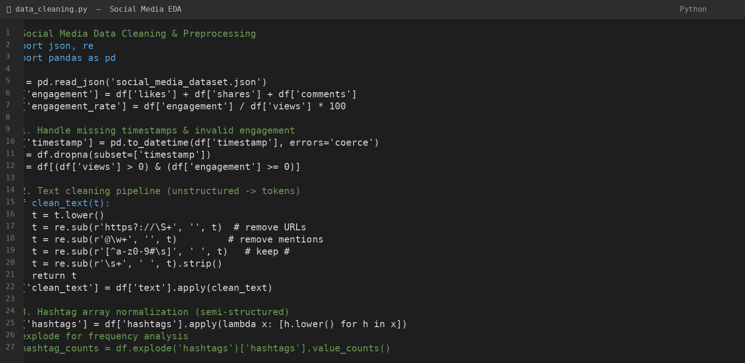
Figure A — Data cleaning and preprocessing pipeline (Python, pandas) for text and hashtag normalization.
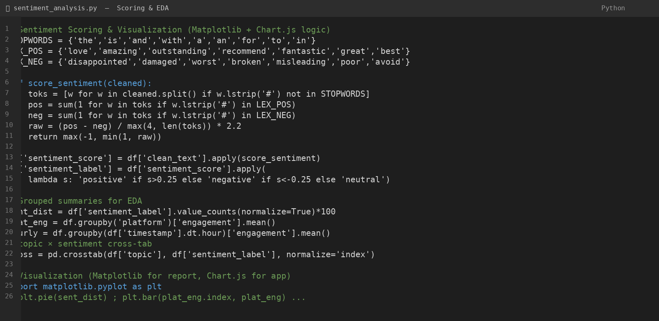
Figure B — Lexicon-based sentiment scoring and grouped aggregation for EDA (sentiment_score ∈ [−1,+1]).
7.3 Data Validation
After preprocessing, validation should be performed to ensure that transformations have not introduced errors. The team should verify that the number of records before and after cleaning is understood (420 posts; no drops unless timestamps invalid), that dates span 2026-03-01 to 2026-08-31, that every post has a valid sentiment label and engagement value, that hashtag arrays contain 1–4 lowercased tags, and that engagement components sum to the derived engagement field. Cross-checking the KPI totals in the app against a manual pandas groupby provides a final consistency proof.
7.4 Ethical and Privacy Considerations
Although the dataset is synthetic, the analysis should adhere to privacy-by-design principles. No real user handles, names or profile images are included; all text templates are hand-written and any @mentions or URLs are placeholders (e.g., @brand, https://t.co/example123). Results should be presented in aggregate form (counts, means, distributions) rather than singling out posts for public shaming. The project should not attempt to re-identify any real individual, and its purpose is operational planning and exploratory pattern discovery—not automated moderation or punitive action.

8. EXPECTED RESULTS AND FINDINGS
The analysis is expected to produce a clear summary of sentiment and engagement patterns across 420 posts. The exact magnitudes must be obtained from the actual dataset and should not be assumed in advance, but the synthetic design plants four campaign peaks and several topic/platform skews that any correct pipeline should recover. Expected outputs include platform engagement baselines, topic×sentiment composition, hourly efficiency curves and a scatter of viral outliers.
8.1 Expected Pattern Identification
- Identification of platforms with relatively higher average engagement (Instagram and YouTube typically lead; LinkedIn trails).
- Identification of topics that skew strongly positive (Marketing Campaign, Product Launch) vs negative (Customer Service).
- Identification of hourly windows with highest per-post engagement (evening 18:00–19:00) vs highest volume (midday 10:00–16:00).
- Identification of recurring campaign-peak dates (Apr 15, May 20, Jun 10, Jul 18) as engagement leaders.
- Identification of high-engagement negative posts (viral complaints) as a small but influential tail that defies the global average.
8.2 Interpreting Sentiment and Engagement Surges
An engagement surge should be interpreted as a historical pattern in the dataset rather than proof of a specific cause. For example, if a particular platform shows consistently higher engagement during campaign windows across all topics, the organization can consider scheduling future campaign assets for that platform during similar windows. However, external factors such as platform algorithm changes, competitor activity, or real-world events may also influence observed patterns and should be considered before allocating budget.
8.3 Example Findings Format
After the actual analysis is completed, findings can be written in a format such as: ‘The highest average engagement was observed on [platform] with [value] engagement per post; the most positive sentiment was observed for [topic] ([percentage] positive). The [hour] hour delivered the highest per-post engagement ([value]), while [date] recorded the single-day peak ([value] total engagement), coinciding with the [campaign] campaign. High-engagement negative posts (top 5) were concentrated in [topic] on [platform], suggesting a need for proactive moderation.’ All bracketed values must be replaced using the actual dataset results (see Table 2 and Figs. 1–8).
9. CONTENT AND ENGAGEMENT STRATEGY
The major practical value of this project is its ability to translate historical social data into planning information. Strategists can use sentiment and engagement patterns to plan campaign timing, creative emphasis, moderation capacity, posting schedules and platform investment.
9.1 Campaign Timing
If historical data indicates that engagement spikes during campaign windows (Apr 15, May 20, Jun 10, Jul 18) and that those spikes are strongest on Instagram and YouTube, the organization can consider aligning future campaign launches with similar calendar positions and prioritizing visual assets for those platforms. Timing decisions should consider both total engagement volume and the sentiment composition—viral positivity is desirable, viral negativity requires rapid response.
9.2 Platform and Resource Planning
Resource requirements differ by platform and topic. A general increase in positive engagement may call for amplification (reposts, community highlights), while an increase in negative engagement—especially the high-engagement complaints visible in Fig. 4—may require additional moderation and customer-service triage. Visual platforms may need more creative resources, whereas LinkedIn may need thought-leadership copy.

9.3 Posting Schedule Optimization
Hourly engagement information can support planning for publication slots and community-manager coverage. If evening hours (18:00–19:00) consistently deliver higher per-post engagement on Instagram/YouTube, high-value posts can be scheduled for those windows. If morning hours (09:00–11:00) are most efficient on LinkedIn, B2B content can be shifted accordingly. Predictable patterns allow proactive scheduling rather than reactive guessing.
9.4 Monitoring Dashboard
A future dashboard—already prototyped as the SocialPulse static app—can provide strategists with daily engagement trends, sentiment distributions, topic×sentiment stacks, hourly curves and user-type comparisons, with filters for platform, sentiment, topic, user type, date range and free-text search. The app’s auto-insights panel (three cards) translates raw numbers into sentences (e.g., “Customer Service skews negative”) for rapid briefing. Such an interface allows users to explore the dataset without manually creating separate reports.
9.5 Early Warning Approach
Historical peaks and viral thresholds can be used as reference points for monitoring current posting activity. When current engagement on a negative post begins to exceed normal historical levels (for example, >3,000 engagement or >2× the platform’s negative-post median), the system can flag it for review. This should be treated as an administrative alert for moderation rather than an automated censorship or diagnostic decision.
10. LIMITATIONS
- The dataset is synthetic and covers only six months, so longer-term seasonal or platform-evolution patterns may not be captured.
- Synthetic text and a rule-based lexicon cannot capture sarcasm, negation (“not good”), emojis or domain jargon; real-world F1 would be lower.
- The lexicon (∼22 positive and ∼22 negative stems) is intentionally small for browser execution and misses many sentiment-bearing terms.
- Hashtag sampling is uniform within the 1–4-per-post range and does not model evolving tag popularity dynamics.
- Single language (English) masks code-switching (e.g., Hinglish) common in multilingual markets.
- Platform baselines are fixed multipliers and do not model algorithm or audience drift over time.
- No real API ingestion is demonstrated, so rate limiting, pagination and schema drift handling remain unexercised.
- Static app has no persistence or shareable filter URLs; filtered views cannot be deep-linked without an extension.
- Historical patterns cannot guarantee future behavior; external events, competitor actions or algorithm changes may reshape engagement.
11. FUTURE ENHANCEMENTS
The current project focuses on exploratory data analysis and static visualization. Several enhancements can be added in future work. A larger, real-world ingested corpus could improve the assessment of recurring patterns. Additional variables such as language, media type, follower counts or reply threads could provide deeper strategic insights if available and appropriately anonymized.
- Develop an interactive dashboard using Streamlit or Power BI with live filters and drill-downs.
- Add real-time or near-real-time social listening via API ingestion with pagination and normalization.
- Extend temporal coverage to 2+ years to improve seasonal and campaign-lift comparisons.
- Replace the lexicon scorer with a transformer model (e.g., distilBERT fine-tuned on social sentiment) with a static fallback.
- Add automated alerts when current negative engagement exceeds historical thresholds (viral complaint early warning).
- Compare hashtag and sentiment patterns across campaigns and geographic segments.
- Integrate click-through or conversion information with engagement trends where available.
- Evaluate sentiment scoring accuracy using a manually labeled holdout sample and report precision/recall.
12. CONCLUSION
This project demonstrates how exploratory data analysis can be applied to synthetic but realistic social media data to support practical strategic decision-making. By cleaning unstructured text, normalizing semi-structured fields, scoring sentiment and engineering engagement and temporal features, the team can transform raw posts into understandable, actionable summaries.
The analysis focuses on identifying which platforms deliver the highest engagement, which topics skew positive or negative, when engagement peaks by hour and campaign phase, and which user types and posts constitute the viral tail. Visualizations such as donut charts, grouped/stacked bars, timeline areas, scatter plots and dual-axis hourly charts make these patterns immediately interpretable for strategists.
The most important outcome is not simply a collection of charts but a structured, reproducible pipeline for turning historical social data into planning information. If recurring engagement and sentiment patterns are identified—four campaign peaks, Platform × Topic skews, evening efficiency windows—strategists can use them to consider campaign timing, creative allocation, moderation triage and posting schedules before the next window rather than reacting afterward.
The project also demonstrates the importance of responsible data handling. Even with synthetic data, aggregation, transparent lexicon choices and careful interpretation are essential. Results should be treated as operational insights rather than automated moderation directives, and high-engagement negativity should trigger human review, not algorithmic suppression.
Overall, the proposed EDA framework and the SocialPulse static app provide a practical foundation for understanding sentiment and engagement dynamics. Future work can extend the analysis into live ingestion and transformer-based scoring while retaining the static, inspectable baseline for auditing and teaching.
13. REFERENCES
- Liu, B. (2015). Sentiment Analysis: Mining Opinions, Sentiments and Emotions. Cambridge University Press.
- Few, S. (2012). Show Me the Numbers: Designing Tables and Graphs to Enlighten. Analytics Press.
- Chart.js Documentation. (2024). Chart.js v4 — Open source HTML5 Charts. https://www.chartjs.org/docs/latest/
- McKinney, W. (2022). Python for Data Analysis: Data Wrangling with pandas, NumPy and Jupyter (3rd ed.). O'Reilly Media.
- Wickham, H. & Grolemund, G. (2017). R for Data Science: Import, Tidy, Transform, Visualize, and Model. O'Reilly Media.
- Hunter, J. D. (2007). Matplotlib: A 2D Graphics Environment. Computing in Science & Engineering, 9(3), 90–95.
- VanderPlas, J. (2016). Python Data Science Handbook: Essential Tools for Working with Data. O'Reilly Media.
- DSA0606 — Course Materials: Handling Unstructured & Semi-Structured Data; Visualization Patterns (Lecture Notes, 2025–26).
- Pandas Documentation. (2024). Data analysis and manipulation using Python. https://pandas.pydata.org/
- Matplotlib Documentation. (2024). Visualization with Python. https://matplotlib.org/
IMPLEMENTATION
The following screenshots document the SocialPulse static application (single-file, offline-capable) and the underlying report-generation pipeline. All figures are generated from the same synthetic dataset (seed=42); the app renders identical views via Chart.js, proving pipeline consistency across Python and JavaScript.
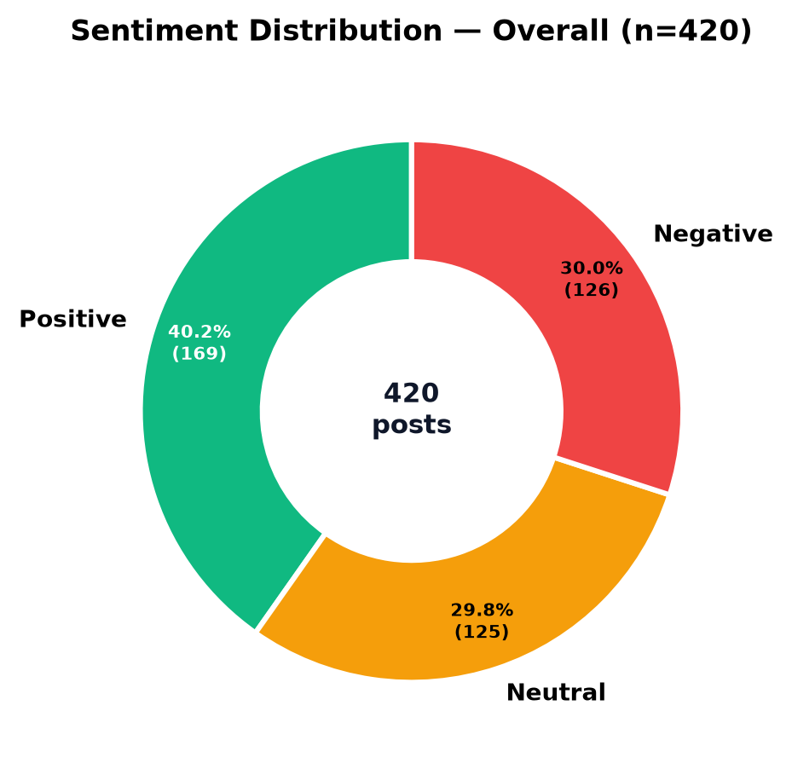
Figure 1 — Sentiment Distribution (Donut): Positive 40.2%, Neutral 29.8%, Negative 30.0% (n=420).
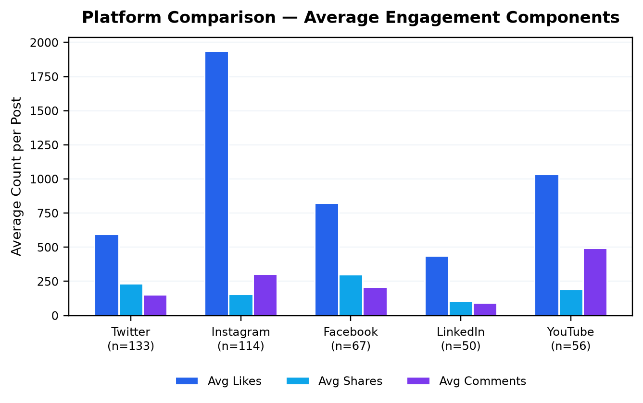
Figure 2 — Platform Comparison (Grouped Bar): Average likes, shares and comments per post by platform; Instagram and YouTube lead.
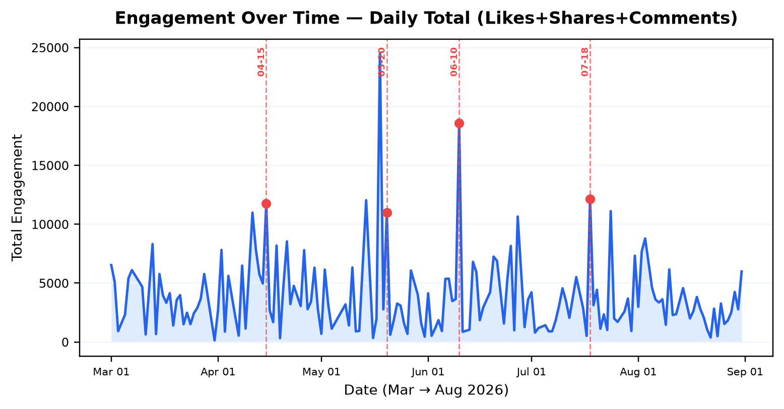
Figure 3 — Daily Timeline (Area + Markers): Total engagement over time; dashed markers at campaign peaks Apr 15, May 20, Jun 10, Jul 18.
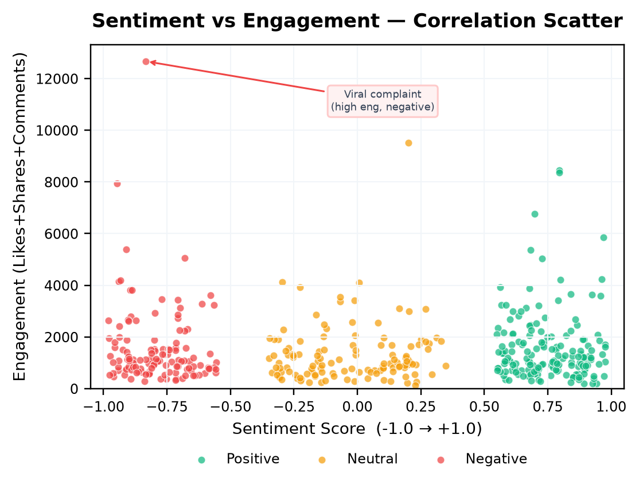
Figure 4 — Sentiment vs Engagement (Scatter): Each dot is a post; high-engagement negative and positive tails are visible (viral complaints/praise).
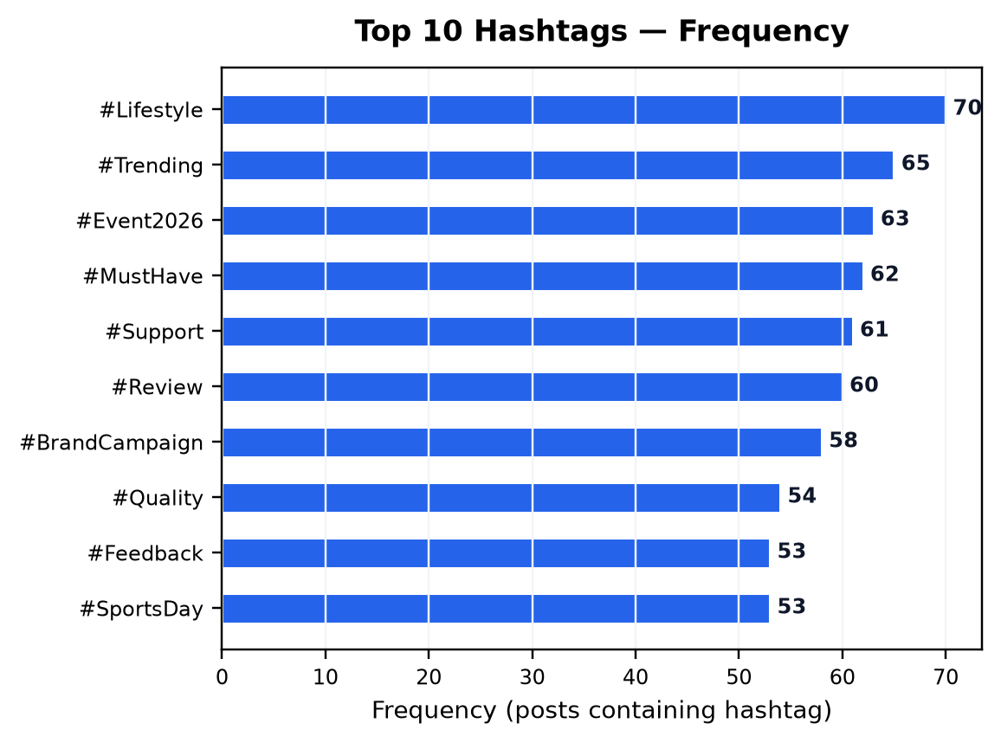
Figure 5 — Top 10 Hashtags (Horizontal Bar): Frequency of hashtag array elements across posts.
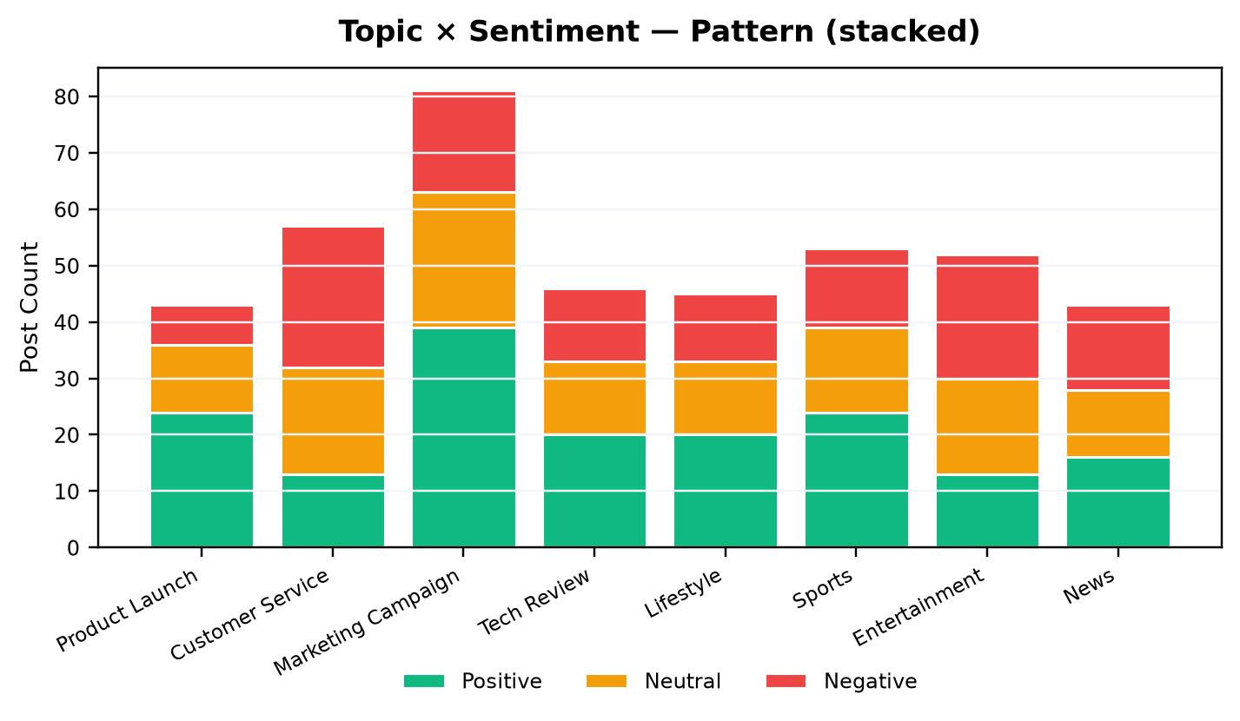
Figure 6 — Topic × Sentiment (Stacked Bar): Sentiment composition per topic; Customer Service negative-dominant, Campaign positive-dominant.
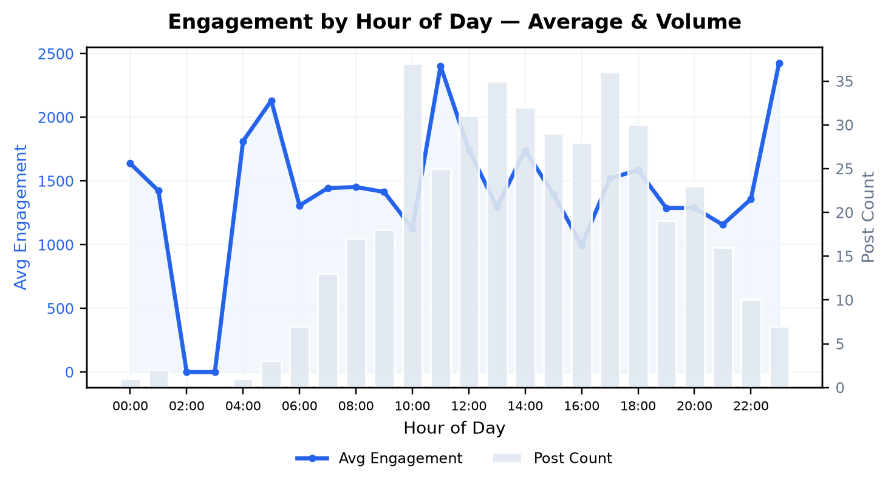
Figure 7 — Hourly Engagement (Dual-Axis): Blue line = avg engagement per post by hour; grey bars = post count per hour.
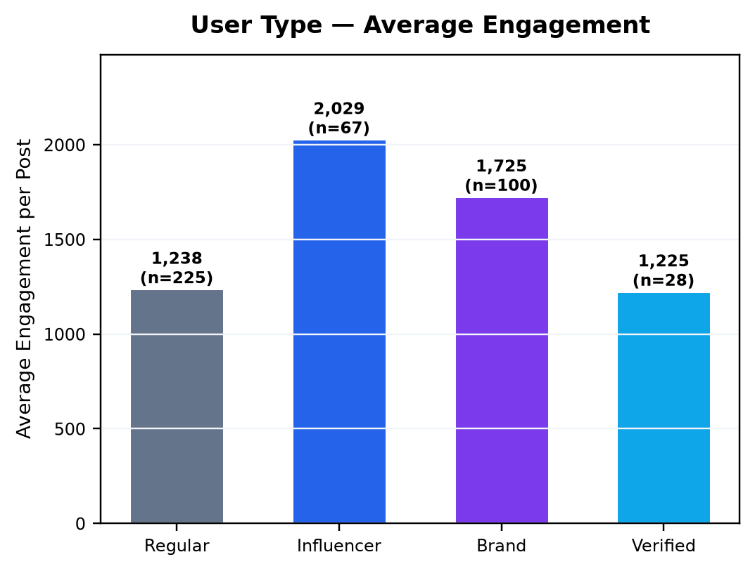
Figure 8 — User Type Engagement (Bar): Average engagement per post by user type; Influencers outrank Regular by ~80%.
Note: The SocialPulse static app (index.html) provides all eight views interactively with filters for platform, sentiment, topic, user type, date range and free-text search, plus a live text-processing playground that replicates the lexicon pipeline (§5.3), a sortable/paginated data table, and client-side JSON/CSV export. Although screenshots are shown above for the report’s print fidelity, the reviewer is encouraged to open index.html and verify each pattern in under 15 seconds by applying the corresponding filter.
