**Calculating our costs: The formula**

The formula below is the sum of our actual costs for the test hour divided by the number of queries served in that hour. It gets slightly complicated so that we can prorate the cost of our actual Dynamo usage against our provisioned capacity, but is otherwise fairly straightforward:

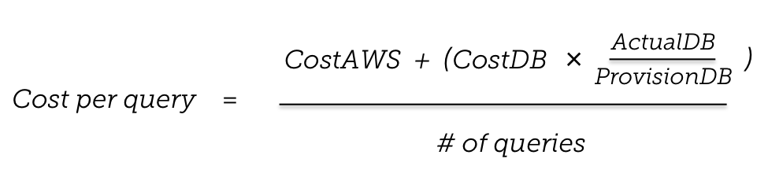

With our automated tests and this formula, we can now precisely estimate and then validate the costs of any new or changed API we expose to customers. We use a dashboard to make this immediately visible to both executives and engineers. In turn, the team responds with business and engineering decisions to improve the product, forming a closed-loop agile process that greatly increases our efficiency while lowering the risks of innovation.