Environmental Sustainability: An Explainable AI Framework for Assessing Associations Between Thermal Power Generation, Coal Consumption, and Air Quality in Selected Indian States

Venkata Arun Srinivas Nibhanupudi
Walsh College
QM640: Data Analytics Capstone
Mr. Jainesh Garg
Term 3
August 4, 2026

GitHub Repository and Data Access
Public repository: https://github.com/VenkataArunSrinivas/environmental-sustainability-aqi-framework
The public GitHub repository is the project’s access point for source files that may be redistributed, code, notebooks, data-quality outputs, figures, and replication instructions. The current public branch contains the three CPCB workbooks and partial National Power Portal folders. The companion upload package adds the reusable Python source package, scripts, tests, notebooks, source logs, data dictionaries, derived station-month summaries, figures, and report files.
The repository version accompanying this interim submission documents the current data audit, code structure, and reproducibility plan. It is not final-model-ready because a continuous common series for thermal generation, coal consumption, meteorology, and a validated air-quality outcome has not yet been harmonized. This distinction is intentional and prevents repository visibility from being mistaken for analytical completion.
Table 1
Interim Repository Status and Access Plan
Item | Current status | Interim evidence / required action
Repository visibility | Public | Verify access without sign-in; refresh screenshot after upload.
Raw source files | AQI and partial power files present | Preserve originals; republish only when permitted.
Code and documentation | Upload package prepared | Upload src, scripts, tests, notebooks, source log, dictionary, and README.
Interim derived data | Prepared locally | Upload station-month summaries, figures, and interim workbook.
Final panel and models | Not available | Complete continuous drivers, weather, target validation, panel, and final models.
Note. The repository is synopsis- and interim-documentation-ready but is not yet final-model-ready. Appendix A provides local file-structure evidence.

Environmental Sustainability: An Explainable AI Framework for Assessing Associations Between Thermal Power Generation, Coal Consumption, and Air Quality in Selected Indian States

Introduction

Background and Context
Air pollution is a persistent environmental-sustainability and public-health challenge in India. The Central Pollution Control Board (CPCB) communicates ambient air quality through pollutant measurements and the National Air Quality Index (AQI), which summarizes concentrations of particulate and gaseous pollutants into a common public-facing scale (Central Pollution Control Board, n.d.). National analyses of government monitoring data show that particulate matter is a dominant concern and that the quality, spatial coverage, and temporal continuity of monitoring data vary substantially across locations (Sharma & Mauzerall, 2022). These differences make data quality an analytical issue rather than only a preprocessing inconvenience.
Coal-based thermal electricity generation is an operationally important activity because generation levels and coal consumption reflect changing combustion intensity. Dispersion-modeling and emissions-inventory research has shown that coal-fired power plants contribute to particulate and gaseous pollution, but the size and location of the contribution depend on plant technology, fuel quality, controls, meteorology, and transport processes (Guttikunda & Jawahar, 2014). Broader source-contribution research also shows that power generation is only one part of a multi-sector air-pollution burden that includes industry, residential combustion, transport, dust, and open burning (Chatterjee et al., 2023).
The current project therefore does not attempt plant-level source attribution. It evaluates whether two measurable operational drivers—monthly thermal power generation and monthly coal consumption at thermal power stations—are associated with monthly air-quality outcomes after accounting for meteorology, season, monitoring coverage, and persistent location differences. The framework is positioned between a descriptive dashboard and a full chemical-transport or receptor-modeling study. It is designed as a reproducible screening tool that identifies patterns requiring deeper investigation rather than as a regulatory finding.
The primary intended users are the Maharashtra Pollution Control Board and Gujarat Pollution Control Board, together with state environment and energy departments. Odisha remains a conditional candidate for supplementary or expanded analysis because the preliminary audit found substantially shorter valid pollutant coverage than in the two primary states. The broader data-search window is 2019–2026, while the anticipated final common period is approximately 12–18 contiguous months. The exact period has not yet been confirmed.

Problem Statement
Official air-quality, thermal-generation, coal-consumption, meteorological, and population datasets are maintained by different agencies, use different file structures, and do not share a ready-to-use time and geography key. The collected air-quality workbooks provide daily station-level pollutant measurements, whereas the thermal and coal reports are monthly station- or utility-level spreadsheets. Weather and population controls have not yet been incorporated. Consequently, the project cannot yet estimate the proposed relationships without a defensible data-integration process. The core problem is to construct a quality-screened station-month panel that aligns air-quality outcomes with state-month operational drivers while avoiding target leakage, false precision, and unsupported causal claims.

Purpose of the Study
The purpose of the study is to build and evaluate an explainable analytical framework that predicts or explains a monthly air-quality outcome using thermal generation, coal consumption, weather, season, location, and monitoring-quality variables. AQI is the intended primary outcome if a reported AQI series can be obtained or if an official CPCB-compliant AQI calculation can be validated. If that requirement cannot be met, PM2.5 or PM10 will become the primary outcome and the title and interpretation will be updated accordingly. The framework will compare statistical and machine-learning models, use grouped chronological validation, and translate stable model explanations into screening priorities for public-sector users.

Interim Project Status (Progress Snapshot)
- Completed: project scope refined to thermal power generation and coal consumption; Maharashtra and Gujarat designated as primary states; public repository established; three station-level air-quality workbooks audited; partial monthly thermal and coal reports inventoried; reproducible code, tests, source logs, data dictionaries, EDA figures, and an interim data workbook prepared.
- In progress: repository synchronization; source and unit verification; plant-to-state mapping; collection of a contiguous thermal and coal period; weather-data acquisition; target-definition review among reported AQI, validated derived AQI, PM2.5, and PM10; and mentor review of the provisional scope refinements before final modeling.
- Pending: confirmation of the final common period; final Odisha inclusion decision; station-month panel construction; feature engineering; inferential models; machine-learning models; explainability analysis; model-performance comparison; policy recommendations.
Interim Scope-Control Note. Based on the data collected and audited to date, thermal power generation and coal consumption at thermal power stations are the two focal industrial activity indicators. Maharashtra and Gujarat form the current core analytical scope. Odisha remains a conditional extension and will be included only if its observations meet the same temporal-coverage and data-quality requirements applied to the core states. These are provisional, data-driven refinements intended to preserve measurability, reproducibility, and feasibility within the capstone timeline. They will be reviewed with the mentor before final model estimation and the final report; they do not alter the overarching objective of examining associations between industrial activity and air quality.

Scope and Objectives
The primary analytical scope is Maharashtra and Gujarat. Odisha will be included only if at least 12 common months satisfy the pollutant-completeness, monitoring-station, unit-consistency, and industrial-data alignment criteria. The data-search window spans 2019–2026 because the government portals contain different report years and archival structures. This window is not the final study period. The final period will be the longest contiguous 12–18-month interval that passes all required data-quality checks.
Interim working scope and governance status. The previously submitted synopsis specified coal production, mandatory inclusion of Maharashtra, Gujarat, and Odisha, a state-month unit, and monthly AQI. The data audit found that the collected National Power Portal coal files report receipts, consumption, imports, and stock at thermal power stations rather than coal production; the CPCB workbooks do not contain an AQI field; and Odisha has only eight state-month monitoring summaries under the current 75% diagnostic-readiness rule. Accordingly, this interim report uses coal consumption as the measurable operational driver, treats Odisha as conditional, and plans station-month outcomes linked to grouped state-month exposures. These are provisional working decisions, documented for transparency, and will be confirmed or revised with the mentor before final model estimation.
The planned unit of analysis is station-month. Daily pollutant measurements will be aggregated within each station and month after a 75% completeness rule is evaluated. Thermal-generation and coal-consumption values will be aligned at state-month level and repeated across stations only for data alignment. Repetition does not create independent industrial-exposure observations, so grouped or multilevel methods and chronological validation are required. The project will report both the number of valid station-month records and the number of unique state-month exposure periods.
Table 2
Project Objectives
Objective | Description
1 | Complete a reproducible audit of the collected government files and document coverage, units, missingness, and source limitations.
2 | Construct a station-month panel for Maharashtra and Gujarat, adding Odisha only if it meets predefined eligibility rules.
3 | Estimate associations between monthly thermal generation, coal consumption, and the selected air-quality outcome after environmental and temporal controls.
4 | Compare interpretable statistical models with regularized and tree-based machine-learning models using grouped chronological validation.
5 | Use SHAP or permutation importance to produce stable, non-causal driver explanations for pollution-control screening.

Research Questions
Table 3
Research Questions
RQ | Question
RQ1 | To what extent are monthly thermal power generation and coal consumption at thermal power stations individually and jointly associated with the selected monthly air-quality outcome after controlling for weather, station, state, and season?
RQ2 | Do one- and two-month lagged thermal-generation and coal-consumption indicators improve explanation and prediction relative to contemporaneous indicators alone?
RQ3 | Which industrial, environmental, temporal, and monitoring-quality drivers make the largest and most stable contributions to monthly air-quality predictions?
RQ4 | Do explainable machine-learning models improve out-of-sample prediction over statistical and seasonal baselines while retaining sufficient interpretability for environmental decision support?

Research Hypotheses
Table 4
Research Hypotheses
RQ | Null hypothesis | Alternative hypothesis
RQ1 | After controls, thermal generation and coal consumption are not jointly associated with the selected air-quality outcome. | At least one operational driver has a statistically meaningful association with the selected outcome.
RQ2 | Lagged operational drivers do not improve explanatory fit or predictive error. | At least one lagged driver improves fit or out-of-sample prediction.
RQ3 | Explainability results do not identify stable high-importance drivers across validation periods. | One or more drivers have consistently high importance across validation periods and sensitivity analyses.
RQ4 | Machine-learning models do not improve out-of-sample error over the statistical and seasonal baselines. | At least one explainable machine-learning model reduces out-of-sample error while retaining stable interpretation.

Sample Size Computation
The study retains a conservative planning threshold of at least 150 valid station-month observations. For RQ1, alpha = .05 was selected as the conventional Type I error rate, power = .80 as the conventional minimum probability of detecting the assumed effect, and f² = .12 as a conservative small-to-medium effect because aggregate observational air-quality relationships are expected to contain substantial unexplained variation. Ten effective predictors represent two focal drivers plus a parsimonious set of weather, temporal, location, and monitoring-quality controls. A noncentral F calculation yields 145 observations, which is rounded upward to 150 to preserve a modest exclusion buffer (Cohen, 1988). Low-powered designs can miss real effects and exaggerate detected effects, so these assumptions are stated before final modeling rather than selected after inspecting results (Button et al., 2013).
For RQ2, the 150-observation threshold is retained because lagged terms require consecutive months and consume degrees of freedom. For RQ3, 15 observations per approximately 10 effective predictors is used as a stability-oriented planning heuristic for regularization and repeated explanation checks. For RQ4, five chronological blocks with approximately 30 validation observations per block support repeated error estimation without shuffling time. These latter two values are transparent planning assumptions rather than formal power guarantees. Moreover, 150 station-month rows are not 150 independent industrial exposures: state-month drivers repeat across stations. Effective information is constrained by unique state-month periods and temporal dependence, so model complexity and inferential claims will be reduced if exposure coverage is insufficient (Gelman & Hill, 2007).
Table 5
Research Question Solutions, Rationale, and Sample-Size Planning
RQ | Analytical solution | Reason for choice | Expected output | Planning basis
RQ1 | Parsimonious regression or mixed-effects model with controlled industrial drivers | Transparent coefficients and uncertainty; respects repeated stations and shared state-month exposures | Individual/joint driver estimates, confidence intervals, diagnostics | Overall F test: alpha=.05, power=.80, f2=.12, 10 predictors -> N=145; use 150
RQ2 | Restricted contemporaneous and 1-/2-month lag models with nested comparison | Tests delayed relationships while limiting degrees of freedom and preserving chronology | Lag coefficients, fit/error change, sensitivity findings | Retain 150; require consecutive months and reduce lag terms if exposure periods are limited
RQ3 | Ridge/LASSO plus tree ensembles with SHAP or permutation importance | Balances correlated predictors, nonlinear patterns, interpretability, and ranking stability | Ranked drivers, direction, fold/state stability | 15 observations x 10 effective predictors = 150 planning heuristic
RQ4 | Seasonal/persistence and regression baselines versus explainable ML under grouped chronological validation | Tests whether complexity adds defensible held-out value without leakage | MAE, RMSE, out-of-sample R2, state error and stability | 5 time blocks x approximately 30 validation observations = 150
Final decision | Maximum threshold with an exposure-count review | Uses one consistent planning target while acknowledging multilevel dependence | Final N and effective state-month exposure count reported together | 150 station-month planning threshold; unique state-month periods govern inferential strength
Note. The final analytic sample and effective exposure count remain pending the common-period audit.

Literature Survey

Literature Review Approach
The literature review was organized around four themes: Indian air-quality monitoring and data quality; coal and thermal-power emissions; source-attribution limitations and decision support; and interpretable statistical or machine-learning methods. Sources were selected from peer-reviewed journal and conference publications available through publisher pages, DOI records, institutional repositories, and scholarly search tools. Search terms combined India, air quality, CPCB, PM2.5, PM10, coal-fired thermal power, emissions, source apportionment, random forest, gradient boosting, LASSO, and SHAP.
Inclusion criteria were direct relevance to at least one research question, transparent description of data or method, and usefulness for a reproducible analytical decision. Sources were excluded when they were unrelated to ambient air quality, lacked sufficient methodological information, or served only as unsourced commentary. Fourteen core scholarly sources are summarized below across domain evidence, data quality and documentation, statistical power and dataset bias, predictive modeling, and explainability. Government sources are discussed separately because they define the operational data and policy setting rather than substitute for peer-reviewed evidence.
Table 6
Literature Relevance Matrix
Source | Context / data | Method | Key finding | Relevance to this project
Sharma & Mauzerall (2022) | India; CPCB monitoring, 2015-2019 | National quality screening and spatiotemporal analysis | Particulate pollution dominated; monitoring coverage varied. | Supports completeness rules, network diagnostics, and cautious state comparison.
Guttikunda & Jawahar (2014) | Indian coal-fired thermal plants | Emissions inventory and dispersion modeling | Power-plant pollution burden depended on fuel, controls, and location. | Supports thermal/coal drivers while limiting causal interpretation.
Chatterjee et al. (2023) | India and South Asia | Sector emissions, chemical-transport modeling, hybrid PM2.5, mortality | Power, industry, residential combustion, and other sectors jointly contributed. | Supports multi-source controls and non-exclusive sector conclusions.
Gulia et al. (2015) | Urban air-quality management | Review of monitoring, inventories, modeling, and controls | Integrated evidence and stakeholder participation are required. | Supports decision-support orientation and end-user design.
Pant & Harrison (2012) | Indian source-apportionment studies | Critical review of receptor-modeling evidence | Source shares varied by sampling, season, profiles, and method. | Supports explicit limits and sensitivity analysis.
Guttikunda & Goel (2013) | Delhi particulate pollution | Emissions, dispersion, and health-impact assessment | No single source category was sufficient; coordinated control was needed. | Supports omitted-source caveats and non-exclusive interpretation.
Rahm & Do (2000) | Heterogeneous data integration | Data-quality taxonomy and ETL workflow review | Multi-source cleaning requires schema, instance, mapping, and verification controls. | Supports audit-first, metadata-driven harmonization and cleaning log.
Gebru et al. (2021) | Machine-learning datasets | Dataset documentation framework | Provenance, composition, preprocessing, uses, and maintenance should be documented. | Supports source log, data dictionary, datasheet, and usage limits.
Button et al. (2013) | Research reliability | Power analysis and reproducibility synthesis | Low power increases false negatives and effect-size inflation. | Supports a priori assumptions, conservative claims, and transparent limitations.
Torralba & Efros (2011) | Cross-dataset generalization | Dataset-classification and transfer experiments | Dataset-specific signatures reduced external generalization. | Supports monitoring-network bias checks and time/state sensitivity.
Breiman (2001) | General predictive modeling | Randomized tree ensembles | Random forests captured nonlinearities and offered importance estimates. | Supports nonlinear benchmark with stability controls.
Friedman (2001) | General predictive modeling | Gradient boosting | Sequential residual correction modeled complex functions. | Supports a second nonlinear tabular model.
Tibshirani (1996) | Correlated predictors | L1-penalized regression | LASSO shrank and selected predictors. | Supports parsimonious feature handling in a short period.
Lundberg & Lee (2017) | Model explanation | Unified additive attribution | SHAP enabled local and global model-behavior explanation. | Supports explainability with explicit non-causal language.

Thematic Synthesis
The monitoring literature directly supports the project’s emphasis on data eligibility. Sharma and Mauzerall (2022) did not treat every downloaded record as equally representative; they applied explicit data-quality and representativeness procedures before comparing pollutant patterns. This is particularly relevant because the current Maharashtra workbook is much larger than the Gujarat workbook but has a substantially higher proportion of entirely missing pollutant rows. The project will therefore base inclusion on valid station-month coverage rather than file size.
The coal-power literature supports the selected drivers while also limiting their interpretation. Guttikunda and Jawahar (2014) modeled emissions and dispersion using plant characteristics and atmospheric processes that are absent from the current dataset. Chatterjee et al. (2023) likewise combined detailed emissions with chemical-transport and health models. The proposed project uses operational activity indicators instead. It can test whether activity covaries with monitored air quality, but it cannot reproduce formal emissions attribution without stack characteristics, control technology, and dispersion modeling.
The source-apportionment and management literature explains why the proposed product is framed as a screening tool. Pant and Harrison (2012) found that source shares can diverge substantially across methods, seasons, locations, and source profiles. Gulia et al. (2015) emphasized that monitoring, inventories, modeling, control strategies, and stakeholder participation should work together. The proposed output is therefore intended to prioritize follow-up questions for pollution-control and energy agencies rather than substitute for an official source-apportionment study.
The statistical-learning literature supports a tiered model comparison. Multiple or mixed-effects regression provides coefficients, confidence intervals, and transparent assumptions. LASSO or ridge regression controls instability when predictors are correlated or the sample is limited. Random forest and gradient boosting can capture nonlinearities and interactions, while SHAP or permutation importance can summarize model behavior. Because flexible models can overfit a short time series, grouped chronological validation and explanation-stability checks are central design requirements, not optional enhancements.

The data-method literature reinforces the same design logic. Rahm and Do (2000) treat multi-source cleaning as an iterative workflow of profiling, transformation, verification, and metadata management rather than a one-time deletion of nulls. Gebru et al. (2021) show why provenance, collection, preprocessing, permitted uses, and maintenance should be documented for every analytical dataset. O’Brien et al. (2013) link data quality to decision quality, which is especially relevant when outputs may inform public-sector screening. Button et al. (2013) justify pre-specified power assumptions and restrained inference, while Torralba and Efros (2011) demonstrate that dataset-specific signatures can undermine generalization. In this project, unequal station coverage and changing monitoring networks are potential dataset signatures; therefore, completeness controls, grouped chronological validation, and state/time sensitivity checks are part of the substantive analysis.

Data Description

Data Sources and Access
The current evidence base consists of three air-quality workbooks and a partial collection of monthly power-sector reports. The air-quality files were obtained from an official CPCB-related data export and contain daily station-level pollutant measurements. The power files were obtained through National Power Portal or Central Electricity Authority reporting pages. Weather and Census controls remain pending. Official URLs and access instructions are maintained in the project source log and repository documentation.
Table 7
Government Data Sources and Current Collection Status
Component | Government source | Current status | Planned use
Air-quality pollutants | CPCB / Open Government Data Platform | Gujarat, Maharashtra, and Odisha workbooks collected | Station-day audit; station-month outcomes; AQI readiness assessment.
Thermal power generation | National Power Portal / Central Electricity Authority | Sample January 2021 and January 2023 reports plus fuel-wise folder collected | State-month thermal generation after schema and sector-coverage verification.
Coal at thermal stations | National Power Portal / Central Electricity Authority | Selected monthly coal statements for 2023, early 2024, and January 2026 collected | Coal receipt, consumption, import, and stock; coal consumption is the focal driver.
Meteorology | India Meteorological Department | Not yet collected | Rainfall, temperature, and humidity controls.
Population / structural controls | Census of India | Not yet collected | Population density or urbanization context; omitted from fixed-effects models if collinear.

Dataset Overview
The three air-quality workbooks contain 62,780 station-day records and 11 variables. Their common schema includes From Date, To Date, Ozone, CO, SO2, NO2, PM10, PM2.5, State, City, and Station. The nominal file period is August 1, 2021, through July 31, 2023. AQI is not present. The pollutant fields therefore represent the current outcome evidence, while AQI remains an intended derived or separately sourced target pending validation.
Table 8
Preliminary Air-Quality Data Inventory
State | Records | Cities | Stations | Nominal period | First valid pollutant date | Rows with all pollutants missing
Gujarat | 9,490 | 4 | 13 | Aug. 2021–Jul. 2023 | Aug. 1, 2021 | 1,615 (17.0%)
Maharashtra | 48,180 | 28 | 66 | Aug. 2021–Jul. 2023 | Aug. 1, 2021 | 29,385 (61.0%)
Odisha | 5,110 | 7 | 7 | Aug. 2021–Jul. 2023 | Nov. 25, 2022 | 3,374 (66.0%)
Total | 62,780 | 39 | 86 | Up to 24 months | State-specific | 34,374 (54.8%)
No exact or station-date duplicate rows were identified in the preliminary audit. However, absence of duplicates does not imply analytical completeness. Under the explicit provisional AQI-readiness condition of at least three available pollutants including PM10 or PM2.5, 27,911 of 62,780 station-day rows (44.5%) are ready for diagnostic calculation. Applying a 75% monthly completeness rule produces 882 valid station-months: 249 in Gujarat, 577 in Maharashtra, and 56 in Odisha. These aggregate into 24 Gujarat state-month monitoring summaries, 24 Maharashtra summaries, and only eight Odisha summaries. The station-month row count exceeds the 150 planning threshold, but the current 56 unique state-month summaries—and only 48 across the two primary states—remain insufficient for the planned industrial inference until continuous driver and weather data are obtained.

Industrial Data Collected So Far
The coal folder contains monthly statements for portions of April–December 2023, January–April 2024, and January 2026, together with several imported-coal statements. These reports describe coal receipts, consumption, imports, and closing stock at thermal power stations. They do not represent state coal production or mining activity. The project scope has therefore been corrected from coal production to coal consumption at thermal power stations.
The thermal folder contains sample report types for January 2021 and January 2023 and a fuel-wise subfolder. The report codes and sector coverage must be verified before aggregation. A report covering only state-sector utilities cannot be labeled as total state thermal generation. The immediate data-collection priority is to select one consistent report type and obtain every month for a candidate common period.

Data Dictionary
Table 9
Proposed Interim Data Dictionary
Variable | Type / unit | Definition | Analytical role | Source | Status
state | Categorical | State name | Geographic key/control | All sources | Required
city | Categorical | Monitoring city | Descriptive grouping | CPCB | Collected
station | Categorical | Monitoring-station name | Repeated-measures unit | CPCB | Collected
month_year | Date | Calendar month | Time and merge key | Derived | Pending derivation
aqi_reported | Numeric | Official reported AQI, if available | Preferred outcome | CPCB | Not present
aqi_derived | Numeric | CPCB-compliant AQI, if validated | Conditional outcome | Derived | Pending validation
pm25_mean | Numeric | Station-month PM2.5 mean/median | Fallback outcome/profile | CPCB | Collected; units to verify
pm10_mean | Numeric | Station-month PM10 mean/median | Fallback outcome/profile | CPCB | Collected; units to verify
no2_mean / so2_mean / co_mean / o3_mean | Numeric | Monthly pollutant profiles | Secondary outcomes/diagnostics | CPCB | Collected; units to verify
coverage_rate | Numeric (%) | Valid daily readings / expected readings | Eligibility and quality control | Derived | Pending
thermal_generation_gwh | Numeric (GWh) | Monthly thermal electricity generation | Primary driver 1 | NPP/CEA | Partial collection
coal_consumption_kt | Numeric (thousand tonnes) | Monthly coal consumed at thermal stations | Primary driver 2 | NPP/CEA | Partial collection
coal_receipt_kt / closing_stock_kt | Numeric | Monthly coal receipts and stock | Sensitivity/context | NPP/CEA | Partial collection
rainfall_mm | Numeric (mm) | Monthly rainfall | Weather control | IMD | Not collected
temperature_c | Numeric (°C) | Monthly mean temperature | Weather control | IMD | Not collected
season | Categorical | Winter, pre-monsoon, monsoon, post-monsoon | Temporal control | Derived | Pending

GitHub Data Availability Statement
The public repository is the project’s reproducibility channel. The upload package prepared for this submission contains the source log, data dictionary, availability matrix, dataset datasheet, scope-change record, configuration file, reusable source package, audit and analysis scripts, automated tests, notebooks, derived station-month summaries, figures, and a multi-sheet interim data workbook. Raw source files remain unchanged and should be republished only when permitted. The expected public paths are config, data/raw, data/interim, data/processed, docs, notebooks, outputs, reports, scripts, src, and tests. Appendix A documents the current collection and the repository structure prepared for upload.

Analysis

Data Cleaning
Cleaning is being implemented as a reproducible audit-first workflow. Original workbooks will remain unchanged. Dates will be parsed into ISO-compatible values; state, city, station, and plant names will be standardized through explicit mapping files; pollutant columns will be coerced to numeric values; and all conversion failures will be logged. Missing values will never be replaced with zero because zero is a plausible physical value and would create artificial observations.
A station-month will be evaluated against a target threshold of at least 75% valid daily readings for the selected outcome. The threshold will be tested in sensitivity analyses because the official validity requirements may differ by pollutant and AQI calculation method. Extreme values will be flagged against source documentation and distribution diagnostics rather than automatically deleted. AQI will not be calculated until pollutant units, averaging periods, breakpoint rules, and completeness requirements are verified.
Power-station names in the thermal and coal workbooks will be mapped to verified states using official plant directories. Monthly industrial values will be aggregated using a consistent definition across all retained months. The merge will be checked for duplicate state-month keys, unexpected row multiplication, unmatched months, and repeated exposure leakage across training and validation data.
Table 10
Data Cleaning Log
Issue | Variables affected | Detection method | Treatment / rationale
Missing pollutant fields | O3, CO, SO2, NO2, PM10, PM2.5 | Null counts and all-pollutant-missing rows | Do not impute at raw stage; apply station-month completeness rules and report exclusions.
Date and type inconsistency | From Date, To Date, pollutant fields | Parsing tests and conversion errors | Standardize dates; coerce numeric fields; log failures without modifying raw files.
Duplicate records | Station and date | Composite-key check | No duplicates currently detected; retain automated validation.
Unequal station coverage | Station, city, state | Counts by month and station | Use coverage rate and station count; fixed-station sensitivity analysis.
Odisha temporal gap | All pollutant fields | First/last valid date and monthly availability | Conditional inclusion; require at least 12 common valid months.
AQI unavailable | Outcome field | Schema inspection | Use official reported AQI or validated derivation; otherwise use PM2.5/PM10 and revise interpretation.
Industrial report inconsistency | Thermal and coal fields | Header, unit, report-type, and sector audit | Select one consistent report definition and avoid mixing incompatible reports.
Station-to-state mapping | Plant/station names | Official directory matching | Use a documented mapping; do not infer unverified locations from names alone.

Preliminary Descriptive Results
The preliminary analysis is intentionally limited to data availability, completeness, and descriptive pollutant profiles. It does not estimate the effect of thermal generation or coal consumption because the matched industrial and weather series are not complete. These results are still important: they determine which states and periods can support the research questions and prevent the use of a large but misleading raw record count.
Figure 1
Collected Station-Day Air-Quality Records by State
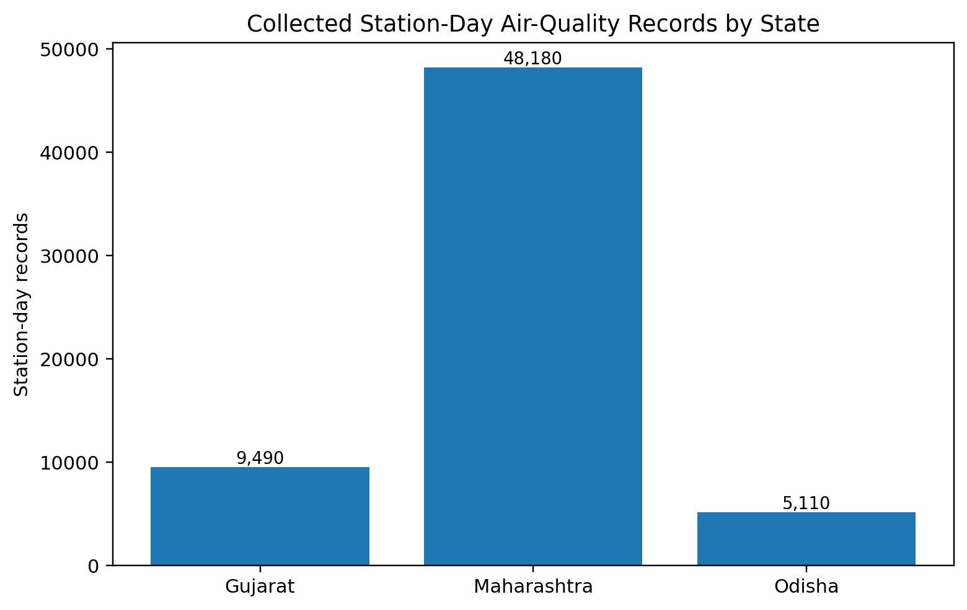
Note. State names are standardized for presentation. Maharashtra contributes most raw rows, but raw volume must be interpreted jointly with missingness and station-month completeness.
As shown in Figure 1, Maharashtra contributes 48,180 station-day rows, compared with 9,490 for Gujarat and 5,110 for Odisha. The imbalance reflects the number of stations rather than superior completeness. Maharashtra has 66 listed stations, Gujarat has 13, and Odisha has 7. A model built from unfiltered rows would therefore be dominated by Maharashtra and could learn monitoring-network structure instead of the intended industrial relationships.
Figure 2
Rows With All Six Pollutant Fields Missing
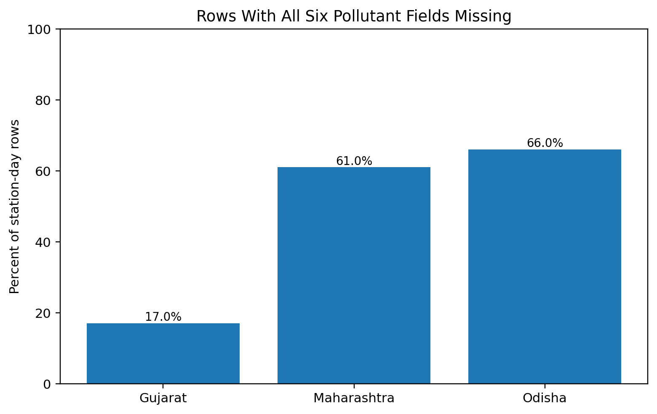
Note. A row is fully missing when O3, CO, SO2, NO2, PM10, and PM2.5 are all absent. This measure differs from the stricter provisional AQI-readiness rule.
Figure 2 changes the interpretation of the raw row counts. Only 17.0% of Gujarat rows have all pollutant fields missing, compared with 61.0% in Maharashtra and 66.0% in Odisha. The result justifies a completeness-driven eligibility rule. It also indicates that station count should be retained as a quality indicator and that results should be checked with a balanced or fixed-station subset.
Figure 3
Monthly Rows With at Least One Valid Pollutant Value
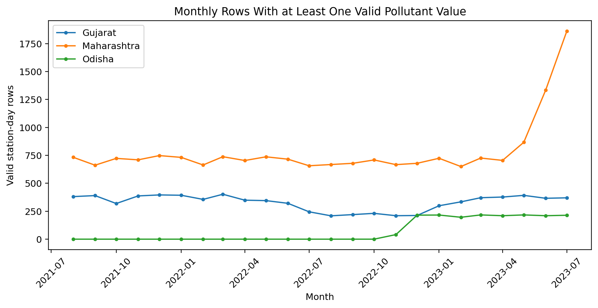
Note. Monthly counts reflect data availability, not population exposure or official state-level air quality.
Figure 3 shows that Gujarat has usable observations throughout the nominal 24-month period, although coverage declines in parts of 2022. Maharashtra has a relatively stable but incomplete series until a sharp increase in valid rows during May–July 2023, which may reflect network expansion or reporting changes rather than an environmental shift. Odisha has no valid pollutant values until November 25, 2022. For this reason, Odisha cannot currently support the same 24-month analysis as the two primary states.
Figure 4
Preliminary Median PM2.5 and PM10 Values by State
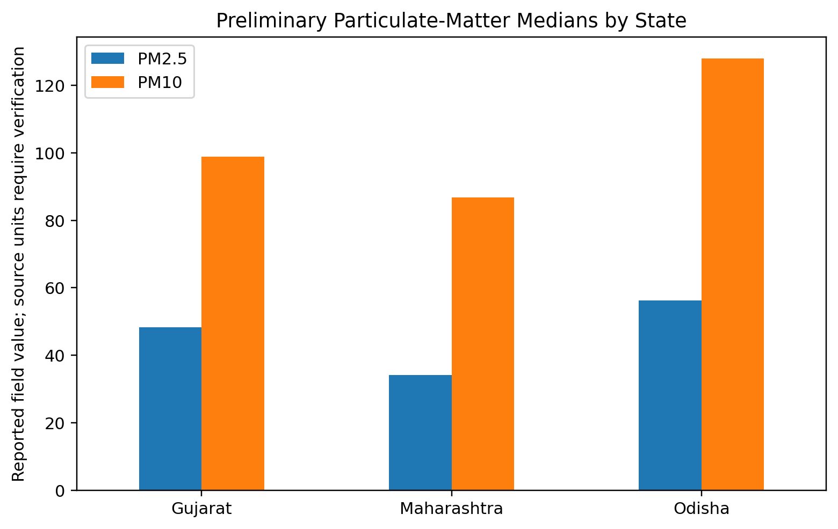
Note. Values are reported exactly as available in the source workbooks. Cross-state interpretation remains provisional until measurement units and averaging periods are verified.
Figure 4 shows higher median reported PM10 than PM2.5 in all three states, which is directionally plausible for ambient particulate measurements. Odisha has the highest preliminary medians, but the state covers only late November 2022 through July 2023 and cannot be directly compared with the full two-year series in Gujarat and Maharashtra. These values are therefore used only to verify that the pollutant fields contain analyzable variation; they are not presented as final state rankings.
Table 11
Preliminary Analysis Insight Summary
Reference | What it shows | Key insight | Decision / next step
Table 8 | Rows, stations, dates, and missingness | Raw volume differs sharply from valid-data coverage. | Use explicit station-month eligibility rather than raw row count.
Figure 1 | Record volume by state | Maharashtra dominates the unfiltered dataset. | Use state/station controls and balanced-network sensitivity.
Figure 2 | Fully missing pollutant rows | Gujarat is substantially more complete than Maharashtra and Odisha. | Calculate outcome-specific completeness and document exclusions.
Figure 3 | Monthly valid records | Odisha begins usable reporting in late 2022; Maharashtra changes in mid-2023. | Keep Odisha conditional and test network-change sensitivity.
Figure 4 | Preliminary particulate medians | Fields contain variation, but coverage and units remain non-comparable. | Verify units and target definition before substantive ranking.
Station-month audit | 75% provisional AQI-readiness rule | 882 station-months pass, but they represent only 56 state-month monitoring summaries. | Report row N and unique exposure-period N; do not treat repeated drivers as independent.

Workflow and Research Design
Figure 5
Interim Explainable AI Research Workflow
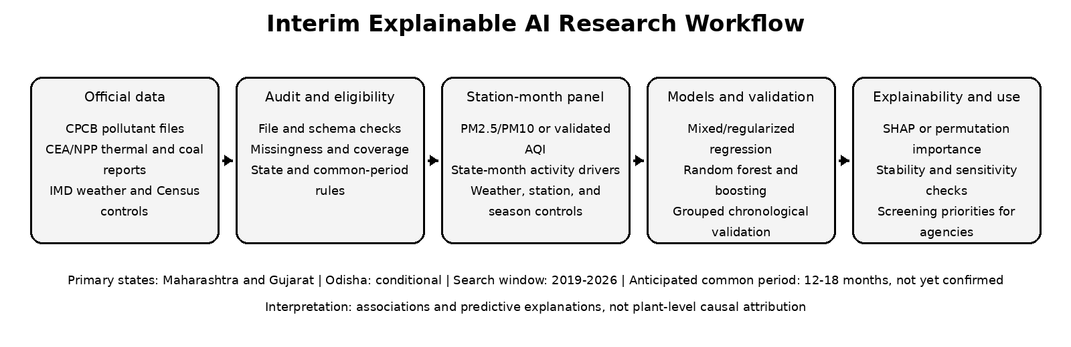
Note. The common period and final outcome remain audit decisions. Odisha is not automatically included.
The workflow in Figure 5 separates data eligibility from modeling. This is essential because the current constraints are not primarily algorithmic. A sophisticated model cannot compensate for unmatched time periods, unverified units, or repeated state-month exposures leaking into both training and validation sets. The research design therefore treats data audit, target definition, and common-period confirmation as formal analytical stages.

Modelling

Choice of Models With Justification
The primary statistical model will be a parsimonious regression with station effects, state and seasonal controls, weather variables, monitoring coverage, thermal generation, and coal consumption. Depending on the final panel structure, the model may use station fixed effects or a mixed-effects intercept. Because there are only two primary states and a possible third conditional state, conventional state-clustered standard errors are not reliable. The report will emphasize effect estimates, uncertainty from time-aware or block-bootstrap approaches, diagnostic checks, and robustness rather than overinterpreting p values.
Ridge and LASSO regression will provide regularized linear benchmarks. Ridge is useful when correlated weather and industrial variables should remain in the model, while LASSO can reduce the active predictor set. Random forest and gradient boosting will be included as nonlinear comparators because they can identify thresholds and interactions without specifying them in advance (Breiman, 2001; Friedman, 2001). Flexible models will be constrained by shallow trees, limited hyperparameter grids, and chronological validation because the common period is expected to be short.
A seasonal-naive or training-period climatology model will serve as the minimum predictive baseline. A model will not be considered useful merely because it fits the training data. It must improve held-out error, show acceptable state-level error, and produce explanations that remain reasonably stable across validation periods. SHAP will be used for a stable tree model when technically appropriate; permutation importance and partial-dependence or accumulated-local-effect plots will be used as alternatives. All explanation methods will be described as model behavior, not causal attribution (Lundberg & Lee, 2017).
Table 12
Planned Models and Justification
Model | Role | Reason for inclusion | Primary limitations
Seasonal-naive / climatology | Minimum baseline | Tests whether complex models beat simple seasonal persistence. | Cannot use industrial drivers or nonlinear relationships.
Multiple or mixed-effects regression | Inferential baseline | Transparent coefficients, confidence intervals, diagnostics, and controls. | Sensitive to omitted variables, functional form, and short exposure series.
Ridge regression | Regularized linear model | Stabilizes correlated predictors and retains all variables. | Coefficients shrink and require scaling; still linear.
LASSO regression | Sparse linear model | Supports parsimonious feature selection in a limited sample. | Selection may be unstable with correlated variables.
Random forest | Nonlinear ensemble | Captures nonlinearities and interactions; provides robust benchmark. | Importance can be biased or unstable; weak extrapolation.
Gradient boosting | Nonlinear ensemble | Strong tabular prediction through sequential residual correction. | Can overfit and requires careful chronological tuning.

Features and Feature Engineering
Table 13
Planned Feature Set and Usage
Feature | Original / engineered | Type | Reason for inclusion | Models
Thermal generation | Original monthly driver | Numeric | Operational combustion intensity. | All final models
Coal consumption | Original monthly driver | Numeric | Fuel use at thermal stations; replaces coal-production scope. | All final models
Lagged drivers | 1- and 2-month lags | Numeric | Tests delayed or persistent relationships. | RQ2 and sensitivity models
Rainfall / temperature / humidity | Original controls | Numeric | Meteorological dispersion and removal conditions. | All controlled models
State / station | Original categories | Categorical / effects | Controls persistent geography and repeated stations. | Regression and ML
Season / month | Engineered categories | Categorical | Controls recurring seasonal variation. | All models
Coverage rate / station count | Engineered quality variables | Numeric | Distinguishes environmental changes from monitoring changes. | All models and sensitivity
Log-transformed activity | Conditional transformation | Numeric | Reduces skew and leverage if diagnostics support it. | Regression and ML
Pollutant components | Excluded from primary AQI feature set | Numeric | Avoids target leakage if AQI is the outcome. | Secondary outcome/profile analysis only

Validation and Leakage Control
Random row-level splitting is not appropriate because multiple stations share the same state-month industrial values and adjacent months are temporally related. The preferred strategy is a grouped chronological split in which all records from the same state-month remain in the same fold and later periods are predicted from earlier periods. Hyperparameter tuning will occur only within the training portion. If the final period is too short for five stable folds, the design will use a smaller rolling-origin evaluation and report the limitation rather than revert to shuffled cross-validation.
The target and feature definitions will also be separated to prevent leakage. If AQI is the outcome, same-period PM2.5, PM10, NO2, SO2, CO, and O3 will not be used as predictors because they are inputs to AQI construction. If PM2.5 or PM10 becomes the primary outcome, the corresponding pollutant will not appear in the feature set, and other same-period pollutants will be treated cautiously because they may reflect the same emission and atmospheric processes.

Evaluation Metrics
Table 14
Evaluation Metrics and Formulae
Metric | Formula | Interpretation | Use
Mean Absolute Error (MAE) | MAE = (1/n) Σ |yᵢ − ŷᵢ| | Average absolute prediction error; lower is better. | All regression models
Root Mean Squared Error (RMSE) | RMSE = √[(1/n) Σ (yᵢ − ŷᵢ)²] | Penalizes large errors more strongly; lower is better. | All regression models
Out-of-sample R² | R² = 1 − Σ(yᵢ − ŷᵢ)² / Σ(yᵢ − ȳtrain)² | Variance improvement over the training-mean baseline; may be negative. | Held-out predictions
Adjusted R² | 1 − [(1 − R²)(n − 1)/(n − k − 1)] | Regression fit adjusted for predictor count. | Statistical models
RMSE improvement | ΔRMSE = RMSEbaseline − RMSEmodel | Positive value indicates improvement over baseline. | Model comparison
Top-k explanation stability | J(A,B) = |A ∩ B| / |A ∪ B| | Overlap of top-ranked drivers across folds or sensitivity runs. | Explainability reliability

Preliminary Findings by Research Question
No final industrial-model coefficients or performance metrics are reported because the integrated driver, weather, and outcome panel does not yet exist. Reporting a sector model at this stage would create false precision. A limited PM2.5 field-value smoke test is reported only to verify that the grouped chronological evaluation code executes correctly; it is not evidence for RQ1-RQ4 and is not a substitute for the final outcome or drivers.
Table 15
Preliminary Findings and Remaining Work by Research Question
RQ | Completed / preliminary evidence | What remains
RQ1 | Maharashtra and Gujarat provide two years of nominal station-day pollutant records; the audit identifies usable stations, missingness, and a feasible station-month design. | Collect a contiguous thermal, coal, and weather series; verify outcome units; build the panel; estimate controlled associations.
RQ2 | The report inventory confirms that monthly thermal and coal data exist, and lag features can be generated after harmonization. | Obtain consecutive months; prevent cross-fold leakage; compare contemporaneous and lagged specifications.
RQ3 | The audit shows that monitoring coverage is likely to influence model behavior and must be included as a quality feature or sensitivity criterion. | Train leakage-controlled models; compute SHAP or permutation importance; test rank stability across time blocks.
RQ4 | Baseline definitions, grouped chronological validation, and relevant metrics are specified. A preliminary PM2.5 smoke test verifies the evaluation pipeline. | Complete the integrated dataset; rerun baselines and candidate models on the validated target; compare held-out performance and explanation stability.

Preliminary Pipeline Verification
A chronological holdout beginning January 2023 was used to verify the modeling workflow on station-month PM2.5 field medians that met a 75% PM2.5 completeness rule. The training interval contained 532 station-months and the holdout contained 311. A previous-month persistence baseline was evaluated on 255 consecutive holdout station-months; a location-season Ridge model was evaluated on all 311 holdout rows using state, station, calendar month, and coverage rate. No industrial or weather variables were available. The results therefore test code and validation mechanics only, not the research hypotheses.
Table 16
Chronological PM2.5 Pipeline Smoke-Test Performance
Model | Training N | Holdout N | MAE | RMSE | Out-of-sample R2 | Interpretive status
Previous-month persistence | 532 | 255 | 12.91 | 18.06 | .67 | Pipeline verification only
Location-season Ridge | 532 | 311 | 14.90 | 22.98 | .48 | Industrial/weather drivers absent
The persistence baseline produced lower holdout error than the location-season Ridge smoke test. This is a useful interim finding: a final machine-learning model must outperform a strong temporal baseline rather than only a training mean. The metric values must not be compared with future AQI models because the target, feature set, and eligible observations will differ.
Figure 6
Interim PM2.5 Pipeline Smoke-Test Performance
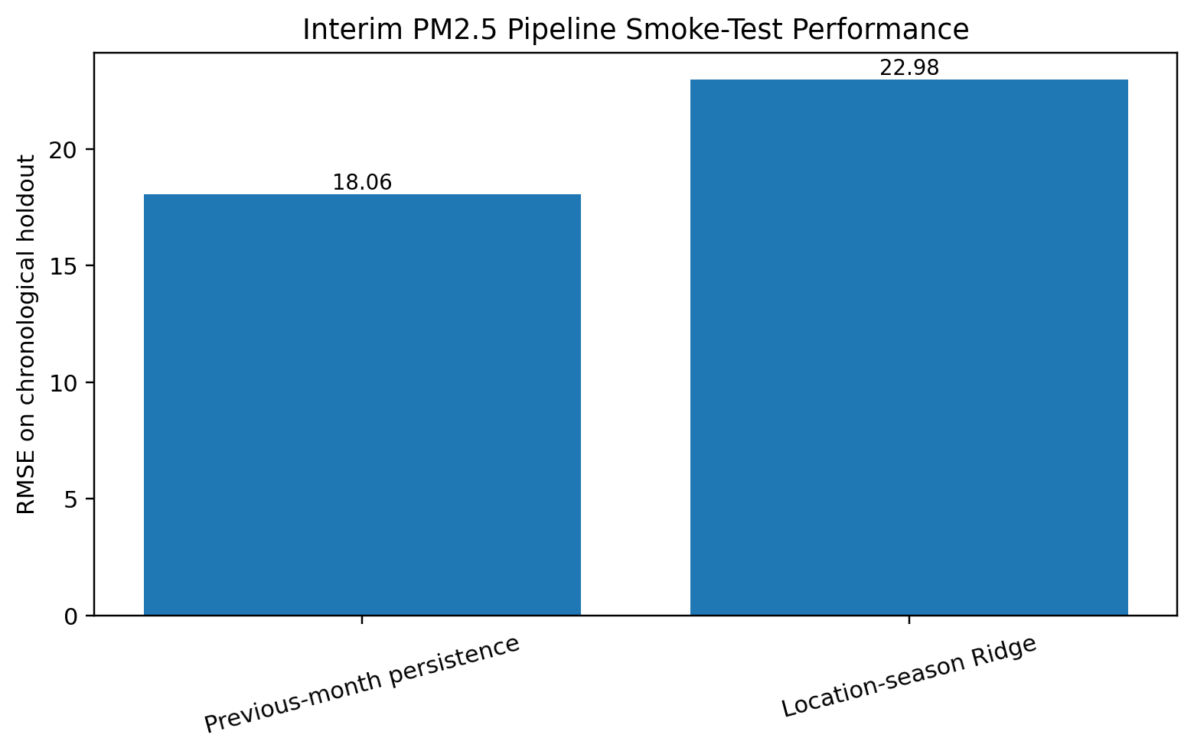
Note. Lower RMSE is better. The chart verifies the chronological evaluation pipeline on PM2.5 field values; it is not final RQ4 performance.

Interim Limitations and Risks
The primary limitation is incomplete alignment of the data sources. The air-quality workbooks cover August 2021 through July 2023, the available coal statements cover selected months in 2023, 2024, and 2026, and the thermal reports currently include only sample months. Weather and population controls are not yet collected. A 12–18-month common period is therefore an expectation, not a confirmed result.
The second limitation is outcome definition. The air-quality workbooks do not contain AQI. Deriving AQI requires verified units, averaging periods, pollutant sufficiency, and official breakpoint rules. Until those conditions are satisfied, PM2.5 or PM10 is the safer fallback. The final report will not mix pollutant concentrations, subindices, and AQI without explicit definitions.
The third limitation is multilevel dependence. Industrial activity varies at state-month level while outcomes may be observed for many stations. This increases the row count but not the number of unique industrial exposures. The study will therefore use grouped time splits, station effects, parsimonious models, and explicit reporting of unique state-month periods. The limited number of states also constrains formal cluster-robust inference.
The fourth limitation is omitted-source bias. Traffic, dust, household combustion, agriculture, industrial processes outside the thermal-power chain, fuel quality, emission-control technology, and atmospheric transport are not fully represented. The results will be framed as associations and predictive explanations. They will not identify a plant as the legal or physical cause of a monitored pollution level.
Scope confirmation risk. The transition from coal production to coal consumption at thermal power stations, the conditional treatment of Odisha, and the proposed station-month analytical unit were driven by the availability and structure of the collected government data. These refinements had not received formal mentor confirmation at the interim submission deadline. They are therefore presented as provisional working decisions and will be confirmed or revised before final model estimation and the final report.

Next Steps for the Final Report
- Review and document the provisional scope refinements with the mentor before final model estimation, then synchronize any confirmed changes across the title, research questions, configuration, repository documentation, and final report.
- Push the updated local repository structure, source log, data dictionary, audit scripts, and permitted derived files to the public GitHub branch.
- Select one consistent thermal-generation report and collect every month for a candidate 12–18-month common period.
- Collect the corresponding monthly coal-consumption statements and verify receipts, consumption, stock, units, and station coverage.
- Acquire monthly rainfall and temperature controls and document the geographic aggregation method.
- Verify pollutant units and determine whether reported or derived AQI is defensible; otherwise formally adopt PM2.5 or PM10 as the primary outcome.
- Generate station-month coverage tables, apply inclusion thresholds, and make the final Odisha eligibility decision.
- Build the grouped station-month panel, create lagged and seasonal features, and complete diagnostic checks.
- Fit baseline, statistical, regularized, and tree-based models using grouped chronological validation.
- Produce SHAP or permutation-based explanations, stability checks, sensitivity analyses, and stakeholder-focused recommendations.

References
Breiman, L. (2001). Random forests. Machine Learning, 45(1), 5-32. https://doi.org/10.1023/A:1010933404324
Button, K. S., Ioannidis, J. P. A., Mokrysz, C., Nosek, B. A., Flint, J., Robinson, E. S. J., & Munafò, M. R. (2013). Power failure: Why small sample size undermines the reliability of neuroscience. Nature Reviews Neuroscience, 14, 365-376. https://doi.org/10.1038/nrn3475
Central Pollution Control Board (n.d.). About National Air Quality Index. https://www.airquality.cpcb.gov.in/ccr_docs/About_AQI.pdf
Chatterjee, D., McDuffie, E. E., Smith, S. J., Bindle, L., van Donkelaar, A., Hammer, M. S., Venkataraman, C., Brauer, M., & Martin, R. V. (2023). Source contributions to fine particulate matter and attributable mortality in India and the surrounding region. Environmental Science & Technology, 57(28), 10263-10275. https://doi.org/10.1021/acs.est.2c07641
Cohen, J. (1988). Statistical power analysis for the behavioral sciences (2nd ed.). Lawrence Erlbaum Associates.
Friedman, J. H. (2001). Greedy function approximation: A gradient boosting machine. The Annals of Statistics, 29(5), 1189-1232. https://doi.org/10.1214/aos/1013203451
Gebru, T., Morgenstern, J., Vecchione, B., Wortman Vaughan, J., Wallach, H., Daumé III, H., & Crawford, K. (2021). Datasheets for datasets. Communications of the ACM, 64(12), 86-92. https://doi.org/10.1145/3458723
Gelman, A., & Hill, J. (2007). Data analysis using regression and multilevel/hierarchical models. Cambridge University Press.
Gulia, S., Shiva Nagendra, S. M., Khare, M., & Khanna, I. (2015). Urban air quality management: A review. Atmospheric Pollution Research, 6(2), 286-304. https://doi.org/10.5094/APR.2015.033
Guttikunda, S. K., & Goel, R. (2013). Health impacts of particulate pollution in a megacity-Delhi, India. Environmental Development, 6, 8-20. https://doi.org/10.1016/j.envdev.2012.12.002
Guttikunda, S. K., & Jawahar, P. (2014). Atmospheric emissions and pollution from the coal-fired thermal power plants in India. Atmospheric Environment, 92, 449-460. https://doi.org/10.1016/j.atmosenv.2014.04.057
India Meteorological Department (n.d.). IMD Data Service Portal. https://dsp.imdpune.gov.in/
Lundberg, S. M., & Lee, S.-I. (2017). A unified approach to interpreting model predictions. Advances in Neural Information Processing Systems, 30. https://proceedings.neurips.cc/paper/2017/hash/8a20a8621978632d76c43dfd28b67767-Abstract.html
National Power Portal (n.d.). Published reports. Ministry of Power, Government of India. https://npp.gov.in/publishedReports
O'Brien, T., Sukumar, A., & Helfert, M. (2013). The value of good data-A quality perspective: A framework for discussion. Proceedings of the 15th International Conference on Enterprise Information Systems, 555-562. https://doi.org/10.5220/0004616805550562
Office of the Registrar General and Census Commissioner, India (n.d.). Census data. Government of India. https://censusindia.gov.in/census.website/en/data
Pant, P., & Harrison, R. M. (2012). Critical review of receptor modelling for particulate matter: A case study of India. Atmospheric Environment, 49, 1-12. https://doi.org/10.1016/j.atmosenv.2011.11.060
Rahm, E., & Do, H. H. (2000). Data cleaning: Problems and current approaches. IEEE Data Engineering Bulletin, 23(4), 3-13.
Sharma, D., & Mauzerall, D. L. (2022). Analysis of air pollution data in India between 2015 and 2019. Aerosol and Air Quality Research, 22(2), Article 210204. https://doi.org/10.4209/aaqr.210204
Tibshirani, R. (1996). Regression shrinkage and selection via the lasso. Journal of the Royal Statistical Society: Series B (Methodological), 58(1), 267-288. https://doi.org/10.1111/j.2517-6161.1996.tb02080.x
Torralba, A., & Efros, A. A. (2011). Unbiased look at dataset bias. Proceedings of the IEEE Conference on Computer Vision and Pattern Recognition, 1521-1528. https://doi.org/10.1109/CVPR.2011.5995347

Appendix A

Current Local Data Collection Evidence
The following screenshots document the current local working copy. They are included as evidence of the collected files and directory organization. The public repository should be synchronized with the non-restricted documentation and code before the graded submission.
Figure A1
Local CPCB Air-Quality Folder
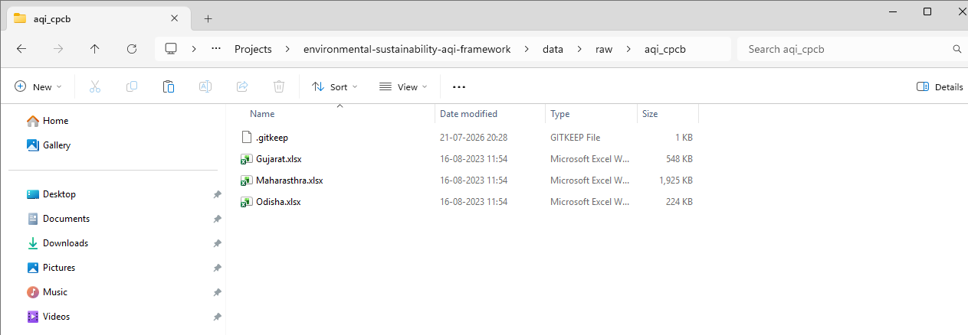
Note. The folder contains the Gujarat, Maharashtra, and Odisha workbooks. The filename spelling should be standardized without modifying workbook content.
Figure A2
Repository Structure Prepared for GitHub Upload
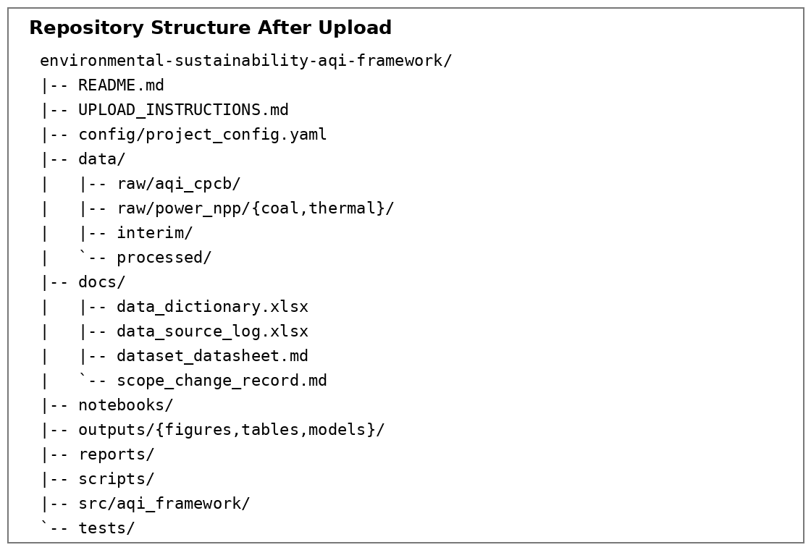
Note. The package creates the top-level folders and files expected for reproducible audit, analysis, testing, modeling, documentation, and report delivery. The public screenshot should be refreshed after these files are uploaded.
Figure A3
Collected Monthly Coal Statements
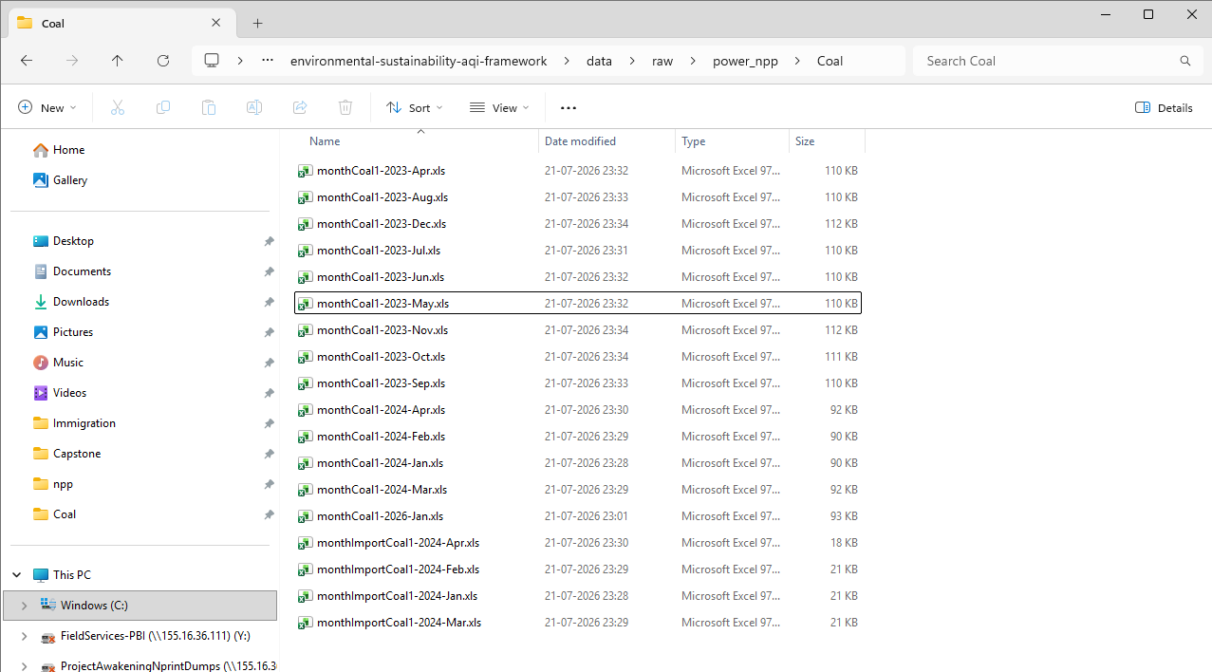
Note. The visible files cover selected months rather than a confirmed continuous analytical period.
Figure A4
Collected Thermal-Generation Reports
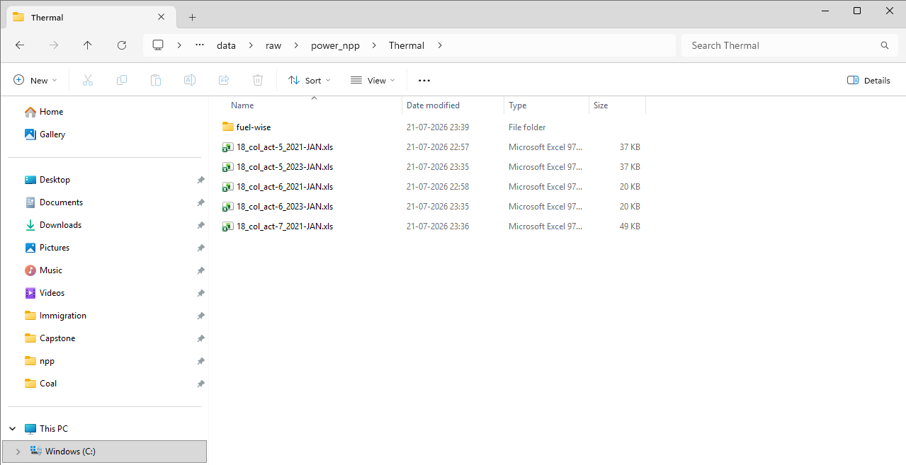

Appendix B

Preliminary Data-Audit Calculations
Table B1
Pollutant Missingness by State
State | O3 missing | CO missing | SO2 missing | NO2 missing | PM10 missing | PM2.5 missing
Gujarat | 22.9% | 18.9% | 20.4% | 26.6% | 22.2% | 18.7%
Maharashtra | 64.9% | 62.8% | 62.5% | 62.1% | 62.7% | 63.8%
Odisha | 66.1% | 66.1% | 66.3% | 67.3% | 66.4% | 66.2%
Table B2
Preliminary Pollutant Summary Values
State | PM2.5 mean | PM2.5 median | PM10 mean | PM10 median | Interpretive status
Gujarat | 54.91 | 48.22 | 107.17 | 98.84 | Provisional; source units to verify
Maharashtra | 45.41 | 34.16 | 107.32 | 86.80 | Provisional; high missingness
Odisha | 60.51 | 56.22 | 134.15 | 127.97 | Provisional; short valid period
Note. The values in Table B2 are descriptive checks of the source fields. They are not final state comparisons and are not labeled with concentration units until source metadata are verified.

