
Project Report on

Social Media Database Management System
MODULE B103A- DATABASES & BIG DATA
SUBMITTED BY
Nallamothu Venkata Divya Sree - GH1056327

Social Media Database Management System Project Report
Introduction
Social media is being used by so many people in their daily life. People use social media to talk to each other and share things among them. Every social media platform has a database behind it. The database is basically a storage unit which keeps all the things like users posts. In order to work a social media platform needs a database to work properly to manage the data of people on social media every day.

The Social Media Database Management System was developed as a database project to represent the basic features of a social networking platform. This system allows users to create accounts(profiles), share posts, comment on posts, react to content, and build connections with other users.
The main goal of this project was to make a database using SQL that's easier to understand. Through this we got to try out many things with databases, like creating tables for database based on the requirements and connecting the tables using the different keys for the database setting rules for database and searching for information in the database
System Design and Implementation
The social media DBMS is designed to store and manage information related to users and their activities on a social media platform like posts and connections of each user. The database is made with five main tables: 1.Users, 2.Posts, 3.Comments, 4.Post_Likes, and 5.Connections.
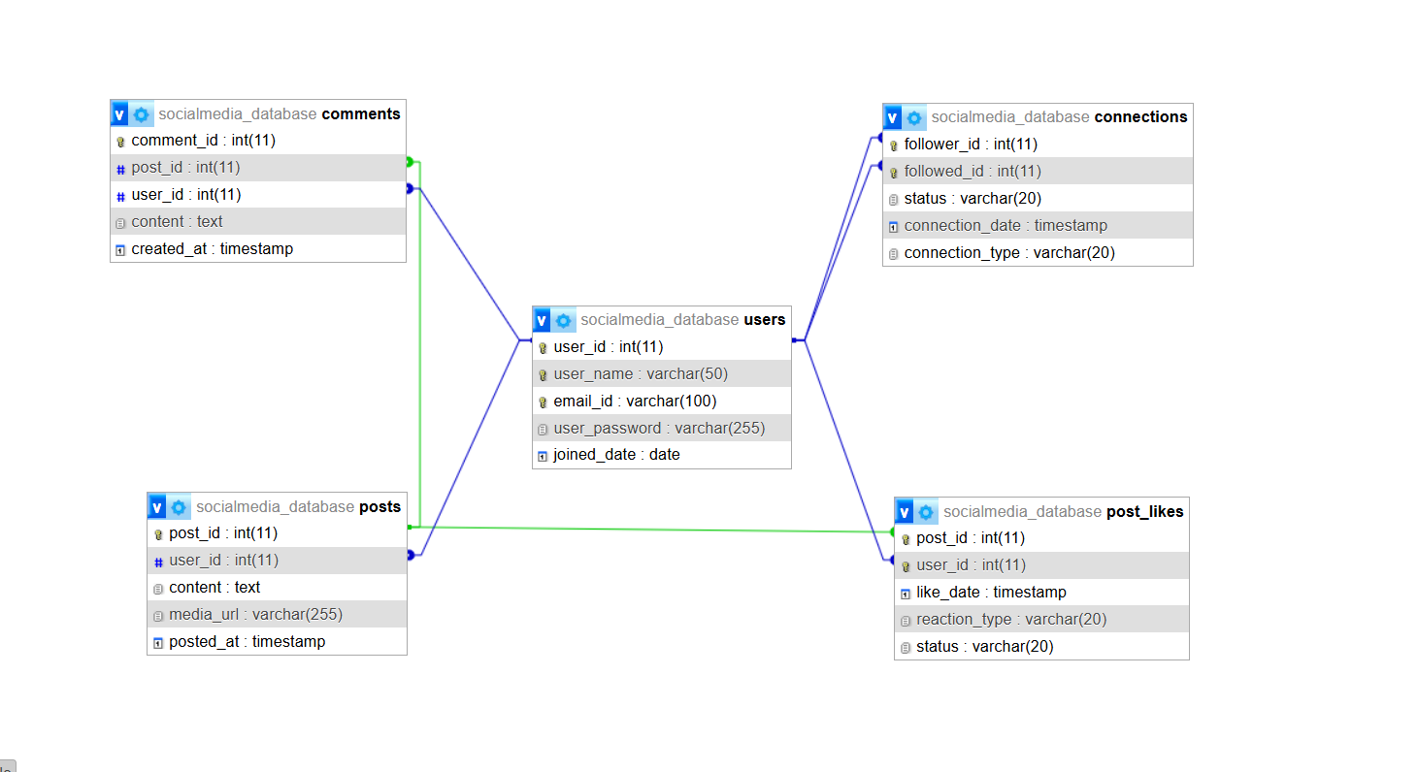
From the above ER diagram, the Users table is very important in the database. This table has all the information of each and every user, details of user like User_ID, the username of the users which they chose and their email address, their password and the date the user joined the platform, Each and every user has a unique User ID, which makes them easy to find them in the system.
The second table: Posts table which stores the content shared by users. It might be any post(media). Every post a user makes is linked to their User ID, which means a user can make various posts but each of them belongs to only one user.
The Comments table stores the data of comments made on each post of a user, every post is linked to a user,by their user ID. So a user can make posts, and each post is made by one user.The comment table has all the comments that other people make on a users posts. This table has all the comments data that people make on a users posts.
The Post_Likes table keeps the record of the reactions given by users to each post. It stores details such as the reaction type, its active status and when the reaction was given. This table shows the users engagement with post.
The Connections table manages relationships between users. It manages information about followers, friends, and connection status(follow request accepted / pending). And from this table, users can connect and interact with other users on social media platforms.
All these tables were created using SQL with primary keys and foreign keys to maintain relationships between each table. Constraints like ‘unique’ and ‘not null’ were used to make sure that data is accurate and prevent any unnecessary duplicate records.
After creating the tables, the sample data is inserted into each one to see if the database is working properly. The connections between the users, comments, likes and connections all worked well, which means the database was set up properly and can perform the tasks needed for a social media platform.

Results
After creating the database for social media and inserting the sample data into each table based on the type of data, different SQL queries were executed to check whether the system was working as expected. And the results showed that all the data was stored properly and the relationships between the tables were working properly.
Multiple queries were used to check the database. ‘Select’ query helped to show records from each table, while the ‘Like’ operator was used to search for specific usernames and posts. ‘Order by’ query was used to sort data in both ascending and descending order, making it easier to organize and view information.
To analyze the data, aggregate functions like ‘count’ and ‘group by’ were used. These queries helped summarize information, such as the number of reactions given to each post and the total number of posts each user created through the data from different tables.
Various join operations were also used to check the relationships between tables. ‘Inner join’ query was used to show the related information from multiple tables, like user details along with their posts. ‘Left join’ and ‘right join’ queries were used to get records even when no matching data was available in one of the tables, confirming that the relationships were correctly established.
Overall, the database worked as expected and successfully supported the main features of a social media platform. The test results showed that users, posts, comments, likes and connections were all linked correctly which meant that data could be stored, managed and retrieved efficiently. The social media database system was a success because it could store and manage data, for media platforms and this was the main goal of the project. The database was able to handle users, posts, comments, likes and connections which're all important parts of a social media platform.

Challenges and Solutions
There was a problem while creating the database. It was because of using the wrong spelling of auto_increament. The correct keyword is AUTO_INCREMENT. Which was corrected later when creating the tables.
Another issue was related to foreign key values. Since Posts, Comments, Likes, and Connections are all connected to users. The parent table values must exist before inserting child table records. This was solved by inserting records in the correct order: Users first, then Posts, then Comments, then Post_Likes, and Connections.
Other problems such as information being the same in unique columns (like user_name and email_id) could also cause errors. This was handled by using different usernames and email IDs for each user.
Conclusion and Future Work
The Social Media Database Management System successfully created and manages user profiles, posts, comments, post likes, and user connections on social media platforms. This project demonstrates the use of primary keys, foreign keys, composite keys, constraints, and different SQL queries.
The system does what project is supposed to do by doing all the functions to work properly by letting the users store the data and retrieve the data from the database when needed easily.
This can be made better in the future by adding other functionalities that users can do. The social media project can be made better by adding things that users can do. For example, the social media project can have messages function and also could add features like notifications and add features like hashtag for the posts while sharing them and also can have features like saved posts and privacy settings.

