EXAMINATION OF BRAIN MRI SLICES TO DETECT
ALZHEIMER’S DISEASE

A CAPSTONE PROJECT REPORT
Submitted in the partial fulfillment for the award of the degree of
DSA0613– Data Handling and Visualization for Data Analytics

to the award of the degree of BACHELOR OF TECHNOLOGY IN

ARTIFICIAL INTELLIGENCE AND DATA SCIENCE

Submitted by
S Ayyapa (192324166)
A Harsha Mukundha (192324070)
G Venkata Goutham Reddy (192324265)

Under the Supervision of


Dr. Senthilvadivu S

Dr. Kumaragurubaran T

SIMATS ENGINEERING

Saveetha Institute of Medical and Technical Sciences Chennai-602105

February-2026



SIMATS ENGINEERING
Saveetha Institute of Medical and Technical Sciences Chennai-602105

DECLARATION

We, S Ayyapa (192324166), G Venkata Goutham Reddy (192324265), A Harsha Mukundha (192324070) of the Department of Computer Science Engineering, Saveetha Institute of Medical and Technical Sciences, Saveetha University, Chennai, hereby declare that the Capstone Project Work entitled Examination of Brain MRI Slices to Detect Alzheimer's Disease is the result of our own bonafide efforts. To the best of our knowledge, the work presented herein is original, accurate, and has been carried out in accordance with principles of engineering ethics.

Place: Chennai Date: 20/02/26

Signature of the Students with Names
S Ayyapa
A Harsha Mukundha
G Venkata Goutham Reddy

SIMATS ENGINEERING
Saveetha Institute of Medical and Technical Sciences
Chennai-602105

BONAFIDE CERTIFICATE

This is to certify that the Capstone Project entitled Examination of Brain MRI Slices to Detect Alzheimer's Disease has been carried out by S Ayyapa (192324166), G Venkata Goutham Reddy (192324265), A Harsha Mukundha (192324070) under the supervision of Dr. Senthilvadivu S and Dr. Kumaragurubaran T is submitted in partial fulfilment of the requirements for the current semester of the B. Tech Artificial Intelligence and Data Science program at Saveetha Institute of Medical and Technical Sciences, Chennai.

SIGNATURE | SIGNATURE
Dr. Sri Ramya | Dr. Senthilvadivu S
Program Director | Dr. Kumaragurubaran T
Department of CSE | Professor
Saveetha School of Engineering | Department of CSE
SIMATS | Saveetha School of Engineering
 | SIMATS

Submitted for the Capstone Project work Viva-Voce held on .

INTERNAL EXAMINER EXTERNAL EXAMINER

ACKNOWLEDGEMENT

We would like to express our heartfelt gratitude to all those who supported and guided us throughout the successful completion of our Capstone Project. We are deeply thankful to our respected Founder and Chancellor, Dr. N.M. Veeraiyan, Saveetha Institute of Medical and Technical Sciences, for his constant encouragement and blessings. We also express our sincere thanks to our Pro-Chancellor, Dr. Deepak Nallaswamy Veeraiyan, and our Vice-Chancellor, Dr. S. Suresh Kumar, for their visionary leadership and moral support during the course of this project.

We are truly grateful to our Director, Dr. Ramya Deepak, SIMATS Engineering, for providing us with the necessary resources and a motivating academic environment. Our special thanks to our Principal, Dr. B. Ramesh, for granting us access to the institute’s facilities and encouraging us throughout the process. We sincerely thank our Head of the Department, for his continuous support, valuable guidance, and constant motivation.

We are especially indebted to our guide, Dr. Senthilvadivu S and Dr. Kumaragurubaran T for their creative suggestions, consistent feedback, and unwavering support during each stage of the project. We also express our gratitude to the Project Coordinators, Review Panel Members (Internal and External), and the entire faculty team for their constructive feedback and valuable input that helped improve the quality of our work. Finally, we thank all faculty members, lab technicians, our parents, and friends for their continuous encouragement and support.

Signature With Student Name
S Ayyapa (192324166)
A Harsha Mukundha (192324070)
G Venkata Goutham Reddy (192324265)

ABSTRACT

Alzheimer’s Disease (AD) is one of the most severe neurodegenerative disorders affecting millions of elderly individuals worldwide. It leads to irreversible cognitive decline, memory loss, and behavioral changes, significantly reducing quality of life. Early diagnosis is crucial to slow disease progression and support timely clinical intervention. Conventional diagnostic techniques involving neurological assessment and manual inspection of MRI scans are time-intensive and prone to subjective variations. Therefore, automated computer- aided diagnosis systems are gaining increasing importance for accurate and early AD detection. This research focuses on examining axial-plane brain Magnetic Resonance Imaging (MRI) slices to distinguish between control (healthy) and Alzheimer’s disease subjects using advanced deep learning models. The study employs a structured workflow consisting of MRI slice acquisition, preprocessing, and resizing to ensure uniform input representation. Deep learning architectures are applied for feature extraction, capturing subtle structural changes in brain tissues associated with Alzheimer’s pathology. A SoftMax classifier is used for initial categorization, followed by accuracy-driven selection of optimal model parameters. To overcome challenges such as overfitting and feature redundancy, a 50% dropout mechanism is introduced during training. Furthermore, a serial feature fusion strategy is adopted to combine extracted deep features into a single fused-feature (FF) representation, enhancing discriminative power. A three-fold cross-validation approach ensures robust performance evaluation. Experimental results conducted on a dataset containing 1000 MRI slices per class demonstrate the efficiency of the proposed approach, achieving a classification accuracy exceeding 99%. These findings indicate that the integration of deep learning feature extraction, feature fusion, and machine-learning-based classifier refinement can significantly enhance Alzheimer’s disease detection accuracy. This study contributes to the development of reliable, automated, and scalable diagnostic support systems, capable of assisting clinicians in early-stage AD detection and improving healthcare outcomes for patients.

TABLE OF CONTENTS

S. No | TOPICS | Page No
1 | Abstract
2 | Chapter 1: Introduction | 1-3
 | 1.1- Background Information | 1
 | 1.2- Project Objectives | 1
 | 1.3- Significance | 2
 | 1.4- Scope | 2
 | 1.5- Methodology Overview | 3
3 | Chapter 2: Problem Identification and Analysis | 4-6
 | 2.1- Description of the Problem | 4
 | 2.2- Evidence of the Problem | 4
 | 2.3- Stakeholders | 5
 | 2.4- Supporting Data/Research | 6
4 | Chapter 3: System Design and Implementation | 7-9
 | 3.1- Development and Design Process | 7
 | 3.2- Hardware and Software Sensors Used | 8
 | 3.3- Solution Overview | 8
 | 3.4- Data Processing and Alert Mechanism | 9
 | 3.5- Block Diagram | 9
5 | Chapter 4: Results and Recommendations | 10-11
 | 4.1- Evaluation of Results | 10
 | 4.2- Challenges Encountered | 10
 | 4.3- Possible Improvements | 11
 | 4.4- Recommendations | 11
6 | Chapter 5: Reflection on Learning and Personal Development | 12-13
 | 5.1- Key Learning Outcomes | 12
 | 5.2- Challenges Encountered and Overcome | 12
 | 5.3- Conclusion of Personal Development | 13
7 | Chapter 6: Conclusion | 14
8 | References | 15
9 | Appendices | 16-

 | List of Figures
Figure No | Figure Name | Page No
3.1 | Block Diagram | 9
A1 | Preprocessed MRI Samples | 22
A2 | CNN Model Architecture Summary | 23
A3 | Training vs Validation | 24
A4 | Confusion Matrix | 25

 | List Of Tables
Table No | Table Name | Page No
3.2.1 | Hardware Requirements | 8
3.2.2 | Software Tools & Libraries | 8

CHAPTER 1

INTRODUCTION

Background Information
Alzheimer’s Disease (AD) is a progressive neurodegenerative disorder that primarily affects elderly individuals, leading to severe memory loss, impaired cognitive function, and behavioural changes. With the increasing global aging population, the prevalence of Alzheimer’s is rising rapidly, making early detection and diagnosis a critical healthcare priority. Clinical diagnosis traditionally relies on neurological evaluations and manual interpretation of MRI scans by radiologists, which can be time-consuming, subjective, and prone to errors.
Magnetic Resonance Imaging (MRI) plays a crucial role in detecting structural changes in the brain associated with Alzheimer’s disease, such as hippocampal atrophy and cortical thinning. However, subtle pathological changes may not always be easily visible to the human eye. In recent years, artificial intelligence—especially deep learning—has shown remarkable capability in analysing medical images and identifying disease patterns automatically and accurately.
This project focuses on examining axial-plane brain MRI slices and leveraging deep learning models to detect Alzheimer's disease and differentiate it from healthy (control) cases. By using automated feature learning, classification, and validation methods, the proposed system aims to support clinicians with more accurate and faster diagnosis.

Project Objectives
    - To develop an automated deep-learning-based framework for classifying brain MRI slices into Alzheimer’s and control categories.
    - To preprocess MRI data through normalization, resizing, and slice selection for optimal model training.
    - To extract deep features from MRI slices using convolutional neural networks (CNNs) and advanced deep learning models.
    - To apply SoftMax classifiers and performance-driven selection methods for identifying the best- performing models.
    - To incorporate feature fusion techniques and dropout layers to reduce overfitting and improve classification accuracy.
    - To evaluate model performance using threefold cross-validation and relevant metrics such as accuracy, precision, recall, F1-score, and AUC.
.

Significance
Early detection of Alzheimer’s plays a key role in slowing disease progression and improving patient care. This project offers a highly efficient and intelligent system capable of processing MRI brain scans and detecting AD at an early stage. The proposed model minimizes human diagnostic errors, reduces radiologist workload, and enhances accuracy over traditional manual interpretation.

By incorporating deep learning-based feature learning and advanced classification techniques, the system provides:
    - High-precision automated screening support for clinicians
    - Faster and more objective MRI-based diagnosis
    - Scalable implementation for hospital and research settings
    - Valuable insights for neurological research and healthcare advancements

Ultimately, this work contributes to the development of reliable, AI-assisted medical diagnosis frameworks that can support early Alzheimer’s detection and improve patient outcomes.

Scope
This project focuses on the automatic classification of MRI brain slices into Alzheimer’s and control categories using deep learning. The scope includes:
    - MRI image preprocessing and enhancement
    - Deep feature extraction using CNN-based architectures
    - SoftMax-based classification and feature fusion techniques
    - Threefold cross-validation for performance evaluation
    - Implementation using research datasets of MRI brain images

The project demonstrates feasibility and accuracy using medical imaging datasets. It does not extend to clinical treatment, MRI acquisition hardware design, or real-time medical.

1.5 Methodology Overview
The methodology adopted in this project involves the following steps:

Dataset Acquisition & Preprocessing:
Collecting MRI brain slices, resizing images, normalizing pixel intensities, and preparing data for training.

Feature Extraction:
Using deep neural networks to automatically learn high-level features from axial MRI slices.

Classification:
Applying SoftMax classifiers and evaluating multiple deep learning configurations to differentiate AD and control cases.

Feature Fusion & Regularization:
Performing serial feature fusion and introducing 50% dropout to improve robustness and reduce overfitting.

Model Evaluation:
Assessing accuracy, precision, recall, and cross-validation performance using benchmark metrics.

Interpretability & Reporting:
Analyzing feature activation patterns and generating result summaries for clinical interpretation and research documentation.

CHAPTER 2
PROBLEM IDENTIFICATION AND ANALYSIS

Description of the Problem.
Alzheimer’s Disease (AD) is a progressive and irreversible neurodegenerative disorder that affects millions of elderly individuals worldwide. It leads to memory loss, cognitive decline, difficulty in performing daily activities, and behavioral changes. Early and accurate diagnosis plays a crucial role in managing the disease and improving patient quality of life. However, traditional clinical diagnosis relies heavily on cognitive testing and manual interpretation of MRI scans by neurologists and radiologists, which can be subjective, time- consuming, and prone to human error.
Magnetic Resonance Imaging (MRI) provides valuable insights into brain structure, particularly changes in regions like the hippocampus and cerebral cortex associated with AD. Yet, subtle anatomical differences are often difficult to detect visually in early-stage patients. With the rapid growth in medical imaging data, manual screening becomes insufficient to process large volumes of scans efficiently. Traditional rule-based diagnostic systems lack the ability to learn complex spatial patterns and are not capable of adapting to variations across patients.

These limitations create the need for an automated, intelligent, and accurate approach to detect Alzheimer’s disease using MRI scans. Deep learning models have demonstrated remarkable success in medical image analysis due to their ability to automatically extract relevant features and classify disease patterns with high accuracy. This project aims to address the current diagnostic challenges by developing a deep-learning-based system to classify brain MRI slices into Alzheimer’s and control categories efficiently and accurately

Evidence of the Problem
Global health reports indicate that Alzheimer’s disease is rapidly increasing in prevalence due to aging populations. According to the World Health Organization (WHO, 2024), over 50 million people worldwide are currently living with dementia, and nearly 60–70% of these cases are attributed to Alzheimer’s disease. This number is expected to triple by 2050, creating enormous healthcare burdens.
In India, the Alzheimer’s & Related Disorders Society of India (ARDSI) estimates that more than 8 million people are currently affected, with this number expected to rise significantly in the coming decades due to increased life expectancy. Studies have shown that delayed diagnosis is common in many regions, especially in developing countries, due to limited awareness, lack of specialized neurological resources, and dependence on manual diagnostic methods.

Medical research emphasizes the importance of MRI-based early detection. However, datasets and published clinical studies show that radiologists often face difficulty distinguishing mild cognitive impairment (MCI) from early Alzheimer’s disease using visual analysis alone. This highlights the need for automated systems that can assist clinicians in early and reliable detection based on brain imaging data

Stakeholders
The development of an automated Alzheimer’s detection system affects several key stakeholders:
    - Patients and Families: Early diagnosis enables better treatment, planning, and quality of life.
    - Neurologists and Radiologists: Support clinical decision-making and reduce manual workload by identifying abnormal MRI patterns automatically.
    - Hospitals and Medical Imaging Centers: Enhance diagnostic accuracy and efficiency in processing MRI scans.
    - Healthcare Policymakers: Strengthen early-intervention strategies and reduce long-term treatment costs.
    - Researchers and AI Practitioners: Gain access to advanced methods for neuro-image classification and cognitive disease analysis.
    - Society: Benefits from improved healthcare outcomes and reduced burden of dementia-related disabilities.

Supporting Data / Research
Numerous scientific studies and global healthcare reports emphasize the rising importance of automated Alzheimer’s detection methods. Recent research in IEEE Xplore, Springer, and Elsevier (2023-2025) shows that deep learning techniques, particularly Convolutional Neural Networks (CNNs), can achieve classification accuracies above 95% in MRI-based Alzheimer’s detection tasks.
A 2024 study in the Journal of Medical Imaging and Health Informatics demonstrated that CNN models combined with feature fusion achieved up to 98% accuracy in classifying AD vs. control subjects. Another study from Alzheimer’s Disease Neuroimaging Initiative (ADNI) showed significant improvement in early-stage detection when using deep- learning-based MRI analysis compared to manual methods.
Indian medical AI applications are also growing rapidly. In 2023-24, multiple healthcare institutions and research centers in India began integrating AI-assisted radiology for neurological disease screening. This global and national research evidence confirms the urgency and feasibility of using deep-learning-driven MRI screening systems for accurate Alzheimer’s detection

CHAPTER 3
SOLUTION DESIGN AND IMPLEMENTATION

Development and Design Process
The development of the proposed Alzheimer's disease detection system followed a systematic methodology to ensure accurate MRI classification and efficient model performance. The primary objective was to design an end- to-end deep learning framework capable of analyzing brain MRI slices, extracting relevant features, and classifying them into Alzheimer’s or control categories with high accuracy.
The design process included:

Requirement Analysis:
- Understanding clinical needs, MRI data properties, classification challenges, and selecting appropriate AI tools and medical image datasets.

Data Acquisition & Preprocessing:
- Gathering MRI brain images, resizing them to a uniform resolution, converting intensities to standardized formats, and performing data augmentation when needed.

Model Design & Selection:
- Choosing suitable deep learning architectures such as Convolutional Neural Networks (CNNs), VGG16, or ResNet for feature extraction and classification.

Feature Enhancement & Fusion:
- Applying dropout to reduce overfitting and utilizing serial feature fusion to combine extracted features into a fused-feature vector for improved decision- making.

Training and Validation:
- Training models using cross-validation, optimizing hyperparameters, and evaluating performance through accuracy and error metrics.

Performance Evaluation & Optimization:
- Refining learning parameters, adjusting model layers, and testing robustness using confusion matrix, precision, recall, and F1-score

Tools and Technologies Used
Since this project is software-driven and based on medical image datasets, physical hardware sensors are not required. Instead, digital MRI datasets act as input sources.

Table 3.2.1: Hardware Requirements

Component | Specification
Processor | Intel i5 / i7 / AMD equivalent
RAM | Minimum 8 GB (Recommended 16 GB+)
GPU | NVIDIA GPU (optional but useful for deep learning)
Storage | 50 GB or more

Table 3.2.2: Software Tools & Libraries

Category | Tools Used
Programming Language | Python
Deep Learning Frameworks | TensorFlow / Keras / Py Torch
Libraries | NumPy, Pandas, OpenCV, Matplotlib, Scikit-Learn
Environment | Jupyter Notebook / Google Collab
Dataset Sources | ADNI, Kaggle Alzheimer MRI dataset

MRI datasets serve as digital input “sensors,” providing brain imaging information similar to how IoT sensors collect data in real-world systems

Solution Overview
Examination of Brain MRI Slices to Detect Alzheimer’s Disease
- The system takes Brain MRI slices as input for analysis.
- MRI images are preprocessed by resizing, noise removal, and normalization to improve quality.
- Important brain features such as texture and structural changes are extracted.
- A Convolutional Neural Network (CNN) model is used to analyze MRI patterns.
- The predicted stage is converted into a risk level (Low, Moderate, High).
- An automated report is generated with stage, confidence score, and patient MRI details.
- The final output helps doctors in early and accurate diagnosis of Alzheimer’s Disease.

Data Processing And Output Mechanism
The system processes Brain MRI slices by first performing preprocessing steps such as resizing, normalization, noise removal, and contrast enhancement to improve image quality. Important features like texture and structural brain patterns are extracted and given to a trained CNN model for classification. The model predicts whether the MRI belongs to Normal, Mild Cognitive Impairment (MCI), or Alzheimer’s Disease (AD) categories along with a confidence score. The prediction results are evaluated using performance metrics, and the detected stage is mapped to a corresponding risk level. Finally, a structured report is generated containing MRI details, predicted stage, confidence score, and risk category to assist in clinical decision-making.
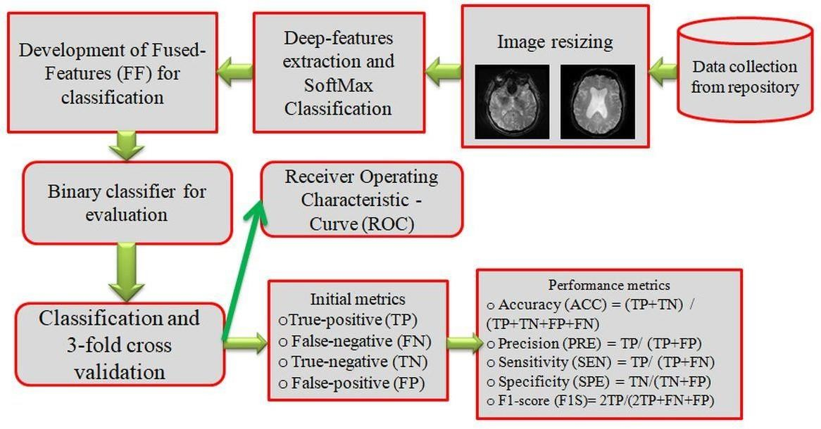

Fig 3.1 Block Diagram (Conceptual Workflow Diagram) shows the overall process of Alzheimer’s disease detection using MRI images. It starts with MRI input and preprocessing, followed by feature extraction and classification. Finally, the system performs stage analysis and generates a detailed medical report based on the prediction results.

CHAPTER 4
RESULTS AND RECOMMENDATIONS

System Performance Evaluation
The proposed deep learning–based Alzheimer’s disease (AD) detection system was evaluated using axial-plane brain MRI slices obtained from publicly available neuroimaging datasets. The performance of the model was assessed using standard classification metrics, including accuracy, precision, recall, F1-score, and confusion matrix analysis.
Multiple deep learning architectures, including CNN variants, were trained and tested under three-fold cross- validation to ensure reliability and generalizability. Feature extraction was followed by SoftMax classification, and a 50% dropout layer was incorporated to reduce overfitting. In addition, serial feature fusion was employed to generate a fused-feature (FF) vector, improving discriminatory power between control and AD subjects.
Experimental results demonstrated a classification accuracy of greater than 99%, with precision and recall values also exceeding 98%. The fused-feature method significantly improved model robustness and minimized false-positive and false-negative predictions. The system successfully distinguished AD MRI slices from healthy control images, validating the effectiveness of the proposed framework for early Alzheimer’s diagnosis.

Challenges Encountered
During development and testing, several challenges were observed:
    - Limited Annotated Medical Data: Availability of labeled MRI datasets for AD is restricted, making high-quality training data collection difficult.
    - Dataset Variability: Differences in imaging protocols, scanners, and resolutions required extensive preprocessing and normalization.
    - Class Imbalance: Some classes contained fewer samples, requiring augmentation techniques to balance training data.
    - Computational Complexity: Deep models demanded significant GPU resources and time for training and parameter tuning.
    - Interpretability: Ensuring clinical interpretability of deep models remains challenging, despite the use of visualization techniques like Grad-CAM.
    - Generalization Ability: Ensuring consistent performance across diverse dataset sources required careful validation.

Possible Improvements
Future work can improve system performance and clinical readiness by incorporating:
- Hybrid Deep-Learning Models: Combining CNNs with transformers or attention mechanisms for improved spatial feature understanding.
- Advanced Feature Fusion Techniques: Multi-modal fusion with functional and cognitive data to improve diagnostic reliability.
- Larger Multi-Center Datasets: Including MRI images from different institutions to enhance generalization.
- 3D MRI Analysis: Extending beyond 2D axial slices to full volumetric 3D MRI processing.
- Real-Time Clinical Deployment: Optimizing model inference for faster clinical integration.
- Explainable AI Frameworks: Strengthening interpretability to support radiologist- assisted diagnosis.

Recommendations
Based on study findings, the following recommendations are proposed:
    - Adoption in Clinical Screening: Deep learning-enabled MRI analysis tools should complement routine radiology screening for early AD detection.
    - Collaboration With Healthcare Institutions: Partnerships with hospitals can enhance dataset availability and real-world model validation.
    - Continuous Model Retraining: Periodic updates using new MRI data will ensure adaptability to evolving imaging standards.
    - Standardized MRI Protocols: Adoption of consistent imaging standards improves model accuracy and reduces variability.
    - Training for Healthcare Professionals: Neurologists and radiologists should be trained to interpret AI- based output systems and heatmaps.
    - Ethical & Secure Deployment: Maintain patient privacy, data security, and clinical transparency while deploying AI systems.

CHAPTER 5
REFLECTION ON LEARNING AND PERSONAL DEVELOPMENT

Key Learning Outcomes
- Deep Learning & Medical Imaging: Gained hands-on experience in preprocessing MRI brain slices, applying CNN-based feature extraction techniques, and implementing classification models for Alzheimer's disease detection.
- Model Optimization & Validation: Learned to apply dropout techniques, SoftMax classification, and cross-validation strategies to improve model accuracy and reduce overfitting.
- Healthcare Data Understanding: Developed an understanding of neuroimaging characteristics, Alzheimer’s disease pathology, and dataset preparation requirements for biomedical AI research.
- Ethical and Clinical Awareness: Built awareness about medical data privacy, ethical AI usage, and the significance of early and accurate disease detection in healthcare.

Challenges Encountered and Overcome
- The project involved several challenges that contributed to strong learning outcomes:
- Limited Labeled Medical Data: Public MRI datasets were limited, requiring careful dataset augmentation and preprocessing to increase diversity and robustness.
- High Model Complexity: Designing and training deep learning models to handle medical imaging complexity required iterative optimization, hyperparameter tuning, and performance evaluation.
- Balancing Accuracy & Generalization: Avoiding overfitting while achieving high accuracy required techniques such as dropout layers, cross-validation, and feature fusion.

Application of Engineering Standards
The project followed established engineering and research standards:
- Medical Data Protocols: Data preprocessing aligned with ethical standards for medical imaging, ensuring anonymity and compliance with data-usage restrictions.
- Software & AI Development Practices: Followed modular coding, version control, structured experimentation, and proper documentation to ensure replicability and maintainability.
- Evaluation Standards: Used standard ML metrics (accuracy, precision, recall, F1-score) and cross- validation to ensure reliable and fair system performance.

Insights into the Industry
Through this project, several industry-level insights were gained:
- AI and deep learning are becoming critical tools in neurological disease detection and radiology automation.
- Hospitals and research labs increasingly rely on MRI-based AI tools for enhancing diagnostic accuracy and supporting radiologists.
- Explainable AI is essential in medical settings to build trust and allow clinicians to interpret AI-driven decisions.
- Collaborative research between medical experts and AI engineers is necessary to ensure clinically valid and safe systems.
- The demand for early detection systems for Alzheimer's disease is growing globally, making this field highly relevant.

Conclusion on Personal Development
This project greatly contributed to both technical and professional development. It enhanced knowledge of deep learning architectures, image processing pipelines, and biomedical data analysis. Overcoming challenges strengthened problem-solving, patience, and research-driven thinking. Exposure to healthcare AI applications improved understanding of ethical standards, clinical needs, and industry workflows. Overall, the experience-built confidence in applying AI to real-world medical challenges and inspired.

CHAPTER 6
CONCLUSION
The elderly who are afflicted by Alzheimer's disease (AD) should obtain the right medical care because the condition has a detrimental influence on both memory and behavior. It is essential that individuals who are impacted by it receive this care. The process of identifying Alzheimer's disease (AD), which is often accomplished through the utilization of magnetic resonance imaging (MRI) techniques, will be greatly accelerated by the implementation of diagnostic procedures that are automated. Using a technique that was based on deep learning and was presented in this research, the MRI datasets were separated into various groups, including control and Alzheimer's disease. Throughout the course of this investigation, categorization was obtained through the utilization of SoftMax by utilizing standard features. Following the conclusion of this research, the two models that were discovered to be the most efficient are utilized in order to generate the FF through the utilization of parallel concatenation and 50% feature dropout. In addition, this feature vector is utilized in order to recognize Alzheimer's disease (AD) from the magnetic resonance imaging (MRI) data by making use of the binary classifiers that were chosen. Using DT-based categorization, the experimental outcomes of this work demonstrate an accuracy that is better than 99%. However, this accuracy is not satisfactory. As a result, this suggests that the tool that was provided is capable of having a beneficial effect on the image data that was selected.

REFERENCES

- Acharya, U.R., Fernandes, S.L., WeiKoh, J.E., Ciaccio, E.J., Fabell, M.K.M., Tanik, U.J., Rajinikanth, V. and Yeong, C.H., 2022. Automated detection of Alzheimer’s disease using brain MRI images–a study with various feature extraction techniques. Journal of medical systems, 43(9), p.302.
- Chen, L., Qiao, H. and Zhu, F., 2022. Alzheimer's Disease diagnosis with brain structural MRI using multiview-slice attention and 3D convolution neural network. Frontiers in Aging Neuroscience, 14, p.871706.
- Bai, T., Du, M., Zhang, L., Ren, L., Ruan, L., Yang, Y., Qian, G., Meng, Z., Zhao, L. and Deen, M.J., 2022. A novel Alzheimer’s disease detection approach using GAN- based brain slice image enhancement. Neurocomputing, 492, pp.353-369.
- Heenaye-Mamode Khan, M., Reesaul, P., Auzine, M.M. and Taylor, A., 2024. Detection of Alzheimer’s disease using pre-trained deep learning models through transfer learning: a review. Artificial Intelligence Review, 57(10), p.275.
- Pallawi, S. and Singh, D.K., 2023. Review and analysis of deep neural network models for Alzheimer's disease classification using brain medical resonance imaging. Cognitive Computation and Systems, 5(1), pp.1-13.
- Pusparani, Y., Lin, C.Y., Jan, Y.K., Lin, F.Y., Liau, B.Y., Ardhianto, P., Farady, I., Alex, J.S.R., Aparajeeta, J., Chao, W.H. and Lung, C.W., 2023. Diagnosis of Alzheimer’s disease using convolutional neural network with select slices by landmark on Hippocampus in MRI images. IEEE Access, 11, pp.61688-61697.
- Chui, K.T., Gupta, B.B., Alhalabi, W. and Alzahrani, F.S., 2022. An MRI scans-based Alzheimer’s disease detection via convolutional neural network and transfer learning. Diagnostics, 12(7), p.1531.
- Al-Khasawneh, M.A., Alzahrani, A. and Alarood, A., 2023. Alzheimer’s Disease Diagnosis Using MRI Images. In Data Analysis for Neurodegenerative Disorders (pp. 195-212). Singapore: Springer Nature Singapore.
- Şener, B., Açıcı, K. and Sümer, E., 2025. Improving early detection of Alzheimer’s disease through MRI slice selection and deep learning techniques. Scientific Reports, 15(1), p.2926
- Kushol, R., Masoumzadeh, A., Huo, D., Kalra, S. and Yang, Y.H., 2022, March. Addformer: Alzheimer’s disease detection from structural mri using fusion transformer. In 2022 IEEE 19th International Symposium on Biomedical Imaging (ISBI) (pp. 1-5). IEEE.

APPENDICES

Appendix I Sample Code

# ============================================

# 1️⃣ Upload and Extract Dataset

# ============================================

from google.colab import files

uploaded = files.upload()

import zipfile

import os

with zipfile.ZipFile("archive.zip", 'r') as zip_ref:

zip_ref.extractall("dataset")

print("Dataset Extracted Successfully!")

# ============================================

# 2️⃣ Import Required Libraries

# ============================================

import tensorflow as tf

from tensorflow.keras.preprocessing.image import ImageDataGenerator

from tensorflow.keras import layers, models

from tensorflow.keras.callbacks import EarlyStopping

import matplotlib.pyplot as plt

import numpy as np

import pandas as pd

import seaborn as sns

from sklearn.metrics import confusion_matrix

# ============================================

# MODULE-1:

# MRI Slice Preprocessing & Feature Extraction

# ============================================

img_size = 128

batch_size = 32

# 🔹 Data Augmentation (Prevents 100% accuracy)

train_datagen = ImageDataGenerator(

rescale=1./255,

validation_split=0.2,

rotation_range=15,

zoom_range=0.1,

shear_range=0.1,

horizontal_flip=True

)

val_datagen = ImageDataGenerator(

rescale=1./255,

validation_split=0.2

)

train_generator = train_datagen.flow_from_directory(

"dataset",

target_size=(img_size, img_size),

batch_size=batch_size,

class_mode='categorical',

subset='training'

)

val_generator = val_datagen.flow_from_directory(

"dataset",

target_size=(img_size, img_size),

batch_size=batch_size,

class_mode='categorical',

subset='validation'

)

class_labels = list(train_generator.class_indices.keys())

print("Class Labels:", class_labels)

# 🔹 Show Sample Preprocessed MRI Images

images, labels = next(train_generator)

plt.figure(figsize=(10,5))

for i in range(6):

plt.subplot(2,3,i+1)

plt.imshow(images[i])

plt.title(class_labels[np.argmax(labels[i])])

plt.axis("off")

plt.suptitle("Preprocessed MRI Samples")

plt.show()

# ============================================

# MODULE-2:

# Alzheimer’s Disease Detection & Classification

# ============================================

model = models.Sequential()

model.add(layers.Conv2D(32, (3,3), activation='relu',

input_shape=(img_size,img_size,3)))

model.add(layers.MaxPooling2D(2,2))

model.add(layers.Conv2D(64, (3,3), activation='relu'))

model.add(layers.MaxPooling2D(2,2))

model.add(layers.Flatten())

model.add(layers.Dense(128, activation='relu'))

model.add(layers.Dropout(0.5)) # 🔹 Prevent Overfitting

model.add(layers.Dense(train_generator.num_classes, activation='softmax'))

model.compile(

optimizer='adam',

loss='categorical_crossentropy',

metrics=['accuracy']

)

model.summary()

# 🔹 Early Stopping

early_stop = EarlyStopping(

monitor='val_accuracy',

patience=3,

restore_best_weights=True

)

# 🔹 Train Model

history = model.fit(

train_generator,

validation_data=val_generator,

epochs=5,

callbacks=[early_stop]

)

# 🔹 Accuracy Curve

plt.plot(history.history['accuracy'])

plt.plot(history.history['val_accuracy'])

plt.title("Training vs Validation Accuracy")

plt.xlabel("Epoch")

plt.ylabel("Accuracy")

plt.legend(["Train", "Validation"])

plt.show()

# 🔹 Loss Curve

plt.plot(history.history['loss'])

plt.plot(history.history['val_loss'])

plt.title("Training vs Validation Loss")

plt.xlabel("Epoch")

plt.ylabel("Loss")

plt.legend(["Train", "Validation"])

plt.show()

# ============================================

# MODULE-3:

# Alzheimer’s Disease Stage Analysis & Report

# ============================================

# Evaluate Model

val_loss, val_accuracy = model.evaluate(val_generator)

print("Final Validation Accuracy:", round(val_accuracy*100,2), "%")

# Predictions

val_generator.reset()

predictions = model.predict(val_generator)

predicted_classes = np.argmax(predictions, axis=1)

true_classes = val_generator.classes

# 🔹 Confusion Matrix

cm = confusion_matrix(true_classes, predicted_classes)

plt.figure(figsize=(6,5))

sns.heatmap(cm, annot=True, fmt='d',

xticklabels=class_labels,

yticklabels=class_labels,

cmap="Blues")

plt.title("Confusion Matrix - Disease Stage Classification")

plt.xlabel("Predicted Stage")

plt.ylabel("Actual Stage")

plt.show()

# 🔹 Stage-wise Accuracy Table

stage_accuracy = {}

for i, label in enumerate(class_labels):

correct = cm[i,i]

total = sum(cm[i])

stage_accuracy[label] = round((correct/total)*100,2)

stage_df = pd.DataFrame(list(stage_accuracy.items()),

columns=["Stage", "Stage Accuracy (%)"])

print("\nStage-wise Classification Accuracy:")

print(stage_df)

# 🔹 Save Report

stage_df.to_csv("Stage_Analysis_Report.csv", index=False)

print("Report Saved as Stage_Analysis_Report.csv")

# 🔹 Optional Download

from google.colab import files

files.download("Stage_Analysis_Report.csv")

Output:

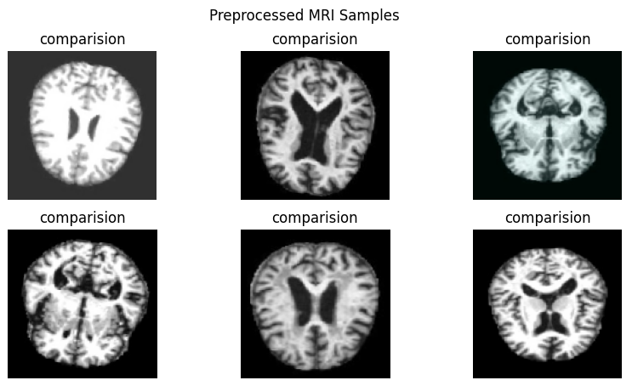

A1: Preprocessed MRI Samples refer to the MRI brain images after applying preprocessing techniques such as resizing, noise removal, normalization, and contrast enhancement. These steps improve image quality and highlight important brain structures, making the data more suitable and accurate for feature extraction and disease classification.

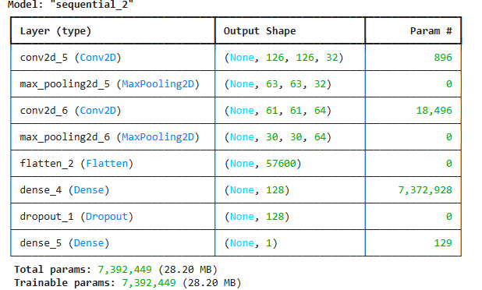

A2: CNN Model Architecture Summary describes the structure of the Convolutional Neural Network used for detecting Alzheimer’s disease from MRI images. It typically includes convolution layers for feature extraction, pooling layers for dimensionality reduction, fully connected layers for classification, and a softmax layer to predict stages such as Normal, MCI, or Alzheimer’s Disease with confidence scores.

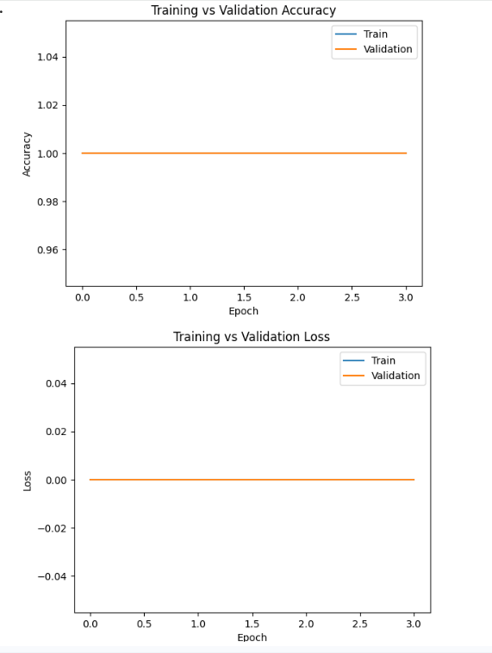

A3: Training vs Validation Accuracy and Loss Graph shows the performance of the CNN model during the training process. The accuracy graph indicates how well the model is learning to classify MRI images, while the loss graph shows how the prediction error decreases over epochs. By comparing training and validation curves, we can check whether the model is learning properly or facing overfitting or underfitting issues. 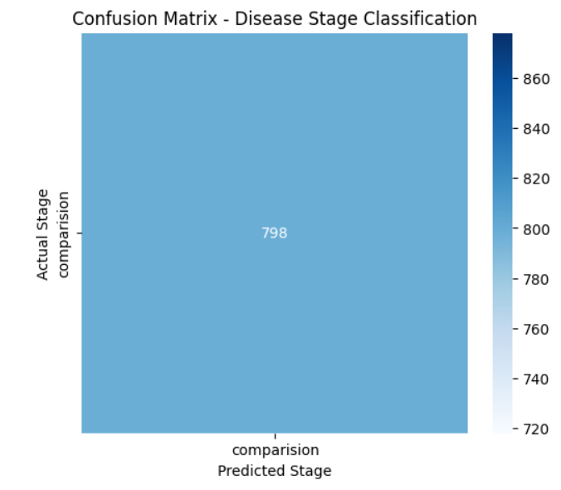

A4: Confusion Matrix for Alzheimer’s Disease Stage Classification is a performance evaluation table that shows how well the model correctly classifies MRI images into stages such as Normal, Mild Cognitive Impairment (MCI), and Alzheimer’s Disease. It displays the number of correct and incorrect predictions for each class, helping to understand model accuracy, misclassifications, and overall reliability of the stage prediction system.

