**NAME: G VENKATA NAGA PHANEENDRA**

**BATCH NO: 126**

**MOBILE NO: 9346835344**

ASSIGNMENT

1. Create three instances.

**EC2 Instance:** These are just the virtual machines in the cloud on which you have the OS level control. You can run whatever you want in them.

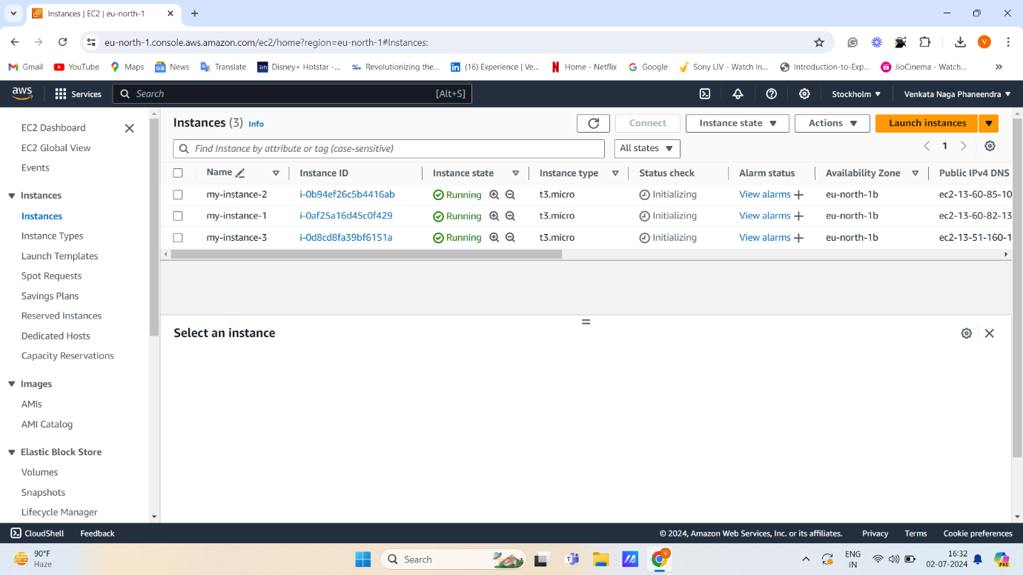

* 1. Attach one EFS(Elastic File Share) to two instance

**EFS:** Amazon EFS is a fully managed, scalable file storage service designed to provide shared access to files across multiple Amazon EC2 instances.

**Step 1:** Create a Security Group.

**Step 2:** Create an EFS file system.

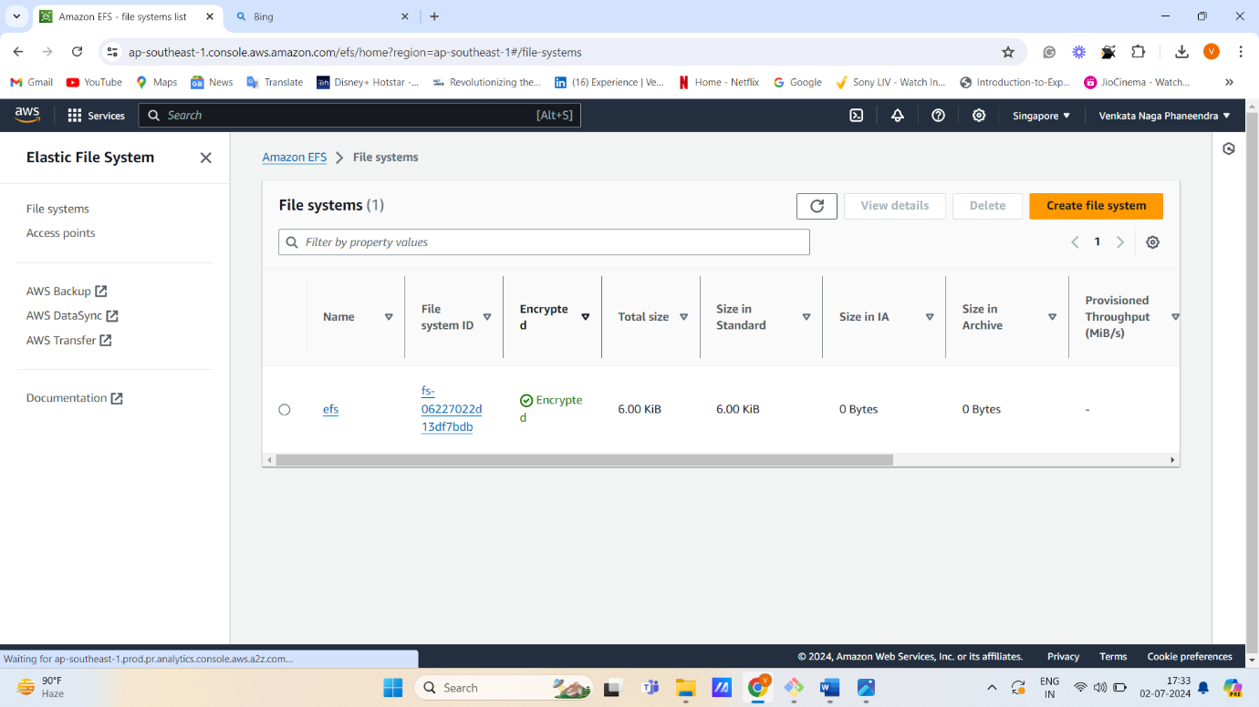

**Step 3:** Launch two instances with customizing parts like

1. Selecting existing security group
2. Taking only Amazon Linux because it works only on Amazon Linux
3. Editing networking sections like vpc, subnets-region
4. Attaching the EFS file system to the EC2 Instance.

**Step 4:** Connect to the server through git bash, putty, mobaxterm

1. Go through the mount points
2. Create a file in that directory.

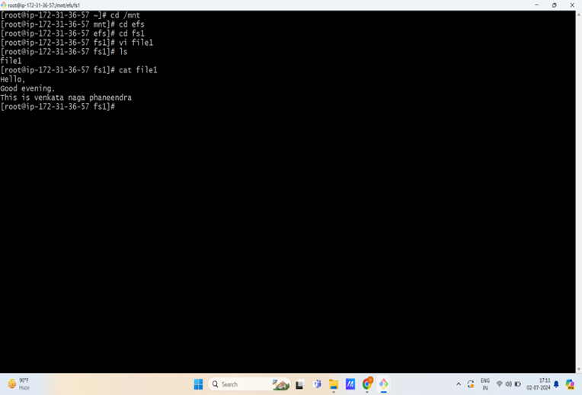

**Step 4:** Now, connect with another server through the same devices mentioned above.

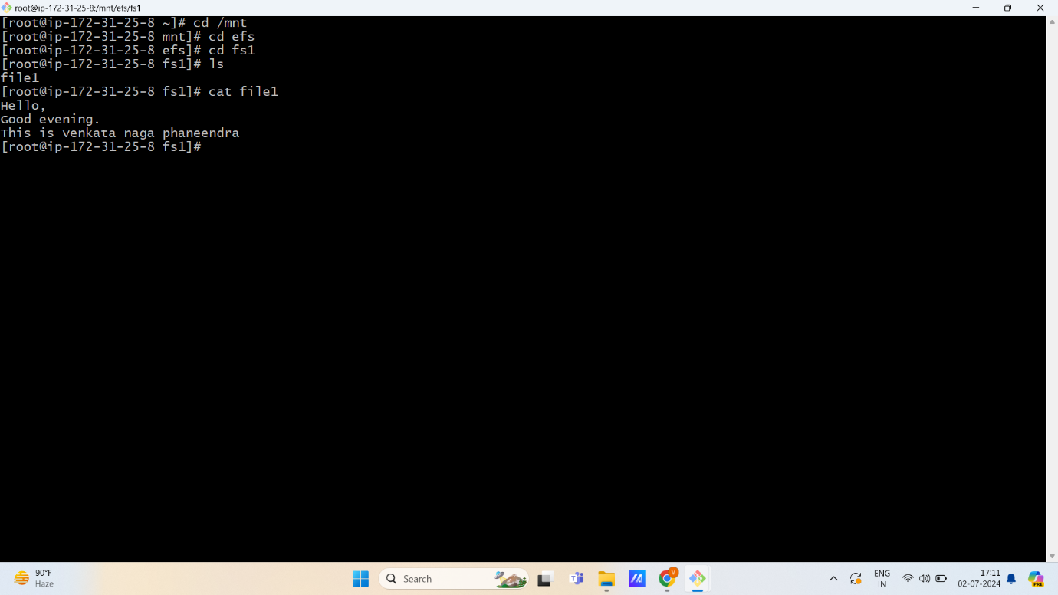

Now we can see, on the second server, the file is shared.

So, we conclude that EFS means, to share a file over any availability zone through single availability zone.

* 1. Attach an EC2 instance with multiple EBS(Elastic Block Store) volumes.

**EBS:** Elastic Block Store (Amazon EBS) is a scalable, high-performance block-storage service designed for Amazon EC2.

**NOTE:** Cross Availability Zone-based attachment is not supported.

**Step 1:** Launch an EC2 Instance with default volume.

**Step 2:** Connect this server using Git bash, putty, mobaxterm.

**df -h:** To see disk-free space in a human-readable format.

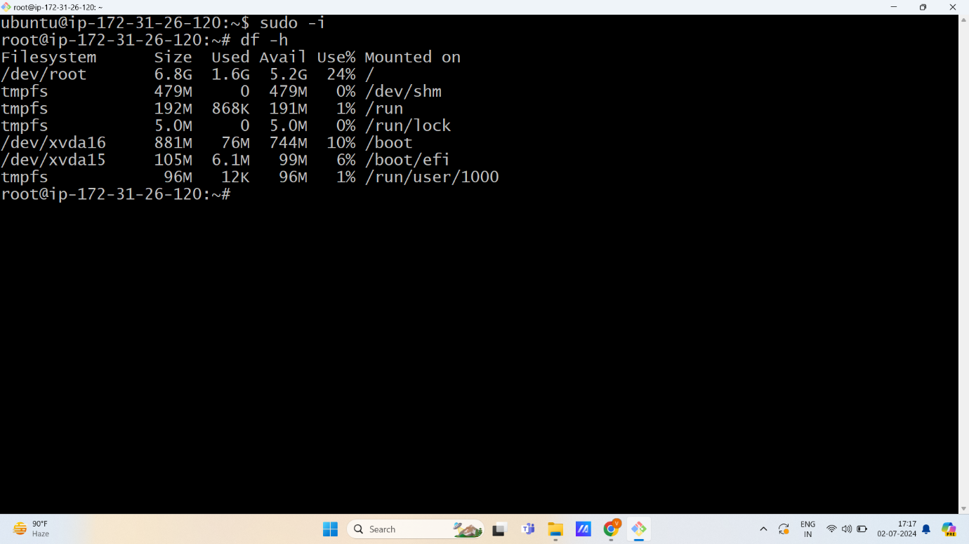

**Step 3:** Create two more different volumes and attach them to an EC2 instance.

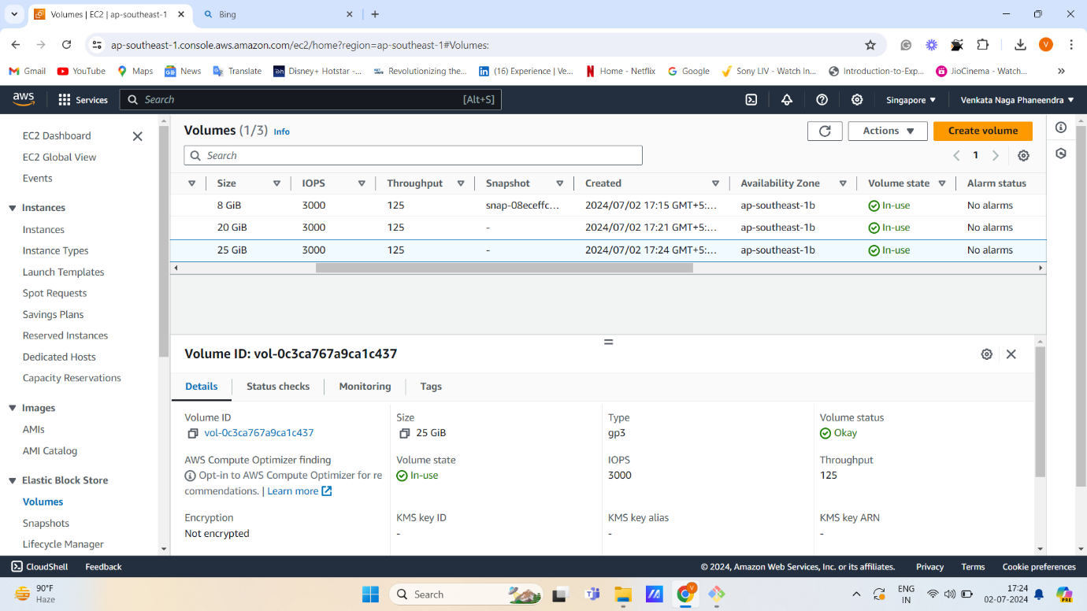

**Step 4:** If we see in the server after attaching volumes, we will see the same default volume. So, Reboot the EC2 instance and run command below:

**lsblk:** To see the block storage of externally added volumes.

