**CROSS-REGION REPLICATION**

STEP – 1: Create two s3 buckets in a different region

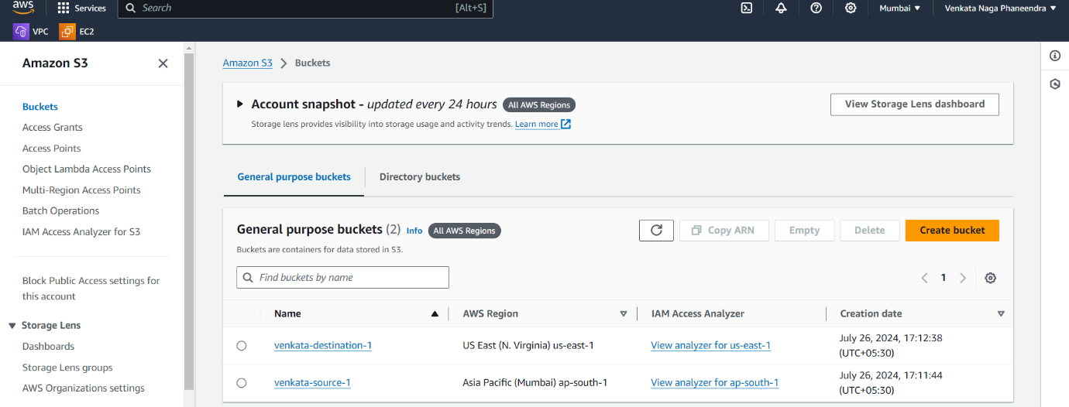

STEP-2: Create a replica rule

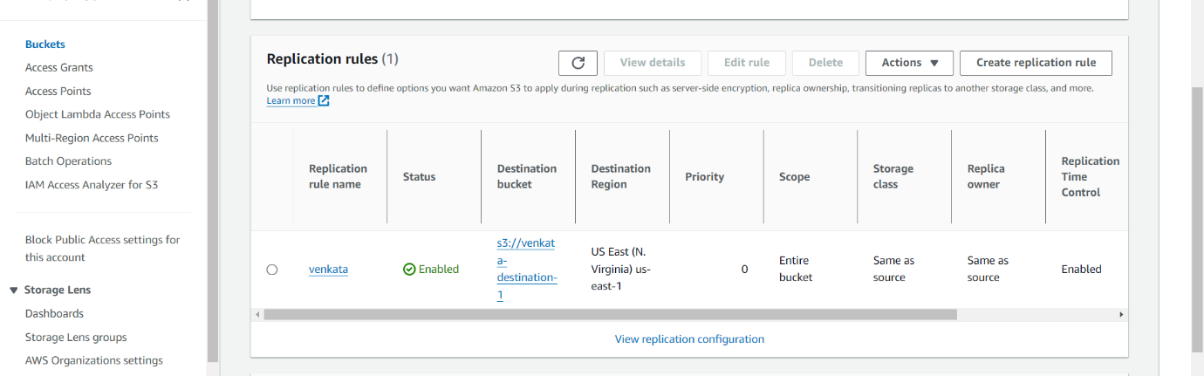

STEP-3: Upload file or folder into source bucket

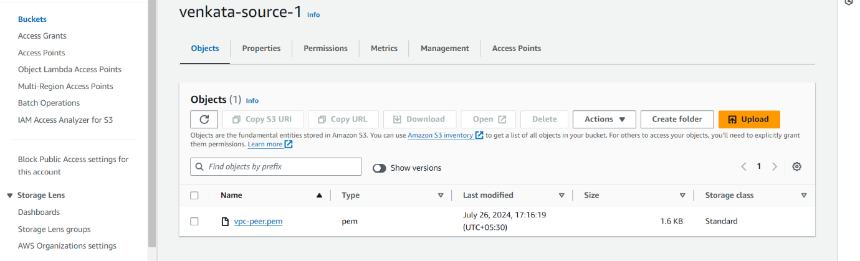

STEP-4: After some time check-in the destination bucket, we will see files uploaded from the source bucket.

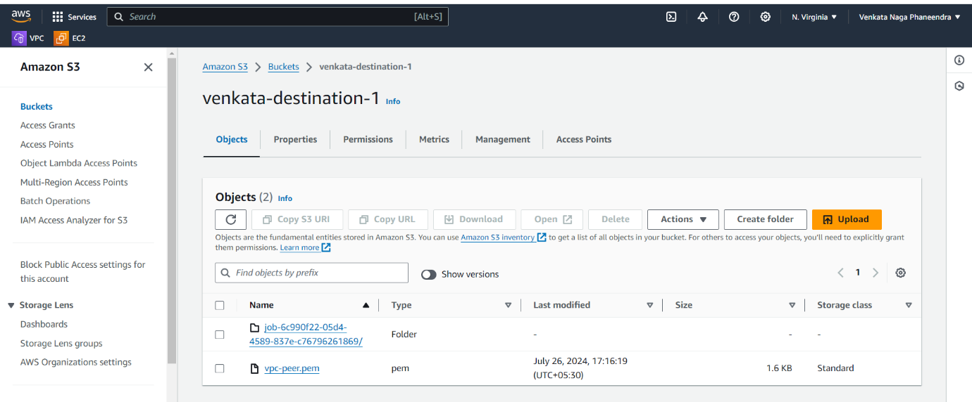

Conclusion: Cross-region replication is done.