**Creating multiple instances with different names using variable block**

**Step 1:** Launch an instance and connect to the server.

* After connecting to the server install aws cli and terraform

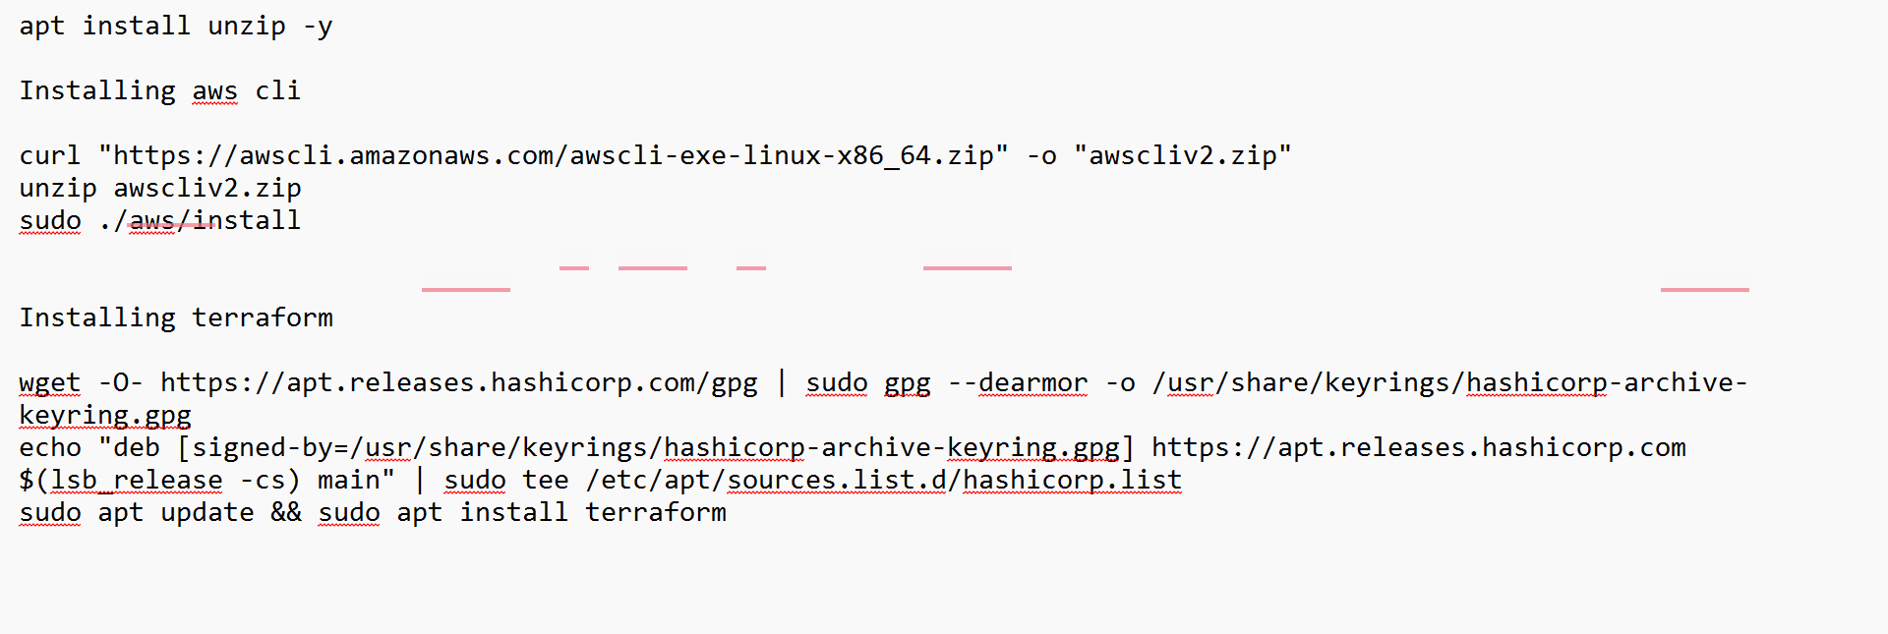

* Then pass aws credentials to the terraform using command

“aws configure” -> “<Give access key>” -> “<Secret access key>” -> “<region>”

“cd .aws” -> “vi credentials” -> “<change name>”

**Step 2:** Make a directory by naming terraform and change to terraform directory.

* Create a “terraform_settings_block.tf”

**terraform** {

**required_providers** {

    aws = {

        source = "hashicorp/aws"

        version = "5.60.0"

    }

  }

}

* Create a “provider.tf”

**provider** "aws" {

    region = "eu-north-1"

    profile = "venky"

}

* Create a “variable.tf”

*# Input Variables*

**variable** "aws_region" {

  description = "Region in which AWS resources to be created"

  type        = string

  default  = "eu-north-1"

}

**variable** "ec2_instance_type" {

  description = "What type of instance"

  type = string

  default = "t3.micro"

}

**variable** "ec2_key_name" {

  description = "key-pair name"

  type = string

  default = "vpc-peer"

}

**variable** "ec2_ami_id" {

  description = "AMI ID"

  type        = string

  default     = "ami-07c8c1b18ca66bb07" *# Amazon2 Linux AMI ID*

}

**variable** "ec2_instance_count" {

  description = "EC2 Instance Count"

  type        = number

  default = 1

}

* Create a “resource.tf”

**resource** "aws_instance" "venky" {

  ami = var.ec2_ami_id

  instance_type = var.ec2_instance_type

  key_name = var.ec2_key_name

  count = var.ec2_instance_count

  availability_zone = "eu-north-1a"

  tags = {

    Name = "venky"

  }

}

**resource** "aws_instance" "venky-vcube" {

  ami = var.ec2_ami_id

  instance_type = var.ec2_instance_type

  key_name = var.ec2_key_name

  count = var.ec2_instance_count

  availability_zone = "eu-north-1b"

  tags = {

    Name = "venky-vcube"

  }

}

**Step 3:** Now we will four commands to launch our resource in the cloud.

* “terraform init” -> Initialize the configuration files

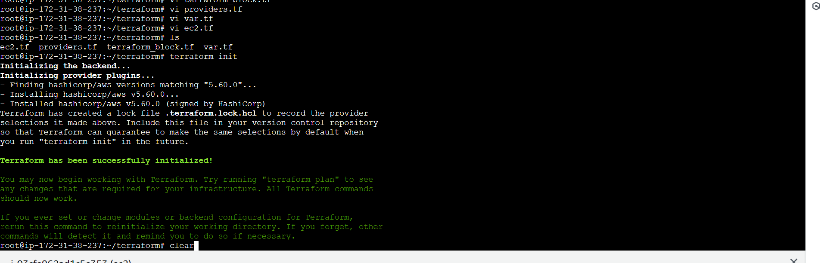

* “terraform validate” -> Validates our configuration files

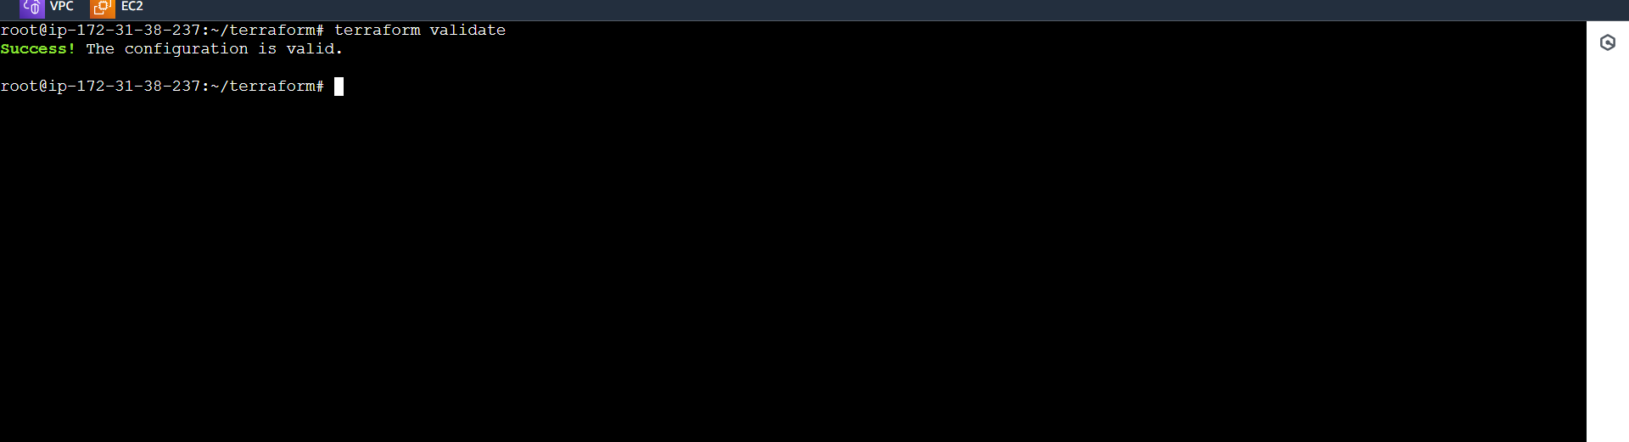

* “terraform plan” -> Plan some actions to achieve the desired state

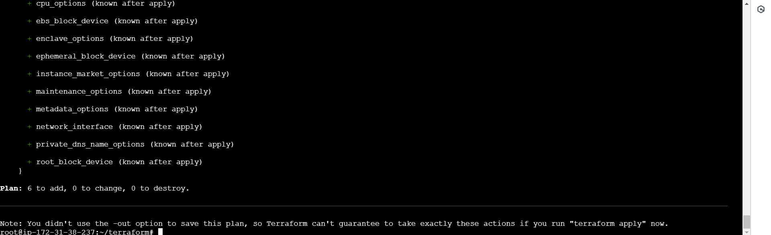

* “terraform apply” -> Apply the actions to achieve the desired state

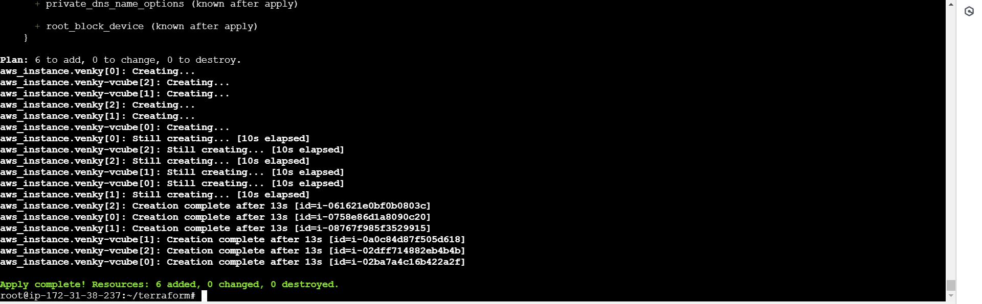

Now, it will launch 6 instances because as I give instance_count 3 in var.tf

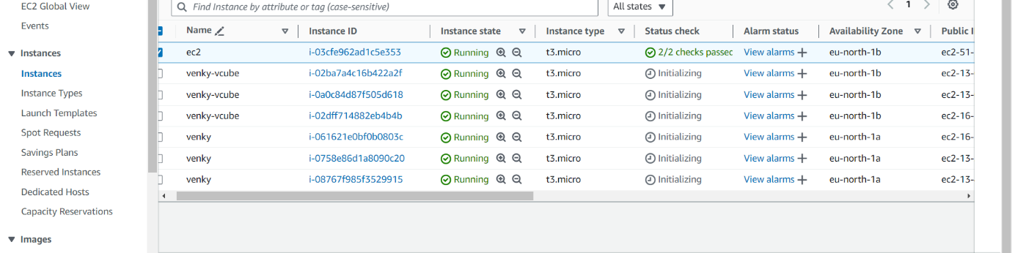

* “terraform destroy” -> Destroys the launched instances

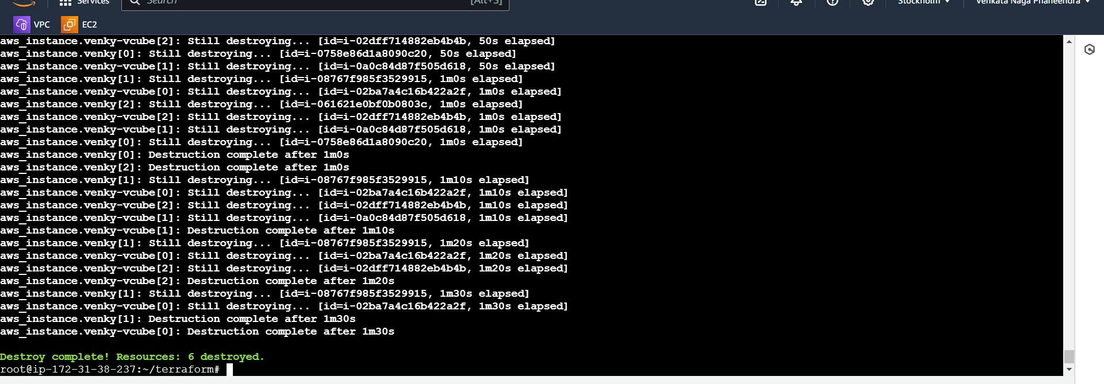

**Conclusion:** Thus, we created instances using terraform block of codes and destroys the instances.