Docker:

Docker is a Containerization platform for packaging, deploying, and running applications as CONTAINERS.

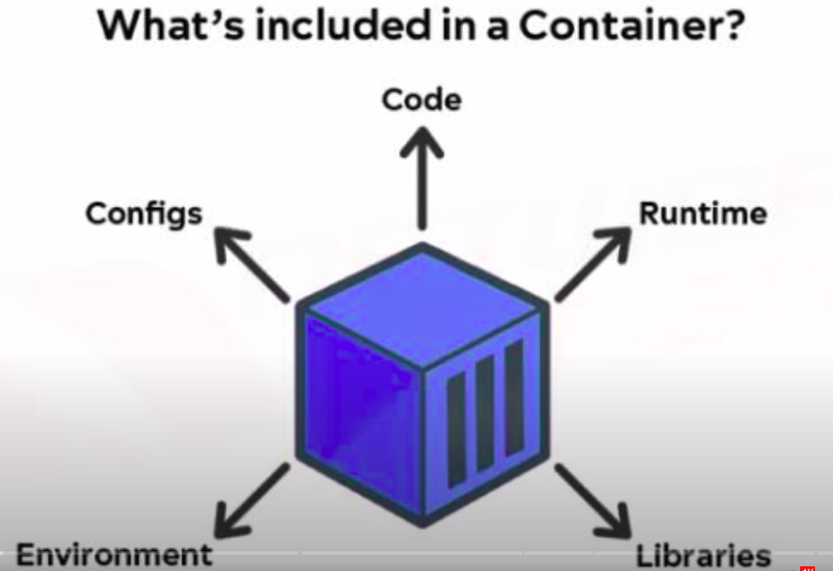

What is containerization?

Containerization is a lightweight form of virtualization that allows you to encapsulate an application and its dependencies into a self-contained unit called a "container."

Docker applications run in containers that can be used on any system: a developer’s laptop, systems on premises, or in the cloud. (it runs the same)

Containers share the host operating system's kernel, but they have their own isolated file system, processes, and networking.

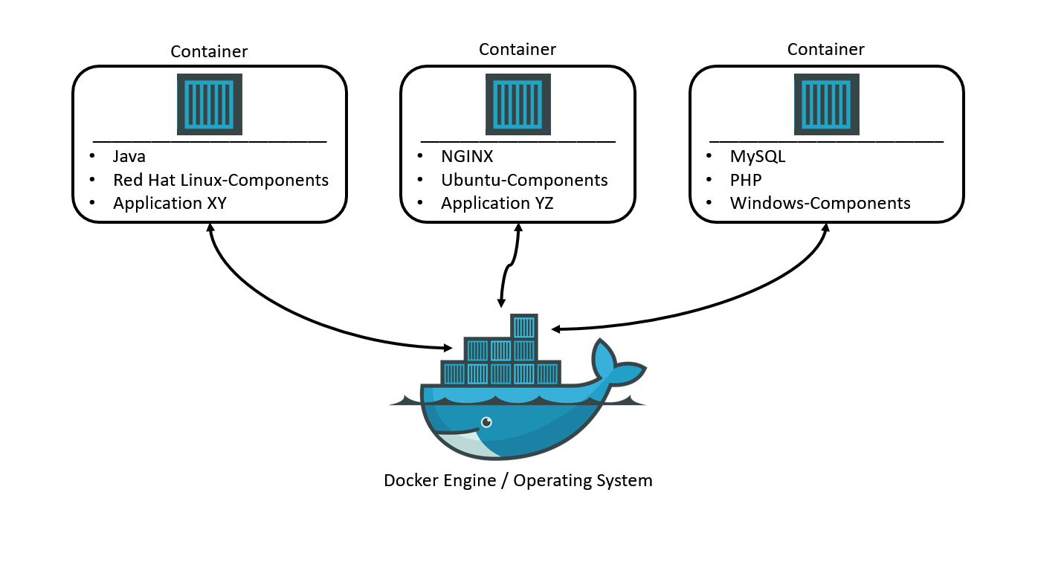

Containers share the host operating system's kernel, but they have their own isolated file system, processes, and networking.

**Difference between VMs & Containers:**

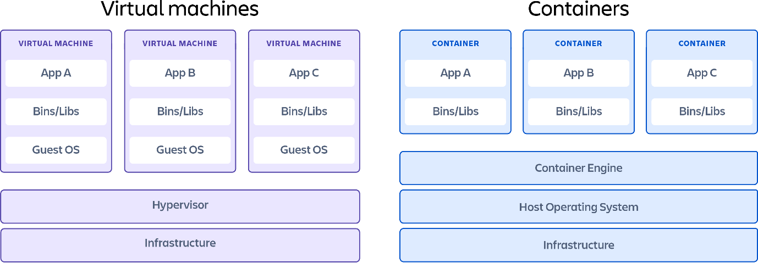

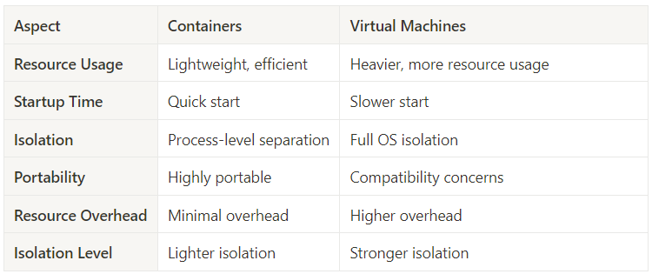

Untitled